

CEC- INNOVENT GARNETON SOUTH SOLAR LIMITED
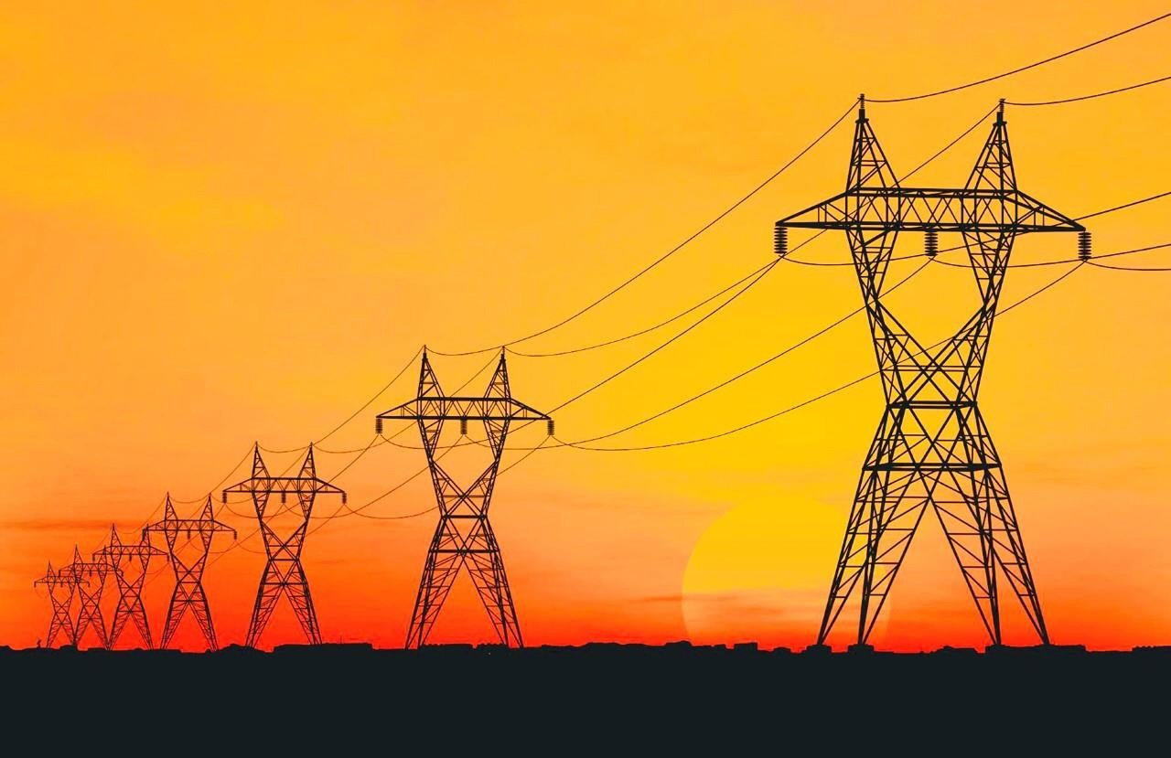
FINAL ENVIRONMENTAL PROJECT BRIEF (EPB) FOR THE PROPOSED 33KV TRANSMISSION LINE FROM GARNETON SOLAR PV SITES TO MWAMBASHI SUBSTATION - KITWE, ZAMBIA

DOCUMENT INFORMATION

Title | Environmental Project Brief for the 33 kV overhead power Transmission Line from Garneton to Mwambashi Substation, Kitwe, Zambia
Consultant | Crownbit Environmental Solutions Limited
Email | fchipatela@gmail.com / jacobtembo@ymail.com
Compiled by | Floyd Chipatela
Reviewed by | Jacob Tembo
Approved by | Client
Report No. | 003

DOCUMENT REVISION RECORD
Rev No. | Issue Date | Description | Issued By
1 | June 2024 | First Draft | CEC PLC
2 | July 2024 | Final Draft | CEC PLC
3 | June 2025 | New Transmission Line Route | ODRIN Consulting/Innovent

EXECUTIVE SUMMARY
Introduction
The Copperbelt Energy Corporation Plc (CEC), in partnership with InnoVent SAS of France, was awarded two Solar PV projects with a total installed capacity of 40 Maw under the Global Energy Transfer Feed-in Tariff (GETFiT) Zambia Solar Photovoltaic (PV) Tender program in 2019. This initiative is part of Zambia's effort to diversify its energy mix and promote renewable energy sources. The two solar PV sites will generate electricity that will be evacuated via a 33 kV overhead transmission line. This transmission line spans approximately 9.2 kilometers and terminates at the ZESCO Mwambashi substation, which is strategically located along Kalulushi Road. The integration of these solar PV projects into the national grid is expected to enhance the reliability and sustainability of the electricity supply in the Copperbelt region.
An Environmental Project Brief (EPB) was initially prepared and submitted to the Zambia Environmental Management Agency (ZEMA) by the Developer, leading to the approval in 2020. This EPB outlined the potential environmental impacts of the project and proposed mitigation measures to minimize negative effects. However, due to delays in project implementation, the environmental approval granted by ZEMA expired, necessitating the preparation and submission of this updated EPB.
The purpose of this updated Environmental Project Brief is to secure fresh approval from ZEMA as the Developer anticipates moving forward with project financing and implementation. This document revisits and reassesses the environmental impacts associated with the construction, operation, and decommissioning phases of the power transmission line. It also updates the proposed mitigation measures to ensure compliance with current environmental regulations and standards.
Regulatory and Policy Framework
In preparation of this EPB relevant policies, laws and environmental and social standards have been reviewed to ensure compliance.
International standards which have been reviewed are the International Finance Corporation (IFC) Environmental and Social Performance Standards, 2012, World Bank (WB) Sustainability Guidelines and the 2024 African Development Bank (AfDB) Integrated Safeguard System. The review of these standards was critical to ensure compliance with the requirements of the project financiers.
The policies reviewed included the 2009 National Policy on the Environment which provides guidance on how to address current and future threats to the environment and to human livelihoods, the National Energy Policy whose objective is to ensure availability of dependable, affordable energy to support poverty reduction and sustained economic growth in an environmentally sound manner by encouraging the economically efficient supply and consumption of energy and the Zambian Renewable Energy Feed-in-Tariff (REFiT) Strategy whose aim is to lower the barriers for increased private sector involvement in renewable energy power generation.
The Environmental Management Act No. 12 of 2011 and the Environmental Impact Assessment Regulations SI No 28 of 1997 provided the overall guidance to the environmental and social Impact Assessment process and the subsequent preparation of the Environmental Project Brief. Other legislation considered included the following:
- Environmental Management (Licensing) Regulations, SI No. 112 of 2013
- Forestry Act (No. 4 of 2015)
- The Noxious Weeds Act, Cap 343
- Mines and Minerals Act, Cap 213
- National Heritage and Conservation Commission Act (Chapter 173)
- Energy Regulation Act, No. 12 of 2019.
- The Zambia Development Agency Act, 2006
- The Electricity Act No.11 of 2019
- The Urban and Regional Planning Act (Number 3 of 2015)
- The Lands Act, 1995
- Agricultural Lands Act, 1960
- Local Government Act, No. 2 of 2019
- The Employment Code Bill, 2019
- Workers Compensation Act (Chapter 271, amended in 1994)
- Factories Act, Cap 441
- Occupational Health and Safety Act, No. 36 of 2010
- Public Health Act (Chapter 295)
- Public Roads Act (No. 12 of 2002)
- Road and Traffic Control Act, Cap 464
- Human Rights Commission Act (No. 39 of 1996)
The Project
The project involves the construction of a 9.2 km stretch of a 33 kV overhead power transmission line. This transmission line is intended to evacuate power generated from the Garneton South (GaS) and Garneton North (GaN) Solar PV parks, which will be located adjacent to each other. A common Collector Station, which will receive and convey power generated from the two solar parks, will be built on the Garneton South Solar Park. From there, an aboveground 33 kV transmission line will be extended. The transmission line will be constructed from steel monopoles and will follow an 18 m wide wayleave that will run alongside the road reserve on the periphery of Zambia compound, behind Mukuba University land, and finally alongside the Kitwe-Chingola dual carriageway before terminating at the ZESCO Mwambashi substation on Kalulushi road. In total, the transmission line will require about 102 steel monopoles for its successful construction. Other necessary materials will include electric conductors, as well as direct current (DC) and alternating current (AC) cables. Although the wayleave will generally maintain a width of 18 m, this width is expected to vary at certain points where underground cables will be used.
Objective of the Project
The objective of the project is to construct a 33 kV overhead transmission line that will provide a combined power evacuation route for the electricity generated from the Garneton South (GaS) and Garneton North (GaN) Solar PV parks. This clean energy will be transmitted into the national and regional power transmission grid system through ZESCO’s Mwambashi substation.
Alternatives
Transmission line route, power design, material/technology and no project alternatives were identified and evaluated against the criteria of environmental soundness, social acceptability, financial viability and technical feasibility.
- Transmission line route alternatives.
Three transmission line routes were identified. The first route was to loop into the Kafironda – Mwambashi transmission Line. This was rejected because it had major technical challenges at the loop in points. The second alternative was the overhead transmission line from Garneton North PV Site to Mwambashi Substation. This alternative was rejected because the land acquisition costs were too much. The third alternative was the Overhead transmission line through the road to Mukuba University. This option was accepted because it leads to little or no displacements and does not involve land acquisition.
- Powerline design alternatives.
The option of laying overhead transmission lines was evaluated against laying underground cables. Constructing underground cables was determined to be very expensive to implement and highly vulnerable to vandalism. Constructing an overhead transmission line was evaluated to be less costly and less prone to vandalism. Therefore, a combination of both overhead and underground transmission lines was preferred. Underground transmission lines will only be laid at the road crossing points, the starting and terminal points.

- Material / technology alternatives.
The use of steel monopoles was evaluated against using towers. The options for towers considered were single circuit towers, namely the Cross-rope suspension and Guyed V structures. These towers were evaluated to be expensive and involve the use of heavy machinery when installing them hence have high ground compaction impacts.

Steel monopoles were evaluated to have a longer life span, have a smaller surface footprint and a relatively shorter compared to towers hence will have fewer visual impacts. Therefore, the use of steel monopoles was preferred.

- No Project Alternative
This alternative would have prevented the project related adverse impacts and risks. Nonetheless, it was not considered because it would not have achieved the sought objective of integration of the power generated from GaS and GaN Solar parks into the national grid, which are integral to sustainable development of the renewable energy subsector.
Environmental Baseline Conditions
Climate
Altitude of around 1200m. The climate consists of cool dry season from April to July, hot dry season from August to October and a warm wet season November to the end of March. Average minimum temperatures range from 10ºC in July to 20ºC in November; average maximum temperatures range between 24ºC in June to 32ºC in October. The project area has a unimodal rainfall pattern. Rainfall is received from October to May of the following year. Wind speeds are generally low at between 1.5-3.3 m/s (5.4-11.9 km/hr) 41.4% of the time and calm (i.e. below 1 m/s or 3.6 km/hr) for 30% of the time.
Landscape and Topography
The Mwambashi stream and its tributaries are the main features influencing topography of the transmission line corridor. The general topography in the area is characterized by anthills and termite mounds. The landscape and visual character along the wayleave for the proposed transmission line is extensively altered, as it runs on the sides of road reserves which have been previously cleared to accommodate other existing power transmission lines and routine clearing of sides of the road reserves.
Physical Infrastructure Along the Proposed Power line Corridor
Major physical infrastructures along this wayleave include, a railway crossing points in between Zambia compound, Mukuba University campus, Chimwemwe Level 1 hospital at the junction of the road to Mukuba University, Kitwe-Chingola Road and Green Home Farm along the Kitwe-Chingola Road. However, these infrastructure will not be disturbed by the proposed transmission line
Air Quality
- Levels of NO2 vary mostly between approximately 80 and 170 µg/m³ across the sites. Apart from one measurement, all measurements fall within the WHO guideline threshold of 200 µg/m³ (1 hour).
- The minimum value recorded for Sulphur Dioxide was 0 µg/m³ (at all sites), and the maximum value was 1100 µg/m³. All measurements fail within the 10-minute guideline threshold of 500 µg/m³ (ZEMA/WHO).
- The minimum value recorded for Ozone was 0 µg/m³ (at all sites), and the maximum value was 112 µg/m³. All measurement falls within the ZEMA 8-hour guideline value of 120 µg/m³.
- Levels of PM2.5 recorded are moderate for all sites, with values ranging mostly between 30-90 µg/m³. Levels of PM 10 recorded are generally moderate for all sites, with values ranging mostly between 30-130 µg/m³.
Noise
The average noise levels observed ranged mainly between about 37dBA to 55dBA, with the lowest average value of 37 dBA and the highest average value of 62 dBA. The main sources of sound in the project area include birds and insects, particularly active in the early morning and early evening, chatter from pedestrians and vehicle traffic on the Kitwe – Chingola Road
Hydrogeology and Hydrology
The surface water bodies within the project area are the Luanshimba and Mwambashi Stream. However, only the Luanshimba stream will be crossed by the proposed transmission line. Generally, groundwater levels go down between June and November (the dry season) and rise between December and April during the rainy season. The rise in groundwater levels between December and April is as a result of increased base flow – groundwater supplying surface water bodies and consequently, during the period of between June and November, when the groundwater water levels in these surface water bodies declines
Ecological Resources
Terrestrial flora along the powerline corridor is characterised by a secondary Miombo woodland vegetation type. The dominant tree species commonly observed include Marquesia macroura, Brachystegia boehmii, Brachystegia floribunda, Maprounea africana, Mimusops zeyheri, Bauhinia petersiana, Julbernardia globiflora, Isoberlinia angolensis and Erythrophleum africanum. The project area is generally degraded due to human activities hence trees found in the area and secondary growth trees.
The dominant shrubs that were observed along the powerline corridor include the invasive alien species of Tithonia diversifolia and a type of grass called bamboo grass. The common grass species observed include hyperhenia spp, missanthiunia spp, themedia triandria, setaria spp and Lodentia simplex
Notable aquatic plants encountered during field investigative studies include reeds, sedges (Cyperus spp.) and creeping grass (Imperata cylindrical). There are no endangered or rare flora species identified along the transmission line corridor.
Lizards (Lacertilia), rats (Rattus Norvegicus), squirrel (Sciuridae), springhare (Pedetes capensis), shrews (Soricidae) and insects such as click beetles (Alaus spp), wasps, bean bug (Riptortus serripes) and small mottled willow moth (Spodoptera exigua) were observed on site. Common fish species in the Luanshimba stream include Tilapia (common breams), Yellow Bell Bream (Serranochromis Macrocephalus), Zigzag Barb (Barbus Miolepis) and Makobo (local name).
Common woodland birds seen, heard or evident in the project area include Swainson’s spurfowl (Pternistes swainsonii), common quail (Coturnix coturnix), Cape turtle dove (Streptopelia capicola) and African crows.

Threatened Species
No threatened or restricted range plant or animal species have been identified or are specifically expected to occur along the powerline corridor,
Social Baseline Conditions
- The land affected by the project is under the leasehold tenure system and the land use around the project area comprises agriculture, built environment and vegetation cover.
- The project area Garneton falls under Chimwemwe Constituency whose population increased from 117,341 in 2010, with 57,740 males and 59,601 females: to 166,283 in 2022, with 81,017 males and 85,266 females.
- Learning institutions in close proximity to the Project Site (Itimpi Ward) include Mukuba University, St. Francis Technical Secondary School, Garneton Secondary School, and Mwambashi Primary School.
- The community surrounding the Project area is serviced by Garneton Clinic. Provision of health services will soon improve once the Chimwemwe Level 1 hospital is commissioned and become operational. The most prevalent diseases in the project area are Malaria, Diarrhea, Respiratory tract infections, Sexually transmitted disease and HIV/AIDS
- The major economic activities in Kitwe District are mining, commerce, trade and industry, agriculture, livestock production, energy, transport, and communications. The most prevalent livelihood activity in the project area is subsistence agriculture. This includes both crop and livestock farming.
- Field investigative surveys established that there are no known physical cultural heritage sites and sacred sites along the transmission line corridor or cultural practices that are undertaken within the Project area.

Environmental and Social Impacts
The main impacts identified and evaluated were impacts on air quality, noise, surface water, terrestrial vegetation and fauna and socioeconomic impacts. The table below shows the significance rating for each of the assessed impacts.

Environmental component | Ref # | Impact during construction & operation phase | CONSTRUCTION PHASE  Impact significance without mitigation |  | OPERATIONAL PHASE  Impact significance with mitigation
 |  |  | Without mitigation | With mitigation | Without mitigation | With mitigation
Biophysical Impacts | 6.1.4.1 | Air emissions | Medium | Very Low | Low | Low
 | 6.1.4.2 | Noise emissions | Low | Very Low | Very Low | Very Low
 | 6.1.4.3 | Surface water quality | Moderate | Low | NA | NA
Ecological Impacts | 6.2.1 | Terrestrial vegetation | Low | Very Low | Low | Very Low
 | 6.2.2 | Avifauna | Low | Very Low | Low | Very Low
Socioeconomic impacts | 6.1.2 | Boost to local economy and multiplier effect | Medium | Moderate | N/A | N/A
 | 6.3.1 | Landscape and visual amenity | Low | Very Low | Low | Low
 | 6.3.2 | Settlements and land | Very Low | Very Low | Insignificant | Insignificant
 | 6.3.3 | Land use and livelihoods | Moderate | Very Low | N/A | N/A
 | 6.3.5 | Cultural heritage | Insignificant | Insignificant | Insignificant | Insignificant
 | 6.3.6 | Community health, safety and security | Low | Very Low | Low | Low
 | 6.3.7 | Occupational Health and Safety | Medium | Low | Medium | Low

Environmental Management Commitments
The Environmental and Social Management Plan (ESMP) has been developed to ensure compliance with Zambian regulatory requirements and IFC Environmental and Social Sustainability policies, guidelines, standards, and other mandates. The ESMP includes mitigation measures tailored to the predicted environmental and social impacts and risks, aiming to avoid or minimize adverse effects while enhancing benefits throughout the project development phases.
For the implementation of the ESMP, senior management of the Proponent will commit to achieving the environmental and social performance levels identified in the plan for the power transmission line Project. The Contractor will play a central role in meeting these performance levels during the construction phase. As part of daily contract management and operational procedures, the Contractor will implement the ESMP and report to the Proponent on environmental, health, and safety issues related to the construction of the transmission line. Some of the key commitments in the ESMP are:
- Mitigating dust generation through regular watering of dust prone areas during the construction phase
- Reducing air pollution from exhaust emissions by regularly servicing construction equipment and project vehicles
- Notifying the regional offices of the National Heritage Conservation Commission for any discoveries of archaeological and cultural significance. A chance find procedure will be developed
- Restricting site clearing activities to defined project corridors only.
- Sensitizing members of the community about the hazards associated with the project and posting danger signs around the site to prevent access by members of the community
- Subjecting employees to appropriate occupational health and safety training and providing them with appropriate personal protective equipment
- Prioritizing as much as possible members from the local communities for existing job opportunities
- Putting measures in place to mitigate spills from mobile equipment which will be used
Consultations and negotiations held / conducted
The Environmental Management Act No. 12 of 2011, Environmental Impact Assessment Regulations SI 28, African Development Bank Integrated Social Safeguard emphasize the need for effective stakeholder engagement in the environmental and social impact assessment process. A rigorous stakeholder engagement process has been undertaken for the project. Stakeholder consultations began in 2019 and continued throughout the ESIA process. Consultations have involved one-on-one meetings as well as public scoping meetings with key stakeholders, interested and affected parties. Minutes of these meetings are attached to this report under Appendix 2.1 and 2.2. During stakeholder engagement, project background information was presented to consulted people to enable them to appreciate the nature of the project for them to participate fully in discussing project impacts and mitigation measures.
Among the stakeholders engaged included those who grow seasonal crops along the identified wayleave and those with titled land on whose activities or land is likely to be displaced by the transmission line project. Other key stakeholders who were identified and engaged include the Ministry of Agriculture, Forestry Department, Zambia Forestry and Forestry Industries Corporation (ZAFFICO), ZESCO, Road Development Agency (RDA), Zambia Railways Limited, Energy Regulations Board (ERB), Kitwe City Council and Civic Leaders.
Grievance Redress Mechanism
A grievance mechanism has been developed for potential use by stakeholders. The aim of the grievance mechanism is to achieve mutually agreed resolution of grievances raised by all stakeholders. The objectives of the grievance mechanism are:
- To provide Project Affected People (PAP) with a straightforward, accessible and prompt avenue for making a complaint or resolving any dispute that may arise during the project.
- To ensure that appropriate and mutually acceptable corrective actions are identified and implemented to address the complaints
- To verify that complaints are satisfied with the outcomes of corrective actions
- To avoid or minimize the need to resort to judicial proceedings which can be long and expensive
The grievance mechanism has outlined the process of submitting, screening, investigating, discussing corrective actions and closing out grievances. While alternative grievance resolution mechanism has been prioritized, the mechanism has made provision for grievants to subject their grievances to the courts of law for resolution.
The process of grievance redress will be as follows:
- Identification of grievance: identify or receive grievances during meetings or via phone calls and record on grievance form.
- Logging of Grievance: All grievances will be recorded on a grievance form and await determination of severity of grievance by the committee responsible for handling grievances.
- Investigation of Grievance and recommendation of corrective action: undertake consultation with the complainant, conduct site visits or inspections to verify the grievance and gather all necessary physical evidence including pictures.
- Discussion of Corrective Action with complainant and agreement of implementation period: Discuss all recommended options for corrective actions as well as the complainant’s preference. Also, clearly highlight all company policies and all relevant laws and regulations considered when considering the complaint.
- Documentation of agreed position: all agreed positions after thorough consideration and discussion of corrective action will be fully documented.
- Implementation of agreed position: The grievance receiving committee will ensure that the agreed position is implemented within a stipulated timeframe.
- Close grievance: grievance will be signed off by complainant after completion of implementation of the agreed position or action.
Environmental and social management plan
The Environmental Management Plan (ESMP) is a tool designed to ensure the implementation of mitigation measures and monitoring by outlining roles and responsibilities of key stakeholders in respect to environmental management. ESMP seeks to address all the possible negative environmental impacts at the various project phases. The total cost of ESMP implementation is estimated at USD 691,401. This tentative budget will be financed by both InnoVent and CEC. The table below shows the cost breakdown.

Activity | Estimated Cost (Us$)
ESMP Implementation (Construction Phase) | 180,000
ESMP Implementation (Operation Phase) | 331,000
ESMP Implementation (Decommissioning) | 7,000
PAP’s compensation | 134,401
Audits | 39,000

The table below shows the key elements of the ESMP and their associated costs.

Key ESMP Aspects During the Construction Phase

Ref | Aspect / Issue | Potential Impact / Risk | Mitigation Measures | Performance Indicator (Target) | Frequency and Monitoring  Action | Responsible Person | Cost (US$) | Best Practice Guidance
C1 | Dust generation from various construction activities | Dust generated can affect workers’ health and safety on site and sensitive receptors in nearby settlements and private farms | Water should be regularly sprinkled on dusty access roads and work areas. Also, appropriate speed limits on dusty roads should be set to minimize dust generation | No visible dust plumes along access roads and construction sites. | Daily visual monitoring of dust emissions | CEC and contractors | 3000 | World Bank General EHS Guidelines: Occupational Health and Safety; Occupational Health and Safety Act 2010 of the Laws of Zambia; IFC PS 2 - Labour and Working Conditions.
C5 | Clearing of vegetation to pave way for construction powerline infrastructure may impact on the existing modified habitat. | Loss of vegetation (tree species) and natural habitats for small mammals, birds and insects | Clearing of vegetation should only be confined to areas where the infrastructure will be installed to minimize loss of vegetation and wildlife habitats | No clearing of vegetation beyond the confines of the project footprint | Daily visual inspection of clearing activities during the construction phase. | Contractor for clearing works | 2000 | IFC Performance Standard 6: Biodiversity Conservation and Sustainable Management of Living Natural Resources. Zambian Forest Act, 1973
C6 | Construction and operation of the powerline | Risk of accidents involving members of the public through unauthorized access to the project construction site. | Access to the active construction site should be restricted and members of the community should be  sensitized on the dangers of trespassing at the project site | Zero accidents or injuries on site involving members of the public. | Daily security surveillance and Quarterly community sensitization meetings | CEC / Contractor(s) | 2000 | World Bank EHS Guidelines: Community Health and Safety; IFC PS 4: Community Health Safety and Security; Occupational Health and Safety Act, No. 36 of 2010 of the Laws of Zambia.
C10 | Occupational health and safety of workers working on site. | Reduced occupational health and safety among workers | Development of a Health and Safety Policy to guide occupation health and safety actions during the construction and operations.  Provision of appropriate personal protective equipment and adherence to all applicable laws and standards | Risks of preventable accidents that can potentially result in injuries and/or fatalities substantially reduce. | Daily risks identification and implementation of management measures conducted prior to commencement works | CEC and its Contractor(s) | 1000 | World Bank EHS Guideline: Occupational Health and Safety; IFC PS 4: Community Health Safety and Security; IFC PS1; IFC PS 2; IFC PS 5; Occupational Health and Safety Act, No. 36 of 2010 of the Laws of Zambia
C20 | Surface Water | Siltation and sedimentation of surface water may occur during construction  And accidental spills | Land clearing should be limited to the surface before the bank of the river and streams and all waste should be collected and appropriately disposed of by a competent and licensed sanitation company. | Zero incident of siltation into the stream  Zero incident of oil spillage | Incident register | CEC / Contractor(s) | 1000 | IFC Performance Standard 3: Resource efficiency and pollution prevention

Key ESMP Aspects During the Operation Phase

Ref | Aspect / Issue | Potential Impact / Risk | Mitigation Measures | Performance Indicator (Target) | Frequency and Monitoring  Action | Responsible Person | Cost (US$) | Best Practice Guidance
OP3 | Operations of the Power transmission line | Risks of electric shock, thermal burn AND exposure to Electromagnetic Field (EMF) | Adequate warning signs should be installed to caution the community against starting bush fires near the site and loitering near facilities with high voltage. | Number of warning signs | Daily inspection of the premises and installed fencing around the project site. | Site Manager | 2000 | World Bank EHS Guidelines: Community Health and safety (General site Hazards); IFC PS 4: Community Health Safety and Security.
OP6 | Occupational health and safety of workers working on site. | Reduced occupational health and safety among workers | A Health and Safety Policy should be established to guide operations of the facility.  Safety rules should be enforced and complied with by workers, and those coming to site | Risks of preventable accidents that can potentially result in injuries and/or fatalities substantially reduced. | Daily risks identification and implementation of management measures conducted prior to commencement of works. | Site Manager | 1000 | World Bank EHS Guidelines: Occupational Health and Safety; IFC PS 4: Community Health Safety and Security; IFC PS1; IFC PS 2; IFC PS 5; Occupational Health and Safety Act, No. 36 of 2010 of the Laws of Zambia.

Conclusion

The EIA studies for the combined Power transmission line evacuation route were undertaken to gather baseline information and compile a report that would provide sufficient information to allow ZEMA to make an informed decision with regards to allowing the construction of the proposed overhead power transmission line that will facilitate the integration of electricity generated from GaS and GaN into the national grid. The update of this Environmental Project Brief has been done in alignment with national legislation, the IFC Performance Standards and the KfW Sustainability Guidelines.
The combined power transmission line route does not disturb any critical habitat as defined by the IFC. The proposed wayleave for the power transmission line follows existing right of way (RoW) and will in most places run parallel with existing similar power transmission infrastructures and hence not expected to result in significant loss of vegetation in the process of land clearing. All individuals whose land or other property will be impacted by the project will be appropriately compensated through the implementation of mitigations that are aligned with IFC Performance Standard 5. Occupational health and safety issues for the workforce during both the construction and operational phases of the project are of concern due to the potential unfamiliarity of the local workforce with good international work practice procedures. However, this can easily be mitigated through appropriate training and implementation of health and safety management system throughout the construction and operational phases of the project.
The benefits of job creation and opportunities for local suppliers cannot be overlooked. This combined with the sole objective of the GETFiT program of integrating renewable energy into the national grid will result in increased benefits to the surrounding local communities and the nation at large.
The impacts of the construction and operation of the power transmission line are adequately addressed in this report. There are no impacts that are assessed to be of greater significance after mitigation; all range from low to insignificant. It is concluded that if mitigation and monitoring measures contained in the Environmental and Social Management Plan (ESMP) (Appendix 1.1) are implemented and the developer commits to enhancing community benefits through creation of local jobs and use of locals will outweigh the negative impacts.

_______________________________
Caroline Sinkamba
Senior Manager- HSE and Risks Copperbelt Energy Corporation Plc

TABLE OF CONTENTS

DOCUMENT INFORMATION i
DOCUMENT REVISION RECORD i
EXECUTIVE SUMMARY ii
TABLE OF CONTENTS ix
LIST OF TABLES xiii
LIST OF FIGURES xiv
ABBREVIATIONS AND ACRONYMS xv
1 INTRODUCTION 1
1.1 Project Background and Rationale 1
1.2 Location of the Project 1
1.3 The Project 1
1.4 Project Objective 2
1.5 Developer and Track Record 2
1.6 Percentage of Shareholding by Each Shareholder 3
1.7 Project Contact Person 3
1.8 Total Project Cost/Investment 4
1.9 Proposed Project Implementation Date 4
2 POLICY, LEGAL AND INSTITUTIONAL FRAMEWORK 5
2.1 Policy Framework 5
2.1.1 National Policy on the Environment (NPE) 5
2.1.2 National Energy Policy 5
2.1.3 REFIT Policy 6
2.2 Legal Framework 6
2.2.1 Environmental Management Act (EMA) Act 12 of 2011 6
2.2.2 EIA Regulations (SI No. 28 of 1997 Part 2 and 3) 7
2.2.3 Environmental Management (Licensing) Regulations, SI No. 112 of 2013: 7
2.2.4 Waste Management: Part III (Regulations 10-15) SI. No. 112 of 2013: 7
2.2.5 Noise 7
2.2.6 Natural Resources Management 8
2.3 Other Relevant National Legislation 8
2.4 Institutional Framework 19
2.5 International Agreements and Conventions 21
2.6 International Standards 23
2.6.1 IFC Performance Standards on Environmental and Social Sustainability (2012) 24
2.6.2 World Bank Environmental, Health and Safety Guidelines 27
2.6.3 KfW Development Bank Sustainability Guideline (2016) 28
2.6.4 Equator Principles 28
2.6.5 International Labour Organisation (ILO) Conventions 29
2.6.6 Environmental and Social Categorization and Rationale 29
3 DESCRIPTION OF THE PROJECT 30
3.1 Location of the Proposed Project 30
3.2 Proposed Transmission Line route 30
3.3 Nature of the Project 33
3.4 Project Area of Influence 33
3.5 Raw Materials 36
3.6 Products and by Products 36
3.7 Production Capacity 36
3.8 Main Activities 36
3.8.1 Preparation Phase 36
3.8.2 Construction Phase 37
4 PROJECT ALTERNATIVES 42
4.1 Mitigation Hierarchy 42
4.2 Identification of Alternatives 43
4.3 Analysis of Alternatives 44
4.3.1 Transmission line route alternatives 44
4.4 Power Transmission line Design Alternatives 44
4.4.1 Overhead Line (preferred alternative) 45
4.4.2 Underground Cables 45
4.4.3 Material / technology alternatives 45
5 DESCRIPTION OF THE BASELINE ENVIRONMENT 47
5.1 Climate 47
5.2 Landscape and Topography 48
5.3 Physical infrastructure along the powerline corridor 51
5.4 Air Quality and Noise 52
5.4.1 Air Quality 52
5.4.2 Noise 55
5.5 Geology and Soils 56
5.6 Hydrology and Hydrogeology 57
5.6.1 Hydrology 57
5.6.2 Hydrogeology 57
5.7 Ecological Resources 59
5.7.1 Flora Terrestrial Flora 59
5.7.2 Aquatic flora 59
5.7.3 Fauna Terrestrial species 60
5.7.4 Aquatic fauna 60
5.7.5 Avi Fauna 60
5.7.6 Threatened Species 60
5.7.7 Protected / Conservation Areas 61
5.7.8 IFC Critical Habitat Status Assessment 61
5.8 Social, Economic and Cultural Environment 63
5.8.1 District Administration 63
5.8.2 Land Tenure and Land Use 63
5.8.3 Population and settlements 64
5.8.4 Education and Health Services Education 64
5.8.5 Economy and Livelihoods 65
5.8.6 Culture and Heritage 66
5.9 Built Environment 66
5.10 Potential Displacements and Compensation 66
5.11 Stakeholder Engagement 67
6 ENVIRONMENTAL AND SOCIAL IMPACT ASSESSMENT –POWER TRANSMISSION LINE 69
6.1 Positive Impacts 70
6.1.1 Local investment and Employment Opportunities 70
6.1.2 Boost to local economy and multiplier effect 72
6.1.3 Enhanced power supply through integration of solar generated electricity 72
6.1.4 Negative Impacts Bio-physical Impacts 73
6.1.5 Noise Emissions 74
6.1.6 Impact on surface water quality 76
6.2 Ecological Impacts 77
6.2.1 Terrestrial Ecology 77
6.3 Avifauna 78
6.4 Socio-economic Impacts 79
6.4.1 Landscape and Visual Amenity 79
6.4.2 Settlements and Land 80
6.4.3 Land-Use and Livelihoods 81
6.4.4 Impact Assessment 81
6.4.5 Cultural Heritage 82
6.4.6 Community Health, Safety and Security 83
6.4.7 Occupational Health and Safety 85
7 CUMULATIVE IMPACTS 86
8 ENVIRONMENTAL AND SOCIAL MANAGEMENT PLAN 86
9 DECOMMISSIONING AND CLOSURE PLAN 86
10 SUMMARY AND CONCLUSION 87
DECLARATION OF AUTHENTICITY OF REPORT CONTENTS 87
REFERENCES 89
APPENDICES 90
APPENDIX 1.1: ENVIRONMENTAL AND SOCIAL MANAGEMENT PLAN FOR THE POWERLINE 91
APPENDIX 1.2: IMPACT ASSESSMENT METHODOLOGY 92
APPENDIX 1.3: ENVIRONMENTAL MONITORING PLAN FOR POWER TRANSMISSION LINE 93
APPENDIX 2.1: MINUTES OF CONSULTATIVE MEETINGS 94
APPENDIX 2.2: LIST OF CONSULTED INDIVIDUALS AND ORGANIZATIONS 95
APPENDIX 3: WASTE MANAGEMENT PROCEDURE 96
APPENDIX 4: WATER TEST RESULTS 97
APPENDIX 5: SOIL SURVEY REPORT 98
APPENDIX 6: BIODIVERSITY REPORT 99
APPENDIX 7: LIVELIHOOD RESTORATION PLAN 100
APPENDIX 8: VALUATION REPORT FOR AGRICULTURAL FIELDS 101
APPENDIX 9: LETTERS OF CORRESPONDENCE 102
APPENDIX 10: SAMPLE QUESTIONAIRE 103
APPENDIX 11: PROOF OF LAND OWNERSHIP 104
APPENDIX 12: A CHANCE FIND PROCEDURE FOR CULTURAL AND HERITAGE FEATURES 105
APPENDIX 13: DRAWINGS FOR THE 33KV POWER TRANSMISION LINE ROUTE 106
APPENDIX 13_1: DRAWINGS FOR THE 33KV POWER TRANSMISION LINE ROUTE_THREE OPTIONS 107
APPENDIX 13_95: DRAWINGS TRANSMISION LINE ROUTE_SORROUNDING FEATURES 108
APPENDIX 14: CERTIFICATE OF INCOPORATION 109

LIST OF TABLES

Table 2.2.6-1: Other Relevant Legislation 9
Table 2.2.6-1: Institutions with a Supervisory and Monitoring role Relevant to the Project 19
Table 2.2.6-1: International Treaties and Conventions of Relevance to the Project 21
Table 2.6.1-1: IFC Performance Standards and their Applicability to the Project 24
Table 2.6.6-1: Coordinates of the Power Transmission Line 31
Table 2.6.6-1: Underground sections of the power transmission line 33
Table 5.4.1-1: ZEMA Standards for Ambient Air Emissions 53
Table 5.4.1-2: WHO Ambient Air Quality Guidelines (2005) 53
Table 5.4.2-1: IFC Noise Level Guidelines 56
Table 5.7.8-1: High Level Critical Habitat Assessment 62
Table 5.8.6-1: Matrix for Determining Overall Significance of Impacts 69
Table 5.8.6-2: Impacts as a result of the Construction and Operation of the Transmission Line 70
Table 6.1.1-1: Impact Assessment with Respect to Local Investment and Employment 71
Table 6.1.2-1: Impact Assessment with respect to local economy and multiplier effect 72
Table 6.1.4-1: Impact Assessment of Air Emissions 73
Table 6.1.4-2: : Impact Assessment of Noise Emissions 75
Table 6.1.4-3: Assessment of Impacts on surface water quality 76
Table 6.2.1-1: Assessment of Impacts on Terrestrial vegetation 77
Table 6.2.2-1: Assessment of Impacts on Avifauna 79
Table 6.3.1-1: Assessment of Impacts on Landscape and Visual Amenity 80
Table 6.3.2-1: Assessment of Impacts on Settlement and Land 81
Table 6.3.4-1: Assessment of Impacts on Land-Use and Livelihoods 82
Table 6.3.5-1: Assessment of Impacts on Cultural Heritage 83
Table 6.3.6-1: Assessment of Impacts on Community Health, Safety and Security 84
Table 6.3.7-1: Assessment of Impacts on Occupational Health and Safety 85
Table 6.3.7-1: Decommissioning and Closure Plan (To be incurred by ZESCO) 86

LIST OF FIGURES

Figure 1.3-1: Underground sections of the power transmission line 2
Figure 1.6-1: Percentage of Shareholding by each Shareholder 3
Figure 3.2-1: Transmission Line Route and Surrounding Infrastructure 32
Figure 3.8-1: Proposed Extension of Substation Perimeter Fence 40
Figure 3.8-2: Proposed Project Schedule for the Power Transmission Line 40
Figure 4.1-1: Mitigation Hierarchy 42
Figure 5.1-1: Annual Rainfall and Temperature of the Project Area 47
Figure 5.1-2: Average number of rainy days and sunshine hours in the project area 48
Figure 5.2-1: Apparent slope towards Luanshimba stream 49
Figure 5.2-2: Anthill along the wayleave for the transmission line 49
Figure 5.2-3: Contour map of the project area and the powerline corridor 50
Figure 5.3-1: Kitwe-Chingola Railway Line to be crossed by the overhead transmission line. 51
Figure 5.3-2: Chimwemwe Level 1 hospital along the road to Mukuba university 51
Figure 5.3-3: Existing transmission lines along the wayleave for the proposed power line 52
Figure 5.7-1: Common vegetation type along the powerline corridor 59
Figure 5.11-1: Stakeholder engagement to update PAPs information. 68

ABBREVIATIONS AND ACRONYMS
Acronym /  Abbreviation | Definition
AC | Alternating Current
CBD | Central Business District
CEC | The Copperbelt Energy Corporation Plc
CIA | Cumulative Impact Assessment
DC | Direct Current
DOF | Department of Forestry
EIA | Environmental Impact Assessment
EIS | Environmental Impact Statement
EMA | Environmental Management Act
EPs | Equator Principles
EPB | Environmental Project Brief
EPC | Engineering Procurement Construction
EPPCA | Environmental Protection and Pollution Control Act
ESIA | Environmental and Social Impact Assessment
ESMP | Environmental and Social Management Plan
ERB | Energy Regulation Board
ha | Hectares
HIA | Heritage Impact Assessment
IFC | International Finance Corporation
ILO | International Labour Organization
IUCN | International Union for Conservation of Nature
kV | Kilovolts
kWh | Kilowatts hour
MOTA | Ministry of Tourism and Arts
MW | Mega Watt
MWp | Mega Watt peak
MWSEP | Ministry of Water, Sanitation and Environmental Protection
NCS | National Conservation Strategy
NEAP | National Environment Action Plan
NEP | National Energy Policy
NHCC | National Heritage Conservation Commission
PS | Performance Standards
PV | Photovoltaic
REFiT | Renewable Energy Feed in Tariff
SI | Statutory Instrument
USD | United States Dollar
WARMA | Water Resources Management Authority
ZESCO | Zambia Electricity Supply Corporation
ZEMA | Zambia Environmental Management Agency

INTRODUCTION

Project Background and Rationale
The Copperbelt Energy Corporation Plc (CEC), in partnership with InnoVent SAS of France, was awarded two Solar PV projects with a total installed capacity of 40 MWac under the Global Energy Transfer Feed-in Tariff (GETFiT) Zambia Solar Photovoltaic (PV) Tender program in 2019. This initiative is part of Zambia's effort to diversify its energy mix and promote renewable energy sources. The two solar PV sites will generate electricity that will be evacuated via a 33 kV overhead transmission line. This transmission line spans approximately 8.1 kilometers and terminates at the ZESCO Mwambashi substation, which is strategically located along Kalulushi Road. The integration of these solar PV projects into the national grid is expected to enhance the reliability and sustainability of the electricity supply in the Copperbelt region.
An Environmental Project Brief (EPB) was initially prepared and submitted to the Zambia Environmental Management Agency (ZEMA) by the Developer, leading to the approval in 2020. This EPB outlined the potential environmental impacts of the project and proposed mitigation measures to minimize negative effects. However, due to delays in project implementation, the environmental approval granted by ZEMA expired, necessitating the preparation and submission of this updated EPB.
The purpose of this updated Environmental Project Brief is to secure fresh approval from ZEMA as the Developer anticipates moving forward with project financing and implementation. This document revisits and reassesses the environmental impacts associated with the construction, operation, and decommissioning phases of the power transmission line. It also updates the proposed mitigation measures to ensure compliance with current environmental regulations and standards.

Location of the Project
The power transmission line will extend from a substation to be situated at the Garneton South Solar PV site to the ZESCO Mwambashi Substation. The Garneton South Solar PV site is situated approximately 20 km northwest of Kitwe's central business district, within the Garneton area. The transmission line's endpoint will be at the ZESCO Mwambashi Substation, located on Kalulushi Road, just a few hundred meters from the junction with Kalulushi – Chingola Road. The transmission line's right-of-way will follow the road reserve along the outskirts of Zambia Compound, pass through the Mukuba University land, and continue alongside the Kitwe-Chingola dual carriageway before reaching the ZESCO Mwambashi Substation on Kalulushi Road.

The Project
The project involves the construction of approximately 9.2 km stretch of a 33 kV overhead power transmission line. This transmission line is intended to evacuate power generated from the Garneton South (GaS) and Garneton North (GaN) Solar PV parks, which will be located adjacent to each other. A common Collector Station, which will receive and convey power generated from the two solar parks, will be built on the Garneton South Solar Park. From there, an aboveground 33 kV transmission line will be extended. The transmission line will be constructed from steel monopoles and will follow an 18 m wide wayleave that will run alongside the road reserve on the periphery of Zambia compound, behind Mukuba University land, and finally alongside the Kitwe-Chingola dual carriageway before terminating at the ZESCO Mwambashi substation on Kalulushi road. In total, the transmission line will require about 102 steel monopoles for its successful construction. Other necessary materials will include electric conductors, as well as direct current (DC) and alternating current (AC) cables. Although the wayleave will generally maintain a width of 18 m, this width is expected to vary at certain points where underground cables will be used. The variations are detailed in the table below:
Figure 1.3-1: Underground sections of the power transmission line
Underground Power Cable Section | Wayleave Linear  Distance | Wayleave  Width
Terminal Point at Garneton PV Substation | 191.6m | 6m
Road Frontage to Rem of Farm 3011 | 1000m | 6m
Chingola-Kitwe Dual Carriage way (T3)  crossing point | 100m | N/A
Mwambashi Substation 33kV Feeder Bay  Termination point | 113.17m | 6m
Total Distance | 1404.77m

Project Objective
The objective of the project is to construct a 33 kV overhead transmission line that will provide a combined power evacuation route for the electricity generated from the Garneton South (GaS) and Garneton North (GaN) Solar PV parks. This clean energy will be transmitted into the national and regional power transmission grid system through ZESCO’s Mwambashi substation.

Developer and Track Record
The proposed power transmission line will be developed by the CEC-InnoVent Garneton South Solar Limited (co-owned by CEC and InnoVent). The company was incorporated on 23rd November 2018 under the Patent and Companies and Registration Agency.
CEC, a member of Southern African Power Pool (SAPP) and listed on the Lusaka Securities Exchange, is an independent power generation, transmission, and quality electricity distribution company with interests in Zambia and sub-Saharan Africa. As a developer of energy infrastructure in Africa, CEC is respected in the region for its skills in designing and operating transmission systems and its status as an emerging independent power generating company. Over the years, CEC has developed various transmission lines within the Copperbelt Province, including the CEC- DRC interconnector. In recent years, CEC has developed two solar farms in Kitwe: The Itimpi 60 MWp park and the 34 MWp Riverside solar park. Currently, CEC is undertaking an expansion project: 130 MWp Itimpi Phase II scheduled for commissioning in quarter 3 of 2025.
InnoVent is a world-renowned company that designs, builds, and runs more than 450 MW of solar and wind farms in France and more than 10 countries in Africa. The company was founded in 2001 and is based in Villeneuve d'Ascq, France.

Percentage of Shareholding by Each Shareholder
The Garneton South project is held by a Special Purpose Vehicle which is a Zambian company registered as CEC - InnoVent Garneton South Solar Limited.
Figure 1.6-1: Percentage of Shareholding by each Shareholder
Shareholder | Country of Origin | Percentage ownership | Address and Contact Person
Copperbelt Energy Corporation Plc (CEC) | Zambia | 51% | Stand 3614, 23rd Avenue, Nkana East, Kitwe, Zambia
InnoVent Renewable Energy Zambia Limited | France | 49% | Stand 4015a, The Gallery Office Park, Frost Building, Rhodes Park, Lagos Road, Lusaka, Zambia

Project Contact Person
Name: Caroline M. Sinkamba
Company: CEC - InnoVent Garneton South Solar Limited
Designation: Senior Manager – Health, Safety, Environment, Social & Risk, Copperbelt Energy Corporation Plc.
Office Address: 23rd Avenue, Nkana East
Postal Address: P.O Box 20819, Kitwe, Zambia.
Phone: Tel:+260 212 244285 / Mobile: +260 960 632602.
Email: sinkambac@cec.com.zm

Total Project Cost/Investment
The total Project investment value for the 33 kV transmission line is estimated at approximately USD 2,500,000.00.

Proposed Project Implementation Date
Project implementation is expected to be executed over a period of 10 Months after approval by ZEMA. The power transmission line is expected to be connected to the ZESCO grid by November 2025

POLICY, LEGAL AND INSTITUTIONAL FRAMEWORK
An overview of the national environmental and social policies and legislation applicable to the project are provided in this chapter. Also included, are the relevant international treaties, conventions, and good practice standards, such as the IFC Performance Standards.

Policy Framework

National Policy on the Environment (NPE)
The National Policy on Environment (NPE), which was officially launched in 2009, is the overall policy on environment and provides environment and natural resources management policies to address current and future threats to the environment and to human livelihoods and provides policy guidelines for sustainable development. The NPE was preceded by the National Conservation Strategy (NCS), adopted in 1985, which saw the establishment of environmental legislation and institutions. The NCS was updated in 1992 through the National Environment Action Plan (NEAP) to meet the demands of economic liberalization and new technical information.
Amongst others, a specific objective of the NPE is to accelerate environmentally and economically sustainable growth in order to improve the health, sustainable livelihoods, income and living conditions of the poor majority with greater equity and self-reliance.
The development of the power transmission line project will be carried out in line with the energy sector objective of the NPE: ‘to meet national energy needs with increased efficiency and environmental sustainability’.
Other strategies relevant to the proposed Project include:
      - Ensure that plans for development and construction of industries have adequate and appropriate waste disposal and pollution control facilities organized to meet international standards.
      - Promote use of environmental guidelines and EIA before sites are developed and ensure application of a monitoring and auditing system for operating industries.

National Energy Policy
The Zambia National Energy Policy (2008) (NEP) sets out a number of policy measures for electricity and renewable energy (RE). The overall objective of the NEP is ‘to ensure availability of dependable, affordable energy to support poverty reduction and sustained economic growth in an environmentally sound manner by encouraging the economically efficient supply and consumption of energy’.
Policy measures to address energy and environmental issues include increasing the utilization of renewable energy sources.
The policy recognizes that accessibility to electricity by the majority of the Zambians remains low and increasing access is a priority, and that renewable energy represents one of the best sources of electricity supply. Policy measures to address energy and environmental issue include increased utilization of renewable energy sources.

REFIT Policy
The Zambian Renewable Energy Feed-in-Tariff (REFiT) Strategy was approved by the Zambian cabinet in July 2017 and formally launched by the Ministry of Energy in October 2017. The REFiT Policy was developed with the following aims:
      - To lower the barriers for increased private sector involvement in renewable energy power generation.
      - In the short-term aim to increase power generation through private sector investments in renewable energy.
      - In the medium to long-term aim to contribute to the creation of a diversified energy mix and increase energy security in Zambia.
GETFiT Zambia became the official implementation program for the REFiT Strategy. The REFiT Strategy provides an allocation of 200MW for small- to medium-scale projects with a maximum size of 20MW, to be procured over a period of three years. Eligible technologies include hydro, solar photovoltaic (PV), geothermal, biomass, waste energy, and wind power. The REFiT Strategy initially allocated 100MW for solar PV projects, however this was increased to 120 MW later on.

Legal Framework

Environmental Management Act (EMA) Act 12 of 2011
The Environmental Management (Amendment) No 8 of 2023 is the Principal Act governing and regulating environmental issues in Zambia. Its main functions include the protection of the environment and control of pollution, in particular to provide for the health and welfare of people, animals, plants and the environment. The EMA repealed and replaced the Environmental Protection and Pollution Control Act (EPPCA) in 2011.
Relevant sections of the Act include:
      - Part III: Integrated Environmental Management which requires the carrying out of Environmental Impact Assessment for certain types of projects.
      - Part IV: Environmental Protection and Pollution Control which provide for conservation of natural resources; and
      - Part VII: Public Participation which gives the public the right to be informed and participate in environmental decision making.
Applicability: The developer will undertake the Environmental Impact Assessment studies leading to the development of an Environmental Project Brief in line with the Environmental Management Act and the relevant EIA Regulations.
Compliance: This Environmental Project Brief has been compiled following the Environmental Impact Assessment studies conducted by an independent environmental practitioner engaged by the Developer in line with the Environmental Management Act and the relevant EIA Regulations.

EIA Regulations (SI No. 28 of 1997 Part 2 and 3)
As part of the implementation process the government through the EPPCA adopted a framework for environmental impact assessment for all developmental projects in Zambia and the Environmental Impact Assessment (EIA) Regulations were established in 1997. These regulations continue to be in force under the EMA. Under the new act, it is mandatory that all development plans, policies, and projects undergo a process of environmental impact assessment (Part III).
Relevance/Compliance: The proposed project falls within the category of projects that require an Environmental Project Brief (EPB). ZEMA has confirmed this via the GETFiT Tender Process. This EPB has therefore been prepared in compliance with these regulations.

Environmental Management (Licensing) Regulations, SI No. 112 of 2013:
Under this statutory instrument established in accordance with Section 43, the EMA controls and regulates the following areas relevant to the project:

Waste Management: Part III (Regulations 10-15) SI. No. 112 of 2013:
These regulations provide definitions of waste and sets out the licensing requirements for transporters and waste disposal sites.
Relevance/Compliance: Construction and operational activities of the proposed project have potential to generate waste whose management, transportation and disposal may require licensing.

Noise
Under the Act a person who emits noise shall take reasonable measures to ensure that the ‘best practicable option’ is adopted to prevent or minimize adverse effects on the environment due to noise. Under Division 6 of Part IV, provision is made by the EMA for the ZEMA to set up noise emission standards, procedures for noise measurement, application of appropriate noise abatement measures and advise on noise pollution abatement measures. Currently, ZEMA is in the process of developing regulations and noise emission standards.
Relevance/Compliance: Noise nuisance to local communities is likely to result from some construction activities, especially during site clearing and leveling. Although Zambian noise emission standards are still under development, relevant design and management measures will be implemented by the project to minimize potential noise impacts according to Good International Industry Practice (GIIP) and recognized standards.

Natural Resources Management
Provision is made by the EMA for ZEMA to develop regulations for the conservation and protection of natural resources (Part IV Division 8 of EMA).
Relevance: The project will involve the direct use of natural resources such as land, construction materials and surface water, which will need to be managed sustainably in order to avoid their degradation or depletion and ensure the viability of the project.
Compliance: In accordance with section 77 of the EMA the project shall not introduce any invasive alien species into any element or segment of the environment. Should any land dereliction or contamination occur as a direct result of project activities, the project will be responsible for carrying out rehabilitation works within such period as the ZEMA inspectorate may specify.
In addition, and subject to the provisions of the EMA, various natural resources shall be managed in accordance with specific Acts pertaining to environmental protection and management of these elements. For example, in relation to the present project, water resources shall be managed in accordance with the Water Resources Management Act, 2011; regional and urban planning shall be managed in accordance with the Town and Country Planning Act, etc. These and other relevant acts relating to environmental protection and management with regards to the project, and the compliance thereof, are discussed further below.
Under the Act an inspector may carry out survey to assist in the proper management and conservation of natural resources, inspect land uses to determine their impact on the quality and quantity of natural resources; and publicize land use guidelines and natural resources conservation regulations.

Other Relevant National Legislation
The Acts outlined in Table 2-3-1 below have also been reviewed in order to ensure that the project complies with other relevant existing laws that have a bearing on environmental management and the project.

Table 2.2.6-1: Other Relevant Legislation
Ref | Legislative Instrument | Description | Relevance and/or Compliance
Constitution
1 | The Zambian Constitution | The Constitution of Zambia Act (as amended by Act No. 2 of 2016) is the fundamental law of the land and provides the framework on which all other laws stand.  In particular, Part IV – Bill of Rights of the Constitution which enshrines fundamental human rights and protection of property, and Part XIX: Land, Environment and Natural Resources which establishes the principles of environmental and natural resources management and development and the protection and utilization of environmental and natural resources.  The Zambian Constitution recognizes certain fundamental rights of relevance to the project:  Article 11: states that every person in Zambia irrespective of race, place of origin, political opinions, colour, creed, sex, or marital status, is entitled to fundamental right to life, liberty, security of the person and the protection of the law, freedom of conscience, expression, assembly, movement, association, protection of young persons from exploitation, protection for the privacy of his home and other property and from deprivation of property without compensation.  Article 16: provides that property of any description shall not be compulsorily taken possession of, and interest in or right over property of any description shall not be compulsorily acquired, unless by or under the authority of an Act of Parliament which provides for payment of adequate compensation for the property or interest or right to be taken possession of or acquired.  Article 23: guarantees protection from discrimination on the ground of race, tribe, sex, place of origin, marital status, political opinions, colour or creed.  Article 24: guarantees protection of young persons from exploitation including employment which interferes with their education and well-being,  physical or mental ill treatment, all forms of neglect, cruelty or exploitation and trafficking. | Although the land comprising the project site is already under title and owned by the CEC, some seasonal agricultural fields exist on site as a result of encroachments by the locals in the surrounding communities. The locals will be compensated accordingly to satisfy the provisions of the constitution and international guidelines. Article 23 protects against all forms of discrimination, is also very important with regards to women or the vulnerable who may not have any title to land (and therefore not entitled to any compensation) in a traditional male dominated society.

Ref | Legislative Instrument | Description | Relevance and/or Compliance
Natural Resources/Heritage
2 | Forestry Act (No. 4 of 2015) | This Act repeals and replaces the Forests Act, 1999. The Act provides for the establishment and declaration of National Forests, Local Forests, joint forest management areas, botanical reserves, private forests and community forests; provides for the conservation and use of forests and trees for the sustainable management of forests ecosystems and biological diversity; provide for the implementation of the United Nations Framework Convention on Climate Change, Convention on International Trade in Endangered Species of Wild Flora and Fauna, the Convention on Wetlands of International Importance, especially as Water Fowl Habitat, the Convention on Biological Diversity, the Convention to Combat Desertification in those Countries experiencing Serious Drought and/or Desertification, particularly in Africa and any other relevant international agreement to which Zambia is a party. | Although the Forestry Act is not directly relevant to the Proposed Project (i.e. Project Site is not located in a protected forest area governed by the Act), the project construction (vegetation clearing) will involve the removal of trees and will adhere to the general principals of the Act in the conservation of trees and forest resources.
3 | The Noxious Weeds Act, Cap 343 | This Act provides for the declaration, control, and eradication of noxious weeds. | Under this Act the project will be responsible for preventing the introduction and/or controlling the spread of common weeds on the site, e.g. Tithonia diversifolia. In addition, undesirable invasive species must not be introduced under any landscaping activities. Species declared as noxious weeds under the act (such as Lantana camara) are prohibited.
4 | Mines and Minerals Act, Cap 213 | The Mines and Minerals Act of 1997 regulates the law relating to mines and minerals. The Act provides for the granting of or, renewal and termination of mining rights. It also provides for the control mining activities with regard to environmental protection. The Act repeals the Mines and Minerals Act of 1976. | The developer will ensure that all aggregates required for the project are sourced from existing permitted quarries or borrow pits
6 | National Heritage and Conservation Commission Act (Chapter 173) | The Act of 1989 provides for the conservation of ancient, cultural, and natural heritage, relics, and objects of aesthetic, historical, prehistoric, archaeological, or scientific interest by preservation, restoration, rehabilitation, reconstruction, adaptive use, and good management.  The Commission also provides regulations for archaeological excavation and export of relics. If a development is unable to proceed without affecting an item of heritage, permission must be sought from the NHCC as outlined in Sections 35 and 36 of the National Heritage Conservation Commission Act. | The project site and immediate surrounds provides a good source of river sand and stone aggregates as evident on site. All measures will be undertaken to protect and conserve the cultural and natural heritage of the project area. For any new discoveries made of items of historical or archaeological interest during implementation of the project, the provisions of the NHCC Act shall apply, and the required procedures for the reporting of such  discoveries shall be followed.

Ref | Legislative Instrument | Description | Relevance and/or Compliance
Energy Regulation, Investment and Standards
7 | Energy Regulation Act, No. 12 of 2019. | The Act of 2019 makes provision with respect to the production and distribution of energy in Zambia and establishes the Energy Regulation Board for purposes of control and licensing of energy undertakings. The Board shall, in conjunction with other Government agencies, formulate measures to minimize the environmental impact of the production and supply of energy and the production, transportation, storage and use of fuels and enforce such measures by the attachment of appropriate conditions to licenses held by undertakings. | The Project will undertake to transmit electricity; the Developer shall apply for a license for energy transmission in accordance with provisions of this Act prior to the commencement of the development. Permits shall also be obtained in accordance with provisions of this Act for any on-site fuel storage facilities that may be necessitated during construction and operational phases (Sections 8-9).
8 | The Zambia Development Agency Act, 2006 | The act provides a legal framework for investment in Zambia and recognizes the role of other agencies, including those responsible for environmental protection, in authorizing specific projects. In considering an application from an investor for a license, permit or certificate of registration, the Act stipulates that the Board shall have regard to the impact the proposed investment is likely to have on the environment and, where necessary, the measures proposed to deal with an adverse environmental consequence in accordance with the  Environmental Protection and Pollution control Act (Section 69d). | CEC and InnoVent may be required to apply for an investors license from the Zambia Development Agency (ZDA); the preparation of an Environmental Project Brief for the project complies with the terms of the Act.
9 | The Electricity Act No.11 of 2019 | The Electricity Act (EA) regulates the generation, transmission, distribution, and supply of electricity.  The EA authorizes the compulsory acquisition of land by the state whenever necessary for the generation, transmission, distribution, or supply of electricity by an operator of any undertaking. Before such an order is given, however, the operator shall have taken all reasonable steps to acquire the land intended to be used on reasonable terms by agreement with the owner of the land.  The Act states that adequate compensation shall be paid to any person who suffers loss or damage through the exercise of the powers conferred by this section in accordance with the provisions of the Lands Acquisition Act. | Part of the proposed powerline will be installed parallel to the 220-kV power line within a perimeter where CEC have a right of way. The rest of the wayleave will be obtained from private, and the road reserve paved by Road Development Agency. All those local people who have encroached the site for the power transmission line wayleave and the road reserve have been identified and their displacement will be compensated accordingly. An appropriate Livelihoods Restoration Plan has also be prepared for the affected individuals. All this will be done in line with the provisions of the Act.
Land Use, Land Acquisition and Regional Planning
12 | The Urban and Regional Planning Act (Number 3 of 2015) | The Act provides for development, planning and administration principles, standards and requirements for integrated urban and regional planning processes and systems so as to ensure multi-sector and level cooperation and coordination; the Act endeavours to ensure sustainable urban and rural development by promoting environmental, social, and economic sustainability in development initiatives and controls at all levels of urban and regional planning. The Act repeals the Town and Country Planning Act, 1962, and the Housing (Statutory and Improvement Areas) Act, 1975. | The development cannot proceed without planning permission from the local authorities. The necessary documentation will be submitted to the relevant authorities for approval for project implementation in accordance with the terms of the Act.
13 | The Lands Act, 1995 | The Act provides for the alienation, transfer, disposition, and charge of land. Although the Act does not refer to matters of conservation this Act is important as the land is one of the basic natural resources. The Act also provides for compulsory acquisition of land by the president whenever he is of the opinion that it is desirable or expedient to do so in the interest of the republic. | The site is located on private land with title held by the Developer (CEC), so this Act may not be applicable.
14 | Agricultural Lands Act, 1960 | The act was passed in 1960 for the protection and alienation of land for agricultural purposes. This may be applicable during relocation of some small- scale farmers. | The project area has no agricultural land that needs to be protected in line with the Act. The Developer will work together with the Ministry of Agriculture to ensure that the provisions of the Act are adhered to.
15 | Local Government Act, No. 2 of 2019 | An Act to provide for an integrated local government system; give effect to the decentralisation of functions, responsibilities and services at all levels of local government; ensure democratic participation in, and control of, decision making by the people at the local level; revise the functions of local authorities; provide for the review of tariffs, charges and fees within the area of a local authority; provide for the proceedings of the council and committees; provide for the role of traditional leadership in democratic governance; repeal and replace the Local  Government Act, 1991; and provide for matters connected with, or  incidental to, the foregoing | Implementation and operation of the new development will be subject to the procedures laid out by the local authorities; all applicable by-laws will be adhered to.
Employment, Health, Safety and Human Rights
16 | The Employment Code Bill, 2019 | The Employment Code Bill repeals and replaces the Employment Act, 1965, the Employment (Special Provisions)Act, 1966, the Employment of Young Persons and Children Act, 1933 and the Minimum Wages and Conditions of Employment Act, 1982.  This Act regulate the employment of persons; prohibit discrimination at an undertaking; constitute the Skills and Labour Advisory Committees and provide for their functions; provide for the engagement of persons on contracts of employment and provide for the form and enforcement of the contracts of employment; provide for employment entitlements and other benefits; provide for the protection of wages of employees; provide for the registration of employment agencies; regulate the employment of children and young persons; provide for the welfare of employees at an undertaking and provide for  employment policies, procedures and codes in an undertaking. | The developer will ensure that all recruitment procedures and conditions of employment of persons to work under the project complies with the provisions of the Act.
17 | Workers Compensation Act (Chapter 271, amended  1994) | The act provides for the establishment and administration of a Fund for the compensation of Workers disabled by accidents, or diseases contracted by, such workers in the course of their employment, and for the payment of compensation to dependents of Workers who die as a result of such accidents or diseases. | There is a possibility that some workers employed on this project, may be involved in accidents. In case of any accidents occurring to any worker, the developer and appointed contractor(s) will treat  such employees in accordance with the provisions of this Act.
18 | Factories Act, Cap 441 | The Factories Act provides a framework for the setting of regulations to ensure the safety, health and welfare of persons employed on construction work sites and in factories. | The power transmission project during operation and as a construction site is subject to provisions of the Act as a place of work. All work procedures and workers Personal Protective Equipment (PPE) will be required to meet the provisions of this Act. Inspection procedures for the operation of all plant and equipment during construction and operation will be governed by  this Act.
19 | Occupational Health and Safety Act, No. 36 of 2010 | An Act to establish the Occupational Health and Safety Institute and provide for its functions; provide for the establishment of health and safety committees at workplaces and for the health, safety and welfare of persons at work; provide for the duties of manufacturers, importers and suppliers of articles, devices, items and substances for use at work; provide for the protection of persons, other than persons at work, against risks to health or safety arising from, or in connection with, the activities of persons at work; and provide for matters connected with, or  incidental to, the foregoing. | The project will involve procedures and activities with inherent risks to the occupational health and safety of employees and other persons. The developer and appointed contractor(s) shall be obliged to comply with the provisions of the Act.
20 | Public Health Act (Chapter 295) | The Act provides for the prevention and suppression of diseases and general regulation of all matters connected with public health in the country under the local authority of each district as the enforcement agency. | For the proposed project, this will cover such matters as solid waste management, levels of hygiene and the standards of the general working environment. Good housekeeping and proper waste management and disposal protocols will be adhered to by the contractor and the developer to avoid the spread of vermin and  diseases.
21 | Public Roads Act (No. 12 of 2002) | This Act provides for the care, maintenance, and constriction of public roads in Zambia, and for the regulation of inter alia road signage (including temporary signs) and storm water disposal structures | The designs of project access roads will adhere to the requirements of this Act, including the use of temporary safety signage.
22 | Road and Traffic Control Act, Cap 464 | The Roads and Traffic Control Act, provides for the control of traffic, and for the regulation of storm water disposal structures. | Deliveries of materials especially for the construction phase will result in a considerable amount of additional traffic on public roads and site access routes.  Signs and directions to control traffic movement to ensure a safe environment both in proximity to and within the site will be put in  place.
23 | Human Rights Commission Act (No. 39 of 1996) | The Act covers the functions, powers and composition of Human Rights Commission which include investigation of human rights violations; investigation of any maladministration of justice; and proposing effective measures to prevent  human rights abuse. | The project will adhere to all laws and guidelines (including international standards) with regards to land acquisition, compensation, and employment.

Institutional Framework
The Zambia Environmental Management Agency (ZEMA) is a statutory body under the Ministry of Water, Sanitation and Environmental Protection (MWSEP) which facilitates at the national level the coordination of the various line Ministries and regulatory bodies that play a role in the management and conservation of the environment.
Government ministries, departments and local authorities work on behalf of the public to ensure that ecological, cultural, social, and economic issues are addressed in line with existing government policies and legislation. Their main responsibility is to ensure that the proposed project meets all the sectoral requirements for which the agency is mandated.
Institutions with a supervisory and monitoring role relevant to the Project are described in the table below.
Table 2.2.6-1: Institutions with a Supervisory and Monitoring role Relevant to the Project
Institution | Responsibility
Zambia Environmental Management Agency (ZEMA) | ZEMA is responsible for the enforcement of the provisions of the EMA on environmental impact assessment, pollution control, natural resources management and solid waste management which includes establishment of landfill sites.  The services provided by the ZEMA specifically in relation to EIA studies include:  - Assisting the developer to determine the scope of EIA studies.  - Reviewing project briefs, terms of reference, and environmental impact statements (EIS) and decision-making.  - Disclosure of the EIS to the public through the media.  - Holding public hearing meetings to discuss the EIS with stakeholders.  - Conducting verification surveys of the affected environment.  - Monitoring the project once implemented.  - Conducting compliance audits of the project between 12 and 36 months after implementation; and  - General administration of all the Regulations under the EMA.  In addition to the Project Environmental Permit, ZEMA is responsible for the issuing of licenses relating to:  - emissions (air and wastewater),  - waste management and  - hazardous waste management.
Water Resources Management Authority (WARMA) | A statutory body under the Ministry of Water, Sanitation and Environmental Protection which is responsible for the management of water resources and liaises with ZEMA on issues relating to water pollution.  In accordance with the provisions of the Water Resources Management Act, WRMA will regulate and control the rates of water abstraction to ensure that available surface and underground water resources are not depleted and is responsible for issuing of water permits (previously known as ‘water rights’).
The National Heritage Conservation Commission (NHCC) | The NHCC, which falls under the Ministry of Tourism and Arts (MOTA), is responsible for the identification of sites of cultural and historical interest and their conservation. In the case of new discoveries of cultural or historical sites, the NHCC will be the first agency to be notified and give guidance on how to handle and preserve them. The NHCC is responsible for issuing permissions to Remove/Alter/Destroy heritage sites and for establishing concession agreements for the management of heritage sites. The heritage impact assessment (HIA) was conducted as part of the field  investigative studies.
Ministry of Health (MoH) | The Ministry of Health is concerned with issues of health of the human population. This ministry works hand in hand with local authorities to ensure quality good health of the residents through provision of health services and health risks awareness. As such the MoH is responsible for monitoring the health status and trends of the communities in the project area through the Health Management Information System.
Department of Energy (DOE) | The DOE falls under the Ministry of Energy and its functions, among others, are to develop and implement a Policy on Energy, integrate the Energy sector into Zambia’s national and regional development strategies; to regulate the Energy sector through appropriate legislation including the development of new laws and byelaws.
The Energy Regulation Board (ERB) | The ERB is the statutory body under the Ministry of Energy which has the mandate of regulating the energy sector in line with the provisions of the Energy Regulation Act of 2003. In order to carry out this role, the ERB, among other functions, ensures that all energy utilities in the sector are licensed, monitors levels and structures of competition, and investigates and remedies consumer complaints. The unit price of the electricity to be generated by the Project and sold to the national grid will be regulated by the ERB. ERB issues licenses for electricity generation plants and energy related facilities such as bulk fuel storage facilities.
Provincial Planning Office | Planning permission for the Project will be sought through the Provincial Planning Office (Copperbelt Province)
District Councils | The district councils are responsible for issuing Building Permits, Fire Permits, and permissions for establishment of waste disposal sites (landfills).

International Agreements and Conventions
Zambia is a party to a number of international and regional conventions related to the environment and natural resources management which influence the country’s policies and legislation. The environmental treaties and conventions most relevant to the project are described in the table below.
Table 2.2.6-1: International Treaties and Conventions of Relevance to the Project
Name of Convention (Date of ratification) | Description | Aspects related to the Project
Convention on Biological Diversity (1992) | The Convention is relevant in that land clearing activities have potential to cause loss of habitat and associated biodiversity and habitat disturbance.  In addition, the IFC Performance Standard 6 (Biodiversity Conservation and Sustainable Natural Resource Management) reflects the objectives of the Convention to conserve biological diversity and promote use of renewable natural resources in a sustainable  manner. | The project will be executed sustainably in such a way as to conserve natural aquatic, woodland, and wildlife habitat as far as possible and minimize disturbance to the site ecosystem.
United Nations Framework Convention on Climate Change.  (1996) | The Convention is relevant as the clearing of land for the Project has the potential to contribute to climate change since loss of vegetation deprives the earth of the carbon sink which help mitigate global warming. | The Project will ensure a conservative approach to vegetation clearing so as to limit loss of vegetation.
African Convention on the Conservation of Nature and Natural Resources | This convention aims at enhancing environmental protection, to foster the convention and sustainable use of natural resources and to harmonize and coordinate policies in these fields. | This convention is relevant to the planning, construction, and operation phases of the proposed project.
Convention on the Protection of World Cultural and Natural Heritage  (ratified 1984) | Provides for the identification, protection, conservation, presentation, and transmission to future generations of the cultural and natural heritage which are of outstanding universal value from the point of view of history, art, or science. | The project will implement the necessary procedures to protect cultural and natural heritage.  Special care will be taken so as not to disturb the sites at Nakayombo Cemetery which is found about 1.2 km northeast of the Project Site. During construction phase, a chance find procedure will be followed to avoid loss of features of cultural or heritage importance which might have not be identified during field investigative surveys on site.
UNESCO Convention for the Safeguarding of the Intangible Cultural Heritage | This is an international agreement for safeguarding intangible cultural heritage and to ensure respect for intangible cultural heritage of communities, groups and concerned individuals. | The project will implement the necessary procedures to protect cultural and natural heritage.
Convention on International Trade in Endangered Species of Wild Flora and Fauna (CITES) | This is an international agreement between governments to ensure that international trade in specimens of wild animals and plants does not threaten their survival. | The developer will strive to ensure protection of the biodiversity in the surrounding area of the Project site.
Basel Convention on the control of transboundary movements of hazardous wastes and their disposal | International treaty that was designed to reduce the movements of hazardous waste between nations, and specifically to prevent transfer of hazardous waste from developed to less developed countries | Waste management during the construction and operation of the Project will be managed accordingly.
Stockholm Convention on Persistent Organic Pollutants  Ratified : 1979 | The objective of this Convention is to protect human health and the environment from persistent organic pollutants by prohibiting, phasing out as soon as possible, or restricting the production, placing on the market and use of substances, and establishing provisions regarding waste consisting of, containing, or contaminated  by any of these substances. | PCBs containing substances such as coolants and lubricants may be used in electrical components on site (i.e. transformers). Any such expired substances or their empty containers will be handled and disposed of accordingly.

International Standards
This EPB report makes appropriate reference to internationally recognised standards in order to establish a transparent regulatory framework for the Project which is in line with both national requirements and the international lenders requirements.
Therefore, whilst complying with national legislations, the Developer will also comply with additional international lender requirements (EPs, IFC Performance Standards and EHS Guidelines) in the implementation of the proposed Project. The social and environmental impact assessments that have been carried out for the Project also involved public consultation with interested and affected parties, formulation of environmental and social management plans and mechanisms for redress of grievances associated with the Project.
The IFC Performance Standards and EHS Guidelines and other international standards relevant to the Project are briefly outlined below.

IFC Performance Standards on Environmental and Social Sustainability (2012)
The IFC Performance Standards (IFC PSs) define client’s roles and responsibilities for managing their projects and the requirements for receiving and retaining the IFC support or the support from institutions that subscribe to the Equator Principles. The IFC applies the PSs to manage social and environmental risks and impacts and to enhance development opportunities in its private sector financing of projects in the member countries eligible for financing. There are eight Performance Standards.
Table 2.6.1-1: IFC Performance Standards and their Applicability to the Project
IFC Performance Standard | Applicability to this project
PS1: Assessment and Management of Environmental and Social Risks and Impacts  PS1 establishes the importance of (i) integrated assessment to identify the environmental and social impacts, risks, and opportunities of projects; (ii) effective community engagement through disclosure of project-related information and consultation with local communities on matters that directly affect them; and (iii) the client’s management of environmental and social performance throughout the life of  the project. | CEC and InnoVent will establish and maintain a process for identifying the environmental and social risks and impacts of the proposed project for the life of the project.
PS2: Labour and Working Conditions  PS2 asks that companies treat their workers fairly, provide safe and healthy working conditions, avoid the use of child, or forced labour, and identify risks in their primary supply chain. | CEC, InnoVent and contractors will employ several people to work on the project especially during construction phase. These workers will either be direct, contracted or supply chain workers. CEC will ensure that what is provided for in this performance standard is adhered to. In Zambia, the law recognizes workers ‘rights to form and join workers’ organizations of their choice. CEC will not interfere with this right of workers in  line with this PS2.
PS3: Resource Efficiency and Pollution Preventions  PS3 guides companies to integrate practices and technologies that promote energy efficiency, use resources—including energy and water—sustainably, and reduce greenhouse gas emissions. | This performance has no direct bearing on proposed project as there will be no direct discharge of effluents into the streams.  However, during the construction phase, water runoff from the construction site may result in erosion and sediment loading of the streams in the area. To mitigate this impact, CEC undertakes to maintain a vegetative cover on the soil surface. Clearing of the site for the power transmission line will be done in such way as to maintain the leaf litter layer. Along the power transmission line, stumping of trees will not be allowed to maintain soil integrity. Clearing of vegetation will strictly be confined to way leave area of the power transmission  line.
PS4: Community, Health, Safety and Security  PS4 helps companies adopt responsible practices to reduce such risks including through emergency preparedness and response, security force management, and design safety measures. | CEC will ensure that the project is designed, constructed, operated, and decommissioned in accordance with good international industry practice (GIIP), taking into consideration safety risks to third parties or Affected  communities.
PS5: Land Acquisition and Involuntary Resettlement PS5 advises companies to avoid involuntary resettlement wherever possible and to minimize its impact on those displaced through mitigation measures such as fair compensation and improvements to and living conditions. Active community engagement throughout the process is  essential. | The project will affect agricultural fields. CEC and InnoVent will compensate all those affected. A Livelihood Restoration Plan for the affected individuals is proposed and attached in Appendix 7.
PS6: Biodiversity Conservation and Sustainable Management of Living Natural Resources PS6 recognizes that protecting and conserving biodiversity, maintaining ecosystem services, and managing living natural resources | The footprint for the power transmission line is a brownfield site with little vegetation.  However, the wayleave for the power
adequately are fundamental to sustainable development. | transmission line will be cleared leading to the loss of flora and termite mounds, or  ‘termitaria’. The clearance will be confined to wayleave area. However, the impact will be very small as most of the wayleave area is  already cleared for agricultural fields.
PS7: Indigenous Peoples  PS7 seeks to ensure that business activities minimize negative impacts, foster respect for human rights, dignity, and culture of indigenous populations, and promote development benefits in culturally appropriate ways. Informed consultation and participation with IPs throughout the project process is a core requirement and may include Free, Prior and Informed  Consent under certain circumstances. | No indigenous people as defined by IFC PS7 will be affected by CEC project in the area.
PS8: Cultural Heritage  PS8 aims to guide companies in protecting cultural heritage from adverse impacts of project activities and supporting its preservation. It also promotes the equitable sharing of benefits from the use of cultural heritage. | The Zambia National Heritage Act has listed the heritage sites throughout the country.  None of the listed cultural heritage will be affected by the proposed project. The reconnaissance survey conducted so far indicates that there are no heritage sites within the wayleave area. The nearest heritage site is the Dag Hammarskjold Memorial Museum on Kitwe-Ndola Road about 55 km from the proposed project site. Any heritage sites or feature that will be discovered during the implementation of the project will be reported to the National Heritage Conservation  Commission (NHCC).

World Bank Environmental, Health and Safety Guidelines
The World Bank EHS Guidelines (30 April 2007) are technical reference documents with general and industry-specific examples of Good International Industry Practice (GIIP), as defined in IFC's PS3 on Resource Efficiency and Pollution Prevention. The World Bank EHS industry-specific guidelines that would be relevant and applicable to the proposed Project include the EHS Guideline for Electric Power Transmission and Distribution (2007).
The EHS Guidelines contain the performance levels and measures that are normally acceptable to IFC and are generally considered to be achievable in new facilities at reasonable costs by existing technology. For IFC-financed projects, application of the EHS Guidelines to existing facilities may involve the establishment of site-specific targets with an appropriate timetable for achieving them. The environmental assessment process may recommend alternative (higher or lower) levels or measures, which, if acceptable to IFC, become project- or site-specific requirements.

KfW Development Bank Sustainability Guideline (2016)
This Guideline describes principles and procedures to assess the environmental, social and climate impacts during the preparation and implementation of Financial Cooperation (FC) measure financed by KfW Development Bank. In this context, this Guideline pursues the following objectives:
      - to define a common binding framework to incorporate environmental, social and climate standards into the planning, appraisal, implementation, and monitoring of FC measures.
      - To enhance transparency, predictability, and accountability in the decision-making processes of the internal environmental and social due diligence (ESDD) and climate assessments.
      - To improve the due diligence of economic risks associated with FC measures by taking account of the environmental, climate and social aspects.
KfW Development Bank requires compliance with relevant national standards and legal requirements as well as the standards of the World Bank Group (i.e. for public agencies the Environmental and Social Safeguards of the World Bank and the IFC Performance Standards for cooperation with the private sector) and their General and sector-specific Environmental, Health and Safety (EHS) Guidelines as well as the Core Labour Standards of the International Labour Organization (ILO) as already narrated above.

Equator Principles
The Equator Principles are a risk management framework, adopted by financial institutions, for determining, assessing, and managing environmental and social risk in projects and are primarily intended to provide a minimum standard for due diligence to support responsible risk decision- making. Equator Principle Financial Institutions (EPFIs) commit to implementing the Equator Principles in their internal environmental and social policies, procedures and standards for financing projects and will not provide Project Finance or Project- Related Corporate Loans to projects where the client will not, or is unable to, comply with the Equator Principles. In order to facilitate potential access to funding for project development potential, borrowing organizations need to consider the Equator Principles and environmental and social risk management as part of the ESIA process.
There are 10 principles as shown below, and these require that Projects conduct an ESIA process in compliance with the IFC Performance Standards on Environmental and Social Sustainability.
- Review and categorization.
- Social and environmental assessment
- Applicable environmental and social standards
- Environmental and Social Management System and Equator Principles Action Plan
- Stakeholder Engagement
- Grievance mechanism
- Independent review
- Covenants
- Independent monitoring and reporting
- Reporting and Transparency

International Labour Organisation (ILO) Conventions
In addition, Zambia is a signatory to various International Labour Organisation (ILO) Conventions which are relevant to working conditions and regulation on site during construction and operation of the Project. These include:
      - C138 - Minimum Age Convention, 1973 (ratified 1976)
      - C182 - Worst Forms of Child Labour Convention, 1999 (ratified 2001)
      - C111 - Discrimination (Employment and Occupation) Convention, 1958 (ratified 1979)
      - C017 - Workmen's Compensation (Accidents) Convention, 1925 (ratified 1964)
      - C148 - Working Environment (Air Pollution, Noise and Vibration) Convention, 1977 (ratified 1980)
      - C155 - Occupational Safety and Health Convention, 1981 (ratified 2013)

Environmental and Social Categorization and Rationale
This is a Category B project according to IFC’s Policy on Environmental and Social Sustainability. The proposed investment is expected to have limited environmental and social impacts, which are site-specific, temporary and none is expected to be significant. Those impacts can be avoided or mitigated by adhering to applicable performance standards, procedures, guidelines, and design criteria as described in the following sections. This categorization is consistent with the categorization of other similar projects within this sub-sector. The main environmental, social, occupational health and safety risks identified for this project relate to the management of solid and liquid waste; dust during construction, the capacity of the contractor to manage their social, environmental and safety performance and engage with project stakeholders; assurance of fair, safe and healthy working conditions for all workers during construction and operations; and management of community health and safety.

DESCRIPTION OF THE PROJECT

Location of the Proposed Project
The power transmission line will extend from a substation located at the Garneton South Solar PV site to the ZESCO Mwambashi Substation. The Garneton South Solar PV site is situated approximately 20 km northwest of Kitwe's central business district, within the Garneton area. The transmission line's endpoint will be at the ZESCO Mwambashi Substation, located on Kalulushi Road, just a few hundred meters from the junction with Kalulushi – Chingola Road. The transmission line's right-of-way will follow the road reserve along the outskirts of Zambia Compound, pass behind the Mukuba University land, and continue alongside the Kitwe-Chingola dual carriageway before reaching the ZESCO Mwambashi Substation on Kalulushi Road.
Notable landmarks along the transmission line route and not necessarily expected to be displaced by the project include:
- Zambia Compound Township (to be left on the left side of the transmission line from Garneton South
- Litana farm (a private farm).
- Luanshimba stream (to be crossed by the transmission line).
- Kitwe Chingola Railway line (to be crossed by the transmission line).
- Mukuba University.
- Mbachi Farm opposite Mukuba University.
- Chimwemwe level 1 hospital and the junction of Chingola-Kitwe road and Mukuba university road
- Kitwe-Chingola dual carriage way (to be crossed by the transmission lime using underground cables).
- Green Home farm.
- Ichimpe Forest reserve on the Kitwe Road, side of the Kitwe-Chingola dual carriage way

Proposed Transmission Line route
Initially, the transmission line was passing through Mukuba University land affecting the perimeter perimeter fence, and some auxiliary structures on the front part of the university. The line route has been optmised and now will avoid Mukuba University land by passing behind it. With this route realignment, the length of the transmission line has reduced from 10km to 9km. Now new PAPs are affected by this realignment, but trees are affected. Since the new section of the transmission line was not covered under this EPB, the following will be done before commencing construction of the transmission line.
- Appropriate studies will be conducted and appropriate updates to the ecological specialist report, EPB and the ESMP will be made if needed.
- The Forestry Department will conduct the resource assessment for the new section as well before the permit is issued
- The GPS coordinates for key points along the wayleave are included in the table below:
Table 2.6.6-1: Coordinates of the Power Transmission Line
POINT | LOCATION | EASTING | NORTHING
A | Mwambashi Substation | 621767.4626 | 8593478.206
B | Kalulushi Road | 621777.56 | 8593501.531
C | Kalulushi Sabina Road T-Junction | 621830.9407 | 8593486.682
D | Chingola-Kitwe Road | 621845.9151 | 8593504.127
E | Chingola-Kitwe Road | 621989.4212 | 8593955.685
F | NFCA Green Farm | 622012.7972 | 8594029.037
G | NFCA Green Farm | 622662.095 | 8593818.065
H | NFCA Green Farm | 622940.2806 | 8593726.616
I | Chingola-Kitwe Road | 623046.2164 | 8593688.307
J | Chingola-Kitwe Road | 623132.5736 | 8593647.254
K | Chingola-Kitwe Road | 623225.9313 | 8593598.142
L | Chingola-Kitwe Road | 623367.9479 | 8593494.148
M | Chingola-Kitwe Road | 623514.0036 | 8593353.67
N | Chingola-Kitwe Road | 623750.5236 | 8593035.039
O | Chingola-Kitwe Road | 624104.1219 | 8592565.452
P | Chingola-Kitwe Road | 625356.8645 | 8593181.446
Q | Mukuba University Campus | 625617.189 | 8593696.158
R | Garneton | 628476.4435 | 8593504.622
S | Dale Litana Farm | 628137.883 | 8594959.156
T | CEC Titled Land-Garneton | 628262.7022 | 8595153.271
U | Proposed Garneton South Solar PV plant | 628279.2492 | 8595156.786
V | Proposed Garneton South Solar PV plant | 628280.1116 | 8595157.026

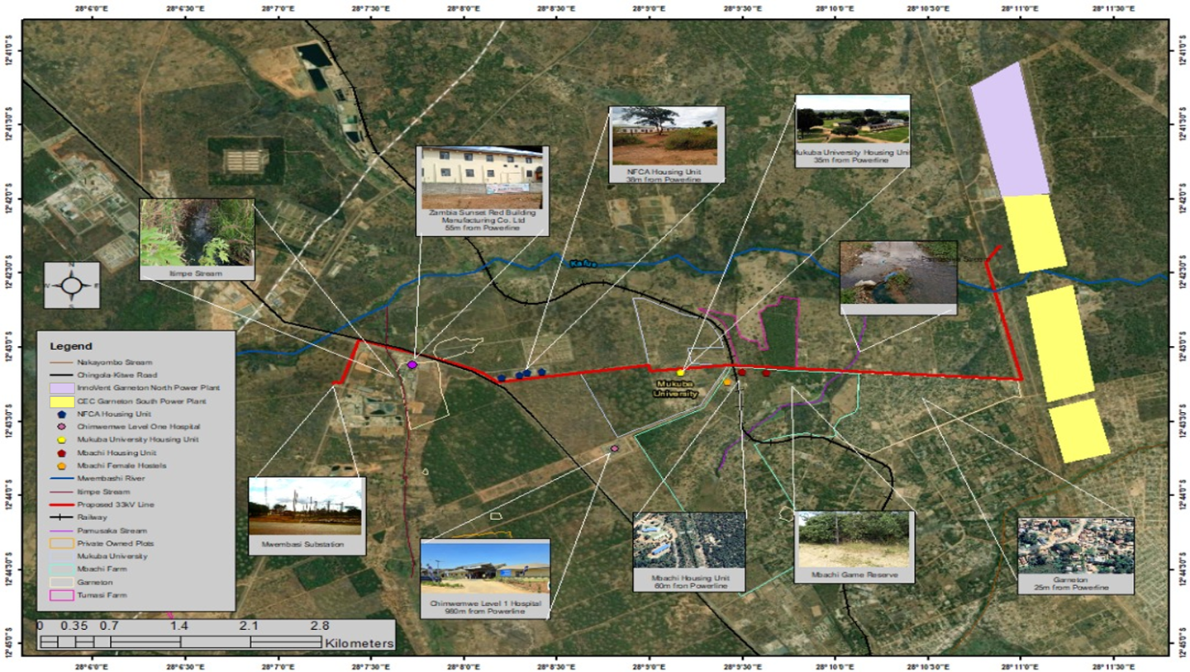
Figure 3.2-1: Transmission Line Route and Surrounding Infrastructure

Nature of the Project
The project will involve construction of a 9 km stretch of a 33 kV overhead power transmission line. This transmission line is intended to evacuate power generated from the Garneton South (GaS) and Garneton North (GaN) Solar PV parks, which will be located adjacent to each other. A common substation, which will receive and convey power generated from the two solar parks, will be built on the Garneton South Solar Park. From there, an aboveground 33 kV transmission line will be extended. The transmission line will be constructed from steel monopoles and will follow an 18 m wide wayleave that will run alongside the road reserve on the periphery of Zambia compound, passing behind Mukuba University land, and finally alongside the Kitwe-Chingola dual carriageway before terminating at the ZESCO Mwambashi substation on Kalulushi road. The power transmission line shall be constructed using steel monopole structures which are expected to vary in height from 12m to 14m with ACSR Bisson conductor/Copper conductor/ per phase. The power transmission line shall be equipped with a single overhead optical guard wire (OPGW). The OPGW shall run on top of the phase conductors and terminate at the landing gantry at Mwambashi Substation where it will be linked into the fiber optical cable that that extends the optical cable into the substation control room. The Mwambashi Substation will be upgraded to accommodate the load from the new 33kv transmission line. Although the wayleave will generally maintain a width of 18 m, this width is expected to vary at certain points where underground cables will be used. The variations are detailed in the table below:
Table 2.6.6-1: Underground sections of the power transmission line
Underground Power Cable Section | Wayleave Linear  Distance | Wayleave  Width
Terminal Point at Garneton PV Substation | 191.6m | 6m
Road Frontage to Rem of Farm 3011 | 1000m | 6m
Chingola-Kitwe Dual Carriage way (T3)  crossing point | 100m | N/A
Mwambashi Substation 33kV Feeder Bay Termination point | 113.17m | 6m
Total Distance | 1404.77m

Project Area of Influence
The direct area of influence for the proposed transmission is the actual wayleave corridor measuring 9km long and 18m wide. The project will affect all immovable assets within the defined wayleave corridor. The optimization of this wayleave corridor has resulted in avoiding the transmission line impacting key infrastructure such as Mukuba University. The direct area of influence will mainly be impacted by biophysical impacts such as removal of vegetation and land degradation due to the excavations which will be done. Apart from impacting the direct area of influence, social impacts are expected to affect people outside the wayleave corridor and the immediate surrounding areas. Social impacts such as exposure to dust and noise are expected to impact communities living within the 200m radius from the project site. Social impacts such as access to employment opportunities and the risk of traffic accidents due to the movement of project vehicles and equipment are expected to extend beyond 500m from the project site. The transmission line:
- Shares its boundary with a built up community called Garneton on the left for about 2.5km. On the right side, there are private farms, with highly disturbed forests. These farm areas though disturbed in terms of vegetation (trees), play host to various ecological organisms that include birds, snakes, butterflies and small mammals.
- Crosses a small stream called Pamusaka Stream. This stream is used by locals for washing of clothes as well as drawing water for home use. The aquatic body also provides home to aquatic organisms such as monitor lizards, fish, frogs and many other small organisms.
- Passes in between two thick forests on both sides belonging to Mbachi Farms on the left and Tumatsi Farm. These private farms have maintained their natural nature with closed canopy. They are predominantly miombo forests with large trees providing home to various organisms. Mbanchi farms is been stocked with antelopes serving as an important ecological home for both flora and fauna. These farms share about 700m of direct interaction with the transmission line before the line crosses a railway line.
- Passes close to Mukuba University for a stretch of 500m and a further 500m of the Universities natural forest land.
- Crossing the Ichimpe Stream. This stream drains its water into the Mwambashi stream and provides a habitat for various aquatic organisms. The Transmission line turns south west for a distance of about 500m to its final point at the Mwambashi Substation. It passes through secondary regeneration forests that are host to birds, snakes, butterflies and small mammals.
Generally, the areas to be affected directly or indirectly by the project are private owned land farms that have been disturbed and have lost their natural ecological status due to anthropogenic activites such as agriculture, settlement and extraction of trees for energy (charcoal and firewood). Further the wayleave follows the public road infrastructure for its greater potion. This means there will be minimal destruction of trees or indeed ecosystems for purposes of access or for installation of the transmission line. The area of significant interest that will require much attention is the area were the transmission line passes between the two farms which have natural and undisturbed forests. The farms are Mbachi and Tumatsi farms which have kept their forests dense and intact.
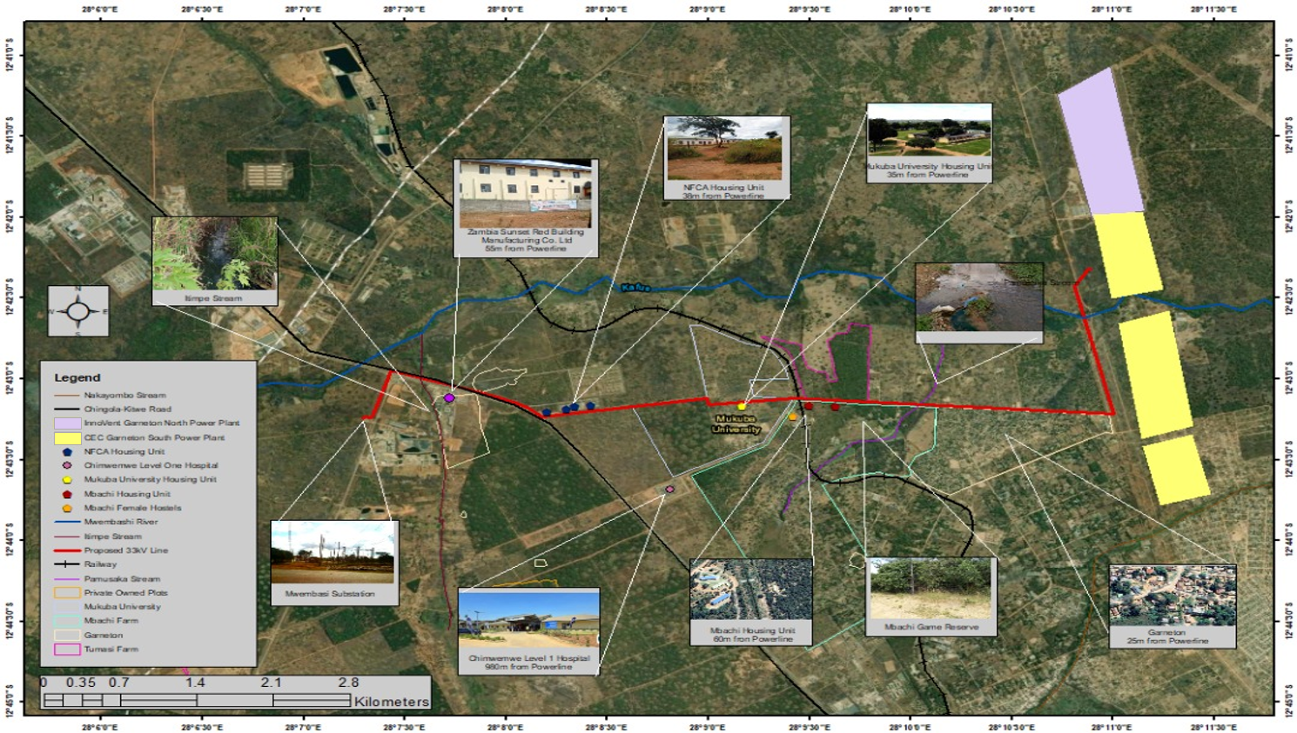
Figure 3.4.1: Transmission Line Map and Infrastructures

Raw Materials
The main construction materials shall include but not limited to the following:
- Steel monopoles
- River sand for concrete works
- Cement for concrete works
- Aggregates of various sizes for concrete
- Insulators
- ACSR Conductors (Aluminum conductor steel-reinforced cables)
- Transformers
- Hammered copper cables.
- Timber of various sizes
- Accessories such as bolts and nuts
- Water for concrete works
During the construction and powerline installation process, all the raw materials required will be stored at the Central Switching Station in Nkana East, except construction aggregates which will be delivered to site whenever needed. No hazardous chemical compounds will be used at any stage during the construction and operation of the power transmission line . Machinery that requires fuel will be serviced at the central switching station where fuel storage facilities have been installed. All water supply requirements will be met by means of water bowsers which will be stationed on site whenever required. All works that require use of electricity will be done at the CEC central Switching Station in Nkana East and parts will only require assembling on site.

Products and by Products
The main product of the project is a fully constructed overhead transmission line with a capacity to transmit 33 kV of electricity to be generated from the GaS and GaN Solar PV parks.
The resulting by-products from the project shall include waste materials from the construction process such as empty cement bags and other packaging materials, aggregates, steel off-cuts, bolts & nuts, wood, waste (domestic) from camp sites, etc. All waste shall be disposed of in designated sites and where possible recycled or reused.

Production Capacity
The transmission line will have the capacity to transmit 330 kV of electrical power.

Main Activities

Preparation Phase
Key activities under this phase include.
      - Reconnaissance survey - using maps and preliminary ground truthing.
      - Line verification based on the preliminary survey.
      - Wayleave acquisition
      - Detailed line survey and pegging
      - Geotechnical ground investigations; and
      - Topographical investigations

Construction Phase
During the detailed wayleave selection process, the center line and the wayleave boundaries will be established. The construction of the powerline will be done by an independent contractor to be supervised by CEC and/or InnoVent. The following is the description of typical line construction activities.

Bush Clearing
Bush clearing will be done by removing standing vegetation. This practice is used to ensure that sufficient clearance is maintained between the conductor and the ground, and to facilitate maintenance of the line should need arise. Clearing of the wayleave will be done by a contractor to be engaged by the Developer. The contractor will undertake the work as outlined in the tender document.
Looking at the nature of vegetation in the project area and preliminary assessment of vegetation along the proposed wayleave, no merchantable timber is expected to be generated. All wood waste resulting from bush clearing will be used by the local communities as wood fuel as well as for erosion and sedimentation control. No burning of wood waste shall be allowed on site.

Erecting Structures
Where possible, structures for sites are established with minimal excavating. However, in particularly steep terrain, a flat area may be constructed for the structure site. The structures maybe assembled horizontally on the ground and set in place by a crane. An alternative method would be to assemble the structure vertically one piece at a time at the structure location.

Stringing Conductor
Once the structures are erected, a tractor or equivalent vehicle strings the conductor and overhead shield wires through pulleys attached to the insulators. The conductor wires are attached by hand to the insulators. The shield wires provide a path to the ground for lightning strikes.

Installation of Counterpoise
Counterpoise is installed in areas where ground resistance is high to improve grounding and reduce the number of lightning caused outages on the line.

Upgrade Works at Mwambashi Substation.
The following upgrade works will be undertaken at the ZESCO Mwambashi substation to facilitate termination of the transmission line and integration of the power evacuated from GaS and GaN solar parks into the national grid.
- Extension of substation fence
The existing perimeter fence will be extended by 140m². The fence will protect the substation infrastructure from vandalism and theft and will mitigate trespass by members of the community thereby protecting them from health and safety risks associated with power substations.
- Extension of the 33kV busbar
The busbar will serve as a common connection point for multiple incoming and outgoing power lines. Will maintain grid stability by managing power distribution by collecting it from various sources and distributing it to different feeders.
- Installation of the new 33kV line switch gear
This consist of circuit breakers, switches, and protective relays that work together to ensure reliable and safe operation of the power grid. It will be used for connecting or disconnecting power lines for maintenance, repairs and isolating faulty sections to prevent damage and ensure grid stability.
- Installation of line bay control and protection panel
This ensures reliable power transmission and protects equipment from damage. This is done by monitoring and controlling the operation of a transmission line, triggering actions to isolate the faulty section once a fault or anomalies are detected. This will mainly consist relays, control system and indicators.
- Installation of communication system equipment
The communication system equipment will enable reliable data exchange, monitoring and control of substation operations. The communication system will also facilitate data transmission between control centres and other substations.
- Civil works to reposition part of the substation drainage network
A well aligned drainage system is important in protecting substation infrastructure from flooding thus ensuring the safety and integrity of substation installation an important factor in sustainable power transmission.
- Installation of a 33kV cable from the newly constructed line bay to the take off point as detailed in the General Arrangement drawing
- The cable will facilitate the evacuation of power to into the grid and subsequently for use by the intended users.
Much of the new installations will be done within the already acquired land. Only 140m² additional land will be needed for the substation. The detailed design parameters for the substation upgrades have not been made available yet. Once all the missing information is known, an initial environmental review of the proposed substation upgrade activities will be done to ascertain the actual scope and whether the new activities will materially alter the findings, impacts and mitigation measures informed by the already approved EPB for the power transmission line. If the changes are deemed material, the project sponsors will ensure that relevant studies are conducted to document the new impacts and the appropriate mitigation measures. The studies will aim to:
- Document biodiversity impacts and proposed mitigation measures
- Identify potential wastes and prescribe appropriate waste management measures
- Identify any new PAPs and recommend appropriate measures to compensate for immovable assets to be lost and appropriately restore the livelihood of the PAPs
- Assess the impact of the proposed activities on the traffic in the area, occupational health and safety, noise levels, air quality and pollution of ground and surface water
- Identify compliance requirements by Zambian laws and policies as well as the AfDB Operational Safeguards and the International Finance Corporation Environmental and Social Standards and ensure that the requirements are satisfied.
The figure below shows the additional land which wil be needed for the proposed substation upgrades.
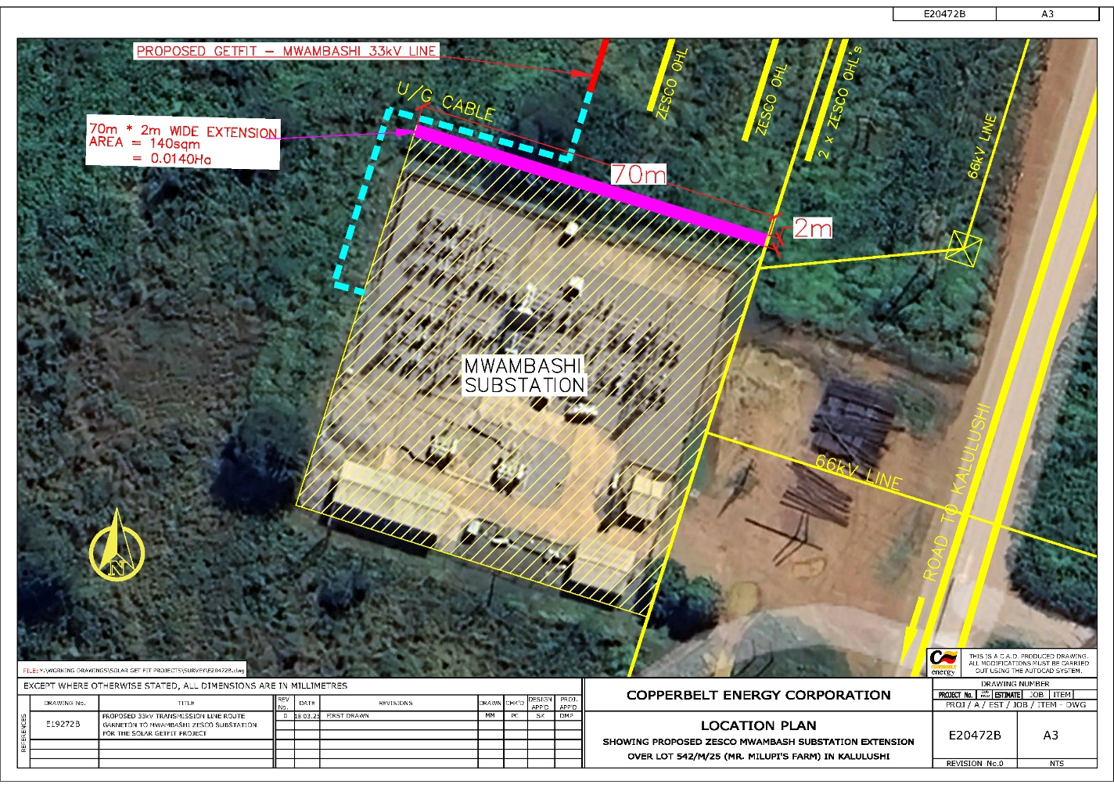
Figure 3.8-1: Proposed Extension of Substation Perimeter Fence

Clean-up
Clean-up activities shall be on-going as construction progresses and shall involve the removal of all waste materials from the construction site, and installation of erosion control and stabilization techniques, where required.

Re-vegetation
The wayleave will be allowed to naturally re-vegetate under the vegetation control program. An active re-vegetation program shall be implemented in erodible areas (i.e. road crossings, watercourse crossings).

Operation Phase
The proposed power lines will be operated and maintained by ZESCO in accordance with standard procedures designed to ensure the integrity of the power line system. Route maintenance of the wayleave, technical inspections and line patrols, general line performance and normal switching shall constitute the operational phase of the power lines.
The vegetation along the wayleave will be controlled to minimize conducting power to the ground and ground clearances shall not to be exceeded. The Developer will use a combination of mechanical bush control and manual cutting for vegetation clearing in the wayleave prior to Transfer of the Shallow Grid Connection.

Decommissioning Phase
Transmission line infrastructures are usually not decommissioned as they may be turned into a common carrier if need be. However, decommission of the transmission line described herein, may arise once the power generation at GaS and GaN completely stops. This may then entail dismantling of steel monopoles and transporting them to ZESCO’s facilities for storage.

Schedule and Lifetime of the Project
The project is expected to be implemented over a period of approximately 10 months, commencing in January 2025
Figure 3.8-2: Proposed Project Schedule for the Power Transmission Line
Project Phase | Activity | Duration
Construction | Line survey | 1 month
 | Profiling | 1 month
 | Tower spotting | 1 month
 | Land preparation (digging holes and trenches) | 1 month
 | Planting poles | 2 weeks
 | Dressing of poles | 2 weeks
 | Stringing of conductors | 2 weeks
 | Preparation works for line bays at Mwambashi and Solar PV plant | 2 weeks
 | Extension of the 33kV busbar (Mwambashi Substation) | 2 weeks
 | Civil works to reposition part of the substation drainage network (Mwambashi Substation) | 1 month
 | Construction and equipping of a new 33kV line bay (Mwambashi Substation) | 2 weeks
 | Installation of a 33kV cable from the newly constructed line (Mwambashi Substation) | 2 weeks
 | Installation of protection, control, and communication panel (Mwambashi Substation) | 3 weeks
 | Inspection and testing of powerline | 2 weeks
 | Commissioning of powerline | 1 week
Operation | Power transmission and maintenance of powerline | 25 years
Decommissioning | Removal of steel mono poles and cables | 1 month
 | Concrete foundations fracturing | 1 month
 | Revegetation of disturbed areas | 3 months

PROJECT ALTERNATIVES

Mitigation Hierarchy
A key aspect of considering alternatives is the mitigation hierarchy. Implementing the mitigation hierarchy is crucial when considering alternatives. The mitigation hierarchy is defined as:
- Avoidance: measures taken to avoid creating impacts from the outset, such as careful spatial or temporal placement of elements of infrastructure, in order to completely avoid impacts on certain components of biodiversity.
- Minimization: measures taken to reduce the duration, intensity and / or extent of impacts (including direct, indirect, and cumulative impacts, as appropriate) that cannot be completely avoided, as far as is practically feasible.
- Rehabilitation/restoration: measures taken to rehabilitate degraded ecosystems or restore cleared ecosystems following exposure to impacts that cannot be completely avoided and/ or minimized.
- Offset: measures taken to compensate for any residual significant, adverse impacts that cannot be avoided, minimized and / or rehabilitated or restored, in order to achieve no net loss or a net gain of biodiversity. Offsets can take the form of positive management interventions such as restoration of degraded habitat, arrested degradation, or averted risk, protecting areas where there is imminent or projected loss of biodiversity.
The mitigation hierarchy was applied to the project as summarized in the table below.
Figure 4.1-1: Mitigation Hierarchy
Mitigation Hierarchy | Action
Avoidance: | Transmission line route alternatives: The initial search for wayleave for the transmission line included environmental and social criteria such as biodiversity of the potential route, other sensitive features such a rivers or wetlands, land ownership and land use.  During route selection, the Developer avoided areas with high biodiversity, sensitive features and community land ownership that supported livelihoods of local communities, despite forming the shortest possible route. The transmission line route selected for the project does not support any Critical Habitat as defined by the IFC Performance Standards and will not result in any major economic or social displacements.
Minimization: | Wayleave layout or dimensions: Once the preferred site was selected more detailed surveys were undertaken to identify and confirm the extent of potential displacements and the impact on the PAPs. Much of the selected transmission line route comprises servitudes of Gazetted road reserves which are free of any developments. The wayleave route does not represent or form part of a natural habitat, the vegetation along this route has undergone extensive disturbance due to the fact that it forms part of the wayleave which was in the past cleared  mechanically.
Rehabilitation/restoration: | While the footprint of power transmission line will result in the total clearance of all vegetation, natural revegetation will be allowed once construction works are completed.
Off-set: | No biodiversity off-set is required as the project will have no significant adverse impact on biodiversity.

Identification of Alternatives
During the planning phase of the Project a number of alternatives were considered. Alternatives considered include the following:
- Transmission line route alternatives.
- Powerline design alternatives.
- Material / technology alternatives.
- No-Go alternative.
Throughout the assessment of these alternatives the following criteria were used:
- Environmental including biodiversity, fauna and flora, and habitat.
- Social and community including land ownership, land use and proximity to communities.
- Financial – including life cycle costs balanced against initial capital expenditure and operational costs; and
- Technical – considering whether the options are viable if they can be efficiently implemented, maintained, and operated.

Analysis of Alternatives

Transmission line route alternatives
In arriving at the proposed wayleave, the Developer considered other alternative routes within the sounding area, which were not selected due to presence of physical structures, presence of farmlands and their proximity to ZESCO grid connection points (Mwambashi or Kafironda substations). The following alternatives were assessed:
- Option 1 – Loop into the Kafironda – Mwambashi transmission Lime
This route entails having a substation at the Garneton North Solar PV site and extending a power transmission lime from this which would then be looped into the existing ZESCO Kafironda- Mwambashi transmission line on the Mufulira-Sabina Road. This represents a wayleave with a stretch of about 6 km. This wayleave would follow along the existing CSS129 (220/132 kV) transmission lines belonging to CEC until the loop in point. Although this seemed like an easier alternative, it comes with major technical challenges at the loop in points and hence was not preferred.
- Option 2 – Overhead transmission line from Garneton North PV Site to Mwambashi Substation
This option entails having a substation at the Garneton North Solar PV site from which a combined overhead power transmission lime would be extended to connect to the ZESCO Mwambashi substation on Kalulushi Road. This route requires land acquisition from owners of land which is privately owned to secure the wayleave (18 m) until the line reaches the public roads (Chingola-Kitwe and Kalulushi roads) on which it can run on the road reserves. This option was not selected because it involves land acquisition which may be expensive and involve very long processes.
- Option 3 – Overhead transmission line through the road to Mukuba University
This option entails having a substation at the Garneton South Solar PV site from which a combined overhead power transmission lime would be extended to connect to the ZESCO Mwambashi substation on Kalulushi Road. The wayleave for the transmission line would run alongside the road reserve on the peripherals of Zambia compound, passing through Mukuba University Land and finally alongside the Kitwe-Chingola dual carriage way before terminating at the ZESCO Mwambashi substation on Kalulushi road. This wayleave option represented a 10 km stretch and little or no potential physical displacements. However, this alternative was again reviewed and realigned to avoid encroaching Mukuba University land. The power transmission route will now pass behind Mukuba University land. With this realignment the power transmission line has been shortened to 9km.
- Option 3 is the most preferred, because it leads to little or no displacements and does not involve land acquisition. This option does not have any major technical difficulties compared to option 1.

Power Transmission line Design Alternatives
To adopt the Steel Monopoles as the preferred design for the power transmission line, the following options were considered:

Overhead Line (preferred alternative)
This alternative involves transmission of power using overhead aluminum cable conductors strung on steel monopoles. The design is according to ZABS and ERB standards and should be sufficient to carry the load required for at least 30 years. Although overhead transmission line has more negative impacts on the environment as it requires clearing of vegetation to create wayleave, it is cheaper to construct and maintain and less vulnerable to vandalism. The Developer is committed to mitigating any negative impacts which may arise as a result of this alternative. Steal monopoles can be easily sourced locally or imported and hence the preference. However, it is important to note that underground cables will be used in small portions of the transmission line, e.g. at road crossing points and at the starting and terminal points.

Underground Cables
This alternative involves transmitting power underground by use of hammered copper cables. The design of the underground cable line is according to ZABS and ERB standards and should be sufficient to carry the expected load for a prolonged time. The underground cable would have minimal negative impacts on the environment. However, it is very expensive to implement and highly vulnerable to vandalism. Thus, this alternative was not chosen.

Material / technology alternatives

Towers
Several designs for Towers are used for power transmission such as the use of overhead towers which are suited for transmission lines covering long distances with multiple lines. The options include single circuit towers, namely the Cross-rope suspension and Guyed V structures. However, these normally have a height of 55m which could result in increased visual impacts on the surrounding environment. The construction of these towers also uses heavy equipment which could results in impacts such as soil compaction and increased soil erosion and sedimentation. In addition, steel towers fetch a moderately higher cost and may not be the best option.

Reinforced Concrete (RC) Poles
The reinforced concrete poles have become very popular as line supports in recent years. They have greater mechanical strength, longer life and permit longer spans than steel poles. Moreover, they give good outlook, require little maintenance, and have good insulating properties. The holes in the poles facilitate the climbing of poles and at the same time reduce the weight of line supports. The RC poles are manufactured at a high cost and moreover, the cost of transportation is high owing to their heavy weight. Therefore, such poles are often manufactured at the site in order to avoid heavy cost of transportation. The GETFiT Solar site will not be provided with a facility for manufacture the RC poles.

Steel Monopoles
These are made of steel and suitable for powerlines because they are strong and hence, they have a longer lifespan of up to 80 years. The chosen steel mono poles will cover a relatively smaller surface area on the ground and will have a height of 12m to 14m. This became the preferred option.

Justification for the selected option
The steel monopoles are suitable to run the 9.7km proposed route, they are preferred because they will have minimal impacts on the environment. In terms of area, they occupy the smallest compared to the steel towers, but they are still strong enough. The project lifetime is about 25 years, but these steel monopoles can go up to 80 years. Thus, at decommissioning stage, they will still be an asset of high value.

No-Project alternative
This alternative would have prevented the project related adverse impacts and risks. Nonetheless, it was not considered because it would not have achieved the sought objective of integration of the power generated from GaS and GaN Solar parks into the national grid, which are integral to sustainable development of the renewable energy subsector. The proposed project is part of the GETFiT energy program which is aimed to supplement the country’s large hydro energy sources which have been negatively affected by changes in the climatic trends (uneven rainfall and declining water levels), and patterns in the recent past.

DESCRIPTION OF THE BASELINE ENVIRONMENT

Climate
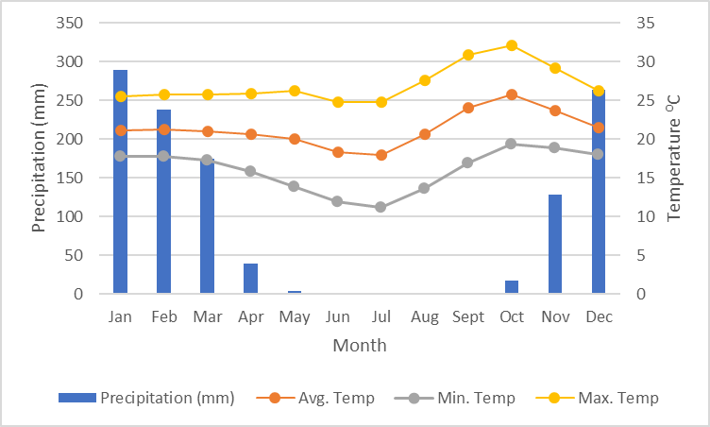
Kitwe is favoured with climate typical to the Copperbelt region of the Zambian plateau, which at an altitude of around 1200m, is a modified tropical with three distinct seasons. The climate consists of cool dry season from April to July, hot dry season from August to October and a warm wet season November to the end of March. Average minimum temperatures range from 10ºC in July to 20ºC in November; average maximum temperatures range between 24ºC in June to 32ºC in October. The wettest months are December, January and February which experience intense thunderstorms. The mean annual rainfall in Kitwe is in the region of 1154 mm. Calculated storm events for data collected at Kafironda Meteorological station show the 50 year Maximum 24-hour Precipitation as 136 mm and the 100-year Maximum Precipitation over a 24-hour period is calculated as 150 mm.
Figure 5.1-1: Annual Rainfall and Temperature of the Project Area
Rainfall is mainly influenced by the Inter Tropical Convergence Zone (ITCZ), which brings moist winds from the Atlantic Ocean (North-West), and North-East and South-East Trade Winds from the Indian Ocean. Therefore, wind direction changes during the rainy season depending on the position of the ITCZ and is mainly northerly ranging from north-west to east. During the dry season, winds are mostly Easterlies, ranging from north-east to south-east. The project area has a unimodal rainfall pattern. Rainfall is received from October to May of the following year. January is the wettest month with 20 rainy days while May records the lowest number of rainy days, 6. The mean sunshine duration varies from 7.2 hours per day in March and February to 10.9 hours per day in October. The mean RH varies from 32% in September to about 84% in January.

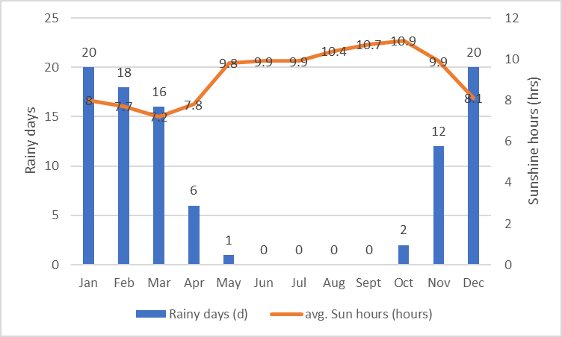
Figure 5.1-2: Average number of rainy days and sunshine hours in the project area
Wind speeds are generally low at between 1.5-3.3 m/s (5.4-11.9 km/hr) 41.4% of the time and calm (i.e. below 1 m/s or 3.6 km/hr) for 30% of the time. Winds can go up to 16 knots (29 km/hr) during the rainy season and gusting is experienced during storms with wind speeds of up to 21 knots (39 km/hr) at a time. Wind speed generally increase from July to October, are steady during the rainy season except for gusts due to the nature of rain clouds and decrease from April to June.

Landscape and Topography
The Mwambashi stream and its tributaries are the main features influencing topography of the transmission line corridor. The general topography in the area is characterized by anthills and termite mounds. The selected wayleave for the transmission line passes through ground elevation changes due to the presence of streams (Mwambashi, Munsaka and Luanshimba streams) which in most cases dictates the landforms. The landscape and visual character along the wayleave for the proposed transmission line is extensively altered, as it runs on the sides of road reserves which have been previously cleared to accommodate other existing power transmission lines and routine clearing of sides of the road reserves.

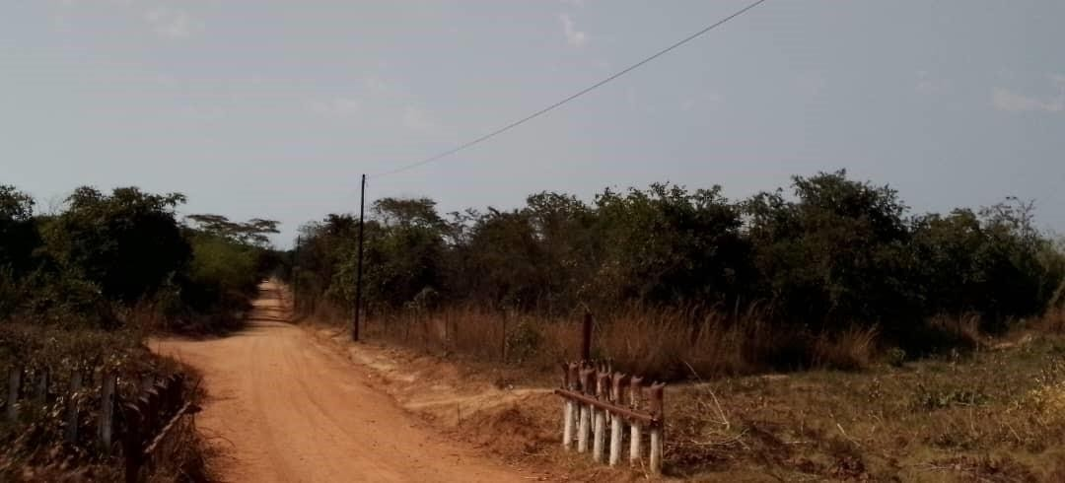
Figure 5.2-1: Apparent slope towards Luanshimba stream
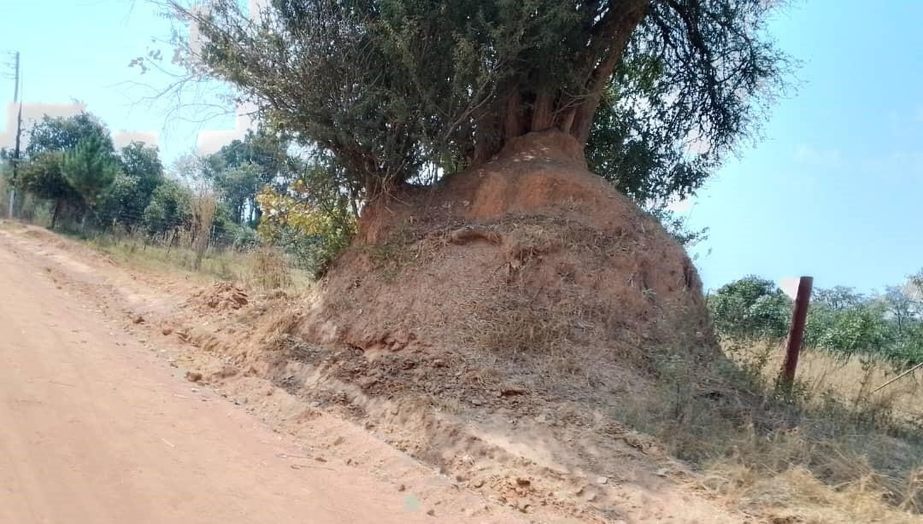
Figure 5.2-2: Anthill along the wayleave for the transmission line

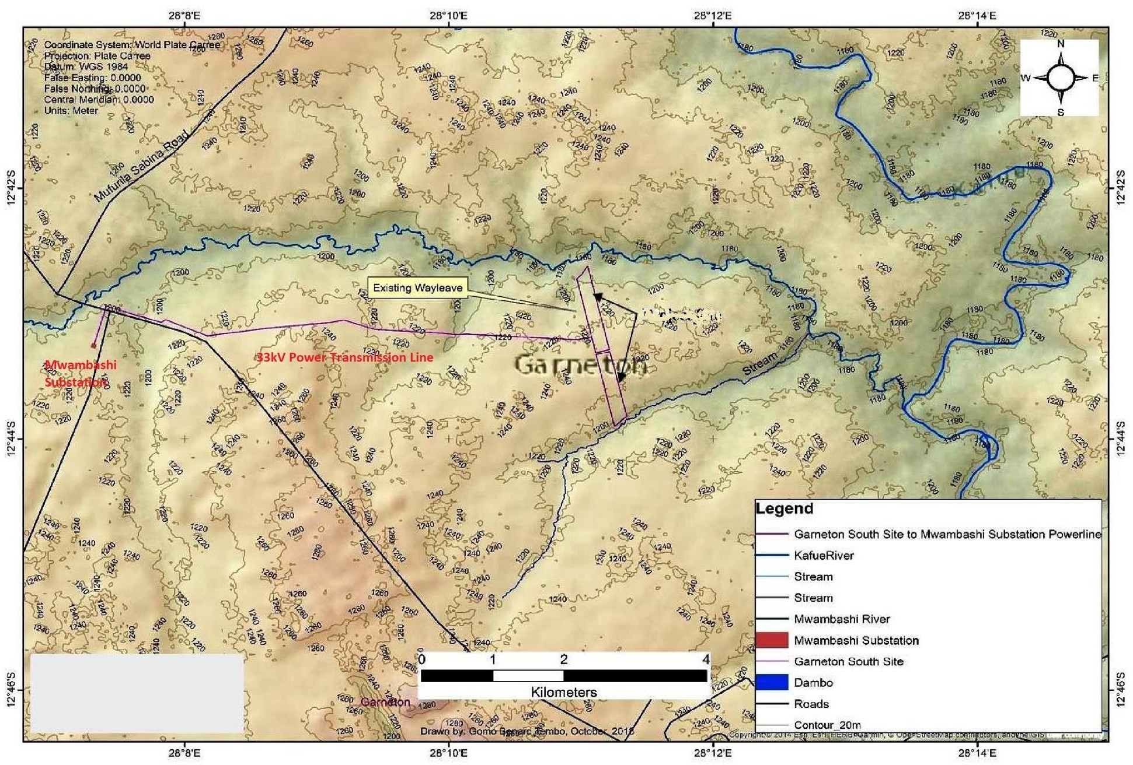
Figure 5.2-3: Contour map of the project area and the powerline corridor

Physical infrastructure along the powerline corridor
The transmission line wayleave follows the road reserve from Zambia Compound near Garneton township and runs behind Mukuba University before reaching the turnoff at the Kitwe-Chingola dual carriage way. The wayleave then heads west towards Sabina following the sides of the road reserve along the Kitwe-Chingola dual carriage way until the point at which it will run across onto the road reserve on the Kalulushi Road before terminating at Mwambashi substation. Major physical infrastructures along this wayleave include, a railway crossing points in between Zambia compound, Mukuba University campus, Chimwemwe Level 1 hospital at the junction of the road to Mukuba University, Kitwe-Chingola Road and Green Home Farm along the Kitwe-Chingola Road. In some areas, the transmission line will run parallel to existing power transmission lines especially along Kitwe-Chingola Road and Kalulushi road.
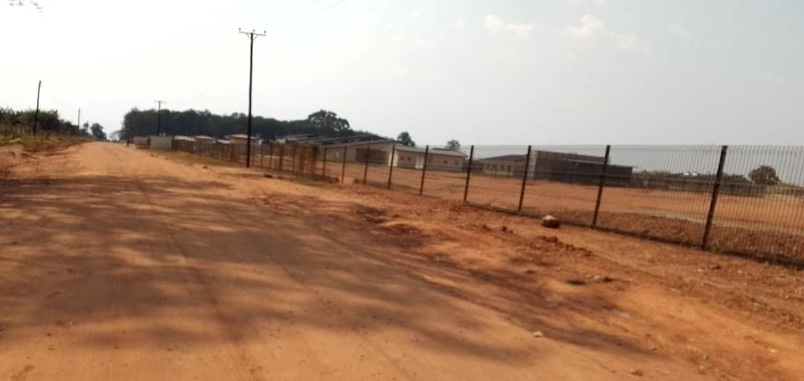
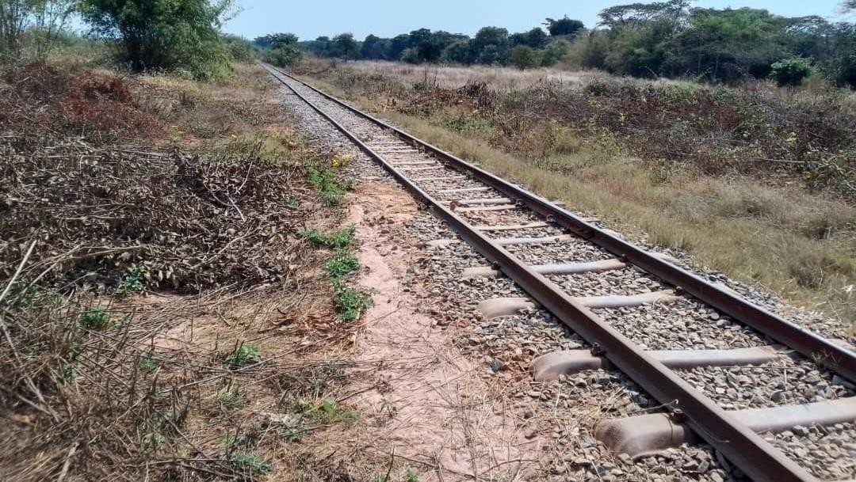
Figure 5.3-1: Kitwe-Chingola Railway Line to be crossed by the overhead transmission line.
Figure 5.3-2: Chimwemwe Level 1 hospital along the road to Mukuba university
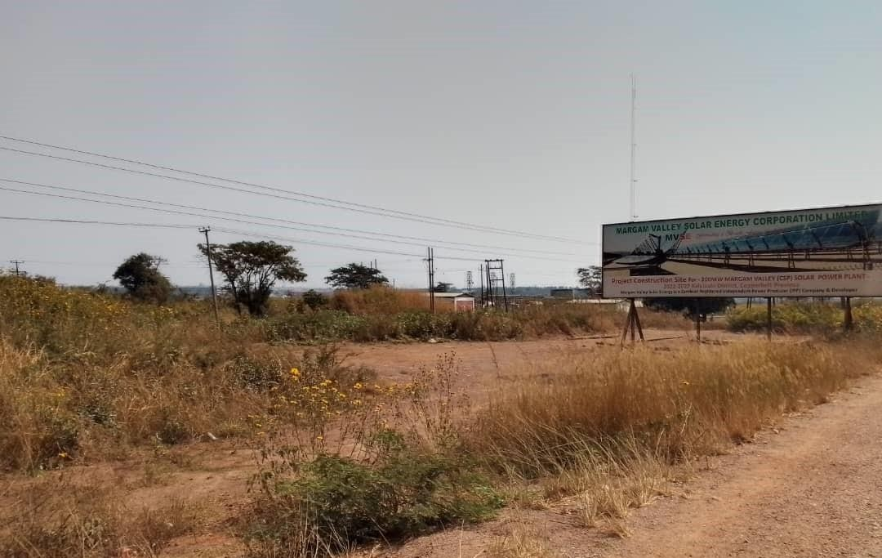
Figure 5.3-3: Existing transmission lines along the wayleave for the proposed power line

Air Quality and Noise

Air Quality
The noise and air quality data reported in this section is inferenced from observations monitored in the area around Mukuba University. Ambient air sampling was carried out using a portable air quality monitoring machine manufactured by Aeroqual (‘Aeroqual Series 500’) which can be configured with interchangeable gas and particle sensors for NO2, SO2, O3 and PM2.5, PM10.
For each day of the survey period, air quality (AQ) data was collected at the five sampling locations and parameters were measured at regular. For the purposes of this study, the average of the measurements taken during the daily survey period (06-22) is taken as a reasonable approximation of the 24-hour average.
The results of the ambient air test obtained were compared with ZEMA standards for ambient air emissions and IFC/WHO ambient air quality guidelines. Measured parameters that fell below guideline values of either of the standards were considered non-polluting at the time of the baseline study. The ZEMA standards and IFC/WHO guidelines are presented in tables below.

Table 5.4.1-1: ZEMA Standards for Ambient Air Emissions
Parameter | ZEMA Standard  (µg/m3) | Averaging duration
SO2 | 500  350 | 10-minutes  1-hour
NO2 | 150 | 24-hour
O3 | 120 | 8-hour
PM2.5 | 70 | 24-hour
PM10 | 70 | 24-hour

Table 5.4.1-2: WHO Ambient Air Quality Guidelines (2005)
Parameter | IFC/ WHO guideline  value (µg/m3) | Averaging duration
SO2 | 20  500 | 24-hours  10 Minute
NO2 | 200 | 1-hour
O3 | 100 | 8-hour daily  maximum
PM2.5 | 25 | 24-hours
PM10 | 50 | 24-hours

The following air quality results were obtained at the time of site visit and comparison with standards was made.

Nitrogen dioxide
- Levels of NO2 vary mostly between approximately 80 and 170 µg/m³ across the sites.
- The minimum value recorded was 21 µg/m³, while the maximum value was 212 µg/m³.
- Although levels of NO2 vary fairly widely during the course of the day, a consistent pattern of levels (mostly around 100-150 µg/m³) was recorded across the week of monitoring for all locations. This might be attributed to proximity of the main trunk road (T5) which carries moderate to high volumes of traffic including transit traffic to other districts and the DRC to the north.
- Apart from one measurement, all measurements fall within the WHO guideline threshold of 200 µg/m³ (1 hour). Apart from two measurements, all 24-hour averages derived for all sites fall within the 24-hour ZEMA guideline value of 150 µg/m³.

Sulphur Dioxide
- When detected the levels of SO2 vary mostly between approximately 100 and 300 µg/m³ across the sites; many measurements recorded no detection.
- The minimum value recorded was 0 µg/m³ (at all sites), and the maximum value was 1100 µg/m³.
- All measurements (bar one measurement of 1,100 µg/m3 taken at one location and one measurement of 900 µg/m³ taken at another location) fail within the 10-minute guideline threshold of 500 µg/m³ (ZEMA/WHO). SO2 is a common pollutant of mining industrial processes in Kitwe, and shifting wind conditions may result in a temporary surge in the levels of this gas.
- The 24-hour averages derived vary between 0 µg/m3 (on days that SO2 was not detected in any of the samples taken at a particular site) and a maximum of 375 µg/m³ (at one location). On days that SO2 was detected the daily averages calculated vary mostly between 25 and 66 µg/m3, which represents values above the guideline threshold of 20 µg/m³ for a 24-hour duration (WHO). It should be noted, however, that this may be due to an insufficient number of daily readings taken during the period of sampling which do not adequately represent the 24-hour duration.

Ozone
- Most samples taken at all sites registered no detection of ozone (i.e. 0 µg/m³).
- The minimum value recorded is 0 µg/m³ (at all sites), and the maximum value is 122 µg/m³.
- In the few cases where detected, levels of O3 across all sample sites vary mostly between 10 and 50 µg/m³, although outliers include 93 and 112 µg/m³, 100 µg/m³, and 82 µg/m³.
- Apart from the one measurement at 112 µg/m³, all measurements fall within the WHO 8- hour guideline value of 100 µg/m³. All measurements fall within the ZEMA 8-hour guideline value of 120 µg/m³.

Particulate matter PM2.5
- Levels of PM2.5 recorded are moderate for all sites, with values ranging mostly between 30-90 µg/m³.
- The minimum level recorded is 4 µg/m³ and a maximum level of around 243 µg/m³ was recorded.
- The 24-hour average values derived range mostly between 40-60 µg/m³ which is within the ZEMA guideline of 70 µg/m³, although a number of values exceed this.
- The PM 2.5 values recorded are generally higher at two sampling points (ranging mostly between 30-110 µg/m³) compared to the remaining points (where levels range mostly between 30-80 µg/m³). This might be attributed to proximity to the main trunk road which experiences moderate to heavy traffic.
- Although mostly within guideline limits, the levels of PM2.5 measured exceeded the guideline limits on a number of occasions with one or two significant outliers. This is to be expected during the dry season which experiences fresh winds and dusty conditions.

PM10
- Levels of PM 10 recorded are generally moderate for all sites, with values ranging mostly between 30-130 µg/m³.
- The minimum level recorded was 8 µg/m³, while the maximum level recorded was 206 µg/m³.
- The 24-hour average values derived for all sites range mostly between 30-80 µg/m³ which is moderately above the guideline thresholds of 70 (ZEMA) and 50 (WHO) µg/m³. This is to be expected during the dry season which experiences fresh winds and dusty conditions.
The results of the study indicate that the site is devoid of air pollutants, and the general atmospheric conditions of the project area are normal for a peri-urban area.
The survey recorded generally low levels of particulate matter (PM2.5 and PM10) (season taken into account), and low levels of gaseous pollutants. Apart from one measurement, all measurements of NO2 fall within the WHO guideline threshold of 200 µg/m³ (1 hour). Likewise, SO2 levels were found to be low and within the 10-minute guideline threshold of 500 µg/m³ for most sampling points. Apart from one measurement of 112 µg/m³, all measurements of O3 fall within the WHO 8-hour guideline value of 100 µg/m³, and all measurements fall within the ZEMA 8-hour guideline value of 120 µg/m³.

Noise
For each day of the survey period data on the maximum, minimum, and average noise levels were collected at specific sampling locations. The results were compared with the IFC Noise Level Guidelines for residential receptors.

Table 5.4.2-1: IFC Noise Level Guidelines
Receptor | One Hour LAeq* (dBA)
 | Daytime (07:00 - 22:00) | Night-time (22:00 - 07:00)
Residential; institutional; educational | 55 (free field) | 45 (façade)
Industrial; commercial | 70 (free field) | 70 (free field)
*Equivalent Continuous Level over 1 Hour (in effect, the average sound energy level over 1 hour).
Noise levels were measured at regular intervals during these sampling. Generally, noise pollution is very low in the project area with no major industries present in the local area and limited sources of mechanical noise.
The average noise levels observed ranged mainly between about 37dBA to 55dBA, with the lowest average value of 37 dBA and the highest average value of 62 dBA. These levels can be compared to noise levels attributed to a whisper (30dBA), light rain (40dBA), a quiet office (50dBA) and a normal conversation (60dBA).
The main sources of sound in the project area include:
- Birds and insects, particularly active in the early morning and early evening.
- Chatter from pedestrians.
- Motor Traffic, especially heavy goods vehicles and four-wheeled motor vehicles travelling on the Kitwe-Chingola dual carriage way where the highest noise level (62 dBA) was recorded. Typical noise levels along the dual carriage way varied between 44-56 dBA as compared to 37-44 dBA for other places.
Apart from a few outlying measurements, most average noise levels measured around the site fall within guideline levels of 55 dBA for daytime and 45 dBA for nighttime (22.00-07.00).

Geology and Soils
The geology of Kitwe district and the Project site is composed mainly of recent rock formations such as the Katanga system, Kundelungu and Muva quartzite. Basement Supergroup rock types of schist occupy the central part of the district. Muva Super group rocks of quartzite and sericite schist occur in the north and south-western part of the district. The Katanga Super group, the host of the Lower Roan Sub-group which contains copper and cobalt mineralization occur in the western part and has the major development of the city on its eastern part (Kitwe District State of Environment, 2010).
The soils of the area are closely related to the geology. The more resistant quartzite rock types have given rise to shallow and stoney soils while clayey, slightly deep soils are formed on the iron and manganese parent material. In general terms the soils of the area belong to the major group of the urban districts of the Copperbelt which is well drained, deep, yellowish red/strong brown, loamy/clayey soils with inclusions (20%) of moderately- imperfectly drained, deep-shallow, gravelly clayey soils and are classified as chromi/grey-haplic Acrisols with dystric Leptosols. They are associated to either of the following series Kasempa, Mufulira & Misamfu soil series which have low to very low nutrients content and are highly acidic hence agricultural productivity is very low.

Hydrology and Hydrogeology

Hydrology
The Luanshimba stream is the only surface water body that will be crossed by the proposed transmission line. The Luanshimba stream flows in the westerly direction from Garneton area until it joins the Mwambashi stream after cutting through the Litana farm. The Mwambashi stream is also a tributary of the Kafue River. Because of its location, at the lower lying area of a densely populated township (Zambia compound), the Luanshimba stream is at a high risk of pollution. Major pollutants include domestic wastes such as food packages and plastics that are mostly washed down the stream especially during the rainy season.

Hydrogeology
The primary contributor to the availability and presence of groundwater resources in the project area is rainfall. Nonetheless, the lithology of the geological material as well as its hydraulics (porosity, permeability, and hydraulic conductivity) is equally important in guaranteeing constant recharge to the groundwater and consequent availability. The rainfall regime has remained reasonably uniform over a long period in the study area and provides sufficient recharge potential for the aquifers although seasonal groundwater level fluctuations may occur as the result of the spatial variability of the rainfall.
The groundwater in the area is mostly used for domestic purposes. Rain-fed agriculture is predominantly used by many smallholder farmers in the project area. Importantly, groundwater is critical for recharging the main drainage systems (Mwambashi River and the Kafue River) and other surrounding streams. Thus, there is active interaction between groundwater and surface water sources in the area.
Generally, groundwater levels go down between June and November (the dry season) and rise between December and April during the rainy season. The rise in groundwater levels between December and April is as a result of increased base flow – groundwater supplying surface water bodies and consequently, during the period of between June and November, when the groundwater water levels in these surface water bodies declines (Ministry of Energy and Water Development, 1995).
Variations in geological structures, geomorphology and rock types contribute to the various groundwater conditions within the project area. The primary aquifers are the karstic highly fractured carbonates and the alluvial aquifers. Groundwater also occurs within the secondary features within Kundelungu metasediments, the mine series, the breccias and some areas of the igneous rocks. The Project Site falls under the Kafue catchment which is the largest catchment in the project area and covers much of the Copperbelt Province.

Ecological Resources

Flora Terrestrial Flora
Terrestrial flora along the powerline corridor is characterised by a secondary Miombo woodland vegetation type. The dominant tree species commonly observed include Marquesia macroura, Brachystegia boehmii, Brachystegia floribunda, Maprounea africana, Mimusops zeyheri, Bauhinia petersiana, Julbernardia globiflora, Isoberlinia angolensis and Erythrophleum africanum. Due to their value for firewood, most of the miombo woodlands have been cut by the locals and only small secondary regenerations are commonly encountered such that the only mature trees found standing in the project area are those of Parinari curatellifolia and Erythrophleum africanum. These trees were observed standing because the latter is hard to cut, and the former does not produce either good charcoal or firewood.
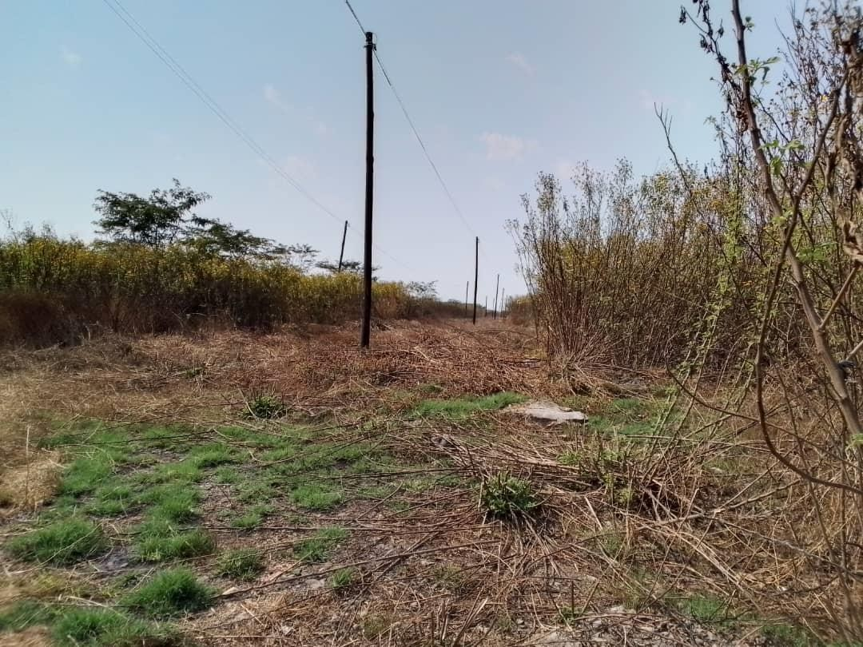
The dominant shrubs that were observed along the powerline corridor include the invasive alien species of Tithonia diversifolia and a type of grass called bamboo grass. The common grass species observed include hyperhenia spp, missanthiunia spp, themedia triandria, setaria spp and Lodentia simplex.
Figure 5.7-1: Common vegetation type along the powerline corridor

Aquatic flora
The power line corridor will cross over the Luanshimba stream towards the southern boundary of Zambia compound. Notable aquatic plants encountered during field
investigative studies include reeds, sedges (Cyperus spp.) and creeping grass (Imperata cylindrical).
There are no endangered or rare flora species identified along the transmission line corridor.

Fauna Terrestrial species
Lizards (Lacertilia), rats (Rattus Norvegicus), squirrel (Sciuridae), springhare (Pedetes capensis), shrews (Soricidae) and insects such as click beetles (Alaus spp), wasps, bean bug (Riptortus serripes) and small mottled willow moth (Spodoptera exigua) were observed on site.
There are no threatened, rare, or endangered species of fauna registered or known to exist on the study site or its immediate surrounding environments with respect to national or international conservation status except squirrels.

Aquatic fauna
Verbal interviews with the locals confirmed presence of crocodiles on the Mwambashi stream, although no evidence of big fish species was found. Common fish species in the Luanshimba stream include Tilapia (common breams), Yellow Bell Bream (Serranochromis Macrocephalus), Zigzag Barb (Barbus Miolepis) and Makobo (local name).

Avi Fauna
Common woodland birds seen, heard or evident in the project area include Swainson’s spurfowl (Pternistes swainsonii), common quail (Coturnix coturnix), Cape turtle dove (Streptopelia capicola) and African crows. Bird activity was noticeably higher near the Luanshimba stream on the periphery of Zambia compound. This is probably so because of availability of scavenging materials and water.
There are no rare, endangered or threatened fauna species identified along the transmission line corridor.

Threatened Species
No threatened or restricted range plant or animal species have been identified or are specifically expected to occur along the powerline corridor, largely because it is located near an urban area and comprises a disturbed primary Miombo with no meaning vegetation that could harbor it. Due to their value for firewood, most of the miombo woodlands have been cut by the locals and only small secondary regenerations are commonly encountered such that the only mature trees found standing in the project area are those of Parinari curatellifolia and Erythrophleum africanum.
A total of 18 species of global conservation concern are listed for Zambia (Collar et al. 1994 in Leonard, 2005). Only the endangered Grey-crowned crane and vulnerable wattled crane may occur in proximity to the site, i.e. on the river lines of the Kafue River located over 4 km east of the transmission line corridor and none are considered at risk from the Project. The Kitwe District Forestry department will conduct a resource assessment before a permit to clear vegetation along the proposed transmission line corridor is issued.

Protected / Conservation Areas
The transmission line corridor will not cut across any protected forest area. The Ichimpe forest reserve which located on opposite Mukuba University was recently degazetted and now hosts the Chimwemwe Level 1 hospital. Regardless of this, the transmission line wayleave does not still cut across the land for this degazetted forest reserve. The Shibuchinga Game Management Area (IUCN category VI conservation area) is found about 50 km in Lufwanyama District and not expected to be impacted on by the Project.
Although there are no public Forest reserves in the project area, private firms have shown interests in forest conservation and game ranching. One such initiative is a private game ranch located opposite the land for Mukuba University, which is fenced with bunox wire and slowly being stocked with small antelopes.

IFC Critical Habitat Status Assessment
IFC Performance Standard (PS) 6 and its supporting Guidance Note 6 (www.ifc.org) sets out the requirements for categorizing habitat status as Modified¹, Natural² and Critical, and the implications for developers. This section summarizes the status of habitats in the project area in alignment with IFC definitions and thresholds.
Clause GN43 of the GN6 indicates that natural habitats should not be interpreted as untouched or pristine habitats, may have undergone historic or recent anthropogenic impact, and should be assessed by comparing current and historic conditions to determine the degree of impact. If the habitat still largely contains the principal characteristics and key elements of its native ecosystem such as complexity, structure, and diversity then it should be considered a natural habitat regardless of the presence of some invasive species, secondary forest, human habitation, or other human induced alteration.
Most of the miombo woodland vegetation along the transmission line corridor have been cut by the locals for firewood and charcoal and only small secondary regenerations are commonly encountered such that the only mature trees found standing in the project area are those of Parinari curatellifolia and Erythrophleum africanum which are of less value to the community. The vegetation in the servitudes along the road reserves comprises the invasive alien species of Tithonia diversifolia with no other co-existing with other herbaceous vegetation. The Tithonia diversifolia is a late pioneer species commonly found in most disturbed areas especially along the roads. No part of the proposed transmission line could be considered as a natural habitat because there are no predominantly intact habitat structures, species composition and ecological functionality.
In terms of IFC requirements, triggers for Critical Habitat primarily focus on the presence of i) Critically Endangered and Endangered species (Criterion 1); Endemic and Restricted Range species (Criterion 2); iii) Migratory and Congregatory species; iv) Highly Threatened and/or Unique ecosystems and v) Key Evolutionary Processes. No critical habitat triggers have been confirmed to occur on the project site, as summarized in the Table below.

Table 5.7.8-1: High Level Critical Habitat Assessment
IFC criterion | Rationale
Criterion 1. Critically Endangered and Endangered Species | Not triggered – No critically endangered or endangered species of flora or fauna has been confirmed or likely to occur on the site.
Criterion 2. Endemic and Restricted Range Species | Not triggered – No endemic or restricted range species of flora or fauna confirmed or likely to occur on the site. Some plant species could be endemic to Zambia or the region but are not considered to have restricted ranges.
Criterion 3. Migratory and Congregatory Species | Not triggered – No migratory or Congregatory species occur on the project site or are likely to be impacted by project infrastructure (e.g. power transmission lines).
Criterion 4. Highly  Threatened and / or Unique Ecosystems | Not triggered – Miombo woodland is a widespread habitat type that is resilient to disturbance, and recovers after fire, cultivation or exploitation if left alone.
Criterion 5. Key  Evolutionary Processes | Not triggered – The Miombo woodland along the transmission line corridor is  extremely degraded and is not in any evolutionary stage

Implications for the Project
IFC GN6 Clause 14 requires that: The client will not significantly convert or degrade natural habitats unless all of the following are demonstrated:
        - No other viable alternatives within the region exist for development of the project on modified habitat.
        - Consultation has established the views of stakeholders, including Affected Communities, with respect to the extent of conversion and degradation; and
        - Any conversion or degradation is mitigated according to the mitigation hierarchy.
In terms of the above, “significant conversion or degradation is: i) the elimination or severe diminution of the integrity of a habitat caused by a major and/or long-term change in land or water use or ii) a modification that substantially minimizes the habitat’s ability to maintain viable populations of native species.
Clause 15 states: In areas of natural habitat, mitigation measures will be designed to achieve no net loss of biodiversity where feasible. Appropriate actions include:
        - Avoiding impacts on biodiversity through the identification and protection of set-asides.
        - Implementing measures to minimize habitat fragmentation, such as biological corridors.
        - Restoring habitats during operations and / or after operations; and
        - Implementing biodiversity offsets.
Note: no net loss is defined as the point at which project-related impacts on biodiversity are balanced by measures taken to avoid and minimise the project’s impacts, to undertake on site restoration, and finally to offset significant residual impacts, if any, on an appropriate geographic scale [author’s underlining]. The project has met the above requirements through the following:
- The Transmission line will take about 17.46ha of land where agricultural activities and shrubs are cleared on titled land and a few miombo trees in some portions.
- Project layout has excluded areas close to the streamlines and all riparian vegetation will be retained to avoid disturbance of such habitats.
- Mitigation measures will also include monitoring of alien invasive plants and restoration of construction disturbed areas.

Social, Economic and Cultural Environment

District Administration
Kitwe District has two systems of governance: The District Administration and The Kitwe City Council. The District Administration is headed by the District Commissioner’s Office under the Office of the President. This Office ensures that the development plans of central government are well represented at district level. The Kitwe City Council is headed by the Mayor; and its function is to implement developmental programmes in the City and to ensure that the City is functioning properly. The Council is also in charge of city planning and providing services to the communities in its jurisdiction such as waste management, construction of roads and drainages, land administration, among other responsibilities.
The selected wayleave for the proposed transmission line follows existing road reserves with servitudes granted to the Road Development Agency (RDA), to this end the Developer has already initiated correspondence with the RDA to permit the clearing of the wayleave. However, the overall project area falls under the jurisdiction of the Council. Therefore, the Council has planning authority over the project area.

Land Tenure and Land Use
Land tenure in Zambia is governed by State and Customary ownership. Usually, the local authority handles issues of land administration on behalf of the state. The selected wayleave for the proposed transmission line follows existing road reserves with servitudes granted to the Road Development Agency (RDA), to this end the Developer has already initiated correspondence with the RDA to permit the clearing of the wayleave. A stretch of the wayleave that will cut through the land belonging to Mukuba University comprises individual residential parcels of land whose ownership is in some identified members of staff at the university. The Developer has already initiated the process to acquire the required with of the wayleave from the individual owners on a willing seller- willing buyer basis.

Population and settlements
Kitwe District in the Copperbelt Province has a population of 661, 901, with 321,654 males and 340,247 females. This represents an increase from 517,543, with 256, 740 males and 260, 803 females in 2010 (Zambia Statistics Agency, 2022). According to the 2022 Census Report by Zambia Statistics Agency (2022), the population growth rate for Kitwe was calculated at 2.1. The project area Garneton falls under Chimwemwe Constituency whose population increased from 117,341 in 2010, with 57,740 males and 59,601 females: to 166,283 in 2022, with 81,017 males and 85,266 females.
The population of Kitwe, like the rest of the country is predominantly young. Up to 70 percent of the population is below the age of 30 years. The age structure of Kitwe defines a young population with slightly over 66 percent of its population below the age of 25 years. This structure demands corresponding provision of social services such as schools, medical facilities, housing, recreation, and other economic activities. Population increases in Kitwe has however not been accompanied by development of basic infrastructure.
Most of the population is concentrated in the urban areas of Kitwe, with a minor proportion living in family farms. The edges of the city are rimmed by unplanned compounds some of which are located in the vicinity of industrial areas, such as mining plants e.g. smelter, which are areas that are heavily affected by industrial pollution. Additionally, unplanned settlements have also contributed to incidences of disease outbreaks e.g. Cholera.

Education and Health Services Education
Kitwe district has 156 public schools which are complimented by a number of private schools (https://www.epdc.org/sites/default/files/documents/Zambia_subnatz_Kitwe.pdf). The number of high schools is not sufficient to meet the demand for high school education. These are mainly situated in urban areas. Although many schools and staff houses are in good condition, others are still in need of infrastructural rehabilitation. Kitwe has 5 tertiary public learning institutions which include the Copperbelt University, Mukuba University, Mwekera Forestry College, Zambia Institute of Management and Kitwe Nursing school. There are several other private tertiary learning institutions within the district which also provide tertiary education. Learning institutions in close proximity to the Project Site (Itimpi Ward) include Mukuba University, St. Francis Technical Secondary School, Garneton Secondary School, and Mwambashi Primary School.

Health
Provision of quality health services is important for economic growth and productivity is enhanced with good health. Kitwe District is serviced by thirty-four (34) government and over forty-four (44) private Health Centers. In addition, the District has two (2) government and two (2) private hospitals. The current health infrastructure is inadequate to service the entire district (KDHO, 2009). The community surrounding the Project area is serviced by Garneton Clinic. Provision of health services will soon improve once the Chimwemwe Level 1 hospital is commissioned and become operational. The Garneton clinic was opened in the late 2000s and has a catchment population of 9,523 patients. It catchment areas include:
- Garneton
- Twatasha
- Zambia Compound
- East Garneton
- Luyando
The most prevalent diseases in the areas and their prevalence rates are as follows:
- Malaria (340/1000)
- Diarrhea (230/1000)
- Respiratory tract infections (457/1000)
- Sexually transmitted disease
- HIV/AIDS
Garneton clinic offers the following services:
- Mother and child health
- Out-patient clinic
- Reproductive health services
- Anti-retroviral therapy
The Clinic is currently facing challenges with load shedding together with the rest of the nation. This is impacting the clinic’s operations in the sense that the clinic is having challenges storing vaccines at the right temperature during load shedding. The Clinic also experiences water supply interruption from NWSC during load shedding.

Economy and Livelihoods
The major economic activities include mining, commerce, trade and industry, agriculture, livestock production, energy, transport, and communications.
Mining: Like most areas on the Copperbelt, the major economic activity has been mining and mining- related. Kitwe has one large scale mine located at Wusakile operated by Mopani Mine and the Copperbelt Energy Corporation. These two together their contractors employ a good percentage of the labour force in the project area. The boost in the local construction sector (both property and roads) has also created new employment opportunities for the population in Kitwe.
Commerce and Trade: There are two commercial centers with shopping facilities including large and medium privately-owned shops. In the recent past, Kitwe has seen construction of three (3) major shopping malls including Mukuba and ECL Mall in Parklands and Copperhill Mall in Mindolo area. Insurance companies, banks, accounting firms, and other professional services like surveying and architectural consultancy are also available in the district. There is a growing number of illegal street vendors. Consequently, this has contributed to increased amounts of waste generation in the district. There is also a rise in the number of people operating in undesignated places especially in the residential areas. The district has four hotels, namely Garden Court, Edinburgh, Sherbourne and Moba. In addition, there are a number of lodges and guest houses that offer accommodation to all levels of clientele.
Industry: The industry is divided in two main areas which are the heavy and light industrial areas north and south of the district. There are, however, few manufacturing companies operating in the district.
Agriculture: Agriculture is one of the economic mainstays of the district. Most agricultural activities are rain fed and major crops grown include maize, groundnuts, and vegetables. Urban backyard gardening and peri-urban farming of crops such as groundnuts, maize, sweet potatoes, and traditional vegetables are also common.
Livestock Production: Other than crop production, the district has two major ranches namely: Cedrics farms, Eureka Dairy and Build elect farms. Poultry farming is also growing in importance with individuals and commercial farms internalizing poultry production. Hybrid farm is one of the major prayers in poultry farming in Kitwe. Fish farming is conducted in Garneton at Macademia Farm and Mwekera Fisheries.
Energy: Major energy sources of the city include electricity, solar, biomass and fossil fuels, charcoal, and coal. Wood fuel in the form of firewood and charcoal is a major source of energy for most people in high density areas including Zambia compound.

Culture and Heritage
Kitwe District does not host any of the heritage or sites of archeological importance found in Zambia. Field investigative surveys established that there are no known physical cultural heritage sites and sacred sites along the transmission line corridor or cultural practices that are undertaken within the Project area. However, in case of any unforeseen archeological findings being unearthed during construction, the Chance Find Procedure shall apply (see Appendix 12).

Built Environment
The project area represents a peri-urban area of the City of Kitwe which is slowly becoming more urbanized due to the increasing importance of the area for industrial and commercial developments. Recent years have seen the construction of new commercial and industrial yards in the area between Wilson Mofya Toll Plaza and the turn off to Kalulushi. Garneton Small-holdings residential area and Zambia compound represents the main built-up areas in the near the transmission line corridor.

Potential Displacements and Compensation
The ESIA studies for the project began in 2019. This process permitted the identification of all features and properties which may potentially be affected by the transmission line project. To date, the process has identified individuals who have been seasonally growing crops along the sides of the road reserve which forms part of the wayleave for the transmission line. These are found on the periphery of Zambia compound on the boundary of a private farm (Litana farm) and will be compensated for the assumed loss of crops and not the land. The Developer and its consultant have already commenced consultations to agree on the best displacement mechanism for these seasonal fields. Suffice note that an initial evaluation exercise to attach value to the crop grown on the land along the road reserve servitude was done in 2019 by experts from the Ministry of Agriculture even though compensations were not disbursed. Due to the length of time that has passed and changes in market value of the crops grown, the Developer is now seeking to undertake fresh valuation of fields to reflect the prevailing market value of crops upon which compensations will be based. Other potential displacements expected from the project include bare land belonging to seven (7) individuals who are members of staff at Mukuba University. These individuals have title to their properties and the acquisition of part of their land will be on a willing seller-willing buyer basis. Correspondence and agreements have already been made with the management of Mukuba University for the other part of the transmission line that will cross through the university land.

Stakeholder Engagement
A rigorous stakeholder engagement process has been undertaken for the project and still ongoing. Stakeholder consultations began in 2019 and has continued which has resulted in the identification of a number of stakeholders. So far, consultations have involved one-on-one meetings as well as public scoping meetings with key stakeholders, interested and affected parties (please refer to minutes of the meetings and full list of consulted persons in Appendix 2.1 and 2.2). During stakeholder engagement, project background information is presented to consulted people to enable them to appreciate the nature of the project, from which they could now deduce the project perceived impacts.
In line with IFC Performance Standard 5, the Developer and its appointed Consultant have engaged with all project affected people (i.e. those who grow seasonal crops along the identified wayleave and those with titled land on the Mukuba University land) whose activities or land is likely to be displaced by the transmission line project (Reference: to appendix 7 ). This has been done through public consultation meetings as well as one-on-one-meetings. A full livelihood restoration plan (LRP) will be developed to address all issues relating to displacements.
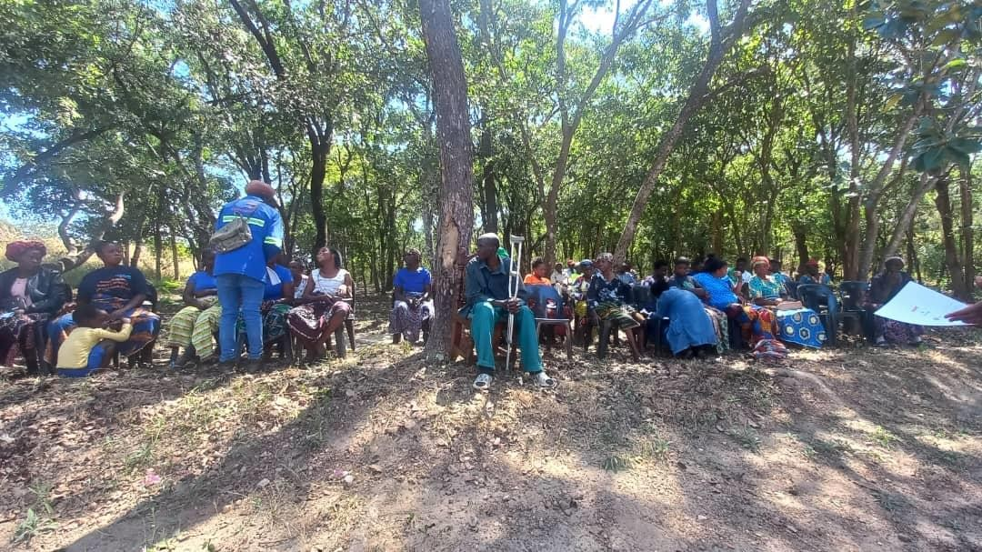
Figure 5.11-1: Stakeholder engagement to update PAPs information.
Other key stakeholders who have been identified for the project include the Ministry of Agriculture, Forestry Department, Zambia Forestry and Forestry Industries Corporation (ZAFFICO), ZESCO, Road Development Agency (RDA), Zambia Railways Limited, Energy Regulations Board (ERB), Kitwe City Council and Civic Leaders.

ENVIRONMENTAL AND SOCIAL IMPACT ASSESSMENT –POWER TRANSMISSION LINE
The environmental and social impacts of the proposed Power Transmission line on the affected environment are assessed in this chapter. Both positive and negative impacts are assessed for the construction, operation, and decommissioning phases of the Project. Mitigation measures for negative impacts and enhancement measures for positive impacts are described. Mitigation and enhancement measures together with monitoring measures for both construction and operation have been carried over into the Environmental and Social Management Plan (ESMP) included in Appendix 1.1.
In arriving at the overall significance of each identified impact, the consequence rating was considered together with the probability of occurrence. The table below gives a summary of how the overall significance of impacts were arrived at (please refer to Appendix 1.2 full the full impact assessment methodology).
Table 5.8.6-1: Matrix for Determining Overall Significance of Impacts
 |  | PROBABILITY
 |  | Improbable | Possible | Probable | Definite
CONSEQUENC | Very Low | Insignificant | Insignificant | Very Low | Very Low
 | Low | Very Low | Very Low | Low | Low
 | Mediu m | Low | Low | Mediu m | Mediu m
 | High | Medium | Medium | High | High
 | Very High | High | High | Very High | Very High

A number of environmental and social impacts were screened prior to the assessment phase. These impacts are described in Table 6-1b. Based on the understanding of the environmental and social sensitivity of the proposed project site and the impacts of the construction and operation of a typical power transmission line, several impacts were screened out of the impact assessment and standard mitigation measures included in the ESMP. In some cases, the impacts for the construction and operation phased of the Project are similar and are therefore assessed together. Cumulative Impacts are assessed separately.

Table 5.8.6-2: Impacts as a result of the Construction and Operation of the Transmission Line
Environmental component | Impact during construction & operation (transmission line) | Addressed in EIA or ESMP
Positive Impacts | Impact on local investment and employment opportunities | Assessed in section 6.1.1
 | Boost to local economy and multiplier effect | Assessed in section 6.1.2
 | Enhanced power supply through integration of solar generated electricity | Assessed in section 6.1.3
Biophysical Impacts | Impact of air emissions | Assessed in section 6.2.1.1
 | Impact of noise emissions | Assessed in section 6.2.1.2
 | Impact on surface water quality | Assessed in section 6.2.1.3
Ecological Impacts | Impact of terrestrial ecology | Assessed in section 6.2.2.1
 | Impact on avifauna | Assessed in section 6.2.2.2
Socio-economic Impacts | Impact on landscape and visual amenity | Assessed in section 6.2.3.1
 | Impact on settlements and land | Assessed in section 6.2.3.2
 | Impact on land-use and livelihoods | Assessed in section 6.2.3.3
 | Impact on cultural heritage | Assessed in section 6.2.3.4
 | Impact on community health and safety | Assessed in section 6.2.3.5
 | Impact on occupational health and safety | Assessed in section 6.2.3.6

Positive Impacts

Local investment and Employment Opportunities
Background and Baseline Conditions
The total Project investment value is estimated at US$ 1,042,235.56, although this will be determined based on, among other factors, the Engineering, Procurement and Construction (EPC) procurement, equipment supply and financing. In addition, the Project is expected to employ a peak construction workforce of 100 people over a period of 12 months. The source of the construction workforce will ultimately be determined by the appointed EPC contractor. The operational phase of the project will support GaS and GaN which will provide a total of 12 permanent job opportunities to the local communities from the area in the form of security guards and general workers on a fulltime basis.
Impact Assessment
The Project will provide a significant positive investment into the national economy and will seek to maximize local (including both Zambian national and people resident around the proposed Project site) employment benefits and local content in and around Kitwe Town. Recruitment, by both the Proponent and third-party contractors will prioritise or target residents of the immediate surrounding communities, and it is expected that most positions can be sourced locally. Priority of employment of unskilled labour will be given to the project affected people, especially those whose agricultural fields will be displaced by the Project.
Local businesses will also benefit during the construction phase as there will be increased spending within the area by those receiving wages who will have improved buying power while employed by the Project. The project is also expected to contribute to an increase in taxes to both the local and central government system. The overall impact will be moderately beneficial both at the national and local scale and a range of measures can be established to maximize local benefits.
Table 6.1.1-1: Impact Assessment with Respect to Local Investment and Employment
Type of Impact | Positive Benefit
Impact Criteria | Construction |  | Operations
 | Without Enhancement | With Enhancement | Without Enhancement | With Enhancement
Intensity/Severity | Medium Positive | - | Medium Positive | -
Geographic Extent | National | Regional/Local | National | Local/National
Duration | Short-Term | Short-Term | Long-Term | Long-Term
Probability | Definite | Definite | Definite | Definite
Consequence | Medium | Moderate | Medium | Moderate
Significance | Medium Benefit | Moderate | Medium Benefit | Moderate

Recommendations and Enhancement Measures
- To maximize benefits of employment, local people shall be given priority when employing workers during the construction of the power line as well as during annual wayleave maintenance. The Contractor(s) shall collaborate with the local leadership when recruiting workers.
- All local recruitment and labour management will be undertaken by the Proponent, or third-party contractors, consistent with Zambian national labour and occupation health and safety laws. This will include any international obligations (including any applicable ILO provisions signed and ratified by Zambia).
- Under the recruitment policies, preferential employment will be promoted for local people, women, and vulnerable groups consistent with national labour law and any affirmative action policies, guidelines, or laws.
- Measures will be put in place measures to ensure no employee or job applicant is discriminated against on the basis of his or her race, gender, marital status, nationality, age, religion, or sexual orientation.
- The Proponent will undertake, to the maximum extent possible, to promote local procurement with preferential buying from businesses in Kitwe town and Copperbelt province. Only where goods or services are not available locally to a sufficient quality or quantity will international markets be accessed.

Boost to local economy and multiplier effect
Some materials, such as sand and crushed stones may be bought locally within the districts, and this will benefit the local economy. Other materials like cement, timber, poles, and conductors will also be bought within the Districts and the Country, which will benefit the national economy.
Table 6.1.2-1: Impact Assessment with respect to local economy and multiplier effect
Type of Impact | Positive Benefit
Impact Criteria | Construction |  | Operations
 | Without Mitigation | With Mitigation | Without Mitigation | With Mitigation
Intensity/Severity | Medium Positive | - | N/A | -
Geographic Extent | Local | Local | N/A | -
Duration | Short-Term | Short-Term | N/A | -
Probability | Definite | Definite | N/A | N/A
Consequence | Medium | Moderate | N/A | N/A
Significance | Medium Benefit | Moderate | N/A | N/A

Enhanced power supply through integration of solar generated electricity
The project is aimed at integrating solar generated energy into the national grid through ZESCO’s Mwambashi substation. The proposed project is part of the GETFiT energy program which is aimed to supplement the country’s large hydro energy sources which have been negatively affected by changes in the climatic trends (uneven rainfall and declining water levels), and patterns in the recent past.

Negative Impacts Bio-physical Impacts

Air Emissions
Background and Baseline Conditions
The wayleave for the transmission line is expected to run along gazette road reserves which experiences dust and exhaust emissions daily. Although the wayleave passes near settlements (Zambia compound and Mukuba University campus), these cannot be considered as in-situ sensitive receptors as the wayleave only passes at the peripherals. However, dust raised during land clearing and construction activities might have a minimal impact.
Impact Assessment
Project construction and operational activities may lead to a range of air emissions that are a risk to community health and safety. Such activities will include those listed below:
        - Vegetation Clearing During Construction: The establishment of the wayleave will require the clearing of approximately 8.1 km stretch with a width of 18 m. Both manual and mechanical clearing methods may be used which may result in generation of dust.
        - Construction Traffic: The Project will require movement of materials for successful construction of the transmission line. Materials such as sand and aggregates will be transported and offloaded from one place to another. The movement of traffic will likely exacerbate fugitive dust generated from unpaved roads such as the access road to Mukuba University which connects all the way to GaS and GaN Solar PV sites which are the starting points for the transmission line.
In terms of the total air emissions generated by the Project, it is probable that any significant impact will be limited to fugitive dust during the construction phase, and the key receptors will be the settlement at Mukuba University and Zambia compound. As summarized in Table 6-2-1, the air emissions impacts are medium during construction, but this may be reduced to very low if suitable mitigation measures as presented below are adopted.
Air emissions during the operational phase are likely to be of low significance (See Table 6-2-1). Power Transmission does not generate emissions and any emissions will likely be focused on fugitive dust from untreated access roads, cleared areas and areas without vegetative cover. Again, there are no households present within the proposed project site, so impacts are limited to occupational exposure and potential exposure by the property owners on the adjacent land.
Table 6.1.4-1: Impact Assessment of Air Emissions
Type of Impact | Negative Impact
Impact Criteria | Construction |  | Operations
 | Without Mitigation | With Mitigation | Without Mitigation | With Mitigation
Intensity/Severity | Medium | Low | Low | Low
Geographic Extent | Localised | Localised | Localised | Localised
Duration | Short-Term | Short-Term | Long-Term | Long-Term
Probability | Definite | Probable | Definite | Probable
Consequence | Medium | Very Low | Low | Low
Significance | Medium | Very Low | Low | Low
Recommendations and Mitigation Measures
The following recommendations and mitigations measures are proposed to reduce air emissions impacts.
- The Developer will adopt suitable measures to manage fugitive dust from vegetation clearing during the construction phase. This will include a program of dust management that limits both occupational and community exposure to dust, including regular watering of open areas and material stockpile areas.
- The Developer will adopt measures to control the generation of fugitive dust from construction traffic including limiting construction vehicles speeds to the 30 km/hr on the access roads to the site and on site. An appropriate speed must be adopted on access roads to the site to ensure limited dust generation.
- Establish a grievance mechanism throughout the construction phase to deal with any community complaints regarding dust.

Noise Emissions
Background and Baseline Conditions
The wayleave for the transmission line is expected to run on the sides of Gazetted roads including the Kitwe-Chingola dual carriage which experiences heavy traffic on a daily basis. Therefore, common sources of noise around along the transmission line corridor is vehicular traffic. Sensitive receptors, with respect to noise generated will include Zambia compound and Mukuba University.
Impact Assessment
Project construction activities may lead to a range of noise emissions that may pose a risk to community health and safety. Such activities will include the ones listed below:
        - General Construction Noise: Bush clearing as well as trenching and digging.
        - Movement of Construction Traffic: The Project will require movement of materials for successful construction of the transmission line. Materials such as sand and aggregates will be transported and offloaded from one place to another. The movement of traffic will likely generate noise which may be felt by receptor communities. These access routes already experience a certain load of traffic and therefore the introduction of construction traffic will likely have a cumulative impact on noise.
The impact on the receptors is expected to be largely of low significance where noise is limited to normal working hours of between 08:00 – 18:00, given that the project area already has moderate baseline noise emissions from vehicular traffic. Impacts on local receptors can be easily mitigated to reduce the impact to very low. There are no operational activities that generate significant noise. The impact on the ambient noise levels during the operational phase is unlikely to occur and therefore no impact assessment or specific mitigation measures are recommended.
Table 6.1.4-2: : Impact Assessment of Noise Emissions
Type of Impact | Negative Impact
Impact Criteria | Construction |  | Operations
 | Without Mitigation | With Mitigation | Without Mitigation | With Mitigation
Intensity/Severity | Medium | Low | Very Low | Very Low
Geographic Extent | Localised | Localised | Localised | Localised
Duration | Short-Term | Short-Term | Long-Term | Long-Term
Probability | Probable | Probable | Probable | Probable
Consequence | Low | Very Low | Very Low | Very Low
Significance | Low | Very Low | Very Low | Very Low
Recommendations and Mitigation Measures
The following recommendations and mitigations measures are proposed to reduce noise emissions impacts during construction.
          - The Developer will minimize construction noise exposure to nearby receptors by ensuring that noisy construction activities are not undertaken in direct proximity to these receptors and limited where possible.
          - Construction vehicles and plant will be serviced according to manufacturer’s specifications,
and maintenance records must be kept up to date and presented for inspection as required.
          - Avoid or limit, noise generating construction activities outside of “normal working hours” where possible. Where working outside normal working hours is required, this should be determined together with the local authorities and communicated with sensitive receptors.

Impact on surface water quality
Water quality could be affected by construction activities. Trenching and digging of foundation holes - especially near Luanshimba stream which will be crossed - for erection of steel poles is a key activity that may contribute to pollution of surface water. These activities could lead to water contamination from sedimentation and increased turbidity of water.
Accidental oil or other spillages and discharges of waste into surface water may cause water quality to deteriorate. Therefore, impact during construction is expected to be of moderate to low significance.
Table 6.1.4-3: Assessment of Impacts on surface water quality
Type of Impact | Negative and Direct Impact
Impact Criteria | Construction |  | Operation
 | Without Mitigation | With Mitigation | Without Mitigation | With Mitigation
Intensity/Severity | Very Low | Very Low | NA | NA
Geographic Extent | Local | Local | NA | NA
Duration | Long term | Long term | NA | NA
Consequence | Low | Very Low | NA | NA
Probability | Probable | Possible | Unlikely | Unlikely
Significance | Moderate | Low | NA | NA

Ecological Impacts

Terrestrial Ecology
Background and Baseline Conditions
As can be seen from the baseline data, the powerline corridor is not ecologically sensitive. Hence, no, or very limited impact on biodiversity is expected. Flora providing habitats to birds, snakes and other predators may also be affected, as vegetation of the understory is reduced. However, no plant or animal species of conservation concern were found or are expected to occur. Miombo woodland is a widespread habitat type in Zambia and has low sensitivity as it is highly resilient, and many species are able to rapidly recover from disturbance by re-sprouting from cut stems.
Assessment of Impacts
Construction Phase: Project development will entail the clearance of approximately 8.1 km stretch of an 18 m wide wayleave. However, the greater portions of the proposed wayleave have already been cleared. Owing to the above, the impact extent is rated as local within which the habitat loss is permanent and of low intensity. The impact is therefore assessed as having an overall low consequence. Given that the likelihood of this impact is definite the pre-mitigation impact significance is low.
Operation Phase: Project operation will entail general wayleave maintenance to keep vegetation to the minimum height and prevent tree re-growth in order to have a clear safety height between the ground and the overhead conductors. Following construction, if equipment and/or fill material from other areas is imported there is a high risk that alien invasive plants (such as Lantana camara and Tithonia diversifolia) may be introduced and could spread into adjacent areas where they may replace indigenous vegetation.
The potential operational impacts on terrestrial habitats and fauna are considered of Local extent, long-term duration and of low intensity resulting in an overall low consequence, which together with the probable likelihood results in a pre-mitigation impact significance of low. Additional mitigation measures are summarized below which will reduce the potential post-mitigation impact significance to very low.
Table 6.2.1-1: Assessment of Impacts on Terrestrial vegetation
Type of Impact | Negative and Direct Impact
Impact Criteria | Construction |  | Operation
 | Without Mitigation | With Mitigation | Without Mitigation | With Mitigation
Intensity/Severity | Low | Very Low | Low | Very Low
Geographic Extent | Local | Local | Local | Local
Duration | Permanent | Permanent | Long term | Long term
Consequence | Low | Very Low | Low | Very Low
Probability | Definite | Definite | Probable | Possible
Significance | Low | Very Low | Low | Very Low
Recommendations and Mitigation Measures
Where only some branches, and not the whole tree, are in the wayleave, the affected tree shall only be trimmed instead of cutting down. During construction, trees along the proposed transmission line routes shall be stamped as opposed to uprooting.
Bush clearing to create the wayleave on the proposed transmission line shall be restricted to the required swath. All trees cut shall be left for use by local communities in the project area as firewood or for construction. During operation, vegetation re-growth will only require pruning and slashing which will minimize further losses.
Wayleave clearing for the transmission line shall be based on the standard Client’s guidelines. The Developer shall work closely with the Forestry Department to find the best way to reinvest in vegetation to compensate for the loss. Implementation of the mitigation measures described above will reduce the impacts on terrestrial habitats to very low significance.

Avifauna
Background and Baseline Conditions
Clearing of vegetation may disturb the habitat for some birds and may lead to the damage of nests, eggs, or newly hatched chicks. Furthermore, poaching of birds by workers is also likely to take place during construction.
The power line to be constructed may stand in migration routes for some bird species. Migratory birds fly from one ecological region to another, and they follow certain established routes every year. The transmission line may therefore traverse routes for some migratory birds which may lead to bird collisions with the conductors and, ultimately death of the birds. Some birds (especially big birds) may get electrocuted by the power line once it is energized.
Assessment of Impact
The predicted impact on avifauna is of local extent, long-term duration, low intensity with overall very low consequence, which together with its probable likelihood results in an overall impact significance of very Low.

Table 6.2.2-1: Assessment of Impacts on Avifauna
Type of Impact | Negative and Direct Impact
Impact Criteria | Construction |  | Operation
 | Without Mitigation | With Mitigation | Without Mitigation | With Mitigation
Intensity/Severity | Very Low | Very Low | Low | Very Low
Geographic Extent | Local | Local | Local | Local
Duration | Long term | Long term | Long term | Long term
Consequence | Low | Very Low | Low | Very Low
Probability | Probable | Possible | Probable | Possible
Significance | Low | Very Low | Low | Very Low

Recommendations and Mitigation Measures
Bird diverters shall be placed on conductors in identified portions of the transmission line to prevent bird collision with conductors. During construction, care shall be taken to rescue any bird that will be found by taking them to safe areas within the same locality. Anti-poaching and general sensitization programmes shall be implemented among the construction work force.

Socio-economic Impacts

Landscape and Visual Amenity
Background and Baseline Condition
The landscapes and vegetation along the wayleave for the proposed transmission line comprises of disturbed natural Miombo woodland. Most of the vegetation along the powerline corridor has been cleared for firewood or charcoal which has left it in a degraded state and greatly transformed the landscape in the project area.
Impact Assessment
The transmission line wayleave follows the road reserve from Zambia Compound near Garneton township and runs past Mukuba University before reaching the turnoff at the Kitwe-Chingola dual carriage way. In most places, the transmission line will run parallel to existing power transmission lines e.g. along Kitwe-Chingola Road and Kalulushi road. The type of existing powerlines includes wooden poles as well as steel poles. Therefore, the proposed transmission line which will utilize steel monopoles is expected to perfectly blend with the existing trend or type of poles.
The Project is considered to have a low impact with respect to visual intrusion and changes in visual amenity.

Table 6.3.1-1: Assessment of Impacts on Landscape and Visual Amenity
Type of Impact | Negative Impact
Impact Criteria | Construction |  | Operations
 | Without Mitigation | With Mitigation | Without Mitigation | With Mitigation
Intensity/Severity | Low | Very Low | Low | Low
Geographic Extent | Localised | Localised | Localised | Localised
Duration | Permanent | Permanent | Permanent | Permanent
Probability | Probable | Probable | Probable | Probable
Consequence | Low | Very Low | Low | Low
Significance | Low | Very Low | Low | Low

Recommendations and Mitigation Measures
The form, color, or texture of the components of the transmission line will be chosen to blend and minimize aesthetic impacts. The type of poles intended to be used for the transmission line are expected to blend with or complement the existing powerlines which will share the same right of way.

Settlements and Land
Background and Baseline Conditions
The wayleave for the proposed transmission line is not expected to impact or result in displacement of any settlements. However, the portion of the wayleave at Mukuba University is expected to cut at the perimeter of seven (7) undeveloped residential stands belonging to members of staff at Mukuba University. Negotiations with the individual owners of these pieces of land have commenced and the owners are more than willing to sell part of their pieces of land to the Developer at commercial rates.
Impact Assessment
The only feature likely to be impacted on by the project is undeveloped land of which the individual owners are willing to trade on a willing seller-willing buyer basis. Other than these pieces of land, the project will not have any direct impact on housing or physical. The impact to due to loss of land is considered very low to insignificant.
The project will not impact on any settlements and therefore the impact of the operational life of the Project on local settlement and housing development will be insignificant.
Table 6.3.2-1: Assessment of Impacts on Settlement and Land
Type of Impact | Negative Impact
Impact Criteria | Construction |  | Operations
 | Without Mitigation | With Mitigation | Without Mitigation | With Mitigation
Intensity/Severity | Low | Very Low | Very Low | Very Low
Geographic Extent | Localised | Localised | Localised | Localised
Duration | Short-Term | Short-Term | Permanent | Permanent
Probability | Probable | Probable | Probable | Probable
Consequence | Very Low | Very Low | Very Low | Very Low
Significance | Very Low | Very Low | Insignificant | Insignificant
Recommendations and Mitigation Measures
The Developer will facilitate formal valuation of the pieces of land to be sold to the project and ensure fair compensation at prevailing commercial land prices.

Land-Use and Livelihoods
Background and Baseline Description
The transmission line wayleave follows the road reserve from Zambia Compound near Garneton township and runs past Mukuba University before reaching the turnoff at the Kitwe-Chingola dual carriage way. In most places, the transmission line will run parallel to existing power transmission lines. A portion of the wayleave at the periphery of Zambia compound is used by the locals for temporal seasonal agricultural activities. Individual owners of these small pieces of crop fields have been identified and consulted (refer to appendix 7 for proof of consultations). The Developer already facilitated the assessment and evaluation of the economic significance of the seasonal crops grown on these pieces of land. The intention of the Developer is to compensate the locals for land clearing which will be based on the assumed loss of crops and not the land value as it falls under a gazette road reserve and hence no one can claim ownership. Initial assessment values were computed in 2019, although compensations were not disbursed. Therefore, the intention is to conduct fresh evaluations which will form the basis for compensation. The Livelihood Restoration Plan (LRP) in the annexure elaborates this activity.

Impact Assessment
Construction of a transmission line and creation of an 18 m wayleave is expected to result in minimal loss of livelihoods for the locals who grow season crops along the wayleave stretch near Zambia compound. The overall impact of loss of livelihoods expected to be moderate to Low.
Table 6.3.4-1: Assessment of Impacts on Land-Use and Livelihoods
Type of Impact | Negative Impact
Impact Criteria | Construction |  | Operations
 | Without Mitigation | With Mitigation | Without Mitigation | With Mitigation
Intensity/Severity | Moderate | Low | N/A | N/A
Geographic Extent | Localised | Localised | N/A | N/A
Duration | Short-Term | Short-Term | N/A | N/A
Probability | Probable | Probable | N/A | N/A
Consequence | Low | Very Low | N/A | N/A
Significance | Moderate | Very Low | N/A | N/A

Recommendations and Mitigation Measures
- An appropriate Livelihood Restoration Plan will be developed to ensure that all locals who have been growing seasonal crops on the part of the wayleave near Zambia compound are compensated for land clearing and empowered in a like way.
- Displacements and compensation will be undertaken consistent with national law and policies and conform to IFC Performance Standards (notably IFS Performance Standards 5 on land acquisition and involuntary resettlement). This will include paying of compensations for land clearing based on the value crops grown on the respective pieces of land.

Cultural Heritage
Background and Baseline Conditions
Although the transmission line will follow existing wayleaves in most parts, the construction process may still lead to the discovery of artifacts of archaeological importance. These resources may be damaged or opened during bush clearing and trenching. If any cultural materials are found the National Heritage Conservation Commission NHCC shall be engaged.
Impact Assessment
The Project is unlikely to impact on any cultural heritage resources as none have been found, nor is the transmission line corridor likely to support any features of heritage value. The impact significance, for both construction and operations, is therefore considered to be insignificant. Standard safeguards should however still be put in place for chance discoveries of artefacts or other aspects of cultural heritage value.

Table 6.3.5-1: Assessment of Impacts on Cultural Heritage
Type of Impact | Negative Impact
Impact Criteria | Construction |  | Operations
 | Without Mitigation | With Mitigation | Without Mitigation | With Mitigation
Intensity/Severity | Zero to Very Low | Zero to Very Low | Zero to Very Low | Zero to Very Low
Geographic Extent | Localised | Localised | Localised | Localised
Duration | Short-Term | Short-Term | Long-Term | Long-Term
Probability | Improbable | Improbable | Improbable | Improbable
Consequence | Very Low | Very Low | Very Low | Very Low
Significance | Insignificant | Insignificant | Insignificant | Insignificant

Recommendations and Mitigation Measures
In the case where any artifacts are found during construction, all works will be stopped and notify the NHCC immediately. Work will only resume when the Conservation specialists have completed their assessments and given clearance. A Chance Find Procedure will be implemented to address any potential discoveries of new cultural heritage features during the construction phase (reference: Appendix 12).

Community Health, Safety and Security
Background and Baseline Conditions
Notable communities along the transmission line corridor include Zambia compound and Mukuba University campus). These communities are exposed to several existing health and safety risks – including the prevalence of malaria, cholera, dysentery, and typhoid and are also exposed to traffic risks, poor sanitation and waste management and water contamination. Project construction activities as noted in above sections can lead to contamination of surface water resources, increased traffic risks due to construction traffic as well as reduced ambient air quality due to dust and exhaust emissions.
Impact Assessment
Project construction and operational activities may lead to a range of community health, safety, or security risk. Two of the key risks, namely air and noise emissions, are assessed separately under Sections 6.2.2.1 and 6.2.2.2 respectively. Additional activities that will pose a risk include those listed below:
        - Traffic risks and accidents during construction and operations: The introduction of construction and operational traffic will expose communities to potential traffic incidents or accidents with Project vehicles. The risk will be cumulative and largely restricted to / or along the main gravel access, which already supports both commuter and pedestrian traffic.
        - Workforce / community interaction: Where a Project introduces a large non-local construction workforce; there is the potential for community health, safety, and security risks where the non-local workforce is permitted to interact with local communities. This may include risky sexual behaviour, spread of HIV and other sexually transmitted diseases, violence and conflict, alcohol abuse amongst other social problems.
The overall impact in terms of construction traffic and potential community incidents is low, however the project will need to establish measures to maximise traffic safety during construction. Given that the project area is in a largely urbanized environment and with a large resident population, the overall impact of the project on community health and safety is low.
Table 6.3.6-1: Assessment of Impacts on Community Health, Safety and Security
Type of Impact | Negative Impact
Impact Criteria | Construction |  | Operations
 | Without Mitigation | With Mitigation | Without Mitigation | With Mitigation
Intensity/Severity | Medium | Low | Low | Very Low
Geographic Extent | Localised | Localised | Localised | Localised
Duration | Short-Term | Short-Term | Long-Term | Long-Term
Probability | Probable | Probable | Probable | Probable
Consequence | Low | Very Low | Low | Low
Significance | Low | Very Low | Low | Low

Recommendations and Mitigation Measures
The following recommendations and measures are proposed to reduce community health and safety impact during construction and operations.
- The Developer will adopt suitable traffic safety measures, with particular focus on ensuring community commuter and pedestrian traffic safety is considered on all access roads leading to the site.
- The Developer will establish emergency response plans for emergency incidences related to any construction or operational activities, infrastructure, or traffic.
- The Developer will establish suitable traffic safety rules to minimize potential traffic hazards on shared access roads that will be used by public traffic and pedestrian traffic.
- The Developer, or third-party contractor(s), will establish a worker health programmes during the construction phase that specifically targets risky behaviors, training and voluntary screening of HIV and other sexually transmitted diseases.

Occupational Health and Safety
Background and Baseline Conditions
The construction of the power line is expected to support a peak construction workforce of at least 50 people. The workforce will be exposed to standard occupational health and safety risks founds at any powerline line construction site including (1) operation of heavy equipment and vehicles, (2) handling of bulk materials, (3) electrocution, (4) general construction risks and (5) exposure to environmental risks such as fugitive dust.
Impact Assessment
All construction phase occupational health and safety risks are those that are typical of any powerline construction, and there is no known unique risk related to the construction of such a plant. As the local workforce will potentially be unfamiliar with international good practice procedures, occupational health and safety risks would be considered of medium significance during construction and medium during operations. It is assumed, that Project, and where relevant third-party contractors, will adopt standard procedures required under national health and labour laws as well as conforming with international health and safety guidelines, which will reduce potential impacts to low significance during both the construction and operational phases.
Table 6.3.7-1: Assessment of Impacts on Occupational Health and Safety
Type of Impact | Negative Impact
Impact Criteria | Construction |  | Operations
 | Without Mitigation | With Mitigation | Without Mitigation | With Mitigation
Intensity/Severity | Medium | Low | Medium | Low
Geographic Extent | Localised | Localised | Localised | Localised
Duration | Short-Term | Short-Term | Long-Term | Long-Term
Probability | Probable | Probable | Probable | Probable
Consequence | Medium | Low | Medium | Low
Significance | Medium | Low | Medium | Low

Recommendations and Mitigation Measures
- The Developer, and where relevant any third-party contractors, will adopt all required occupational health and safety requirements as stipulated under the Zambian Occupational Health and Safety Act, No. 36 of 2010, as well as conform with any relevant international best practice standards.
- This will include the establishment of policies, procedures, and actions during both the construction and operational phase that results in strict adherence to health and safety measures by the Proponent staff, third-party contractors, and supply chain contractors.
- A well-set Emergency Response and Preparedness plan will be availed of the contractor and followed during times of emergency incidents.

CUMULATIVE IMPACTS
The assessment of cumulative impacts arising from the project only identified the impact on aesthetics and landscapes. As mentioned, the transmission line will run parallel to existing power transmission lines in most places, e.g. along Kitwe-Chingola Road and Kalulushi road. The type of existing powerlines includes wooden poles as well as steel poles. The type of materials to be used for the proposed transmission line will be steel monopoles which is expected to add to the cumulative visual impact in the project area.

ENVIRONMENTAL AND SOCIAL MANAGEMENT PLAN
An Environmental and Social Management Plan (ESMP) is included in Appendix 1.1.

DECOMMISSIONING AND CLOSURE PLAN
The key objective of the Decommissioning and Closure Plan is to return the disturbed areas of the Project site back to an acceptable state. In general, the transmission line corridor comprises an already fragmented and disturbed Miombo vegetation type. The rehabilitation program will attempt to restore the wayleave to an acceptable standard. However, decommission of the transmission line described herein, may arise once the power generation at GaS and GaN completely stops. This may then entail dismantling of steel monopoles and transporting them to ZESCO’s facilities for storage. The decommissioning cost is estimated at US$40,000 and the breakdown is as shown in Table 9-1.
Table 6.3.7-1: Decommissioning and Closure Plan (To be incurred by ZESCO)
DECOMMISSIONING AND CLOSURE PLANS | ESTIMATED COST (US$)
Removal of mobile equipment and other movable facilities
Removal of steel monopoles and cables | 10,000
Concrete foundations fracturing | 5,000
Rehabilitation of all disturbed areas
Rehabilitation of all disturbed areas with topsoil. | 15,000
Re-vegetation of the disturbed areas | 10,000
Total | 40,000

SUMMARY AND CONCLUSION
The EIA studies for the combined Power transmission line evacuation route were undertaken to gather baseline information and compile a report that would provide sufficient information to allow ZEMA to make an informed decision with regards to allowing the construction the proposed overhead power transmission line that will facilitate the integration of electricity generated from GaS and GaN into the national grid. The update of this Environmental Project Brief has been done in alignment with national legislation, the IFC Performance Standards and the KfW Sustainability Guidelines.
The combined power transmission line route does not disturb any critical habitat as defined by the IFC. The proposed wayleave for the power transmission line follows existing right of way (RoW) and will in most place run parallel with existing similar power transmission infrastructures and hence not expected to result in significant loss of vegetation in the process of land clearing. All individuals whose land or other property will be impacted by the project will be appropriately compensated through the implementation of mitigations that are aligned with IFC Performance Standard 5. Occupational health and safety issues for the workforce during both the construction and operational phases of the project are of concern due to the potential unfamiliarity of the local workforce with international good work practice procedures. However, this can easily be mitigated through appropriate training and implementation of health and safety management system throughout the construction and operational phases of the project.
The benefits of job creation and opportunities for local suppliers cannot be overlooked. This combined with the sole objective of the GETFiT program of integrating renewable energy into the national grid will result in increased benefits to the surrounding local communities and the nation at large.
The impacts of the construction and operation of the power transmission line are adequately addressed in this report. There are no impacts that are assessed to be of greater significance after mitigation; all range from low to insignificant. It is concluded that if mitigation and monitoring measures contained in the Environmental and Social Management Plan (ESMP) (Appendix 1.1) are implemented and the developer commits to enhancing community benefits through creation of local jobs and use of locals will outweigh the negative impacts.

DECLARATION OF AUTHENTICITY OF REPORT CONTENTS
This is to confirm that the contents of this Environmental Project Brief (EPB) reflect the status of the baseline environment along the transmission line corridor for the proposed 33 kV overhead transmission line recorded at the time of undertaking the ESIA studies. The conditions upon which the previous EPB was approved have been adequately incorporated in this updated version.
We trust that the information described in this EPB provides adequate information to satisfy the laws and regulations of Zambia regarding construction and operation of the proposed power transmission line and meet the Zambia Environmental Management Agency’s (ZEMA) requirements for approval.

_________________________________
Caroline Sinkamba
Senior Manager- HSES and Risks Copperbelt Energy Corporation Plc

REFERENCES
Collar, N.J. et al. 1994. Birds to Watch 2: The World list of threatened birds, (Birdlife Conservation Series No. 4).
IFC World Bank, 2015. Utility Scale Solar Plants A guide for Developers and Investors IFC World Bank Group.
Kitwe City Council, 2010. Kitwe District State of Environment Outlook Report.
Kitwe District Health Office, 2009. The state of health facilities in Kitwe, Copperbelt Province, Zambia.
Ministry of Energy and Water Development, 1995. National Water Resources Master Plan Study, Lusaka, Zambia
Wild, M., Folini, D., Henschel, F., Fischer, N., and Mueller, B., 2015: Projections of long-term changes in solar radiation based on CMIP5 climate models and their influence on energy yields of photovoltaic systems, Solar Energy, 116, 12-24.
World Bank Group, 2007. Environmental, Health, and Safety General Guidelines. World Bank Group.

APPENDICES

APPENDIX 1.1: ENVIRONMENTAL AND SOCIAL MANAGEMENT PLAN FOR THE POWERLINE

APPENDIX 1.2: IMPACT ASSESSMENT METHODOLOGY

APPENDIX 1.3: ENVIRONMENTAL MONITORING PLAN FOR POWER TRANSMISSION LINE

APPENDIX 2.1: MINUTES OF CONSULTATIVE MEETINGS

APPENDIX 2.2: LIST OF CONSULTED INDIVIDUALS AND ORGANIZATIONS

APPENDIX 3: WASTE MANAGEMENT PROCEDURE

APPENDIX 4: WATER TEST RESULTS

APPENDIX 5: SOIL SURVEY REPORT

APPENDIX 6: BIODIVERSITY REPORT

APPENDIX 7: LIVELIHOOD RESTORATION PLAN

APPENDIX 8: VALUATION REPORT FOR AGRICULTURAL FIELDS

APPENDIX 9: LETTERS OF CORRESPONDENCE

APPENDIX 10: SAMPLE QUESTIONAIRE

APPENDIX 11: PROOF OF LAND OWNERSHIP

APPENDIX 12: A CHANCE FIND PROCEDURE FOR CULTURAL AND HERITAGE FEATURES

APPENDIX 13: DRAWINGS FOR THE 33KV POWER TRANSMISION LINE ROUTE

APPENDIX 13_1: DRAWINGS FOR THE 33KV POWER TRANSMISION LINE ROUTE_THREE OPTIONS

APPENDIX 13_95: DRAWINGS TRANSMISION LINE ROUTE_SORROUNDING FEATURES

APPENDIX 14: CERTIFICATE OF INCOPORATION

