

INNOVENT-CEC GARNETON NORTH SOLAR LIMITED

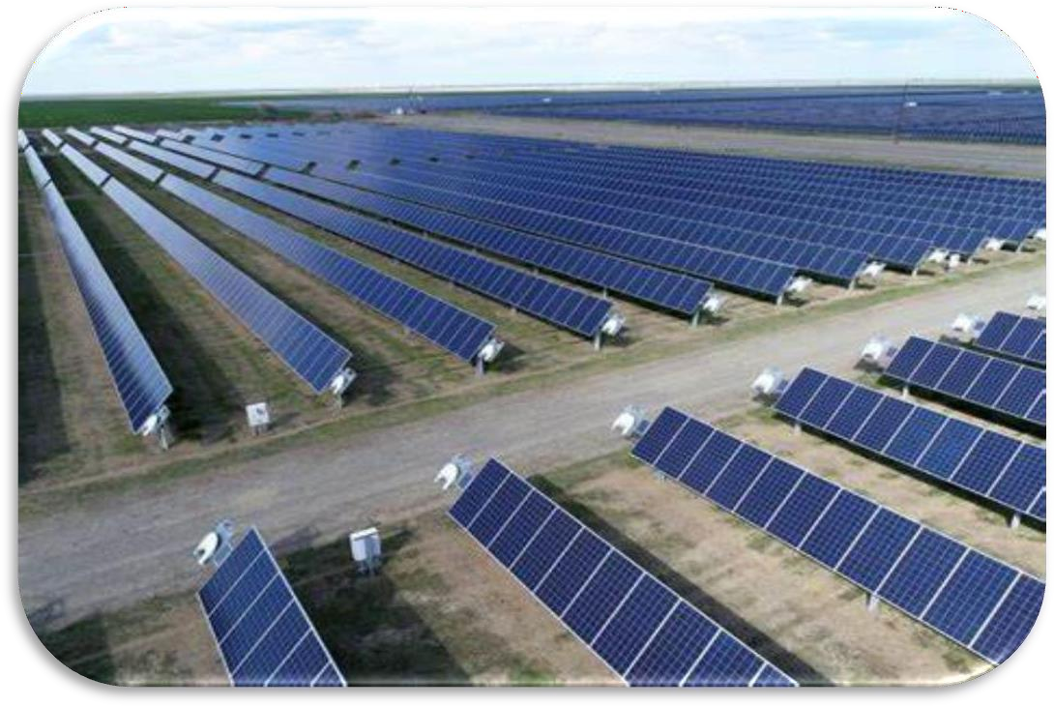

FINAL ENVIRONMENTAL PROJECT BRIEF (EPB) FOR THE PROPOSED 20MWac SOLAR PV PARK AT THE GARNETON NORTH SITE - KITWE, ZAMBIA

**2025**

DOCUMENT INFORMATION

|  |  |
| --- | --- |
| Title | Environmental Project Brief for CEC 20MWac Solar PV Plant, Garneton North, Kitwe, Zambia |
| Consultant | Crownbit Environmental Solutions Ltd |
| Contact Person | Floyd Chipatela – [fchipatela@gmail.com](mailto:fchipatela@gmail.com) |
| Email Address | Jacob Tembo – [jacobtembo@ymail.com](mailto:jacobtembo@ymail.com) |
| Keywords | Solar PV, EPB, Zambia, GETFiT |
| Report No. | 001 |
| Company | Innovent-CEC Garneton North Solar Limited |

DOCUMENT REVISION RECORD

|  |  |  |  |
| --- | --- | --- | --- |
| Rev No. | Issue Date | Description | Issued By |
| 1 | May 2024 | Draft EPB Report | CEC |
| 2 | July 2024 | Final EPB Report | CEC |
| 3 | March 2025 | Revision of the executive summary | InnoVent |

EXECUTIVE SUMMARY

**Introduction**

CEC and InnoVent were awarded a 20MWac solar PV IPP project for Garneton North Solar in April 2019 under the GETFiT program. In accordance with the Zambian legislative requirements and the conditions set under the GETFiT program, InoVent and its partner concluded the ESIA process and obtained environmental approval for the project in 2020. The environmental approval issued by ZEMA for the project expired in 2023 and therefore the proponent has procured the services of another independent Environmental Consultant to update the EPB for the project and secure fresh approval as they anticipate project financing and implementation.

This report, therefore, presents an updated Environmental Project Brief (EPB) prepared for the 20 MWac Garneton North Solar PV Project located some 20 km northwest of Kitwe Central Business District (CBD) in Garneton area, Kitwe District, Copperbelt Province of Zambia. The project will be developed on a 56-ha piece of land on title owned by CEC. Electricity generated from the Garneton North Solar PV Park will be transmitted via a 33kV transmission line (approximately 8.1 km long) which will run alongside the road reserve on the peripheral of Zambian compound, through Mukuba University Land and finally alongside the Kitwe-Chingola dual carriage way before terminating at the ZESCO Mwambashi Substation. A separate EPB for the transmission line will be elaborated and submitted to ZEMA for approval.

**Regulatory and Policy Framework**

The main financier of the project is KFW Development Bank which is a member of the International Finance Corporation (IFC). Therefore, Environmental and Social Impact Assessment (ESIA) is a major requirement for all projects under the GETFiT program and requires full compliance with IFC Performance Standards on Environmental and Social Sustainability, 2012 (“IFC PS”) and the World Bank Sustainability Guidelines. The AfDB updated Integrated Safeguards System (ISS), which became effective on May 31, 2024, harmonises with the IFC Performance Standards. This is why CEC and InnoVent have conducted fresh Environmental Impact Assessment (EIA) studies and prepared an updated EPB for the proposed 20 MWac Garneton North Solar PV Plant.

The EPB has been prepared in accordance with the Environmental Protection and Pollution Control (EIA) Regulations (SI No.28 of 1997) and the Environmental Management (Amendment) Act No. 8, 2023, Section 29, which requires authorization or approval by the Zambia Environmental Management Agency (ZEMA). Additional legislation which has been referenced and considered during the ESIA process include:

* The Constitution of Zambia
* The Water Resources Management Act, 2011
* The Forest Act No. 4 of 2015
* The Noxious Weeds Act, Cap 343
* Mines and Minerals Act, Cap 213
* National Heritage and Conservation Commission Act of 1989
* The Energy Regulation Act No. 23 of 2003
* The Petroleum Act No. 10 of 2008
* The Zambia Development Agency (Amendment) Act No. 15 of 2012
* The Standards Act No. 4 of 2017
* The Electricity Act of 2019
* The Urban and Regional Planning Act No. 3 of 2015
* The Lands Act, 1995
* Agricultural Lands Act, 1960
* The Local Government Act, No. 2 of 2019
* The Employment Code Act No 3 of 2019
* The Workers’ Compensation Act No. 10 of 1999
* The Factories Act No. 2 of 1966
* Occupational Health and Safety Act, No. 36 of 2010
* The Public Health Act, Cap 295 of 1995
* Public Roads Act (No. 12 of 2002)
* The Road Traffic (Amendment) Act, 2022
* Human Rights Commission Act (No. 39 of 1996)
* The Solid Waste Regulation and Management Act No. 20 of 2018
* National Council for Construction Act No. 10, 2020

**The Project**

The Garneton North Solar PV Project entails the construction and operation of a 20 MWac Solar PV Power Plant, along with associated ancillary facilities. The primary components of the project include PV modules with tracking mounting structures, underground DC and AC cables, transmission lines, inverter stations, transformer stations, site transfer / collector station, storage and office buildings, access roads, internal access tracks, a perimeter security fence, and security rooms. The solar park will feature approximately 39,732 solar modules, each with a generation capacity of 630Wp. These modules will be mounted on a single-axis tracking system that follows the sun’s path throughout the day.

The power generated by the Garneton North Solar PV Park will be transmitted via an approximately 10 km power line to the ZESCO Mwambashi Substation, located at along

Kalulushi Road. The project's total estimated cost is USD 24,207,000. It is expected to operate for at least 25 years without significant equipment changes, unless upgraded.

**Objective of the Project**

The primary goal of the project is to contribute to the GETFiT Zambia program, which aims to advance solar power capacity development. Specifically, the project aims to generate and supply up to 20 MWac of clean solar energy to the off-taker, ZESCO, for a duration of 25 years.

**Alternatives**

In arriving at the proposed project site, the Developer considered several other sites along the CSS129 wayleave area which included;

1. **Kitwe Substation-Garneton Wayleave:** This was not selected because there was no point where to connect to the ZESCO powerlines or substation.
2. **CEC Wayleave-Turf Substation:** CEC owns a wayleave from Turf substation to Garneton. However, the land is heavily encroached with both physical structures and agricultural fields.
3. **Garneton North CEC Servitude (preferred site):** CEC owns land of about 56 ha, along the wayleave between Chimwemwe and Sabina Mufulira Road.

The third alternative was selected due to absence of permanent structures or major encroachments and its close proximity to a ZESCO grid connection point.

The GETFiT program is soliciting power from two technology types, small hydro and solar PV. In the first round only, solar PV is allowed to participate in the reverse auction. As such no other technologies other than solar PV were considered for power generation.

**Project site: Environmental and Social Baseline Conditions**

The Project site is located on a gently sloping land (sloping towards existing surface water bodies) with average gradients of between 5% - 7% sloping towards Mwambashi River. The site for the Garneton North Solar PV Park lies between the Mwambashi stream and the Sand Sales dambo (formed as a man-made lake). The Mwambashi stream is a tributary of the Kafue River which it joins in about 4 km east of the Site.

No critical habitats are present on the project site, meaning no threatened, restricted-range, or migratory/congregatory species that meet IFC Performance Standard 6 thresholds are found there. The habitats are neither threatened nor unique and do not contain key evolutionary processes. Following the successful resettlement and compensation of illegal encroachers identified during the ESIA field studies conducted in 2019/2020, and ongoing patrols by the proponent to prevent new encroachments, there are currently no settlers or economic activities on the project site. The vegetation primarily consists of primary Miombo woodland, dominated by shrubs and late pioneer grasses (see biodiversity report in Appendix 5). A well-preserved stand of Miombo vegetation exists on neighboring private farms, which have had restricted entry for many years, maintaining more

natural habitats.

The Project Site forms part of the way-leave that is seasonally cleared to prevent fire outbreaks and disturbance to power transmission. Along all transmission lines, CEC has a right of way for about 200 – 400m from the last point of the transmission line. In addition, for this Site, CEC possesses a title deed for the whole 56 ha land encompassing the Project Site. Regardless of this, the Project site is traversed by bush tracks providing access to private properties found on the immediate north of the Project site. With the proposed project, it is inevitable that common or combined access routes will be devised for full realization of the project layouts and designs. Despite the presence of the Mwambashi stream, there is no established evidence of any livelihoods dependent on fishing. Garneton small holder/low density residential area and Zambia compound (initially unplanned and recently formalized) are found about 1.5 km south-west of the Project site.

**Environmental and Social Impacts**

The impacts of the construction and operation of the Solar PV Plant were assessed and are summarized in Table 1 below. Biophysical, ecological and socioeconomic impacts were assessed for each project component. The four highest rated impacts pre-mitigation were the impact of dust during construction (medium), impact on surrounding surface water bodies (medium), impact on occupational health and safety of the local workforce (medium) and impact on livelihoods of the local communities practicing seasonal agriculture on the Project Site and along the route chosen for the power evacuation line (high). All these impacts can be mitigated through appropriate mitigation measures that will reduce the impact significance post mitigation from low to very low. All other impacts assessed have a residual impact (impact after mitigation) of low to insignificant. Appropriate mitigation measures have been developed as part of a detailed Environmental and Social Management Plan (ESMP) (Appendix 1.1). The table below shows the summary of impacts of the Solar PV Plant

|  |  |  |  |  |  |  |
| --- | --- | --- | --- | --- | --- | --- |
| Environmental component | Ref # | Impact during construction & operation phase of the solar PV plant. | CONSTRUCTION PHASE  Impact significance without mitigation | | OPERATIONAL PHASE  Impact significance with mitigation | |
| Without mitigation | With mitigation | Without mitigation | With mitigation |
| Biophysical  Impacts | 6.2.1.1 | Impact of air emissions | Medium | Very low | Low | Low |
| 6.2.1.2 | Impact of noise emissions | Low | Very low | Very low | Very low |
| 6.2.1.3 | Risk of flooding | Low | Low | Low | Low |
| ESMP | Impact due to soil & groundwater contamination | - | - | - | - |
| ESMP | Impact of increased soil erosion | - | - | - | - |
| Ecological  Impacts | 6.2.2.1 | Impact of terrestrial ecology | Low | Very low | Low | Very low |
| 6.2.2.1 | Impact on aquatic ecology | Low | Very low | Low | Very low |
| 6.2.2.3 | Impact on ecosystem services | Low | Low | Low | Low |

|  |  |  |  |  |  |  |
| --- | --- | --- | --- | --- | --- | --- |
|  | 6.2.3.1 | Impact on landscape and visual amenity | Low | Very low | Low | low |
| Socio- economic Impacts | 6.2.3.2 | Impact on settlements & housing developments | Very low | Very low | Insignificant | Insignificant |
| 6.2.3.3 | Impact on land-use and livelihoods | Insignificant | Insignificant | - | - |
| 6.2.3.4 | Impact on cultural heritage | Insignificant | Insignificant | - | - |
| 6.2.3.5 | Impact on community health and  safety | Low | Very low | Low | Low |
| 6.2.3.6 | Impact on occupational health and safety | Medium | Low | Medium | Low |

**Environmental Management Commitments**

The Environmental and Social Management Plan (ESMP) has been developed to ensure compliance with Zambian regulatory requirements and IFC Environmental and Social Sustainability policies, guidelines, standards, and other mandates. The ESMP includes mitigation measures tailored to the predicted environmental and social impacts and risks, aiming to avoid or minimize adverse effects while enhancing benefits throughout the project development phases.

For the implementation of the ESMP, senior management of the Proponent will commit to achieving the environmental and social performance levels identified in the plan for the Solar PV Project. The Contractor will play a central role in meeting these performance levels during the construction phase. As part of daily contract management and operational procedures, the Contractor will implement the ESMP and report to the Proponent on environmental, health, and safety issues related to the construction of the Solar PV Plant.

The ESMP outlines commitments for capacity building and technology transfer to ensure consistent and acceptable environmental and social performance during the project’s development and construction phases. The Contractor will provide local specialists with the necessary skills and information to achieve the required performance levels, fostering skill and technology transfer to the local community and building national capacity.

The Contractor will conduct environmental audits and inspections of all operations to ensure that environmental monitoring activities at the project site are accurate and relevant to meeting the environmental management objectives of the proposed project. During construction, independent external auditors, such as the Project Proponent, ZEMA, and the GETFiT technical team, will also conduct external audits. These environmental audits and reports will comply with IFC requirements, the Proponent’s procedures, and applicable Zambian environmental regulations. Additional mitigation and enhancement measures for every identified impact are discussed in detail in sections 6 and 7.

**Consultations and negotiations held / conducted**

Consultation with PAPs is one of the key requirements of the AfDB ISS 2023. Hence, it formed the starting point for all activities relating to displacements. Public consultation had been an ongoing activity for the Garneton North Solar PV Project. The basis for consultations were:

* The ESIA process in Zambia makes public consultation with the communities, indispensable.
* The project involves economic displacement (agricultural fields) through displacement of agricultural fields and fruit trees, hence meaningful consultation with PAPs was critical in order to reach agreements with the affected persons to be displaced.
* Local communities had knowledge of local conditions - an invaluable asset to the Developer in terms of finding the suitable information that may assist to plan and implement the project smoothly.

Consultations were done mainly through community meetings with the PAPs and community members living within and near the project area, and some information was disclosed before and during socio-economic surveys.

The first step involved thorough walks throughout the Project site to establish the presence of features which may be liable to displacement prior to project development. This was followed by the identification of the owners in the case of agricultural fields and the users in the case of access routes. A census of the Project Affected Persons was also undertaken during the stage of identification of the owners of agricultural fields. After identifications of owners of agricultural fields, a team of surveyors moved onto the site to map the exact sizes of crop fields falling under the project site. Survey (mapping) of fields was repeated by the Ministry of Agriculture during crop valuation surveys. The ward leadership and local authorities were informed about the next course of action concerning agricultural fields located on the project land.

**Community Meetings**

During the survey exercise, Local representatives, such as the area councilor, ward development chairperson and Kitwe City Council were consulted first as a way of introducing the project and the other players in the LRP exercise. Then before engaging the communities, the area councilor was informed and requested to attend sensitization meetings whenever possible.

The meetings were held at Kitwe City Council and within Garneton area where the site for the proposed Garneton North Solar PV project is located. The main purpose of the meetings was;

* + To give insights on how displacements or resettlement issues are handled in such projects.
  + To get a fair understanding of the social economic baseline indicators of the project area.
  + To establish how grievances have been handled in similar past project implementation and ascertain if there is sufficient capacity to handle Social safeguards at the District level.

Emphasis was placed on a fully inclusive, open and transparent stakeholder participation process in the transfer of information on the project. Stakeholders meetings were held from 18th December 2018 to 19th September 2019 in with Kitwe City Council and in Garneton with the PAPs and other people in communities near the project site.

During the public consultations, the location and aerial extent of the project site was clearly explained to the stakeholders. Stakeholders were also informed of the expected benefits, impacts in terms of economic displacement (loss of seasonal crop fields) and the mitigation measures of how they will be compensated for the losses. Stakeholders, especially the PAPs were also informed of the arrangements to address any grievances that might arise and their opportunity to influence and identify appropriate benefits.

**Grievance Redress Mechanism**

A grievance mechanism has been developed for potential use by stakeholders. The aim of the grievance mechanism is to achieve mutually agreed resolution of grievances raised by all stakeholders.

The objectives of the grievance mechanism are:

* To provide Project Affected People (PAP) with a straightforward, accessible and prompt avenue for making a complaint or resolving any dispute that may arise during the course of the project.
* To ensure that appropriate and mutually acceptable corrective actions are identified and implemented to address the complaints
* To verify that complaints are satisfied with outcomes of corrective actions
* To avoid or minimize on the need to resort to judicial proceedings which can be long and expensive

The process of grievance redress will be as follows:

* Identification of grievance: identify or receive grievances during meetings or via phone calls and record on grievance form.
* Logging of Grievance: All grievances will be recorded on a grievance form and await determination of severity of grievance by the committee responsible for handling grievances.
* Investigation of Grievance and recommendation of corrective action: undertake consultation with the complainant, conduct site visits or inspections to verify the grievance and gathering all necessary physical evidence including pictures.
* Discussion of Corrective Action with complainant and agreement of implementation period: Discuss all recommended options for corrective actions as well as the complainant’s preference. Also, clearly highlight all company policies and all relevant laws and regulations considered when considering the complaint.
* Documentation of agreed position: all agreed positions after thorough consideration and discussion of corrective action will be fully documented.
* Implementation of agreed position: The grievance receiving committee will ensure that the agreed position is implemented within a stipulated timeframe.
* Close grievance: grievance will be signed off by complainant after completion of implementation of the agreed position or action.
* Seek indulgence of Courts of Law: if the complainant is not satisfied with the outcome of the above steps, he/she can take the incidence to the courts of law.

**Environmental and social management plan for Garneton North Solar PV plant**

The Environmental Management Plan (ESMP) is a tool designed to ensure the implementation of mitigation measures and monitoring by outlining roles and responsibilities of key stakeholders in respect to environmental management. The ESMP seeks to address all the possible negative environmental impacts at the various project phases. Environmental management and monitoring is carried out in all stages of the project (Construction and Operational). The document forms part of the Environmental Project Brief for the Garneton North Solar PV Project and also form part of the Contractors working brief for site management. Total cost of ESMP implementation is estimated at USD 600,000. The table below shows the ESMP implementation budget estimate.

|  |  |
| --- | --- |
| **Activity** | **Estimated Cost (Us$)** |
| ESMP Implementation (Construction Phase) | 184,000 |
| ESMP Implementation (Operation Phase) | 331,000 |
| ESMP Implementation (Decommissioning) | 7,000 |
| PAP’s compensation | 39,000 |
| Audits | 39,000 |

A comprehensive ESMP has been developed for the purpose of the project, which includes the key items in the table below

Key items of ESMP – Construction phase

|  |  |  |  |  |  |  |  |  |
| --- | --- | --- | --- | --- | --- | --- | --- | --- |
| **Ref** | **Aspect / Issue** | **Potential Impact / Risk** | **Mitigation Measures** | **Performance Indicator (Target)** | **Frequency and Monitoring**  **Action** | **Responsible Person** | **Cost (Us$)** | **Best Practice Guidance** |
| **Biodiversity** | | | | | | | | |
| **C5** | Clearing of | Loss of | - Clearing of | No clearing | Daily visual | Contractor for | 1000 | IFC |
|  | areas for | vegetation | vegetation should | of vegetation | inspections | clearing works |  | Performance |
|  | installation | (tree | only be confined | beyond the | of clearing |  |  | Standard 6: |
|  | of the | species) and | to areas where the | confines of | activities |  |  | Biodiversity |
|  | scalling solar | natural | solar | the project | during the |  |  | Conservation |
|  | infrastructure | habitat for | infrastructure will | footprint | construction |  |  | and |
|  | may impact | small | be installed to |  | phase. |  |  | sustainable |
|  | on the | mammals, | minimise loss of |  |  |  |  | Management |
|  | existing | birds and | vegetation and |  |  |  |  | of Living |
|  | habitat | insects. | wildlife habitats. |  |  |  |  | Natural |
|  |  |  | - the construction |  |  |  |  | Resources; |
|  |  |  | workers should |  |  |  |  | Zambian |
|  |  |  | be provided with |  |  |  |  | Forest Act, |
|  |  |  | guides and |  |  |  |  | 1973. |
|  |  |  | extents of areas to |  |  |  |  |  |
|  |  |  | be cleared |  |  |  |  |  |
| **Hygiene, Health and Safety** | | | | | | | | |

|  |  |  |  |  |  |  |  |  |
| --- | --- | --- | --- | --- | --- | --- | --- | --- |
|  | Construction | Risky sexual | - Developing an | HIV/AIDS | Record of | IVT / | 5000 | IFC |
|  | sites have | behaviour | HIV/AIDS Policy | Policy | sensitisation | Contractor(s) |  | Performance |
|  | been known | among the | to be adhered to | developed | / education |  |  | Standard 4: |
|  | to promote | population | during the | and | programmes |  |  | on |
|  | risky sexual | Leading to | construction and | implemented; | undertaken |  |  | Community |
|  | behaviour | escalation of | operation phases | Sensitisation | including the |  |  | Health, |
|  |  | new STIs | of the project. | / Education | number of |  |  | Safety and |
| **C13** |  | including HIV/AIDS | - Sensitization programs on | programmes on | people sensitised / |  |  | Security. Public Health |
|  |  | in the local | preventing the | HIV/AIDS | trained on |  |  | Act, Cap 295. |
|  |  | population | spread of STIs | conducted for | STI and |  |  |  |
|  |  | and among | and HIV/AIDS | contractors | HIV/AIDS. |  |  |  |
|  |  | the | for project | and | Frequency: |  |  |  |
|  |  | workforce. | workers including | suppliers; | Bi- annually |  |  |  |
|  |  |  | contractors and |  |  |  |  |  |
|  |  |  | suppliers. |  |  |  |  |  |
| **Capacity Building** | | | | | | | | |
|  | Construction | Employment | - The contractor, | Increased | Record of | Contractor | 5000 | IFC |
|  | of the Solar | opportunities | where possible, | employment | employment, | / IVT |  | Performance |
|  | PV plant | created | should employ | opportunities | annual |  |  | Standard 2 - |
|  |  | forboth | members of the | leveraged to | reports on |  |  | Labour and |
|  |  | skilled and | local | the local | Solar Plant |  |  | Working |
|  |  | non- skilled | communities and | community | Operators. |  |  | Conditions; |
|  |  | labour and. | local experts to |  | Frequency: |  |  | Zambian |
|  |  | multiplier | maximize on the |  | Bi- annually. |  |  | Employment |
|  |  | opportunities | benefits of |  |  |  |  | (Amendment) |
|  |  | for | employment |  |  |  |  | Act No. 15 of |
|  |  | employment | opportunities. |  |  |  |  | 2015. |
|  |  | in support | The jobs for |  |  |  |  |  |
|  |  | sectors. | which local |  |  |  |  |  |
| **C15** |  |  | people qualify |  |  |  |  |  |
|  |  |  | (including non- |  |  |  |  |  |
|  |  |  | technical and |  |  |  |  |  |
|  |  |  | technical) will be |  |  |  |  |  |
|  |  |  | as much as |  |  |  |  |  |
|  |  |  | possible be |  |  |  |  |  |
|  |  |  | offered to the |  |  |  |  |  |
|  |  |  | local people. |  |  |  |  |  |
|  |  |  | - Priority of |  |  |  |  |  |
|  |  |  | employment will |  |  |  |  |  |
|  |  |  | be given to the |  |  |  |  |  |
|  |  |  | project affected |  |  |  |  |  |
|  |  |  | people or their |  |  |  |  |  |
|  |  |  | relatives |  |  |  |  |  |

Key items of ESMP – Operation phase

|  |  |  |  |  |  |  |  |  |
| --- | --- | --- | --- | --- | --- | --- | --- | --- |
| **Ref** | **Aspect / Issue** | **Potential Impact / Risk** | **Mitigation Measures** | **Performance Indicator (Target)** | **Frequency and**  **Monitoring Action** | **Responsible Person** | **Cost (Us$)** | **Best Practice Guidance** |
| **Storage of fuels and oils** | | | | | | | | |
|  | Storage | Potential | - Uncontrolled | No | Weekly | Site Manager | 10 000 | World Bank |
|  | and | contaminati | dumping or | groundwater | inspection |  |  | Group |
|  | handling | on of | littering of any | contaminatio | of dumping |  |  | General EHS |
|  | of fuels | groundwate | waste within the | n arising | sites within |  |  | Guidelines for |
|  | and oils | r from | project area and | from storage | the site to |  |  | Hazardous |
|  | including | spillage of | areas adjacent to | and handling | ensure |  |  | Material |
| **OP17** | handling  of | fuels, oils  and solid | the project site  should be | fuels and oils  including | correct  labelling |  |  | Management;  IFC |
|  | hazardous | wastes | avoided. | hazardous | and usage. |  |  | Performance |
|  | waste on |  | - Uncontrolled | waste. |  |  |  | Standard 3; |
|  | site during |  | dumping of any |  |  |  |  | Zambian |
|  | operationa |  | toxic or |  |  |  |  | Environmenta |
|  | l phase. |  | hazardous waste, |  |  |  |  | l Management |
|  |  |  | including used |  |  |  |  | (Licensing) |

|  |  |  |  |  |  |  |  |  |
| --- | --- | --- | --- | --- | --- | --- | --- | --- |
|  |  |  | oils from |  |  |  |  | Regulations, |
| transformers | 2013. |
| should be |  |
| avoided. |  |
| - Solid wastes |  |
| will be |  |
| temporarily |  |
| stored / |  |
| accumulated on- |  |
| site and later |  |
| collected and |  |
| disposed of at |  |
| approved landfill |  |
| sites |  |
| - Specific |  |
| dumping |  |
| locations |  |
| for litter and any |  |
| other waste |  |
| should be |  |
| provided on site |  |
| **Hygiene, Health and Safety** | | | | | | | | |
|  | Occupatio | Risks to | - Regular | Maintaining | Certified | Site Manager | 10000 | World Bank |
|  | nal Health | workers | measurement of | exposure | and |  |  | General EHS |
|  | and Safety | health and | electrical and | levels within | approved |  |  | Guidelines: |
|  |  | safety | magnetic | the statutory | monitoring |  |  | Occupational |
|  |  | during the | radiation levels | and best | protocols to |  |  | Health and |
|  |  | operation | and taking | practice | be carried |  |  | Safety; World |
|  |  | and | appropriate | limits. | out for all |  |  | Bank EHS |
|  |  | maintenanc | measures when |  | electrical |  |  | Guidelines for |
|  |  | e activities | exposure exceeds |  | and |  |  | Electric |
|  |  | of the | acceptable levels. |  | magnetic |  |  | Power |
|  |  | project as | -Only trained and |  | radiation. |  |  | Transmission |
|  |  | they are | certified workers |  | Approved |  |  | and |
| **OP19** |  | exposed to  electromagn | should be allowed  to install, |  | and  authorised |  |  | Distribution;  Occupational |
|  |  | etic fields. | maintain or repair |  | work |  |  | Health and |
|  |  |  | electrical |  | permits to |  |  | Safety Act |
|  |  |  | equipment. |  | qualified |  |  | 2010 of the |
|  |  |  |  |  | competent |  |  | Laws of |
|  |  |  |  |  | persons |  |  | Zambia; |
|  |  |  |  |  | only. |  |  | Electricity Act |
|  |  |  |  |  | Frequency: |  |  | CAP 433 of |
|  |  |  |  |  | as per |  |  | the Laws of |
|  |  |  |  |  | operations |  |  | Zambia. |
|  |  |  |  |  | and |  |  |  |
|  |  |  |  |  | monitoring |  |  |  |
|  |  |  |  |  | guidelines. |  |  |  |

**Conclusion**

The aim of the Environmental and Social Impact Assessment (ESIA) process is to provide sufficient information for ZEMA to make an informed decision regarding the approval of the proposed solar PV plant and associated power evacuation line. This information is detailed in the Environmental Project Brief, which has been compiled in accordance with national legislation, IFC Performance Standards, and KfW Sustainability Guidelines.

The solar PV site does not support any critical habitats as defined by the IFC. The site is located on privately owned, titled land belonging to CEC with no encroachments. Occupational health and safety concerns for the workforce during both construction and operational phases arise from the potential unfamiliarity of the local workforce with international best practices. These concerns can be effectively mitigated through proper training and the implementation of a health and safety management system throughout the project's construction and operational phases. Additionally, the benefits of job creation and opportunities for local suppliers are significant.

The assessment of the construction and operation of the solar PV plant and the associated power evacuation line concluded that, with mitigation, no impacts will have high or medium significance; all impacts range from low to insignificant. It is concluded that if the proposed mitigation measures are implemented and the developer commits to enhancing community benefits through the creation of local jobs, utilization of local suppliers, and improved security in the areas surrounding the project site, the positive impacts will outweigh the negative ones.

_______________________________

Caroline Sinkamba

***Senior Manager- HSE and Risks Copperbelt Energy Corporation Plc***

TABLE OF CONTENT

DOCUMENT INFORMATION i

DOCUMENT REVISION RECORD i

EXECUTIVE SUMMARY ii

TABLE OF CONTENT xvii

ACRONYMS AND ABBREVIATIONS xxi

LIST OF TABLES xxiii

LIST OF FIGURES xxiv

1 INTRODUCTION 1

1.1 Project Background and Rationale 1

1.2 Location of the Project 1

1.3 The Project Description 2

1.4 Project Objective 3

1.5 Developer and Track Record 3

1.6 Percentage of Shareholding by Each Shareholder 3

1.7 Total Project Cost/Investment 4

1.8 Proposed Project Implementation Date 4

2 POLICY, LEGAL AND INSTITUTIONAL FRAMEWORK 6

2.1 Policy Framework 6

2.1.1 National Policy on the Environment (NPE) 6

2.1.2 National Energy Policy 6

2.1.3 REFiT Policy 6

2.2 Legal Framework 7

2.2.1 Environmental Management Act (EMA) No. 12 of 2011 as amended by EMA Act No. 8 of 2023 7

2.2.2 EIA Regulations (SI No. 28 of 1997 Part 2 and 3) 7

2.2.3 Environmental Management (Licensing) Regulations, SI No. 112 of 2013: 8

2.2.4 Air and Water Pollution: Part II (Regulations 3-9), SI No. 112 of 2013: 8

2.2.5 Waste Management: Part III (Regulations 10-15), SI No. 112 of 2013: 8

2.2.6 Hazardous Waste: Part IV (Regulations 18-30), SI No. 112 of 2013: 8

2.2.7 Pesticides and Toxic Substances: Part V (Regulations 31-40), SI No. 112 of 2013: 8

2.2.8 Noise 9

2.2.9 Natural Resources Management 9

2.2.10 Other Relevant National Legislation 9

2.3 Institutional Framework 21

2.4 International Agreements and Conventions 22

2.5 International Standards 24

2.5.1 IFC Performance Standards on Environmental and Social Sustainability (2012) 24

2.5.2 World Bank Environmental, Health and Safety Guidelines 28

2.5.3 The African Development Bank’s (AfDB) Integrated Safeguards System (ISS) 2023 28

2.5.4 KfW Development Bank Sustainability Guideline (2016) 28

2.5.5 Equator Principles 30

2.5.6 International Labour Organization (ILO) Conventions 30

2.5.7 Environmental and Social Categorization and Rationale 31

3 DESCRIPTION OF THE PROJECT 32

3.1 Location of the Proposed Project 32

3.2 Nature of the Project 36

3.2.1 Raw Materials 37

3.2.2 Process and Technology Solar PV Park 38

3.2.3 Products and by-Products 40

3.2.4 By Products 40

3.2.5 Production Capacity 41

3.3 Temporary Facilities 41

3.4 Associated Facilities 42

3.4.1 Substation 42

3.4.2 Borrow Pits 42

3.5 Schedule and life of Project 42

3.6 Main Activities 43

3.6.1 Planning Phase 43

3.6.2 Construction Phase 43

3.6.3 Commissioning Phase 44

3.6.4 Operational Phase 44

3.6.5 Decommissioning Phase 44

4 PROJECT ALTERNATIVES 45

4.1 Mitigation Hierarchy 45

4.2 Identification of Alternatives 46

4.3 Analysis of Alternatives 46

4.3.1 Site alternatives 46

4.3.2 Technology alternatives 47

4.3.3 Modules Orientation 48

4.4 Site Layout alternatives 48

4.5 No-Project alternative 48

5 DESCRIPTION OF THE BASELINE ENVIRONMENT 50

5.1 Climate 50

5.2 Air Quality 51

5.3 Geology 52

5.4 Hydrology 52

5.5 Hydrogeology 53

5.6 Topography and Landscape 53

5.7 Soils 54

5.8 Land use 55

5.9 Land Tenure 56

5.10 Noise and Vibrations 56

5.11 Ecological Resources 57

5.11.1 Indigenous Vegetation and Habitats 57

5.11.2 Fallow Fields 58

5.11.3 Shrubland 58

5.11.4 Grassland 60

5.11.5 Secondary Miombo 60

5.12 Terrestrial Fauna 61

5.12.1 Mammals 61

5.12.2 Birds (Avifauna) 61

5.12.3 Reptiles 62

5.13 Aquatic Species in the Project Area 62

5.13.1 Aquatic Flora 62

5.14 Aquatic Fauna 62

5.14.1 Fish/ Ichthyology 62

5.15 Vegetation along the Powerline Corridor 63

5.16 Threatened species 63

5.17 Protected / Conservation Areas 63

5.18 IFC Critical Habitat Status Assessment 65

5.19 Implications for the Project 66

5.20 Social, Economic and Cultural Environment 67

5.20.1 Land Tenure and Land Use 67

5.20.2 Population, Land Administration and Settlement 67

5.20.3 Economic and Livelihood Activities 67

5.20.4 Water and Sanitation 68

5.20.5 Education 68

5.20.6 Health Care 69

5.20.7 Energy 69

5.20.8 Traditions, Rites and Archaeology 69

5.20.9 Potential Displacements and Compensation 70

6 ENVIRONMENTAL AND SOCIAL IMPACT ASSESSMENT – SOLAR PV PLANT 73

6.1 Positive Impacts 74

6.1.1 Local investment and Employment Opportunities 74

6.1.2 Improved Utilization of the Land 76

6.1.3 Boost to Renewable Energy Sources 76

6.1.4 Improved Grid Stability and Decreased Transmission Losses 76

6.2 Negative Biophysical Impacts 77

6.2.1 Air Emissions 77

6.2.2 Noise Emissions 79

6.2.3 Risks of Flooding 80

6.2.4 Recommendations and Mitigation Measures 81

6.3 Negative Ecological Impacts 81

6.3.1 Terrestrial Ecology 81

6.3.2 Aquatic Ecology 84

6.3.3 Ecosystem Services 85

6.4 Socio-economic Impacts 85

6.4.1 Landscape and Visual Amenity 85

6.4.2 Settlements and Housing Developments 86

6.4.3 Land-Use and Livelihoods 87

6.4.4 Cultural Heritage 88

6.4.5 Community Health, Safety and Security 89

6.4.6 Occupational Health and Safety 91

6.4.7 Employee Welfare 92

6.4.8 Human Rights 95

6.4.9 Deforestation and Climate Change 99

6.4.10 **Potential Implications of Climate Change on the Project’s Environmental and Social Risks** 100

6.5 Decommissioning Phase Impacts (Solar PV Plant and Transmission Line) 102

6.6 Cumulative Impacts 102

7 ENVIRONMENTAL AND SOCIAL MANAGEMENT PLAN 104

8 DECOMMISSIONING AND CLOSURE PLAN 105

9 SUMMARY AND CONCLUSION 106

DECLARATION OF AUTHENTICITY OF REPORT CONTENTS 108

REFERENCES 109

APPENDICES 110

APPENDIX 1.1: ENVIRONMENTAL AND SOCIAL MANAGEMENT PLAN FOR THE SOLAR PV PARK AND POWERLINE 111

APPENDIX 1.2: IMPACT ASSESSMENT METHODOLOGY 112

APPENDIX 1.3: ENVIRONMENTAL MONITORING PLAN 113

APPENDIX 2.3: PROPOSED FOOTPATHS 114

APPENDIX 3: WASTE MANAGEMENT PROCEDURE 115

APPENDIX 4.1: WATER TEST RESULTS 116

APPENDIX 4.2: HYDROLOGICAL STUDY REPORT 117

APPENDIX 5: SOIL SURVEY REPORT 118

APPENDIX 6: BIODIVERSITY REPORT 119

APPENDIX 7: LIVELIHOOD RESTORATION PLAN 120

APPENDIX 8: AGRICULURAL SURVEY REPORT 121

APPENDIX 9.1: RDA CLEARANCE LETTER 122

APPENDIX 9.2: ZEMA COMFIRMATION OF EPB 123

APPENDIX 9.3: ZEMA DECISION LETTER 124

APPENDIX 9.4: ZESCO MINUTES ON POWER CONNECTION AGREEMENT 125

APPENDIX 10.1: SOCIO-ECONOMIC SURVEY 126

APPENDIX 10.2: SOCIO-ECONOMIC-DATA COLLECTION FORMS 127

APPENDIX 11: CERTIFICATE OF TITLE 128

APPENDIX 12: CULTURAL HERITAGE STANDARD 129

APPENDIX 13: SITE PLAN 130

APPENDIX 14: CERTITICATE OF INCORPORATION 131

APPENDIX 15: DETAILS OF THE PROJECT AFFECTED PERSONS 132

ACRONYMS AND ABBREVIATIONS

|  |  |
| --- | --- |
| **Acronym / Abbreviation** | **Definition** |
| AC | Alternating Current |
| CBD | Central Business District |
| CEC | The Copperbelt Energy Corporation Plc |
| CIA | Cumulative Impact Assessment |
| DC | Direct Current |
| DOE | Department of Forestry |
| EIA | Environmental Impact Assessment |
| EIS | Environmental Impact Statement |
| EMA | Environmental Management Act |
| EPs | Equator Principles |
| EPB | Environmental Project Brief |
| EPC | Engineering Procurement Construction |
| EPPCA | Environmental Protection and Pollution Control Act |
| ESIA | Environmental and Social Impact Assessment |
| ESMP | Environmental and Social Management Plan |
| ERB | Energy Regulation Board |
| Ha | Hectares |
| HIA | Heritage Impact Assessment |
| IFC | International Finance Corporation |
| ILO | International Labour Organization |
| IUCN | International Union for Conservation of Nature |
| kV | Kilovolts |
| kWh | Kilowatts hour |
| MOTA | Ministry of Tourism and Arts |
| MW | Mega Watt |
| MWp | Mega Watt peak |
| MWSEP | Ministry of Water, Sanitation and Environmental Protection |
| NCS | National Conservation Strategy |
| NEAP | National Environment Action Plan |
| NEP | National Energy Policy |
| NHCC | National Heritage Conservation Commission |

|  |  |
| --- | --- |
| PS | Performance Standards |
| PV | Photovoltaic |
| REFiT | Renewable Energy Feed in Tariff |
| SI | Statutory Instrument |
| USD | United States Dollar |
| WARMA | Water Resources Management Authority |
| ZESCO | Zambia Electricity Supply Corporation |
| ZEMA | Zambia Environmental Management Agency |

LIST OF TABLES

Table 1.6‑1: Percentage Shareholding of InnoVent-CEC Garneton North Solar Limited 4

Table 1.8‑1: Key Implementation Dates Table 4

Table 2.2‑1: Other Relevant Legislation 10

Table 2.3‑1: Institutions With a Supervisory and Monitoring Role Relevant to the project 21

Table 2.4‑1: International Treaties and Conventions of Relevance to the Project 23

Table 2.5‑1: IFC Performance Standards and their Applicability to the Project 25

Table 3.1‑1: Coordinates of the Garneton North Solar PV Park 32

Table 4.1‑1: Summary of Mitigation Hierarchy 45

Table 5.1‑1: Annual rainfall and temperature in the project area (source: climate-data.org) 50

Table 5.2‑1: Air Quality Data 52

Table 5.3‑1: Major Geological Formations of The Land 52

Table 5.7‑1: Generalized Soil family types in the project area 55

Table 5.10‑1: Prevailing Noise Levels on the Project Site 56

Table 5.11‑1: Habitat/Vegetation Coverage within the Site 57

Table 5.20‑1: Comparison of Crop Value of Selected PAPs Between 2019 and 2023 71

Table 5.20‑2: Caution Sign Pasted around the Project Land to Deter Encroachments. 72

Table 5.20‑1: Matrix for Determining Overall Significance of Impacts 73

Table 5.20‑2: Impacts as a result of the Construction and Operation of the PV Plant 74

Table 6.1‑1: Impact Assessment with Respect to Local Investment and Employment 75

Table 6.1‑2: Impact Assessment with Respect to Land Utilization 76

Table 6.2‑1: Impact Assessment of Air Emissions 78

Table 6.2‑2: Impact Assessment of Noise Emissions 80

Table 6.3‑1: Assessment of Impacts on Terrestrial Habitats 82

Table 6.3‑2: Assessment of Impacts on Aquatic Habitats 84

Table 6.4‑1: Assessment of Impacts on Landscape and Visual Amenity 86

Table 6.4‑2: Assessment of Impacts on Settlement and Housing Development 87

Table 6.4‑3: Assessment of Impacts on Land-Use and Livelihoods 88

Table 6.4‑4: Assessment of Impacts on Cultural Heritage 89

Table 6.4‑5: Assessment of Impacts on Community Health, Safety and Security 90

Table 6.4‑6: Assessment of Impacts on Occupational Health and Safety 92

Table 6.6‑1: Summary of impacts of the Solar PV Plant 106

LIST OF FIGURES

Figure 3.1‑1: Regional Locality Map 33

Figure 3.2‑1: Typical Installation Layout of a Grid-Connected Solar PV Plant (Source: IFC, 2015) 39

Figure 5.1‑1: Average number of rainy days and sunshine hours in the project area 51

Figure 5.7‑1: Generalized Soil family types in the project area 54

Figure 5.11‑1: Land Cover Map for the Proposed Project Site 57

Figure 5.11‑2: Some Bamboo Species Characterising the Shrubland 59

Figure 5.11‑3: Ground Covered by Small Tree Regrowth and Grass Species within the 59

Figure 5.11‑4: Showing Secondary Miombo Woodland within the Proposed Project Site 61

Figure 5.13‑1: Some Floating and Submerged Aquatic Flora in Mwambashi Flora 62

Figure 5.18‑1: High Level Critical Habitat Assessment 65

Figure 6.4‑1: Assessment of Negative Impacts on Employee Welfare 93

Figure 6.4‑2: Assessment of Negative Impacts on Human Rights 98

# INTRODUCTION

## Project Background and Rationale

With support from the German Cooperation, provided through KfW Bank (a member of the IFC), the government of Zambia sought experienced and qualified developers and investors with a track record in developing, financing, procuring, constructing, and operating utility-scale solar PV projects with an individual installed capacity of up to 20 MWac, totaling up to 120 MW. The Global Energy Transfer Feed-in Tariff (GETFiT) Zambia is the special purpose vehicle (SPV) designed to assist the Zambian government in implementing these projects. The GETFiT tender allowed bidders to be awarded up to two projects with a cumulative maximum capacity of 40 MW.

In April 2019, CEC and InnoVent were awarded two 20 MWac solar PV IPP projects for Garneton North & South Solar, each at a rate of USD 4.80 cents per kWhac. As part of the environmental and social requirements set for the GETFiT projects, CEC and its partner engaged a consultant to conduct Environmental and Social Impact Assessment (ESIA) studies, including the preparation of Livelihood Restoration Plans (LRPs) for all project-affected persons (PAPs). Consequently, separate Environmental Project Briefs (EPBs) were prepared for the Garneton North & South Solar projects, along with the accompanying LRPs, and submitted to the Zambia Environmental Management Agency (ZEMA). The EPBs were approved by ZEMA in 2020. However, project financing was delayed due to unforeseen challenges. Despite this, the developer remained committed to the projects, and the parties agreed to extend the validity of the bids, while the GETFiT Secretariat and KfW worked to restore project financing.

The 3-year environmental approval issued by ZEMA for the projects expired in 2023. Therefore, the Proponent has procured the services of another independent environmental consultant to update the EPBs and LRPs for the project and secure the necessary approvals as they anticipate project financing and implementation.

## Location of the Project

The Project site is located in Garneton area, about 23 km northwest of Kitwe CBD (see figure 3- 1-2). The Garneton North Project site is located on private titled land owned by CEC. The Project site is located 23 km north-west of Kitwe CBD in Garneton Area, Copperbelt Province. The Project site is approximately 56 ha in size, and considered big enough for the 20 MWac solar PV park being proposed. Land marks in close proximity to the site include:

* Farm structures on Riverane Farm located some 600m east of the project site;
* A farmhouse on a private small holder farm located some 270m east of the project site;
* CEC Itimpi solar park on the eastern boarder of the site;
* Farm buildings and other facilities at Proclamation Institute Zambia (PIZ), located some 200m from the site boundary;
* Garneton Small-holder / low density residential area and Zambia high density residential area are found about 1.5 km south east; and
* A water treatment plant run by Nkana Water Supply Company Ltd, about 600m southwest of the Project site on the upstream of Mwambashi stream.

## The Project Description

CEC and InnoVent SAS intends to install a 20 MWac Solar PV plant on a 56 ha piece of land located in Garneton area of Kitwe, hereby called Garneton North. Although a total of 56 ha is allocated for the Garneton North Solar PV park, the actual footprint or area expected to be taken up by installed solar modules will be less than 60% which leaves enough room for internal circulation and maintenance and buffer zones. The Garneton North Solar PV Project will involve the construction and operation of a 20 MWac solar PV power plant accompanied by a range of associated facilities critical for its functioning. The key components of the project include:

* + - **PV Modules**: High-efficiency photovoltaic modules will be used to capture and convert solar energy into electricity. These modules are the primary components responsible for the generation of electric power.
    - **Tracking Mounting Structures**: To maximize energy capture, the PV modules will be mounted on tracking structures that follow the sun's movement throughout the day, optimizing the angle of incidence and thus enhancing power generation efficiency.
    - **Underground DC and AC Cables**: These cables will be used to transport the generated electricity from the PV modules to the inverter stations and subsequently to the transmission lines. The underground installation helps protect the cables from environmental factors and physical damage.
    - **Transmission Lines**: Dedicated transmission lines will be constructed to carry the generated electricity to the designated substation and the national grid (Separate environmental Assessment will be done for the transmission line).
    - **String Inverters** : These will convert the direct current (DC) generated by the PV modules into alternating current (AC), which is suitable for transmission and distribution.
    - **Site Substations**: Substations will be established on-site to manage and regulate the electricity flow, ensuring it is at the correct voltage and frequency for safe transmission to the national grid.
    - **Stores and Office Buildings**: Facilities will be constructed to store equipment, spare parts, and other materials needed for the operation and maintenance of the solar power plant. Additionally, office buildings will provide workspace for the administrative and operational staff.
    - **Internal Access Tracks**: Well-constructed access tracks within the site will facilitate the movement of personnel and equipment, ensuring smooth operation and maintenance activities.
    - **Perimeter Security Fence and Security Rooms**: To ensure the safety and security of the plant, a perimeter fence will be erected around the facility. Security rooms will be established at strategic points to house personnel and equipment necessary for surveillance and protection of the site.

Electricity generated by the Garneton North Solar PV Park will be transmitted via a dedicated 8.1 km power line to the ZESCO Mwambashi Substation. This substation is strategically located a few 100 meters from the Chingola-Kitwe Road turnoff along the Kalulushi Road, enabling effective integration of the generated power into the national grid.

By incorporating these comprehensive infrastructure elements, the project aims to ensure a robust and reliable solar power generation system. The construction and operational phases will be meticulously planned and executed to achieve high efficiency, sustainability, and alignment with the energy needs of the region.

All projects supported by the GETFiT Tender program must adhere to the IFC Performance Standards on Environmental and Social Sustainability, 2012 ("IFC PS"), and the KfW Development Bank Sustainability Guideline, 2016. Additionally, compliance with Zambian legislation and regulations is mandatory. The 20 MWac Solar PV projects are classified as category "B," indicating medium environmental risks, and only require an Environmental Project Brief (EPB) under the GETFiT program. Therefore, this EPB has been prepared in accordance with the Environmental Impact Assessment Regulations SI No. 28 of 1997 and section 29 of the Environmental Management (Amendment) Act, No. 8, 2023. A separate Environmental Project Brief (EPB) for the transmission line will be elaborated and submitted to ZEMA for approval.

## Project Objective

The wider objective of the Project is to form part of the GETFiT Zambia program which intends to facilitate the development of solar power capacity. In essence these GETFiT projects intend to generate clean solar power and transmit this energy into the national and regional power transmission system with ZESCO as the power purchaser. It is the purpose of this specific Garneton North project to fulfill the developer’s GETFiT obligations, which is to add 20 MWac of Solar PV Generation to the national grid by December 2025. After construction and commissioning has been successfully completed, the principal objective of the project will be to generate and supply up to 20 MWac of clean solar energy (weather permitting) to the off taker, ZESCO for 25 years. As per the terms of the Power Purchase Agreement (PPA), ZESCO will purchase this supplied power for the duration of the contract.

## Developer and Track Record

The proposed project will be developed by CEC Plc (a Zambian company) in partnership with InnoVent (a French company) with installed capacity 20 MWac of solar electricity generation.

CEC, a member of Southern African Power Pool (SAPP) and listed on the Lusaka Securities Exchange, is an independent power transmission and quality electricity distribution company with interests in Zambia and sub-Saharan Africa, including optic fibre-based telecommunications. As a developer of energy infrastructure in Africa, CEC is respected in the region for its skills in designing and operating transmission systems and its status as an emerging independent power generating company.

InnoVent is a world-renowned company that designs, builds, and runs more than 450 MW of solar and wind farms in France and more than 10 countries in Africa. The company was founded in 2001 and is based in Villeneuve d'Ascq, France.

## Percentage of Shareholding by Each Shareholder

The Garneton North project is held by a Special Purpose Vehicle which is a Zambian company registered as InnoVent-CEC Garneton North Solar Limited. The company’s registration number is 120180009889.

Table ‑: Percentage Shareholding of InnoVent-CEC Garneton North Solar Limited

|  |  |  |
| --- | --- | --- |
| Shareholder | Percentage ownership | Address and Contact Person |

|  |  |  |
| --- | --- | --- |
| Copperbelt Energy Corporation Plc  (CEC) | 49% | Stand 3614, 23rd Avenue, Nkana East, Kitwe. Caroline M. Sinkamba ( [sinkambac@cec.com.zm](mailto:sinkambac@cec.com.zm) ) |
| InnoVent Renewable Energy  Zambia Limited | 51% | Stand 4015a, The Gallery Office Park, Frost Building, Rhodes Park, Lagos Road, Lusaka  Tom Torne ( [ttorne@innosun.org](mailto:ttorne@innosun.org) ) |

**Project Contact Person Name:** Caroline M. Sinkamba

**Designation:** Senior Manager – Health, Safety, Environment, Social & Risk, Copperbelt Energy Corporation Plc.

**Office Address:** 23rd Avenue, Nkana East

**Postal Address:** P.O Box 20819, Kitwe, Zambia.

**Phone:** Tel:+260 212 244285 / Mobile: +260 960 632602.

**Email:** [sinkambac@cec.com.zm](mailto:sinkambac@cec.com.zm)

## Total Project Cost/Investment

The total Project investment value is estimated at approximately US$24,207,000.

## Proposed Project Implementation Date

Prior to the initiation of onsite activities, a period of development, design, material procurement and component transportation logistics will happen for the project, but will have limited material impact on the site. Once onsite activities are initiated on the Garneton North Project site, the project implementation program will be followed as summarized in table 1-8-1.

The complete preassembly and installation of the single-axis tracking system, with the mounting of solar PV modules will be done during the Major Installation period above. Cable trenching will be done after the heaviest period of the rain season has ended. All the main construction and installation activities will be complete by October 2025 after which system testing, commissioning and ramping up will commence in conjunction with the GETFiT and Zambian Grid Code requirements. The Commercial Operations Date (COD) will be reached during the month of January 2026 with the full 20 MWac connected and feeding into the ZESCO grid. Thereafter the plant will operate for 25 years under the initial Power Purchase Agreement.

Table ‑: Key Implementation Dates Table

|  |  |
| --- | --- |
| Activity | Date |
| Site Clearing Start | August 2024 |
| Civil Works Start | November 2024 |
| First Delivery of Components to Site | January 2025 |
| Major Installation Start | January 2025 |
| Cable Trenching | April 2025 |
| Major Installation Completed | November 2025 |
| Commissioning and Grid Code Compliance Testing | January 2026 |

# POLICY, LEGAL AND INSTITUTIONAL FRAMEWORK

An overview of the national environmental and social policies and legislation applicable to the project are provided in this chapter. Also included, are the relevant international treaties, conventions and good practice standards, such as the IFC Performance Standards.

## Policy Framework

### National Policy on the Environment (NPE)

The National Policy on Environment (NPE), which was officially launched in 2009, is the overall policy on environment and provides environment and natural resources management policies to address current and future threats to the environment and to human livelihoods and provides policy guidelines for sustainable development. The NPE was preceded by the National Conservation Strategy (NCS), adopted in 1985, which saw the establishment of environmental legislation and institutions. The NCS was updated in 1992 through the National Environment Action Plan (NEAP) to meet the demands of economic liberalization and new technical information.

Amongst others, a specific objective of the NPE is to accelerate environmentally and economically sustainable growth in order to improve the health, sustainable livelihoods, income and living conditions of the poor majority with greater equity and self-reliance.

The development will be carried out in line with the energy sector objective of the NPE: ‘to meet national energy needs with increased efficiency and environmental sustainability’. Other strategies relevant to the proposed Project include:

* Ensure that plans for development and construction of industries have adequate and appropriate waste disposal and pollution control facilities organized to meet international standards;
* Promote use of environmental guidelines and EIA before sites are developed and ensure application of a monitoring and auditing system for operating industries.

### National Energy Policy

The Zambia National Energy Policy (2008) (NEP) sets out a number of policy measures for electricity and renewable energy (RE). The overall objective of the NEP is ‘*to ensure availability of dependable, affordable energy to support poverty reduction and sustained economic growth in an environmentally sound manner by encouraging the economically efficient supply and consumption of energy’*.

Policy measures to address energy and environmental issues include increasing the utilization of renewable energy sources.

The policy recognizes that accessibility to electricity by the majority of the Zambians remains low and increasing access is a priority, and that renewable energy represents one of the best sources of electricity supply. Policy measures to address energy and environmental issue include increased utilization of renewable energy sources.

### REFiT Policy

The Zambian Renewable Energy Feed-in Tariff (REFiT) Strategy was approved by the Zambian cabinet in July 2017 and formally launched by the Ministry of Energy in October 2017. The REFiT Policy was developed with the following aims:

* + - * To lower the barriers for increased private sector involvement in renewable energy power generation.
      * In the short-term aim to increase power generation through private sector investments in renewable energy.
      * In the medium to long-term aim to contribute to the creation of a diversified energy mix and increase energy security in Zambia

GETFiT Zambia became the official implementation programme for the REFiT Strategy. The REFiT Strategy provides an allocation of 200 MW for small- to medium-scale projects with a maximum size of 20 MW, to be procured over a period of three years. Eligible technologies include hydro, solar photovoltaic (PV), geothermal, biomass, waste energy, and wind power. The REFiT Strategy initially allocated 100 MW for solar PV projects, however this was increased to 120 MW later on.

## Legal Framework

### Environmental Management Act (EMA) No. 12 of 2011 as amended by EMA Act No. 8 of 2023

The Environmental Management Act (EMA) No 12 of 2011 is the Principal Act governing and regulating environmental issues in Zambia. Its main functions include the protection of the environment and control of pollution, in particular to provide for the health and welfare of people, animals, plants and the environment. The EMA repealed and replaced the Environmental Protection and Pollution Control Act (EPPCA) in 2011. Relevant sections of the Act include:

* Part III: Integrated Environmental Management which requires the carrying out of Environmental Impact Assessment for certain types of projects;
* Part IV: Environmental Protection and Pollution Control which provide for conservation of natural resources; and
* Part VII: Public Participation which gives the public the right to be informed and participate in environmental decision making.

**Relevance:** The Developer has undertaken the Environmental Impact Assessment studies leading to the development of an Environmental Project Brief in line with the Environmental Management Act and the relevant EIA Regulations.

**Compliance:** This Environmental Project Brief has been compiled following the Environmental Impact Assessment studies conducted by an independent Environmental Consultant (Crownbit) engaged by the Developer in line with the Environmental Management Act and the relevant EIA Regulations.

### EIA Regulations (SI No. 28 of 1997 Part 2 and 3)

As part of the implementation process the government through the EPPCA adopted a framework for environmental impact assessment for all developmental projects in Zambia and the Environmental Impact Assessment (EIA) Regulations were established in 1997. These regulations continue to be in force under the EMA. Under the new act, it is mandatory that all development plans, policies and projects undergo a process of environmental impact assessment (Part III).

**Relevance/Compliance**: The proposed project falls within the category of projects that require an Environmental Project Brief (EPB). ZEMA has confirmed this via the GETFiT Tender Process. This EPB has therefore been prepared in compliance with these regulations.

### Environmental Management (Licensing) Regulations, SI No. 112 of 2013:

Under this statutory instrument established in accordance with Section 43, the EMA controls and regulates the following areas relevant to the project:

### Air and Water Pollution: Part II (Regulations 3-9), SI No. 112 of 2013:

These regulations (Statutory Instrument No. 72 of 1993) provide for the ZEMA to regulate the treatment and discharge of sewerage and other effluents into the natural aquatic environment.

**Relevance/Compliance**: Storm water run-off from the on-site workshop maintenance and fuel storage areas will be treated by oil interceptor prior to discharge to the aquatic environment. Other effluents that will be generated and treated on site will include sewerage from site sanitation facilities. The outflow from these wastewater and effluent treatment facilities is subject to compliance with these regulations.

### Waste Management: Part III (Regulations 10-15), SI No. 112 of 2013:

These regulations provide definitions of waste and sets out the licensing requirements for transporters and waste disposal sites.

**Relevance/Compliance**: Construction and operational activities of the proposed project have potential to generate waste whose management, transportation and disposal may require licensing.

### Hazardous Waste: Part IV (Regulations 18-30), SI No. 112 of 2013:

These regulations provide for the control of generation, collection, storage, transportation, pre- treatment, treatment, disposal, export, import and trans boundary movement of hazardous waste as listed in Fifth Schedule or any waste specified in Sixth Schedule, if that waste exhibits characteristics found in the Seventh Schedule to these Regulations.

**Relevance/Compliance**: The project may generate certain types of waste during the construction and operational phases the handling and disposal of which will be subject to these regulations. Examples of these types of wastes include: spent solvents and oily rags; empty paint cans and chemical containers; used lubricating oil and used batteries from maintenance of plant and machinery; broken modules, used transformer oil from maintenance of transformers; soiled materials from accidental spills. The storage, handling and disposal of these wastes will be done in compliance with this section.

### Pesticides and Toxic Substances: Part V (Regulations 31-40), SI No. 112 of 2013:

These regulations provide for ZEMA to regulate the use and importation of pesticides and chemicals into the country.

**Relevance/Compliance**: Small amount of herbicides may be used for the control of weeds and other invasive alien vegetation during construction and operation, use and handling of which will be subject to these regulations.

### Noise

Under the Act a person who emits noise shall take reasonable measures to ensure that the ‘best practicable option’ is adopted to prevent or minimize adverse effects on the environment due to noise. Under Division 6 of Part IV, provision is made by the EMA for the ZEMA to set up noise emission standards, procedures for noise measurement, application of appropriate noise abatement

measures and advise on noise pollution abatement measures. Currently, ZEMA is in the process of developing regulations and noise emission standards.

**Relevance/Compliance:** Noise nuisance to local communities is likely to result from some construction activities, especially during site clearing and leveling. Although Zambian noise emission standards are still under development, relevant design and management measures will be implemented by the project to minimize potential noise impacts according to Good International Industry Practice (GIIP) and recognized standards.

### Natural Resources Management

Provision is made by the EMA for ZEMA to develop regulations for the conservation and protection of natural resources (Part IV Division 8 of EMA).

**Relevance:** The project will involve the direct use of natural resources such as land, construction materials and surface water, which will need to be managed sustainably in order to avoid their degradation or depletion and ensure the viability of the project.

**Compliance:** In accordance with section 77 of the EMA the project shall not introduce any invasive alien species into any element or segment of the environment. Should any land dereliction or contamination occur as a direct result of project activities, the project will be responsible for carrying out rehabilitation works within such period as the ZEMA inspectorate may specify.

In addition, and subject to the provisions of the EMA, various natural resources shall be managed in accordance with specific Acts pertaining to environmental protection and management of these elements. For example, in relation to the present project, water resources shall be managed in accordance with the *Water Resources Management Act, 2011*; regional and urban planning shall be managed in accordance with the *Town and Country Planning Act*, etc. These and other relevant acts relating to environmental protection and management with regards to the project, and the compliance thereof, are discussed further below.

Under the Act an inspector may carry out survey to assist in the proper management and conservation of natural resources, inspect land uses to determine their impact on the quality and quantity of natural resources; and publicise land use guidelines and natural resources conservation regulations.

### Other Relevant National Legislation

The Acts outlined in Table 2.2-1 below have also been reviewed in order to ensure that the project complies with other relevant existing laws that have a bearing on environmental management and the project.

Table ‑: Other Relevant Legislation

|  |  |  |  |  |  |  |  |
| --- | --- | --- | --- | --- | --- | --- | --- |
| **Ref** | **Legislative Instrument** | **Description** | **Relevance and/or Compliance** | | | | |
| Constitution | | | | | | | |
| 1 |  | The Constitution of Zambia Act (as amended by Act No. 2 of |  | | | | |
|  | 2016) is the fundamental law of the land and provides the |  | | | | |
|  | framework on which all other laws stand. |  | | | | |
|  | In particular, *Part IV – Bill of Rights* of the Constitution which |  | | | | |
|  | enshrines fundamental human rights and protection of property, |  | | | | |
|  | and *Part XIX: Land, Environment and Natural Resources* which |  | | | | |
|  | establishes the principles of environmental and natural resources |  | | | | |
|  | management and development and the protection and utilisation |  | | | | |
|  | of environmental and natural resources. |  | | | | |
|  | The Zambian Constitution recognises certain fundamental |  | | | | |
|  | rights of relevance to the project: | Although the land comprising the project site is | | | | |
|  | **Article 11:** states that every person in Zambia irrespective of | already under title and owned by the CEC, some | | | | |
|  | race, place of origin, political opinions, colour, creed, sex or | seasonal agricultural fields exist on site as a result of | | | | |
|  | marital status, is entitled to fundamental right to life, liberty, | encroachments by the locals in the surrounding | | | | |
| The Zambian | security of the person and the protection of the law, freedom of | communities. The | locals | will | be | compensated |
| Constitution | conscience, expression, assembly, movement, association, protection of young persons from exploitation, protection for | accordingly to satisfy the provisions of the constitution and international guidelines. Article 23 | | | | |
|  | the privacy of his home and other property and from deprivation | protects against all forms of discrimination, is also | | | | |
|  | of property without compensation. | very important with regards to women or the | | | | |
|  | **Article 16:** provides that property of any description shall not be | vulnerable who may not have any title to land (and | | | | |
|  | compulsorily taken possession of, and interest in or right over | therefore not entitled to any compensation) in a | | | | |
|  | property of any description shall not be compulsorily acquired, unless by or under the authority of an Act of Parliament which | traditional male dominated society. | | | |  |
|  | provides for payment of adequate compensation for the |  | | | |  |
|  | property or interest or right to be taken possession of or |  | | | |  |
|  | acquired. |  | | | |  |

|  |  |  |  |
| --- | --- | --- | --- |
|  |  | **Article 23:** guarantees protection from discrimination on the ground of race, tribe, sex, place of origin, marital status, political opinions, colour or creed.  **Article 24**: guarantees protection of young persons from exploitation including employment which interferes with their education and well-being,  physical or mental ill treatment, all forms of neglect, cruelty or exploitation and trafficking. |  |
| **Natural Resources/Heritage** | | | |
| 2 | The Water Resources Management Act, 2011 | This Act establishes the Water Resources Management Authority and provides for the integrated management, development, conservation, protection and preservation of the water resource and its ecosystems; the Act ensures the right to draw or take water for domestic and non-commercial purposes, and that the poor and vulnerable members of the society have an adequate and sustainable source of water free from any charges; provides for the constitution, functions and composition of catchment councils, sub- catchment councils and water users associations; repeals and replaces the Water Act,  1949; and provides for matters connected with, or incidental to, the foregoing. | The project may involve the abstraction of surface or underground water. A "Permit to Access Water" may be required.  Section 46(2) of the Act requires a developer to discharge any trade or other effluent (e.g. in this case run-off from workshops and on-site fuel storage areas) in accordance with the provisions of the EMA (2011), and steps must be taken by a developer to control or prevent any water pollution as may be required by the Water Authority (section 49). |
| 3 | Forestry Act (No. 4 of 2015) | This Act repeals and replaces the Forests Act, 1999. The Act provides for the establishment and declaration of National Forests, Local Forests, joint forest management areas, botanical reserves, private forests and community forests; provides for the conservation and use of forests and trees for the sustainable management of forests ecosystems and biological diversity; provide for the implementation of the United Nations Framework Convention on Climate Change, Convention on International Trade in Endangered Species of Wild Flora and Fauna, the Convention on Wetlands of International Importance, especially as Water Fowl Habitat, the Convention | Although the Forestry Act is not directly relevant to the Proposed Project (i.e. Project Site not located in a protected forest area governed by the Act), the project construction (vegetation clearing) will involve the removal of trees and will adhere to the general principals of the Act in the conservation of trees and forest resources. |

|  |  |  |  |
| --- | --- | --- | --- |
|  |  | on Biological Diversity, the Convention to Combat Desertification in those Countries experiencing Serious Drought and/or Desertification, particularly in Africa and any other relevant international agreement to which Zambia is a party. |  |
| 4 | The Noxious Weeds Act, Cap 343 | This Act provides for the declaration, control and eradication of noxious weeds. | Under this Act the project will be responsible for preventing the introduction and/or controlling the spread of common weeds on the site, e.g. *Bidens pilosa*. In addition, undesirable invasive species must not be introduced under any landscaping activities. Species declared as noxious weeds under the act  (such as *Lantana camara*) are prohibited. |
| 5 | Mines and Minerals Act, Cap 213 | The Mines and Minerals Act of 1997 regulates the law relating to mines and minerals. The Act provides for the granting of or, renewal and termination of mining rights. It also provides for the control mining activities with regard to environmental protection. The Act repeals the Mines and Minerals Act of 1976. | The developer will ensure that all aggregates required for the project are sourced from existing permitted quarries or borrow pits |
| 6 | National Heritage and Conservation Commission Act | The Act of 1989 provides for the conservation of ancient, cultural and natural heritage, relics and objects of aesthetic, historical, prehistoric, archaeological or scientific interest by preservation, restoration, rehabilitation, reconstruction, adaptive use and good management.  The Commission also provides regulations for archaeological excavation and export of relics. If a development is unable to proceed without affecting an item of heritage, permission must | The project site and immediate surrounds provides a good source of river sand and stone aggregates as evident on site. All measures will be undertaken to protect and conserve the cultural and natural heritage of the project area. For any new discoveries made of items of historical or archaeological interest during implementation of the project, the provisions  of the NHCC Act shall apply, and the required |

|  |  |  |  |
| --- | --- | --- | --- |
|  |  | be sought from the NHCC as outlined in Sections 35 and 36 of the National Heritage Conservation Commission Act. | procedures for the reporting of such discoveries shall be followed. |
| **Energy Regulation, Investment and Standards** | | | |
| 7 | Energy Regulation Act, Cap 436 | The Act of 1995 makes provision with respect to the production and distribution of energy in Zambia and establishes the Energy Regulation Board for purposes of control and licensing of energy undertakings. The Board shall, in conjunction with other Government agencies, formulate measures to minimize the environmental impact of the production and supply of energy and the production, transportation, storage and use of fuels and  enforce such measures by the attachment of appropriate conditions to licences held by undertakings. | The Project will undertake to generate electricity; the Developer shall apply for a licence for energy generation in accordance with provisions of this Act prior to the commencement of the development. Permits shall also be obtained in accordance with provisions of this Act for any on-site fuel storage facilities that may be necessitated during construction and operational phases (Sections 8-9). |
| 8 | Petroleum Act, Cap 439 | The Act provides for the regulation of the importation, conveyance and storage of petroleum products and other inflammable oil and liquids (e.g. petrol and diesel) for the protection of the public and the environment. | The project might store on-site, a certain amount of diesel for construction and operational purposes; the fuel storage facilities will be constructed and  operated in accordance with regulations as set out in the Act. |
| 9 | The Zambia Development Agency Act, 2006 | The act provides a legal framework for investment in Zambia and recognises the role of other agencies, including those responsible for environmental protection, in authorizing specific projects. In considering an application from an investor for a licence, permit or certificate of registration, the Act stipulates that the Board shall have regard to the impact the proposed investment is likely to have on the environment and, where necessary, the measures proposed to deal with an adverse environmental consequence in accordance with the  Environmental Protection and Pollution control Act (Section 69d). | CEC and InnoVent may be required to apply for an investors licence from the Zambia Development Agency (ZDA); the preparation of an Environmental Project Brief for the project complies with the terms of the Act. |

|  |  |  |  |
| --- | --- | --- | --- |
| 10 | Standards Act, Cap 416 | Provides for the adherence to prescribed standards in all works. | The project shall adhere to relevant Zambian standards e.g. standards pertaining to bulk fuel storage and handling and others. In addition, all project components to be fitted within the Solar PV  Park will meet the local and international standards. |
| 11 | The Electricity Act No.433 of 1995 | The Electricity Act (EA) regulates the generation, transmission, distribution and supply of electricity.  The EA authorizes the compulsory acquisition of land by the state whenever necessary for the generation, transmission, distribution or supply of electricity by an operator of any undertaking (Section 14.1). Before such an order is given, however, the operator shall have taken all reasonable steps to acquire the land intended to be used on reasonable terms by agreement with the owner of the land (Section 14.2).  The Act states that adequate compensation shall be paid to any person who suffers loss or damage through the exercise of the powers conferred by this section in accordance with the provisions of the Lands Acquisition Act (Section 14.4). | The proposed power transmission line will run parallel to an existing 220 kV power line within a perimeter where CEC have a right of way. All those local people who have encroached the site for the Solar PV Park have been identified and their displacement will be compensated accordingly. An appropriate Livelihoods Restoration Plan will also be prepared for the affected individuals. All this will be done in line with the provisions of the Act.  The EIA field investigative studies did not establish presence of any physical structures or agricultural fields. Therefore this Act may not apply to the transmission line. |
| **Land Use, Land Acquisition and Regional Planning** | | | |
| 12 | The Urban and Regional Planning Act (Number 3 of 2015) | The Act provides for development, planning and administration principles, standards and requirements for integrated urban and regional planning processes and systems so as to ensure multi- sector and level cooperation and coordination; the Act endeavours to ensure sustainable urban and rural development by promoting environmental, social and economic sustainability  in development initiatives and controls at all levels of urban and regional planning. The Act repeals the Town and Country | The development cannot proceed without planning permission from the local authorities. The necessary documentation will be submitted to the relevant authorities for approval for project implementation in accordance with the terms of the Act. |

|  |  |  |  |
| --- | --- | --- | --- |
|  |  | Planning Act, 1962, and the Housing (Statutory and Improvement Areas) Act, 1975. |  |
| 13 | The Lands Act, 1995 | The Act provides for the alienation, transfer, disposition and charge of land. Although the Act does not refer to matters of conservation this Act is important as the land is one of the basic natural resources. The Act also provides for compulsory acquisition of land by the president whenever he is of the  opinion that it is desirable or expedient to do so in the interest of the republic. | The site is located on private land with title held by the Developer (CEC), so this Act may not be applicable. |
| 14 | Agricultural Lands Act, 1960 | The act was passed in 1960 for the protection and alienation of land for agricultural purposes. This may be applicable during relocation of some small-scale farmers. | The project area has no agricultural land that needs to be protected in line with the Act. The Developer will work together with the Ministry of Agriculture to ensure that the provisions of the Act are adhered  to. |
| 15 | Local Government Act, Cap 281, 22 of  1991 | The Act provides for the establishment of Councils in districts, the functions of local authorities and the local government system. Some of its functions related to pollution control and the protection of the environment in general. | Implementation and operation of the new development will be subject to the procedures laid out by the local authorities; all applicable by-laws will be adhered to. |
| **Employment, Health, Safety and Human Rights** | | | |
| 16 | The Employment Code Bill, 2019 | The Employment Code Bill repeals and replaces the Employment Act, 1965, the Employment (Special Provisions) Act, 1966, the Employment of Young Persons and Children Act, 1933 and the Minimum Wages and Conditions of Employment Act, 1982. | The developer will ensure that all recruitment procedures and conditions of employment of persons to work under the project complies with the provisions of the Act. |

|  |  |  |  |
| --- | --- | --- | --- |
|  |  | This Act regulate the employment of persons; prohibit discrimination at an undertaking; constitute the Skills and Labour Advisory Committees and provide for their functions; provide for the engagement of persons on contracts of employment and provide for the form and enforcement of the contracts of employment; provide for employment entitlements and other benefits; provide for the protection of wages of employees; provide for the registration of employment agencies; regulate the employment of children and young persons; provide for the welfare of employees at an undertaking and provide for  employment policies, procedures and codes in an undertaking. |  |
| 17 | Workers Compensation Act: | The act provides for the establishment and administration of a Fund for the compensation of Workers disabled by accidents, or diseases contracted by, such workers in the course of their employment, and for the payment of compensation to  dependents of Workers who die as a result of such accidents or diseases. | There is a possibility that some workers employed on this project, may be involved in accidents. In case of any accidents occurring to any worker, the developer and appointed contractor(s) will treat  such employees in accordance with the provisions of this Act. |
| 18 | Factories Act, Cap 441 | The Factories Act provides a framework for the setting of regulations to ensure the safety, health and welfare of persons employed on construction work sites and in factories. | The Solar PV plant during operation and as a construction site is subject to provisions of the Act as a place of work. All work procedures and workers Personal Protective Equipment (PPE) will be required to meet the provisions of this Act. Inspection procedures for the operation of all plant  and equipment during construction and operation will be governed by this Act. |
| 19 | Occupational Health and Safety Act, No. 36 of 2010 | An Act to establish the Occupational Health and Safety Institute and provide for its functions; provide for the establishment of health and safety committees at workplaces and for the health, safety and welfare of persons at work; provide for the duties of manufacturers, importers and suppliers of articles, devices, items  and substances for use at work; provide for the protection of persons, other than persons at work, against risks to health or | The project will involve procedures and activities with inherent risks to the occupational health and safety of employees and other persons. The  developer and appointed contractor(s) shall be obliged to comply with the provisions of the Act. |

|  |  |  |  |
| --- | --- | --- | --- |
|  |  | safety arising from, or in connection with, the activities of persons at work; and provide for matters connected with, or  incidental to, the foregoing. |  |
| 20 | Public Health Act: | The Act provides for the prevention and suppression of diseases and general regulation of all matters connected with public health in the country under the local authority of each district as the enforcement agency. | For the proposed project, this will cover such matters as solid waste management, levels of hygiene and the standards of the general working environment. Good housekeeping and proper waste management and disposal protocols will be adhered  to by the contractor and the developer to avoid the spread of vermin and diseases. |
| 21 | Public Roads Act (No. 12 of 2002) | This Act provides for the care, maintenance and constriction of public roads in Zambia, and for the regulation of inter alia road  signage (including temporary signs) and storm water disposal structures | The designs of project access roads will adhere to the requirements of this Act, including the use of temporary safety signage. |
| 22 | Road and Traffic Control Act, Cap 464 | The Roads and Traffic Control Act, provides for the control of traffic, and for the regulation of storm water disposal structures. | Deliveries of materials especially for the construction phase will result in a considerable amount of additional traffic on public roads and site access routes.  **S**igns and directions to control traffic movement to  ensure a safe environment both in proximity to and within the site will be put in place. |
| 23 | Human Rights Commission Act (No. 39 of 1996) | The Act covers the functions, powers and composition of Human Rights Commission which include investigation of human rights violations; investigation of any maladministration  of justice; and proposing effective measures to prevent human rights abuse. | The project will adhere to all laws and guidelines (including international standards) with regards to land acquisition, compensation and employment. |

## Institutional Framework

The Zambia Environmental Management Agency (ZEMA) is a statutory body under the Ministry of Water, Sanitation and Environmental Protection (MWSEP) which facilitates at the national level the coordination of the various line Ministries and regulatory bodies that play a role in the management and conservation of the environment.

Government ministries, departments and local authorities work on behalf of the public to ensure that ecological, cultural, social and economic issues are addressed in line with existing government policies and legislation. Their main responsibility is to ensure that the proposed project meets all the sectoral requirements for which the agency is mandated. Institutions with a supervisory and monitoring role relevant to the Project are described in Table 2.3-1.

Table ‑: Institutions With a Supervisory and Monitoring Role Relevant to the project

|  |  |
| --- | --- |
| **Institution** | **Responsibility** |
| Zambia Environmental Management Agency (ZEMA) | ZEMA is responsible for the enforcement of the provisions of the EMA on environmental impact assessment, pollution control, natural resources management and solid waste management which includes establishment of landfill sites.  The services provided by the ZEMA specifically in relation to EIA studies include:  Assisting the developer to determine the scope of EIA studies; Reviewing project briefs, terms of reference, and environmental impact statements (EIS) and decision-making;  Disclosure of the EIS to the public through the media; Holding public hearing meetings to discuss the EIS with stakeholders;  Conducting verification surveys of the affected environment; Monitoring the project once implemented;  Conducting compliance audits of the project between 12 and 36 months after implementation; and  General administration of all the Regulations under the EMA. In addition to the Project Environmental Permit, ZEMA is responsible for the issuing of licenses relating to:  emissions (air and waste water), waste management and hazardous waste management. |
| Water Resources Management Authority (WARMA) | A statutory body under the Ministry of Water, Sanitation and Environmental Protection which is responsible for the management of water resources and liaises with ZEMA on issues relating to water pollution.  In accordance with the provisions of the Water Resources Management Act, WRMA will regulate and control the rates of water abstraction to ensure that available surface and underground water resources are not  depleted and is responsible for issuing of water permits (previously known as ‘water rights’). |

|  |  |
| --- | --- |
| The National Heritage Conservation Commission (NHCC) | The NHCC, which falls under the Ministry of Tourism and Arts (MOTA), is responsible for the identification of sites of cultural and historical interest and their conservation. In the case of new discoveries of cultural or historical sites, the NHCC will be the first agency to be notified and give guidance on how to handle and preserve them. The NHCC is responsible for issuing permissions to Remove/Alter/Destroy heritage sites and for establishing concession agreements for the management of  heritage sites. The Heritage Impact Assessment (HIA) was conducted as a component of the ESIA studies. |
| Ministry of Health (MoH) | The Ministry of Health is concerned with issues of health of the human population. This ministry works hand in hand with local authorities to ensure quality good health of the residents through provision of health services and health risks awareness. As such the MoH is responsible for  monitoring the health status and trends of the communities in the project area through the Health Management Information System. |
| Department of Energy (DOE) | The DOE falls under the Ministry of Energy and its functions, among others, are to develop and implement a Policy on Energy, integrate the Energy sector into Zambia’s national and regional development strategies;  to regulate the Energy sector through appropriate legislation including the development of new laws and bye-laws. |
| The Energy Regulation Board (ERB) | The ERB is the statutory body under the Ministry of Energy which has the mandate of regulating the energy sector in line with the provisions of the Energy Regulation Act of 2003. In order to carry out this role, the ERB, among other functions, ensures that all energy utilities in the sector are licensed, monitors levels and structures of competition, and investigates and remedies consumer complaints. The unit price of the electricity to be generated by the Project and sold to the national grid will  be regulated by the ERB. ERB issues licenses for electricity generation plants and energy related facilities such as bulk fuel storage facilities. |
| Provincial Planning Office | Planning permission for the Project will be sought through the Provincial Planning Office (Copperbelt Province) |
| District Councils | The district councils are responsible for issuing Building Permits, Fire Permits and permissions for establishment of waste disposal sites (landfills). |

## International Agreements and Conventions

Zambia is a party to a number of international and regional conventions related to the environment and natural resources management, which influence the country’s policies and legislation. The environmental treaties and conventions most relevant to the project are described in Table 2.4-1

below.

Table ‑: International Treaties and Conventions of Relevance to the Project

| Name of  Convention (Date of ratification) | **Description** | **Aspects related to the Project** |
| --- | --- | --- |
| Convention on Biological Diversity (1992) | The Convention is relevant in that land clearing activities have potential to cause loss of habitat and associated biodiversity and habitat disturbance.  In addition, the IFC Performance Standard 6 (Biodiversity Conservation and Sustainable Natural Resource Management) reflects the objectives of the Convention to conserve biological  diversity and promote use of renewable natural resources in a sustainable manner. | The project will be executed sustainably in such a way as to conserve natural aquatic, woodland and wildlife habitat as far as possible and minimize disturbance to the site ecosystem. |
| United Nations Framework Convention on Climate Change. (1996) | The Convention is relevant as the clearing of land for the Project has the potential to contribute to climate change since loss of vegetation deprives the earth of the  carbon sink which help mitigate global warming. | The Project will ensure a conservative approach to vegetation clearing to limit loss of vegetation. |
| African Convention on the Conservation of  Nature and Natural Resources | This convention aims at enhancing environmental protection, to foster the convention and sustainable use of natural  resources and to harmonize and coordinate policies in these fields. | This convention is relevant to the planning, construction and operation phases of the proposed project. |
| Convention on the Protection of World Cultural and Natural Heritage (ratified 1984) | Provides for the identification, protection, conservation, presentation and transmission to future generations of the cultural and natural heritage which are of outstanding universal value from the point of view of history, art or science. | The project will implement the necessary procedures to protect cultural and natural heritage. During project construction, any discoveries of features of cultural or heritage importance will be handled in line with the  requirements of this convention. |
| UNESCO  Convention for the Safeguarding of the Intangible Cultural Heritage | This is an international agreement for safeguarding intangible cultural heritage and to ensure respect for intangible  cultural heritage of communities, groups and concerned individuals. | The project will implement the necessary procedures to protect intangible cultural and natural heritage. |

|  |  |  |
| --- | --- | --- |
| Convention on | This is an international agreement | The developer will strive to |
| International Trade | between governments to ensure that | ensure protection of the |
| in Endangered | international trade in specimens of wild | biodiversity in the |
| Species of Wild | animals and plants does not threaten their | surrounding area of the |
| Flora and Fauna | survival. | Project site. |
| (CITES) |  |  |
| Basel Convention | International treaty that was designed to | Waste management during |
| on the control of | reduce the movements of hazardous | the construction and |
| transboundary | waste between nations, and specifically to | operation of the Project will |
| movements of | prevent transfer of hazardous waste from | be managed accordingly. |
| hazardous wastes | developed to less developed countries |  |
| and their disposal |  |  |
| Stockholm | The objective of this Convention is to | CEC should not be making |
| Convention on | protect human health and the | use of organic pollutants and |
| Persistent Organic | environment from persistent organic | thus is not affected by this |
| Pollutants | pollutants by prohibiting, phasing out as | Convention. |
| Ratified : 1979 | soon as possible, or restricting the |  |
|  | production, placing on the market and use |  |
|  | of substances and establishing provisions |  |
|  | regarding waste consisting of, containing |  |
|  | or contaminated by any of these |  |
|  | substances. |  |

## International Standards

This EPB report makes due reference to internationally recognised standards in order to establish a transparent regulatory framework for the Project which is in line with both national requirements and the international lenders requirements.

Therefore, whilst complying with national legislations, the Developer will also comply with additional international lender requirements (EPs, IFC Performance Standards and EHS Guidelines) in the implementation of the proposed Project. The social and environmental impact assessments that have been carried out for the Project also involved public consultation with interested and affected parties, formulation of environmental and social management plans and mechanisms for redress of grievances associated with the Project.

The IFC Performance Standards and EHS Guidelines and other international standards relevant to the Project are briefly outlined below.

### IFC Performance Standards on Environmental and Social Sustainability (2012)

The IFC Performance Standards (IFC PSs) define client’s roles and responsibilities for managing their projects and the requirements for receiving and retaining the IFC support or the support from institutions that subscribe to the Equator Principles. The IFC applies the PSs to manage social and environmental risks and impacts and to enhance development opportunities in its private sector financing of projects in the member countries eligible for financing. There are eight Performance Standards.

Table ‑: IFC Performance Standards and their Applicability to the Project

|  |  |
| --- | --- |
| IFC Performance Standard | Applicability to this project |

|  |  |
| --- | --- |
| **PS1: Assessment and Management of Environmental and Social Risks and Impacts** PS1 establishes the importance of (i) integrated assessment to identify the environmental and social impacts, risks, and opportunities of projects; (ii) effective community engagement through disclosure of project-related information and consultation with local communities on matters that directly affect them; and (iii) the client’s management of  environmental and social performance throughout the life of the project. | CEC and InnoVent will establish and maintain a process for identifying the environmental and social risks and impacts of the proposed project for the life of the project. |
| **PS2: Labour and Working Conditions**  PS2 asks that companies treat their workers fairly, provide safe and healthy working conditions, avoid the use of child or forced labour, and identify risks in their primary supply chain. | CEC, InnoVent and contractors will employ several people to work on the project especially during construction phase. These workers will either be direct, contracted or supply chain workers. CEC will ensure that what is provided for in this performance standard is adhered to. In Zambia, the law recognizes workers ‘rights to form and join workers’ organizations of their  choice. CEC will not interfere with this right of workers in line with this PS2. |
| **PS3: Resource Efficiency and Pollution Preventions**  PS3 guides companies to integrate practices and technologies that promote energy efficiency, use resources—including energy and water—sustainably, and reduce greenhouse gas emissions. | This performance has no direct bearing on proposed project as there will be no direct discharge of effluents into the streams. However, during the construction phase, water runoff from the construction site may result in erosion and sediment loading of the streams in the area. To mitigate this impact, CEC undertakes to maintain a vegetative cover on the soil surface. Clearing of the site for the PV Solar Plant will be done in such way as to maintain the leaf litter layer. Along the power transmission line, stumping of trees will not be allowed to maintain soil integrity. Clearing of vegetation will  strictly be confined to way leave area of the transmission line. |
| **PS4: Community, Health, Safety and Security** PS4 helps companies adopt responsible practices to reduce such risks through emergency preparedness and response, security force management, and design safety measures. | CEC will ensure that the project is designed, constructed, operated, and decommissioned in accordance with good international industry practice (GIIP), taking into consideration safety  risks to third parties or Affected communities. The project will be located |

|  |  |
| --- | --- |
|  | within CEC reserved land where there are no settlements for communities. |
| **PS5: Land Acquisition and Involuntary Resettlement**  PS5 advises companies to avoid involuntary resettlement wherever possible and to minimize its impact on those displaced through mitigation measures such as fair compensation and improvements to and living conditions. Active community engagement throughout the process is essential. | The project will affect agricultural fields located on the footprint of the PV Solar Plant and those that fall within the wayleave area for the transmission line. CEC and InnoVent will compensate all those affected. A Livelihood Restoration Plan for the affected  individuals is proposed and attached in Appendix 7. |
| **PS6: Biodiversity Conservation and Sustainable Management of Living Natural Resources** PS6 recognizes that protecting and conserving biodiversity, maintaining ecosystem services, and managing living natural resources adequately are fundamental to sustainable development. | The footprint for the PV Solar Plant is a brownfield site with no vegetation. However, the wayleave for the transmission line will be cleared leading to the loss of flora and termite mounds, or ‘termitaria’. The clearance will be confined to wayleave area. However, the impact will be very small as most of the wayleave area is already cleared for  agricultural fields. |
| **PS7: Indigenous Peoples**  PS7 seeks to ensure that business activities minimize negative impacts, foster respect for human rights, dignity and culture of indigenous populations, and promote development benefits in culturally appropriate ways. Informed consultation and participation with IPs throughout the project process  is a core requirement and may include Free, Prior and Informed Consent under certain circumstances. | No indigenous people as defined by IFC PS7 will be affected by CEC project in the area. |
| **PS8: Cultural Heritage**  PS8 aims to guide companies in protecting cultural heritage from adverse impacts of project activities and supporting its preservation. It also promotes the equitable sharing of benefits from the use of cultural heritage. | The Zambia National Heritage Act has listed the heritage sites throughout the country. None of the listed cultural heritage will be affected by the proposed project. The reconnaissance survey conducted so far indicates that there are no heritage sites within the wayleave area. The nearest heritage site is the Dag Hammarskjold Memorial Museum on Kitwe-Ndola Road about 55 kms from the proposed project site. Any heritage sites or feature that will be discovered during the implementation of the project will be reported to the National  Heritage Conservation Commission (NHCC). |

### World Bank Environmental, Health and Safety Guidelines

The World Bank EHS Guidelines (30 April, 2007) are technical reference documents with general and industry-specific examples of Good International Industry Practice (GIIP), as defined in IFC's PS3 on Resource Efficiency and Pollution Prevention. The World Bank EHS industry-specific guidelines that would be relevant and applicable to the proposed Project include the *EHS Guideline for Electric Power Transmission and Distribution (2007).*

The EHS Guidelines contain the performance levels and measures that are normally acceptable to IFC and are generally considered to be achievable in new facilities at reasonable costs by existing technology. For IFC-financed projects, application of the EHS Guidelines to existing facilities may involve the establishment of site-specific targets with an appropriate timetable for achieving them. The environmental assessment process may recommend alternative (higher or lower) levels or measures, which, if acceptable to IFC, become project- or site-specific requirements.

### The African Development Bank’s (AfDB) Integrated Safeguards System (ISS) 2023

The African Development Bank’s (AfDB) Integrated Safeguards System (ISS) 2023 outlines the principles and requirements for managing E&S considerations for AfDB-funded projects. The broader Integrated Safeguards System comprises:

* + - * The Vision for Sustainable Development, which sets out the Bank Group’s approach and aspirations regarding E&S sustainability;
      * The Environmental and Social Policy, which sets out the Bank’s commitments and the relevant principles and requirements that the Bank must follow regarding projects, activities, and initiatives that it supports; Under The Bank’s due diligence and project classification process, this project has been classified as Category 2.
      * Category 2 projects are Medium-risk operations. These are projects which are likely to induce detrimental, site-specific environmental and/or social impacts that can be minimized by including mitigation measures in an ESMP and in an Abbreviated Resettlement Action Plan (ARAP) or LRP, when applicable.
      * The 10 Operational Safeguards such as OS1: Assessment and Management of Environmental and Social Risk and Impact, OS3: Resource Efficiency and Pollution Prevention and Management, OS4: Community Health, Safety and Security and OS6: Habitat and Biodiversity Conservation and Sustainable Management of Living Natural Resources.
      * The Environmental and Social Guidance Notes (ISS Guidance Notes), which are tools that provide technical guidance for the Bank and its Borrowers on specific methodological approaches, Good International Industry Practice (GIIP) and standards relevant to meeting the requirements of the OSs.

### KfW Development Bank Sustainability Guideline (2016)

This Guideline describes principles and procedures to assess the environmental, social and climate impacts during the preparation and implementation of Financial Cooperation (FC) measure financed by KfW Development Bank. In this context, this Guideline pursues the following objectives:

* + - * to define a common binding framework to incorporate environmental, social and climate standards into the planning, appraisal, implementation, and monitoring of FC measures;
      * To enhance transparency, predictability and accountability in the decision-making

processes of internal Environmental and Social Due Diligence (ESDD) and climate assessments.

* + - * To improve the due diligence of economic risks associated with FC measures by taking account of the environmental, climate and social aspects.

KfW Development Bank requires compliance with relevant national standards and legal requirements as well as the standards of the World Bank Group (i.e. for public agencies the Environmental and Social Safeguards of the World Bank and the IFC Performance Standards for cooperation with the private sector) and their General and sector-specific Environmental, Health and Safety (EHS) Guidelines as well as the Core Labour Standards of the International Labour Organization (ILO) as already narrated above.

### Equator Principles

The Equator Principles are a risk management framework, adopted by financial institutions, for determining, assessing and managing environmental and social risk in projects and are primarily intended to provide a minimum standard for due diligence to support responsible risk decision- making. Equator Principle Financial Institutions (EPFIs) commit to implementing the Equator Principles in their internal environmental and social policies, procedures and standards for financing projects and will not provide Project Finance or Project- Related Corporate Loans to projects where the client will not, or is unable to, comply with the Equator Principles.

In order to facilitate potential access to funding for project development potential, borrowing organizations need to consider the Equator Principles and environmental and social risk management as part of the ESIA process.

There are 10 principles as shown below, and these require that Projects conduct an ESIA process in compliance with the IFC Performance Standards on Environmental and Social Sustainability.

1. Review and categorization
2. Social and environmental assessment
3. Applicable environmental and social standards
4. Environmental and Social Management System and Equator Principles Action Plan
5. Stakeholder Engagement
6. Grievance mechanism
7. Independent review
8. Covenants
9. Independent monitoring and reporting
10. Reporting and Transparency

### International Labour Organization (ILO) Conventions

In addition, Zambia is a signatory to various **International Labour Organization (ILO) Conventions** which are relevant to working conditions and regulation on site during construction and operation of the Project. These include

* C138 - Minimum Age Convention, 1973 (ratified 1976)
* C182 - Worst Forms of Child Labour Convention, 1999 (ratified 2001)
* C111 - Discrimination (Employment and Occupation) Convention, 1958 (ratified 1979)
* C017 - Workmen's Compensation (Accidents) Convention, 1925 (ratified 1964)
* C148 - Working Environment (Air Pollution, Noise and Vibration) Convention, 1977 (ratified 1980)
* C155 - Occupational Safety and Health Convention, 1981 (ratified 2013)

### Environmental and Social Categorization and Rationale

This is a Category B project according to IFC’s Policy on Environmental and Social Sustainability. The proposed investment is expected to have limited environmental and social impacts, which are site-specific, temporary and none is expected to be significant. Those impacts can be avoided or mitigated by adhering to applicable performance standards, procedures, guidelines and design criteria as described in the following sections. This categorization is consistent with categorization of other similar projects within this sub-sector. The main environmental, social, occupational health and safety risks identified for this project relate to the management of solid and liquid wastes; dust during construction, the capacity of the contractor to manage their social, environmental and safety performance and engage with project stakeholders; assurance of fair, safe and healthy working conditions for all workers during construction and operations; and management of community health and safety.

# DESCRIPTION OF THE PROJECT

## Location of the Proposed Project

The Project site is located on a private land which is on title owned by the CEC. The Project site is found in Garneton area, about 23 km north-west of Kitwe town on the Copperbelt Province of Zambia. The Project site is approximately 56 ha in size, and considered big enough for 20 MWac solar PV project being proposed. The actual project footprint is expected to take up less than 60% of the site which leaves enough room for buffer zones and internal circulation. Notable land marks in close proximity to the site include:

* Farm structures on Riverane Farm located some 600m east of the project site;
* A farmhouse on a private small holder farm located some 270m southeast of the project site;
* Farm buildings and other facilities at Proclamation Institute Zambia (PIZ), located some 200m from the site boundary;
* Garneton Small-holder / low density residential area and Zambia high density residential area are found about 1.5 km southwest; and
* A water treatment plant run by Nkana Water Supply Company Ltd, about 600m southwest of the Project site on the upstream of Mwambashi stream.

The Project Site was chosen by the developer due to, but not limited to, its proximity to an existing appropriate voltage substation with sufficient capacity and existing power transformers suitable for the export of the amount of electricity to be generated, i.e. 20 MWac of solar PV power. The Project site was also considered suitable as it is already owned by the developer, with no permanent encroachments or agricultural activities beyond seasonal practices and as such will not result in major losses or displacements to the community. In addition, the soil conditions (rocky and underlain by laterite) are positive for simple, cost-effective piled foundations to be utilized. Above all, the site is located in the way leave area of CEC’s (CSS129) 220 kV power transmission line and hence not expected to result in change of the physical aesthetics of the area. The site has been under continuous pressure from charcoal burning and shifting cultivation, which implies that no losses of significant natural habitats are expected as the result of project implementation.

Electricity generated by the Garneton North Solar PV Park will be transmitted via a dedicated 8.1 km power line to the ZESCO Mwambashi substation. A separate Environmental Project Brief (EPB) for the transmission line will be elaborated and submitted to ZEMA for approval.

Table ‑: Coordinates of the Garneton North Solar PV Park

|  |  |  |  |  |
| --- | --- | --- | --- | --- |
| **POINT** | **LATITUDE** | **LONGITUDE** | **NORTHING** | **EASTING** |
| K1-A | -12.677699° | 28.174363° | 8598219.00 | 627520.00 |
| K1-B | -12.676626° | 28.175924° | 8598337.00 | 627690.00 |
| K1-Z1 | -12.700523° | 28.181789° | 8595691.00 | 628315.00 |
| K1-Z2 | -12.701199° | 28.180134° | 8595617.00 | 628135.00 |

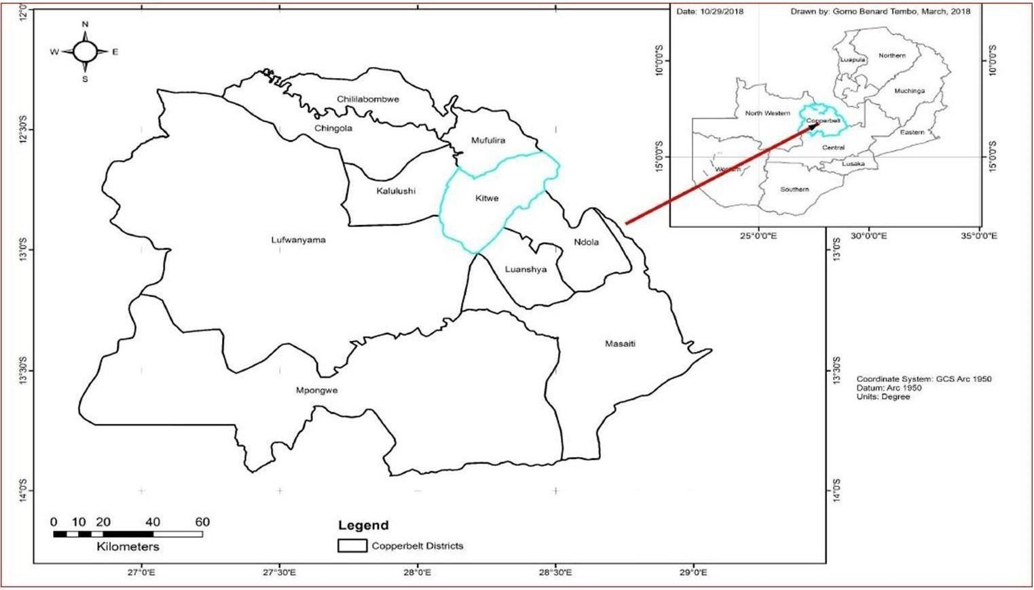

Figure ‑: Regional Locality Map

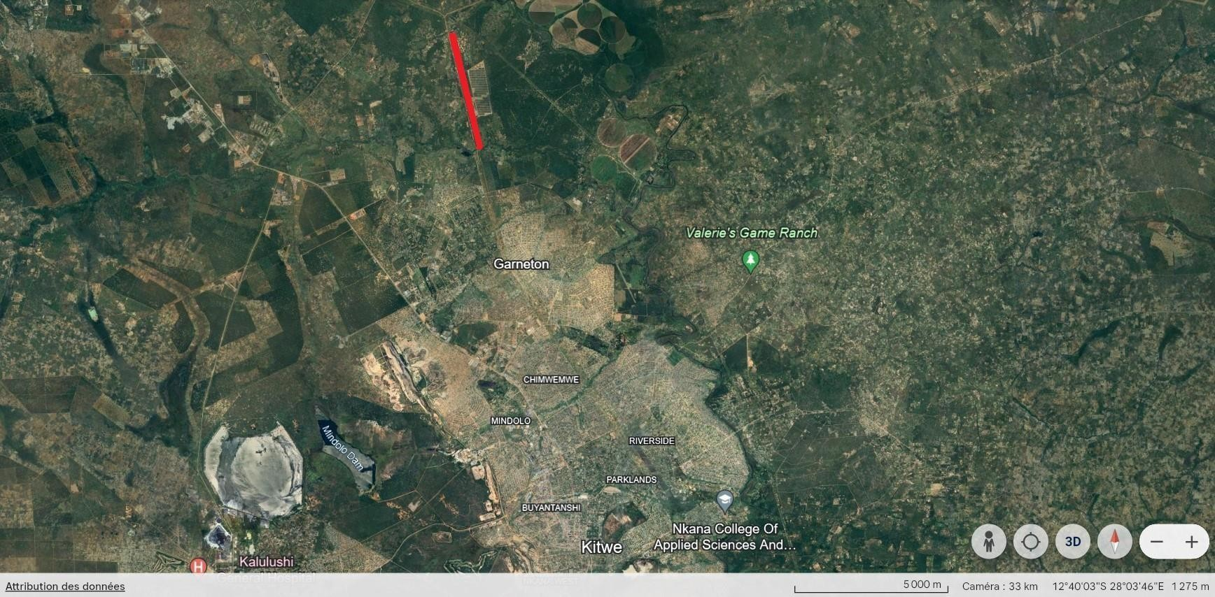

Project Site

CEC Itimpi solar park

Sabina

Figure 3-1- 2: Location of the Garneton North Site In Relation to Kitwe CBD

CEC Itimpi solar park

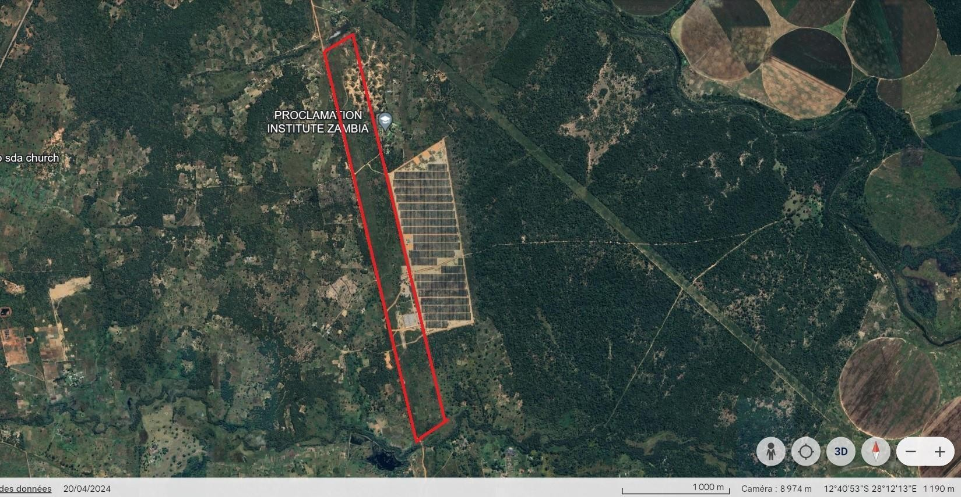

Private farm

Riverane farm

Mwambashi stream

Figure 3-1- 3: Google Satellite Image of the Solar PV Site and Immediate Surrounds

## Nature of the Project

The proposed project entails the construction and operation of a 20 MWac Solar Photovoltaic (PV) Power Plant along with various associated facilities to ensure efficient and reliable energy production. This ambitious venture includes several key components and infrastructure elements that are essential for the successful deployment and operation of the solar power plant. These components include:

* PV Modules: High-efficiency photovoltaic modules will be used to capture and convert solar energy into electricity. These modules are the primary components responsible for the generation of electric power.
* Tracking Mounting Structures: To maximize energy capture, the PV modules will be mounted on tracking structures that follow the sun's movement throughout the day, optimizing the angle of incidence and thus enhancing power generation efficiency.
* Underground DC and AC Cables: These cables will be used to transport the generated electricity from the PV modules to the inverter stations and subsequently to the transmission lines. The underground installation helps protect the cables from environmental factors and physical damage.
* Transmission Lines: Dedicated transmission lines will be constructed to carry the generated electricity to the designated substations and the national grid (Separate environmental Assessment will be done for the transmission line).
* Inverter Stations: These stations will house inverters that convert the direct current (DC) generated by the PV modules into alternating current (AC), which is suitable for transmission and distribution.
* Site Substations: Substations will be established on-site to manage and regulate the electricity flow, ensuring it is at the correct voltage and frequency for safe transmission to the national grid.
* Stores and Office Buildings: Facilities will be constructed to store equipment, spare parts, and other materials needed for the operation and maintenance of the solar power plant. Additionally, office buildings will provide workspace for the administrative and operational staff.
* Internal Access Tracks: Well-constructed access tracks within the site will facilitate the movement of personnel and equipment, ensuring smooth operation and maintenance activities.
* Perimeter Security Fence and Security Rooms: To ensure the safety and security of the plant, a perimeter fence will be erected around the facility. Security rooms will be established at strategic points to house personnel and equipment necessary for surveillance and protection of the site.

Electricity generated by the Garneton North Solar PV Park will be transmitted via a dedicated 8.1 km power line to the ZESCO Mwambashi substation. This substation is strategically located along Kalulushi road about a few hundred meters from the turn-off of the Kalulushi-Chingola roads, enabling effective integration of the generated power into the national grid.

By incorporating these comprehensive infrastructure elements, the project aims to ensure a robust and reliable solar power generation system. The construction and operational phases will be meticulously planned and executed to achieve high efficiency, sustainability, and alignment with the energy needs of the region.

### Raw Materials

**Water Requirement:** During construction, the Project will source its water from boreholes to be drilled on site or purchase water from Nkana Water Supply and Sewerage Company Ltd (NWSSC) that already have a water permit to pump from Mwambashi stream. In this case, PVC pipes will be extended from the water treatment plant located on Mwambashi stream. Approximately 20 m3 per day will be required during construction for drinking, dust suppression, and other construction purposes.

During operations, the main source of water will be the on-site boreholes. Approximately 7.5 m3 per day will be required during the operational phase of the project for the following uses:

* Potable water for drinking;
* Water reserve for firefighting;
* Water for cleaning PV panels, approximately 200 m3 of water will be required for at least 4 times in a year;
* Ablution facilities; and
* Dust suppression.

The PV panels will typically be cleaned using dry brush techniques where possible. Water cleaning will be used under certain situations, where only water cleaning will remove the surface contaminants. It is not expected that the site will be cleaned with water during the rainy season as regular rains reduce the need for panel cleaning.

**Source of Energy:** A diesel propelled electric generator will be used on site by the contractor during the construction phase. An air emission permit will be obtained from ZEMA before commencing using the generator on site.

During operations the project will require power for inverter operation, control room, security systems and welfare facilities. During the period when the project is generating power (i.e. during the sunlight hours), the project will use self-generated power. During the night, the project will draw power from the grid.

Laterite: The terrain of the project site will inform the leveling activities that will be needed to achieve the desired slope at the solar farm. The leveling activities may necessitate the use of borrowed materials such as laterite to stabilize some voids and other soils necessary to facilitate growth of grass within the site, a measure which is necessary to control soil erosion and reduce storm water runoff along the facility. As much as possible these materials will be obtained within the site through the proposed leveling activities. Any deficit which will be identified after detailed topographic surveys are conducted will be sourced from third party suppliers with already existing borrow pits and relevant permits. Establishing new borrow pits will only be resorted to if it will be determined that it is not technically and financially viable to get the materials from existing suppliers. Before a borrow pit is opened up, appropriate environmental and social assessments will be conducted and necessary environmental permits obtained. InnoVent will ensure that the EPC Contractor conducts these studies to the satisfaction of the regulatory authorities and put in place appropriate monitoring measures during operations of the borrow pit and appropriate site decommissioning measures for the borrow pit.

The studies will focus on understanding the species abundance and diversity in the area, assessing critical habitats in the project area, impacts on air quality, soils, noise and community health and safety. Traffic assessments will be conducted to optmise haulage of the materials to mitigate the risk of accidents in the project area. The studies will recommend appropriate mitigation measures and will be submitted to appropriate authorities such as Kitwe City Council and the Zambia Environmental Management Agency for decision.

Aggregates: Various aggregates such as crushed stones and quarry dust will be needed for making concrete structures which will support the solar panel stands and the base for the proposed substation and other requisite facilities that will need to constructed at the site. The EPC contractor will not operate a quarry and crusher for aggregates. The aggregates will be sourced from already existing quarries and crushers. However, the EPC contractor will conductor appropriate due diligence to prequalify existing suppliers of aggregates. Only suppliers with appropriate permits and good record of environmental stewardness will be shortlisted and engaged to supply the needed aggregates.

Steel: Preferably steel is will be procured locally from appropriately licenced suppliers. If the technical and financial considerations will warrant importing steel, the contractor will follow the sound procurement practices which include veting suppliers and ensuring that all importation requirements demanded for by the Zambian laws are followed.

Other materials: Materials such as cement, concrete blocks will be procured locally within Kitwe to encourage local economic development. On products not available in Kitwe will be procured from other surrounding towns. Materials will only be sourced from legally established suppliers with relevant permits.

### Process and Technology Solar PV Park

Solar energy systems produce energy by converting photons “solar radiation” into electrons converting to electricity or heat. The proposed project will use Crystalline PV panels technology to generate electricity with framed solar panels of the dimension of approximately 2m x 1m. The manufacturer of the panels is not yet identified at this stage of the project.

The solar PV technology chosen for this project consists of the following main components:

**PV cell:** The PV cell is the device that generates electricity when exposed to solar radiation. The absorbed solar energy converts the electrons inside the PV cell and produce electrical energy. All PV cells produce Direct Current (DC). There are two main types of Crystalline PV solar cells:

* Monocrystalline – made from a single silicon crystal;
* Polycrystalline ― made from multiple silicon crystals; and

**PV module:** The PV module is the set of interconnected photovoltaic cells encapsulated between a transparent front (usually glass) and a backing support material of either laminate or glass then mounted in an aluminium frame. The modules will appear dark blue or black and will be mounted in an aluminium frame or laminated between durable glass sheets. The modules are designed to absorb the solar radiation and hence are not susceptible to reflection or glinting. Newer modules can also absorb irradiation reflected off the ground via the back of the panel if the back of the panel is glass. This type of module technology is referred as bi-facial modules produced by a number of panel suppliers and can be produced in either monocrystaline or polycrystalline form.

**Mounting structures:** Multiple PV modules are bolted onto a mounting structure that tracks the sun’s progress across the sky usually in an east to west direction. The mounting structures will be steel sections extending between 1 and 3m into the ground depending upon the ground conditions. Approximately 20 to 40 modules will be fitted per frame. There will be approximately 4 to 8 m spacing between each row. The structure supporting the panels can be from 50cm off the ground up to 3 meters off the ground.

**PV array:** The PV array is the complete power generating plant consisting of multiple PV modules wired in series and in parallel. The PV modules will be connected by DC cables directly to the inverters mounted underneath the PV module mounting structures.

**Inverter:** The inverter converts the DC to AC power that is the acceptable power type transmitted by ZESCO Ltd. The inverters AC output will be connected though AC cables to the transformers, which are anticipated to be housed within the transformer stations housing (typically an insulated, steel-framed 20 foot shipping container, or small brick building). The transformers transform the low voltage AC from the inverter to medium voltage. The transformer stations are to be installed in between the panel rows, in a line inside the layout area at the end of each row, located on 4 concrete plots and normally approx. 2.5 x 2.5 x 6 m in dimension.

**Collector Station:** The Collector Station receives all power from the transformer stations via medium voltage underground cables and provides protection and control equipment required to safely manage the plant and to ensure grid code compliance regulations. The station will consist of at least one small building, outdoor electrical plant and equipment and metering. A new 33 kV Collector Station will be constructed alongside the solar arrays.

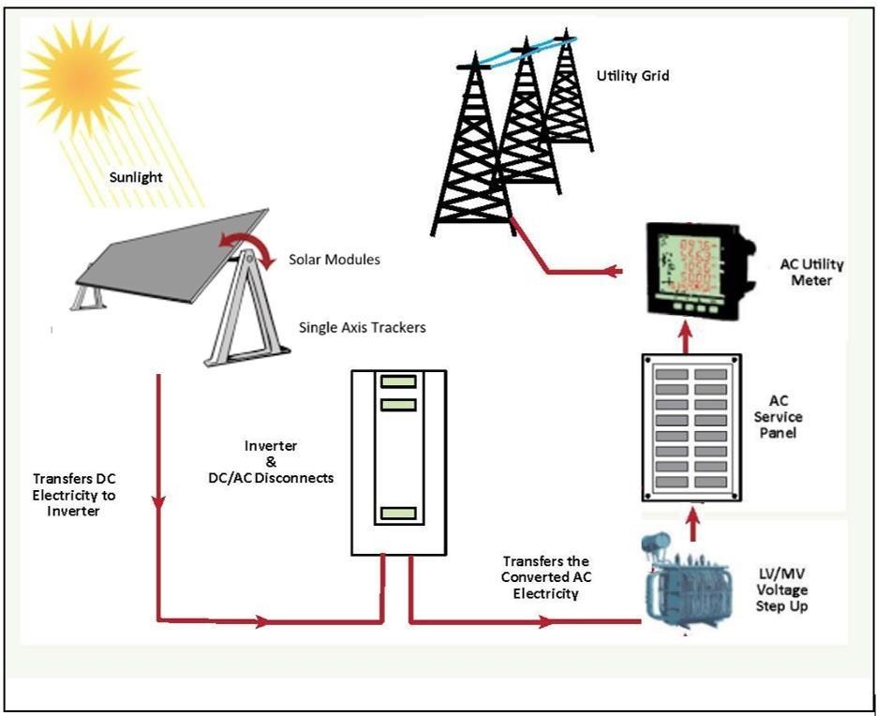

Figure ‑: Typical Installation Layout of a Grid-Connected Solar PV Plant (Source: IFC, 2015)

**Transformer:** The transformer steps up the AC power from the inverters (typically at 33kV) to match the grid voltage in the loop in transmission.

**Security and control building:** A small building containing space for security personnel, welfare facilities and computer control equipment will be located near the substation. It is assumed that all other High Voltage equipment are already installed at the terminal Substation (Mwambashi Substation).

**Access tracks and fencing**: The Project will include stone tracks throughout the site and between panel rows to permit access for maintenance vehicles and personnel. Vegetation (such as grass) may be permitted to grow throughout the site but will be kept low or will be trimmed off on a regular basis if the plant relies of the reflected irradiance to be collected from the underside in the event bi-facial modules are utilised. A security fence and security cameras will surround the site to monitor and prevent possible sabotage. The existing wayleave route is expected to be used as the primary access to the site.

### Products and by-Products

The main product of the proposed project is generation of 20 megawatts alternating current (MWac) of electrical power. This power will be directly fed into the ZESCO national grid, ensuring a steady and reliable supply of electricity to the region. The integration will occur at Mwambashi Substation through the 33 kilovolt (kV) transmission line from the Collector Station at the solar PV site, a critical infrastructure component for the distribution of electricity within Zambia.

The project is designed to be dynamic and adaptive. As it progresses, ongoing data collection and analysis will play a crucial role in refining and enhancing the overall performance and efficiency of the power generation system. This approach ensures that the project remains responsive to emerging trends, technological advancements, and environmental considerations.

### By Products

Non-hazardous and hazardous wastes: There will be waste generated across the lifecycle of the Project. During construction, wastes will comprise of spoil from excavations, general domestic waste including sanitary and food waste, office waste, packaging material (wooden pallets, plastic and cable drums) and concrete. Petrol and diesel will be used during the construction period for vehicles to transport goods and personnel, generators and heavy construction equipment.

Possible waste materials to be generated during the operation phase include waste from maintenance works, broken or cracked PV units, effluent from site control room. Broken panels will be stored in their used crates in the lay down area and will be returned to the manufacturer.

Hazardous materials used on site during operations will include; oils, lubricants, cleaning products, battery materials and specialised gases (for use in switchgear etc.). Minimal waste is expected to be generated during the operations phase. For certain types or transformers or backup generators, oil that needs to be replaced will be recycled, if possible, or safely stored and removed from the site and correctly disposed of. All hazardous wastes will be handled by ZEMA approved and licensed companies to be contracted by the developer. Part of the hazardous wastes will be recycled under the supervision of ZEMA. All solid wastes generated (hazardous and non- hazardous) will be disposed through contracting a ZEMA approved waste handling company.

Waste during decommissioning will be similar to that produced during the construction phase; these include wooden and plastic packaging, cable off cuts, disused solar PV panels, and domestic waste. All solid wastes generated will be disposed of at designated and licensed landfill sites for general, and/or hazardous waste streams.

Wastewater: Wastewater includes any water affected in quality by construction related activities and human influence as well as sewage, water used for washing purposes (e.g. equipment, staff etc.), drainage over potentially contaminated areas (e.g. concrete batching/ mixing areas and equipment storing areas).

Measures will be implemented to manage all wastewater generated during the construction period. Sewage will be stored on site in mobile or underground sanitary storage facilities which will be emptied by a licensed contractor and disposed of at a licensed facility on a regular basis or will be treated through a septic tank reviver (STR).

During operation, the project is not expected to generate significant wastewater which will require serious management. An estimated 200 m3 of water will be required for four times in a year for cleaning / dusting of solar modules. This is not expected to accumulate into significant runoff which may require management.

Vegetative materials: A significant amount of vegetative materials (trees and grass will result from site clearing and leveling activities. These will be stockpiled outside the holding fence and the community will be around to collect it as fire wood. Part of the vegetative materials will be used for making soil conditioners which will then be used for improving soil health during site re- vegetation.

### Production Capacity

The proposed project will have a name plate capacity of 20 MWac where all power generated will be fed directly into the ZESCO national grid at Mwambashi Substation through a 33 kV transmission line from the Solar Plant. The annual production will continue to be revised as more data is collected and site design is optimized.

## Project Area of Influence

The direct area of influence for the solar plant is the 56 hectares piece of land already acquired for the project and land within the 500m radius from the perimeter of the project site and the main access road adjacent to the project site. The project site and the immediate surrounding environment are likely to be affected by physical project impacts such clearing vegetation, excavations, dust and other air emissions such as exhaust fumes abstraction of water resources from the nearby stream. The area of influence for the project may go beyond the project site and the immediate surrounding area if the need to establish borrow pits arise. Adequate assessments and mitigation measures thereof will be implemented should the need for borrow pits or other associated facilities arise. The social impacts are likely to extend to other areas beyond the project area and the immediate surrounding areas. Sand Sales community and other townships within Garneton area will feel the social impact of the project in terms of employment creation, access to social services and community health and safety especially during the construction phase.

Indirect areas of influence will be those areas which other players in the supply chain may have to exploit in order to supply the needed goods and services to the company. The need for aggregates, steel and other construction materials will put pressure on natural resources elsewhere. The PAPs who have been doing agricultural activities within the project area will need land to continue their agricultural activities elsewhere. Figure 3.3.1 shows the project area of influence.

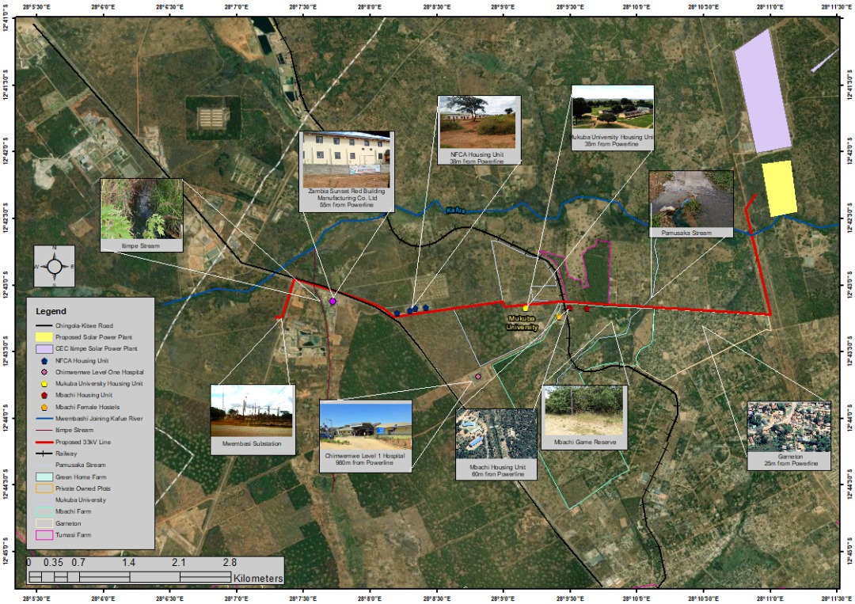

Figure ‑: Project Area of Influence

## Temporary Facilities

There will be temporally facilities that will be constructed during the construction phase, these facilities will help facilitate the construction of the requisite project infrastructure such as installation of the solar panels, and construction of the transmission line. Below are the key temporally and permanent facilities that will be constructed during the construction phase.

* Construction Camp

The construction camp will be constructed within the project area. The preferred location of the construction camp is within the project footprint where biodiversity assessments have already been done. Should the need arise at construction to locate the construction camp outside the footprint of the biodiversity assessments already done, The contractor will assess the area and identify any critical biodiversity which will need to be protected or compensated for. The Kitwe District Forestry Department will be engaged their independent resource assessment and issue a forest permit before any clearing activities can be done.

The construction camp will comprise sleeping quarters, eating area, ablution facilities for both female and males and storage facilties. Water for domestic use will be supplied to the construction camp from the borehole which will be drilled on site. The quality of the water will be periodically assessed to ensure that it is safe for the workers. Where it is determined that the water is not safe for drinking by the workers, the contractor will be procuring portable water from third party suppliers. One such third party being considered is Nkana Water and Sanitation company. Adequate safeguards regarding the quality of the water, legal supply of the water will be included in the water supply agreement which will be made between the supplier and the EPC Contractor.

The EPC Contractor will submit the construction plans for the construction camp to Kitwe City Council for review and decision. The Kitwe City Council will review the plan to ascertain that the proposed features and layout of the facility will not compromise the health and safety of employees.

## Associated Facilities

### Substation

The ZESCO Mwambashi Substation will need to be expanded to accommodate the load that will be coming from the solar farm. The details of the expansion activities and how the new specifications will be made compatible with the old specifications is not yet known. Once this information is available, an initial environmental and social review will be conducted to assess if the new scope will have significant environmental impacts and will significantly alter the current understanding of the environmental and social risks of the project. Should it become necessary to conduct additional studies, these studies will be conducted by competent people and the project environmental and social management plan will be updated to reflect the new environmental and social risks that will be identified and the mitigation measures thereof. If the identified impacts will require development of appropriate procedures, such procedures will be developed and the project Environmental and Social Management System updated accordingly.

### Borrow Pits

Borrow pits will only be developed if the EPC contractor fails to secure raw materials from existing borrow pits. The development of a borrow pit will be preceded by appropriate environmental and social assessments and obtaining relevant permits. The assessments will include developing and environmental and social management plans which will detail properly the potential impacts and the mitigation measures during the development, operations and closure of the borrow pit.

## Schedule and life of Project

Prior to the initiation of onsite activities, a period of development, design, material procurement and component transportation logistics will happen for the project, but will have limited material impact on the site. Once onsite activities are initiated on the Garneton North Project site, the project implementation program will be followed as summarized in table 1-8-1.

The complete preassembly, and installation of the single-axis tracking system, with the mounting of solar PV modules will be done during the Major Installation period above. Cable trenching will be done after the heaviest period of the rain season has ended. All the main construction and installation activities will be complete by November 2024 after which system testing, commissioning and ramping up will commence in conjunction with the GETFiT and Zambian Grid Code requirements. The Commercial Operations Date (COD) will be reached during the month of January 2026 with the full 20 MWac connected and feeding into the ZESCO grid. Thereafter the plant will operate for 25 years under the initial Power Purchase Agreement.

## Main Activities

The project will be carried out in the following phases:

* Development/ planning phase;
* Construction phase;
* Commissioning phase;
* Operational phase; and
* Decommissioning phase.

These phases are described in more detail below.

### Planning Phase

During planning phase, the Developer will assess the key parameters required for the construction and operation of a solar PV power plant. This will include:

* ESIA which investigates the impacts on the surrounding biophysical environment and on the local community;
* Grid code requirements and connections;
* Zambian power requirements and political support;
* Solar resource;
* Geotechnical ground investigations; and
* Topographical investigations

During the planning phase, the project will adapt and evolve to meet the requirements, time schedules and expectations of all the relevant parties.

### Construction Phase

The construction phase will begin with site preparation activities involving clearance of vegetation, treatment against re-growth, installation of fencing and levelling of the site and preliminary earthworks. Thereafter, the site will be marked out, safety and security fencing installed and site access tracks upgraded. Clearance is not anticipated to be site-wide and will depend on the final configuration of the solar modules. The main activities during construction phase will include the following:

* Excavation of cable trenches;
* Ramming or drilling of the mounting structure frames;
* Installation of the modules onto the frames;
* Installation of measuring equipment;
* Laying of cables between the module rows to the inverter stations;
* Construction of inverter station foundations and installation of inverter stations;
* Construction of site substation foundations and installation of site substation plant and equipment;
* Construction of control and security rooms and welfare facilities;
* Testing and commissioning;
* Removal of equipment and demobilization of construction team; and
* Construction of the transmission line.

Where possible; materials, plant and equipment, will be sourced from local suppliers. The bulk of the specialist PV equipment (modules, inverters, protection equipment etc.) will be imported from China, Europe or the USA. The construction phase will take approximately 10 months to complete.

### Commissioning Phase

The commissioning phase will be initiated once construction phase has reached a point where all DC, AC (low voltage) and AC (medium voltage) components are installed and in place. During this phase, components will be brought on line partially and systematically through a ramping up process. This will be done cautiously and over a reasonable period of time with a focus to observe component performance carefully and under minimal loads to ensure optimum equipment and operator safety. During this phase installers and operators will search for faults, hot points and other dangers with specialized equipment. Issues which are identified will then be immediately fixed or replaced. This will take place over several days to ensure all parts of the 20 MWac installation is carefully checked and that when the park is ramped up to full capacity, the entire system is optimized and in safe operation.

In addition to the ramping up of the park, communication and safety equipment testing will take place according to both the project design as well as GETFiT and Zambian Grid Code requirements. These tests will be done in conjunction with ZESCO personnel and requirements.

The successful completion of this commissioning phase will result in Commercial Operation Date (COD). Thereafter the operation phase will commence.

### Operational Phase

The solar PV power plant will be operated on a 24 hour, 7 days a week basis. The operational phase of the project will comprise of the following:

* Regular cleaning of the modules by trained local personnel using a combination of brushes, water and air;
* Vegetation management for under and around the modules to allow maintenance and operation at full capacity;
* Maintenance of all components including modules, mounting structures, trackers, inverters, transformers, substation plant and equipment;
* Site management and maintenance of the welfare facilities;
* Supervision of the electricity production; and
* Site security monitoring.

### Decommissioning Phase

The proposed Project is expected to operate for at least 25 years. Once the plant reaches the end of its life, PV modules may continue to operate as their expected life time is 30 years; they may alternatively be refurbished or replaced to continue operations. The facility may be closed and decommissioned. If decommissioned, all components will be removed and the site rehabilitated. Where possible all materials will be recycled, otherwise they will be disposed of in accordance with local regulations and international best practice.

# PROJECT ALTERNATIVES

Project alternatives are assessed to ensure that aspects are taken into account during the design of extended projects. International best practices, best available technology not entailing excessive costs (BATNEEC), socio-economic impacts and environmental impacts can all affect the approval or rejection of new developments.

## Mitigation Hierarchy

A key aspect of considering alternatives is the mitigation hierarchy. Implementing the mitigation hierarchy is crucial when considering alternative sites and alternative site layouts. The mitigation hierarchy is defined as:

* Avoidance: measures taken to avoid creating impacts from the outset, such as careful spatial or temporal placement of elements of infrastructure, in order to completely avoid impacts on certain components of biodiversity.
* Minimization: measures taken to reduce the duration, intensity and / or extent of impacts (including direct, indirect and cumulative impacts, as appropriate) that cannot be completely avoided, as far as is practically feasible.
* Rehabilitation/restoration: measures taken to rehabilitate degraded ecosystems or restore cleared ecosystems following exposure to impacts that cannot be completely avoided and/ or minimized.
* Offset: measures taken to compensate for any residual significant, adverse impacts that cannot be avoided, minimized and / or rehabilitated or restored, in order to achieve no net loss or a net gain of biodiversity. Offsets can take the form of positive management interventions such as restoration of degraded habitat, arrested degradation or averted risk, protecting areas where there is imminent or projected loss of biodiversity.

The mitigation hierarchy was applied to the project as summarised in the table below.

Table ‑: Summary of Mitigation Hierarchy

|  |  |
| --- | --- |
| **Mitigation hierarchy** | **Action** |
| **Avoidance:** | **Site alternatives:** The initial search for appropriate land parcels for the development of a solar PV plant included environmental and social criteria such as biodiversity of the site, other sensitive features such a rivers or wetlands, land ownership and land use. During site selection, the Developer avoided sites with high biodiversity, sensitive features and community land ownership that supported livelihoods of local communities, despite being located along the wayleave radius. The proposed Project site is located on private title held by the Developer, which has been under continuous season shifting cultivation and hence does not  support any Critical Habitat as defined by the IFC Performance Standards. |
| **Minimisation:** | Site layout alternatives**:** Once the preferred site was selected more detailed surveys were undertaken to confirm the use of the land for livelihoods by adjacent communities and to confirm the  status of the habitats on site. The site was found to comprise mostly what can be characterised as ‘disturbed’ Natural Habitat |

|  |  |
| --- | --- |
|  | that exhibits some degree of modification through seasonal shifting cultivation practices, charcoal burning, sand and aggregate mining (sand pits), wood harvesting and some bush clearance for transmission line wayleave and tracks. No threatened or restricted range species were identified. The western perimeter of the site (Sand Sales) shows more extensive evidence of disturbance as a result of sand mining, while the rest of the site has either been under season agriculture or subjected to rampant charcoal burning. The only portion of the site which may be considered to be in its natural state is the plain along the  Mwambashi stream which will be retained according to the project layout. |
| **Rehabilitation/restoration**: | While the footprint of the solar PV plant (estimated at 60 % of the site) will result in the total clearance of all vegetation, some areas affected by construction activities will be rehabilitated. Some portions of the site especially along the Mwambashi  stream will be retained and allow for regeneration of the natural vegetation. |
| **Off-set:** | No biodiversity off-set is required as the project will have no significant adverse impact on biodiversity. |

## Identification of Alternatives

During the planning phase of the Project a number of alternatives were considered. Alternatives considered include the following:

* Site alternatives;
* Technology alternatives;
* Site layout alternatives;
* No-Go alternative.

Throughout the assessment of these alternatives the following criteria were used:

* Environmental including biodiversity, fauna and flora, and habitat;
* Social and community including land ownership, land use and proximity to communities;
* Financial – including life cycle costs balanced against initial capital expenditure and operational costs; and
* Technical – considering whether the options are viable if they can be efficiently implemented, maintained and operated.

## Analysis of Alternatives

### Site alternatives

The Developer focused on identifying sites that are suitable for solar PV development, but also meeting the criteria for providing electricity to the ZESCO grid and develop solar plant on already secured land. In total, three alternative sites were considered at project planning phase, these include;

1. **Kitwe Substation-Garneton Wayleave:** This was not selected because there was no point where to connect to the ZESCO powerline or substation.
2. **CEC Wayleave-Turf Substation:** CEC owns a wayleave from Turf substation to Garneton. However, the land is heavily encroached with both physical structures and agricultural fields.
3. **Garneton North CEC Servitude (preferred site):** CEC owns land of about 56 ha, along the wayleave between Chimwemwe and Sabina Mufulira Road.

The Developer identified this site as potential site for solar PV development due to its gentle slopes, proximity to grid infrastructures and suitable solar radiation regime. The site is part of the existing wayleave area and on private title held by the CEC. As such, the site is free from any permanent physical structures, except for seasonal agricultural fields and access routes (dirty tracks) which might not result into meaningful economic displacements or losses.

The proposed site is located near the national grid and ZESCO Substation making it possible for power evacuation at the lowest cost. Because solar PV projects have a large footprint for the solar panels, it is important to avoid utilizing land that could be better used for other purposes such as agricultural or real estate development. The proposed project site is mostly characterized by surface rock outcrops with laterite or soil restriction layer close to the surface (<50 cm) as confirmed by the soil and land use survey (see Soil Survey report in Appendix 5) and hence marginally suitable for agricultural use. In addition, the proposed Project site does not represent or host environmentally sensitive receptors such as wetlands or important vegetation as confirmed during field investigative surveys.

The Project site comprises of primarily modified habitat, unlikely to have threatened or restricted range plant or animal species and has acceptable geotechnical conditions. All other technical factors such as solar irradiation, proximity to a sub-station, grid capacity, size and gradient of the site and proximity to other infrastructure were considered preferable for this site.

### Technology alternatives

The GETFiT program is soliciting power from two technology types, small hydro and solar PV. In the first round only, solar PV will be allowed to participate in the reverse auction. As such no other technologies other than solar PV were considered for power generation. There are two common technologies of solar known today namely; Solar Photovoltaic (PV) and Concentrating Solar Power (CSP). The technology that will be employed for the proposed project is Solar Photovoltaic (PV) technology.

PV technology is relatively mature and has already achieved a considerable level of market share. However, their output is not very stable in continuously changing weather and depends on the sun spectrum.

Traditional photovoltaic modules use semiconductors to generate electrical power by converting solar radiation into electricity. PV modules come in many forms, including crystalline silicon modules and thin-film modules based upon amorphous silicon, cadmium telluride and copper indium gallium selenide.

There are two alternative types of mounting systems that can be used for solar PV arrays, these are described below.

### Modules Orientation

#### Fixed Mounted PV System

In a fixed mounted PV system, PV panels are installed at a fixed pre-determined angle during the lifetime of the plant’s operation. Misalignment of the angle of PV panels has been shown to marginally affect the efficiency of energy collection. There are further advantages of fixed mounted systems, including:

* The maintenance and installation costs of a fixed mounted PV system are lower than a ‘tracking’ system, which is mechanically more complex given that these PV mountings include moving parts.
* Fixed mounted PV systems are an established technology with a proven track record in terms of reliable functioning. In addition, replacement parts are able to be sourced more economically and with greater ease than with alternative systems.
* Fixed mounted systems are robustly designed and able to withstand greater exposure to winds than tracking systems.

#### Tracking System

There are various tracking systems. In a dual axis tracking system solar PV panels are fixed to mountings tracking the sun’s movement on two axes. A ‘single axis tracker’ will track the sun from east to west, while a dual axis tracker will in addition be equipped to account for the seasonal waning of the sun. These systems utilise moving parts and technology including solar irradiation sensors to optimise the exposure of PV panels to sunlight. A single axis tracker is considered to increase a solar park’s energy output by approximately 10-30% depending on location.

#### Preferred technology

Having assessed the available technology alternatives, the preferred alternative is the use of solar PV with modules mounted upon a single axis tracking system following the sun’s path during the day in an east-west direction.

## Site Layout alternatives

During site investigative studies, the Crownbit focused on identifying the various environmental and social constraints on the site. This was done by way of specialized surveys including; hydrology and hydrogeology, soils and land use, socio-economic, heritage impact assessment and biodiversity studies. Any sensitive features encountered during field studies were mapped and communicated to the Project Management team to be included in the final design of the layout of the solar PV plant. Some of the sensitive features identified on the site included; streamline areas, access bush roads and surface water bodies. The project will as much as possible avoid interfering with the streamline vegetation to minimize impacts on the natural habitats, while common users of access routes that traverses the site have been engaged for possible formulation of common access route(s).

## No-Project alternative

The Renewable Energy Feed-in Tariff (REFiT) Strategy is a government power sector initiative to accelerate private investments in small- and medium sized renewable energy projects of up to 20 MW. This is aimed at increasing access to clean energy services to supplement other government’s power generation investment programs contained in the Power Systems Development Master Plan and other plans. The Strategy is a guide to Government’s intention of developing the Renewable

Energy subsector to supplement the large hydro energy sources which have been negatively affected by changes in the climatic trends (uneven rainfall and declining water levels), and patterns in the recent past.

GETFiT Zambia is a program jointly developed and implemented by the Ministry of Energy of the Government of the Republic of Zambia and KfW Development Bank. GETFiT Zambia is designed to assist the Zambian Government in the implementation of its REFiT Strategy. In line with this strategy, GETFiT Zambia aims to procure 120 megawatts (MW) of solar PV energy projects within the next three years. GETFiT supports small- to medium-scale Independent Power Producer (IPP) projects up to 20 MW, in line with the REFiT Strategy.

While none of the negative impacts of the project would be realized with the No-project alternative, none of the possible socio-economic benefits, which potentially outweigh the negative impacts, will be realized either. Apart from this, the “No-project” alternative would mean that the vision for the Zambian REFiT Strategy would not be able to be realized. In view of the above the “No- project” alternative is not recommended.

# DESCRIPTION OF THE BASELINE ENVIRONMENT

## Climate

Kitwe is favoured with climate typical to the Copperbelt region of the Zambian plateau, which at an altitude of around 1200m, is a modified tropical with three distinct seasons. The climate consists of cool dry season from April to July, hot dry season from August to October and a warm wet season November to the end of March. Average minimum temperatures range from 11oC in July to 19oC in October; average maximum temperatures range between 24oC in July to 32oC in October. The wettest months are December, January and February which experience intense thunderstorms. The mean annual rainfall in Kitwe is in the region of 1154 mm. Calculated storm events for data collected at Kafironda Meteorological station show the 50 year Maximum 24-hour Precipitation as 136 mm and the 100-year Maximum Precipitation over a 24-hour period is calculated as 150 mm.

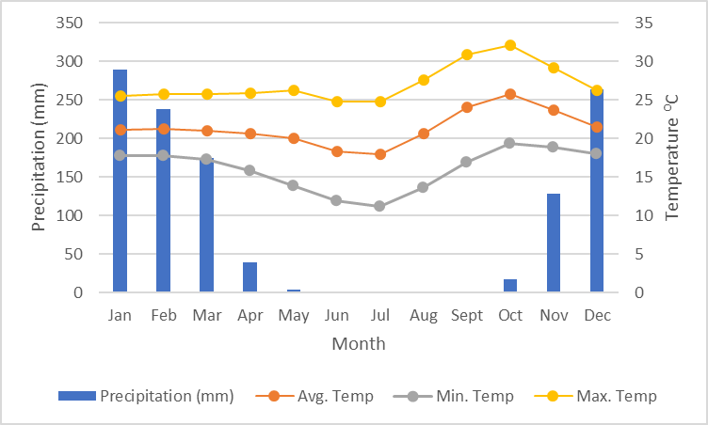

Table ‑: Annual rainfall and temperature in the project area (source: climate-data.org)

Rainfall is mainly influenced by the Inter Tropical Convergence Zone (ITCZ), which brings moist winds from the Atlantic Ocean (North-West), and North-East and South-East trade winds from the Indian Ocean. Therefore, wind direction changes during the rainy season depending on the position of the ITCZ and is mainly northerly ranging from north-west to east. During the dry season, winds are mostly Easterlies, ranging from north-east to south-east. The project area has a unimodal rainfall pattern. Rainfall is received from October to May of the following year. January is the wettest month with 20 rainy days while May records the lowest number of rainy days, 6. The mean sunshine duration varies from 7.2 hours per day in March and February to 10.9 hours per day in October. The mean RH varies from 32% in September to about 84% in January.

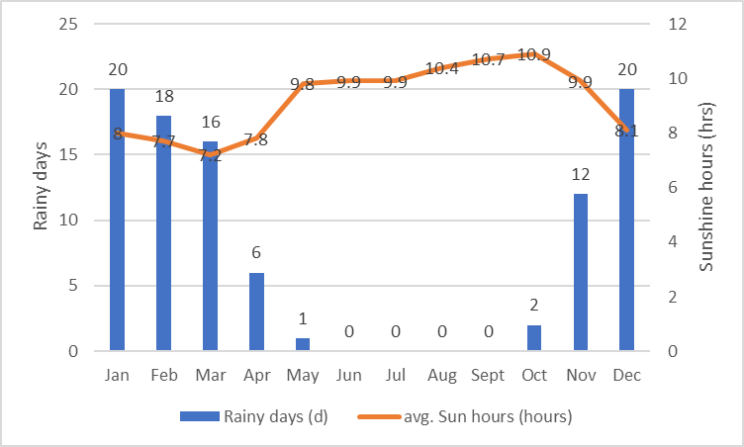

Figure ‑: Average number of rainy days and sunshine hours in the project area

Wind speeds are generally low at between 1.5-3.3 m/s (5.4-11.9 km/hr) 41.4% of the time and calm (i.e. below 1 m/s or 3.6 km/hr) for 30% of the time. Winds can go up to 16 knots (29 km/hr) during the rainy season and gusting is experienced during storms with wind speeds of up to 21 knots (39 km/hr) at a time. Wind speed generally increase from July to October, are steady during the rainy season except for gusts due to the nature of rain clouds and decrease from April to June.

## Air Quality

The quality of ambient air in the project area can be described as generally good, although certain amount of vehicle and machinery exhaust pollution emanates from Wusakile Mine and vehicular traffic. Other sources of air pollution include the burning of fuel (wood and charcoal) in surrounding bushes and townships and the burning of fuel wood during brick making process, especially during the dry season. Increases in fugitive dust levels, particularly under hot and dry conditions, also periodically results in the deterioration of air quality.

Air quality on the Project site was monitored during field investigative surveys, the various parameters recorded included particulate matter (PM2.5 and PM10) as well as the Air Quality Index (AQI). Fine and coarse particulate matter, or dust, is the main pollutant of concern from construction activities of the proposed project. However, possible dust emissions during site preparation phase will be suppressed by regular watering. The main environmental problem with dust is that coarse particles settle on surrounding properties, plants and land, which is often more of a nuisance problem than a health issue. Fine dust particles may block stomata on plant leaves and interferes with transpiration and photosynthetic processes. Fine dust particles may also be a risk to human health. The air quality on and around the project site is generally classified as good and safe. The table below presents the results of air quality parameters monitored during field investigative surveys.

Table ‑: Air Quality Data

|  |  |  |  |  |  |  |  |
| --- | --- | --- | --- | --- | --- | --- | --- |
| **GPS**  **Coordinates of the Location** | **PM2.5**  **(µg/m3)** | **PM10**  **(µg/m3)** | **SO2** | **CO** | **NOx** | **NO** | **Remarks on Air Quality** |
| S12o41’54.6’’  E28o11’09.8’’ | 42 | 68 | Not detected | 13 | 14 | 12 | Good |
| S12o41’54.6’’  E28o11’09.8’’ | 40 | 65 | Not detected | 10 | 16 | 10 | Good |
| S12o41’54.6’’  E28o11’09.8’’ | 45 | 70 | Not detected | 12 | 17 | 14 | Good |

## Geology

The geology of Kitwe district and the Project site is composed mainly of recent rock formations such as the Katanga system, Kundelungu and Muva quartzite. Basement Supergroup rock types of schist occupy the central part of the district. Muva Supergroup rocks of quartzite and sericite schist occur in the north and south-western part of the district. The Katanga Supergroup, the host of the Lower Roan Sub-group which contains copper and cobalt mineralisation occur in the western part, and has the major development of the city on its eastern part (Kitwe City Council, 2010). During the baseline data collection, the main geological features noted comprised of the ‘Undifferentiated Sandstones, especially weakly cemented sandstones of quartz type. There also mineral rich ironstones and Calcareous beds, limestone, which have given rise to reddish clay soils; the geology greatly influences the resultant soil types and properties. The main geological features are summarised as below.

Table ‑: Major Geological Formations of The Land

|  |  |
| --- | --- |
| **Map Unit** | **Main geological features** |
| WQS | White quartzitic gravels and stone spread on the surface over a large area |
| ERO | Extensive rock outcrops extended over one meter above ground |
| LGSS | latelitic gravels in the subsoil from 20cm below the surface |
| IQ | Iron and quartzitic rock parent material |

## Hydrology

The Project area lies in the Kafue River basin. The Project Site is bordered by Mwambashi stream to the east and Sand sales Dambo to the west. The Mwambashi stream and the stream formed from the sand sales lake runs in the northerly direction where they join the Kafue River found about 4 km east of the Project site. The sand sales dam has resulted in the formation of a wider Dambo around the area.

Major sources of water pollution on and around the Project site include illegal dumping of domestic wastes, small-scale agricultural activities and domestic uses such as personal hygiene and drinking. Water samples were collected from existing surface water bodies, while samples for ground water were obtained from boreholes in surrounding private properties to evaluate the baseline surface and ground water quality. The aim was to establish baseline information on the quality of water in the project area prior to project implementation.

Sampling was carried out in accordance with WHO accepted procedure for collection of surface and ground water quality samples. A complete set of chemical, biological and physical analyses were performed on the water samples and sent to a laboratory at the University of Zambia in Lusaka (see full water test results in Appendix 4). The results showed that most of the parameters analysed were within the ZABS limits for drinking water (ZS 190:2010) except for iron, faecal coliforms and total coliforms in some samples.

## Hydrogeology

The primary contributor to the availability and presence of groundwater resources is the rainfall. Nonetheless, the lithology of the geological material as well as its hydraulics (porosity, permeability and hydraulic conductivity) is equally important in guaranteeing constant recharge to the groundwater and consequent availability. The rainfall regime has remained reasonably uniform over a long period in the study area and provides sufficient recharge potential for the aquifers although seasonal groundwater level fluctuations may occur as the result of the spatial variability of the rainfall.

The groundwater in the area is mostly used for domestic purposes. Small-holder farmers in the project area predominantly rely on rain-fed agriculture. Importantly, groundwater is critical for recharging the main drainage systems (Mwambashi stream and the Kafue River) and other surrounding streams. Thus, there is active interaction between groundwater and surface water sources in the area.

Generally, groundwater levels go down between June and November (the dry season) and rise between December and April during the rainy season. The rise in groundwater levels between December and April is as a result of increased base flow – groundwater supplying surface water bodies and consequently, during the period of between June and November, when the groundwater levels recede water levels in these surface water bodies declines (Ministry of Energy and Water Development, 1995).

Variations in geological structures, geomorphology and rock types contribute to the various groundwater conditions within the project area. The primary aquifers are the karstic highly fractured carbonates and the alluvial aquifers. Groundwater also occurs within the secondary features within Kundelungu metasediments, the mine series, the breccias and some areas of the igneous rocks. The Project Site falls under the Kafue catchment which is the largest catchment in the project area and covers much of the Copperbelt Province.

## Topography and Landscape

As this area is a narrow strip below the same land use (power line) they have the same geological formation and the general configuration of the land is same throughout. Topography is influenced by the streams in the north and south of area K, JI and J2 and the power line. The area is mainly gently sloping with steep land being located in the northern and southern tips of the area towards the two streams in the respective directions. Three levels of topography can be distinguished in the area as indicated in the mapping units. The geology of the area is closely related to the soil types occurring in the area. The more resistant quartzitic rock types have given rise to shallow and stoney soils while the iron and manganese parent material is found in clayey, slightly deep soils. The main topographical features are summarized as below.

|  |  |
| --- | --- |
| **Map Unit** | **Topography** |
| 1 | Very slopy land especially towards the stream greater than 10 % |
| 3 | Gently sloping land 0 - 5 % slope |
| 2 | Slopy land 5 - 10% |

During the baseline data collection, the main geological features noted comprised of the ‘Undifferentiated Sandstones, especially weakly cemented sandstones of quartz type. There also mineral rich ironstones and Calcareous beds, limestone, which have given rise to reddish clay soils; the geology greatly influences the resultant soil types and properties.

## Soils

The area is composed of one type of soil in terms of classification. According to the generalized soil map of Zambia (1990) by the Zambia Agricultural research institute, the area is comprised of well drained deep to very deep yellowish red to strong brown, friable, fine loamy to clayey soils having a clear clay increase with depth (chromihaplic) with inclusions (20%) of moderately well drained to, imperfectly drained deep to moderately shallow, gravelly clayey soils ACRISOLS: with gleyl-haplic Acrisols, partly skeletic phaseq; dystric LEPTOSOLS.

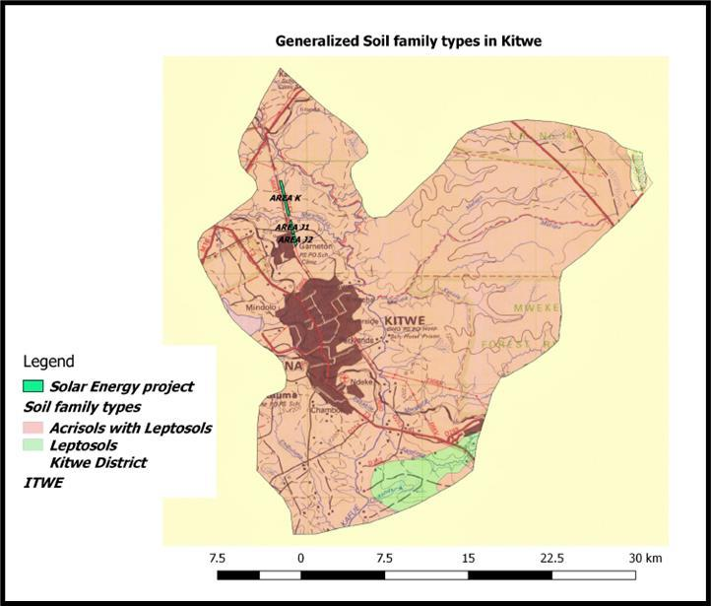Figure ‑: Generalized Soil family types in the project area

Four main soil subgroups were identified on the project site and are mainly differentiated based on the location, topographical and hydrological factors.

Table ‑: Generalized Soil family types in the project area

|  |  |
| --- | --- |
| **Map**  **Unit** | **Brief description of soils** |
| U1 | Shallow stoney soils with stones or gravels on the surface and within the profile |
| U2 | Deep, sandy clay soils: In areas with dense vegetation, there has an accumulation of  organic matter in the top soils. |
| U3 | Moderately deep soils with gravels below the surface in most cases from as high as 20cm  to 100cm. They are marginally suitable to any meaningful agricultural alternative |
| U4 | Imperfectly drained, deep, dark grayish brown sand soils with compacted gravelly sub  soils at 100cm; These soils are structureless, on the surface and are located near dambo or plain areas where they have silty material deposited by water. Some places had compacted sub soils mainly due to accumulation of clay minerals. They are water logged in the rainy season when the soils become saturated with water and thus support grassland regrowth |

**Textures:** mainly sand clay loam textures in the top soil were common on the site in a few places sandy loam textures were noted mainly due to the movement of sandy top soils to the eastern parts where active sheet deposition of Colluvial material was observed. The sub soils have higher clay with common sandy clay textures from 15 to 20 centimeters, the clay increases with depth.

**Soil Structure***:* the top soil is weakly structured and loose, the sub soil is usually sub angular in structure and easily breaks into finer crumbs, physical sorting of particles and movement of loose top soil has led to compacting of the top soil in some areas within the site. Natural hard pans have formed in these areas.

**Soil Consistence***:* these soils on the top are loose and weak when dry becoming strong to hard in the sub soil under very dry conditions, but they are fragile when moist and easy to work, an increase in the moisture conditions to wet status the soils are very sticky and makes workability and movement difficult.

**Biological activity, permeability and porosity***:* A very high porosity was observed in the top 50 cm of these soils, termite and other insect activity had contributed also to the porosity with abundant macro pores, The soils are highly permeable in the top 30cm and moderately permeable in the deeper layer forming a reservoir of moisture.

**Effective soil growing depth***:* Most of the area is shallow to deep (60 cm in depth), these present marginal to low potential for cropping if the area were to be considered for production.

## Land use

Over the last 4 years, the land surrounding the project site has experienced a number of commercial and residential establishments. Notable among these include the newly commissioned CEC Itimpi solar park which is found on eastern border of the project site and some residential homes on the private land found on the western side. . Following the successful compensation and displacement of local people who had been practicing seasonal agriculture on land comprising the project site, the Developer intensified awareness and patrols to stop any new encroachments. Therefore, there

is no other form of land use on the project site except for a secondary regenerating savanna vegetation. The surrounding areas show greater diversity of land-uses.

## Land Tenure

Land tenure in Zambia is governed by State and Customary ownership. The project area is under state land tenure system and under the ownership of CEC as part of the wayleave for the existing 220 kV power lines. No other individual or organization claims to have proof of ownership for the Project Site and the locals who have been practicing season agricultural activities on the site acknowledged that they were aware that the land comprising the Project Site belonged to the CEC.

## Noise and Vibrations

The Project Site is located in Garneton area in the outcast of Kitwe urban, with no major sources of noise. However, common sources of noise around the project site includes vehicular traffic moving along the wayleave service road which provide access to a few owners of private farms and forms the eastern boundary of the Site. Moderate noise levels are generated by tipper trucks transporting laterite and building sand which is sourced from areas surrounding the project site. Noise levels on site are in the range of 34 - 48 dB(A).

The table below gives the noise levels recorded on site during site investigative surveys;

Table ‑: Prevailing Noise Levels on the Project Site

|  |  |  |
| --- | --- | --- |
| **GPS Coordinates of**  **the Location** | **Noise level reading** | |
| **Minimum dB(A)** | **Maximum dB(A)** |
| 35L 0627818  UTM 8598018 | 34 | 48 |
| 35L 0627871  UTM 8597590 | 34 | 42 |
| 35L 0628106  UTM 8596599 | 34 | 47 |
| 35L 0628226  UTM 8595821 | 34 | 44 |
| 35L 0628296  UTM 8595005 | 34 | 48 |

## Ecological Resources

The ecology of the Project site is described below and is based on the literature review and field surveys conducted by a team comprising a biodiversity specialist and a natural resource specialist. At most, site investigative studies involved thorough walks through the entire site along the area earmarked for the solar plant and the power transmission line. All this was done to record dominant trees, shrubs and herbaceous vegetation, including their size (diameter at breast height), and evidence of fauna.

### Indigenous Vegetation and Habitats

High level mapping of broad habitat structure classes based on density of vegetation using 2020 remote sensing imagery (Table 5-7-1. and Figure 5-7-1) shows that there are four (4) types of habitats or vegetation cover within the project site; Secondary Miombo woodland, shrub land, grassland and fallow fields denoted as crop in figure 5-7-1.

Table ‑: Habitat/Vegetation Coverage within the Site

|  |  |  |  |
| --- | --- | --- | --- |
| **No** | **Habitat/vegetation type** | **Area (km2)** | **% Coverage** |
| 1 | Secondary Miombo woodland | 0.192 | 34.29 |
| 2 | Shrubs | 0.16 | 28.57 |
| 3 | Grassland | 0.112 | 20.00 |
| 4 | Fallow fields | 0.096 | 17.14 |
| **Total** | | **0.56** | **100.00** |

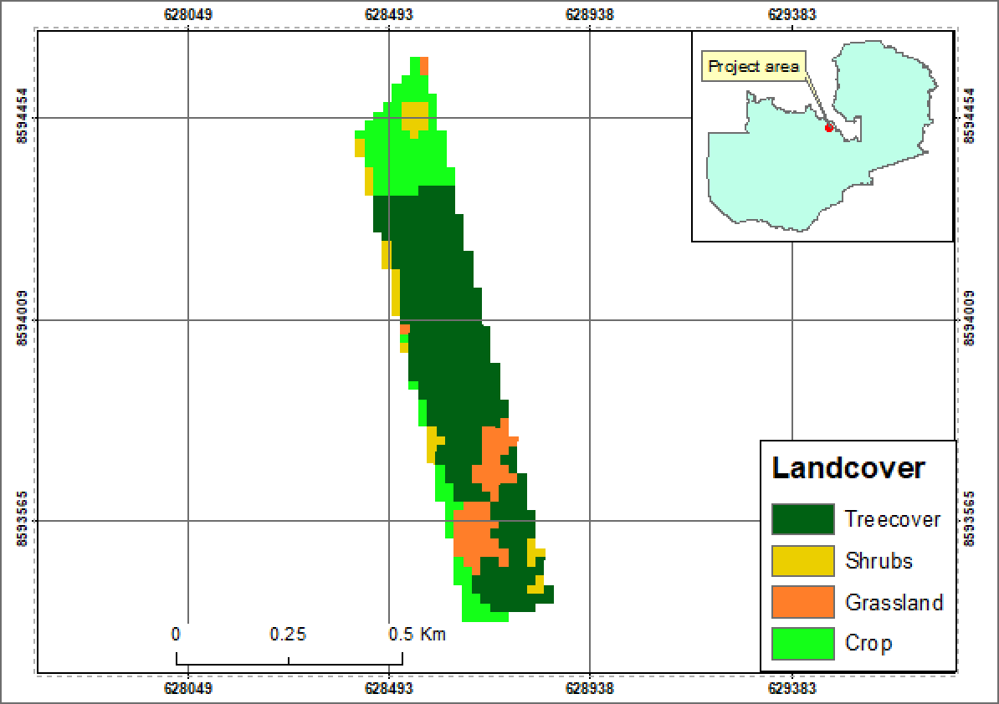

Figure ‑: Land Cover Map for the Proposed Project Site

### Fallow Fields

The least dominant land cover on the GaN project site is fallow crop fields covering about 17% of the total area representing 0.096 km2 of the total area. Most of the fallow fields are concentrated on the southern part of the site near Mwambashi stream. These fallow fields were opened by the illegal encroachers who have since been displaced after receiving full compensations for all assumed losses.

### Shrubland

The second dominant land cover is shrubland covering about 28% representing 0.16km² of the area. During field visit, it was observed that most of the shrubs were tree regenerates which looked like shrubs. Most of these trees stood at 4m with average diameter of less than 10cm. In most areas the trees grew without any distinctive strata and in some areas there was a uniform pure stand of trees growing close to each other. The dominant trees within this land cover were; *Brachystegia boehmii, Brachystegia floribunda* and *Marquesia macroura*. Other notable species observed include; *Julbernardia paniculata*, *Anisophyllus boehmii, Parinari curatellifolia, Isoberlinia angolensis, Dichrostachys cinerea, Uapaca kirkiana,* [*Phyllostachys bambusoides*](https://en.wikipedia.org/wiki/Phyllostachys_bambusoides)(bamboo), *Bauhinia petersiana* and *Diplorhynchus condylocarpon*. This land cover was also characterised by an [evergreen](https://en.wikipedia.org/wiki/Evergreen) perennial flowering plants in the [subfamily](https://en.wikipedia.org/wiki/Subfamily_(biology)) [*Bambusoideae*](https://en.wikipedia.org/wiki/Bambusoideae)of the [grass](https://en.wikipedia.org/wiki/Grass) family [*Poaceae*](https://en.wikipedia.org/wiki/Poaceae)(Bamboo). These were seen growing in colonies especially in areas which were a bit hilly than flat. The figures below show some of the trees characterizing this land cover.

The ground cover was characterised with discontinuous and continuous patches of grass species with different types of grass species that include *hyperhenia spp, missanthiunia spp, themedia triandria, setaria spp* and *lodentia simplex* the latter being the dominant. In some places small plant and herbs were observed saplings and patchy layers of forbs and suffrutices. Mostly the ground cover was thick and denser since the assessment was done in rain season.

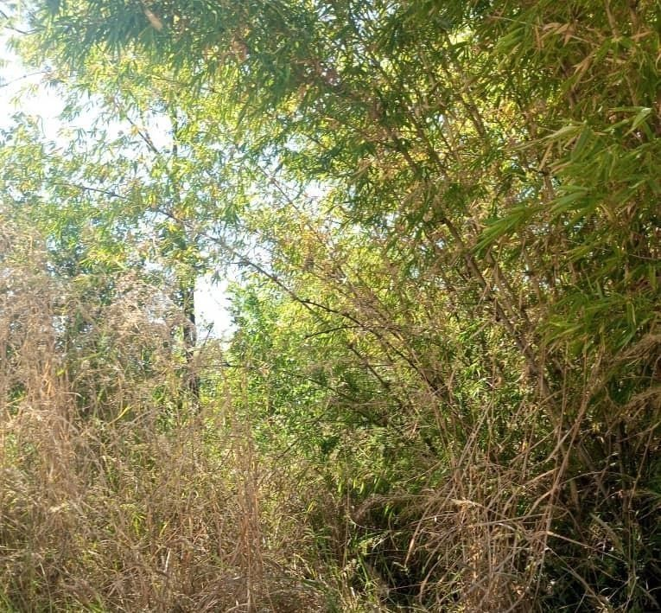

Figure ‑: Some Bamboo Species Characterising the Shrubland

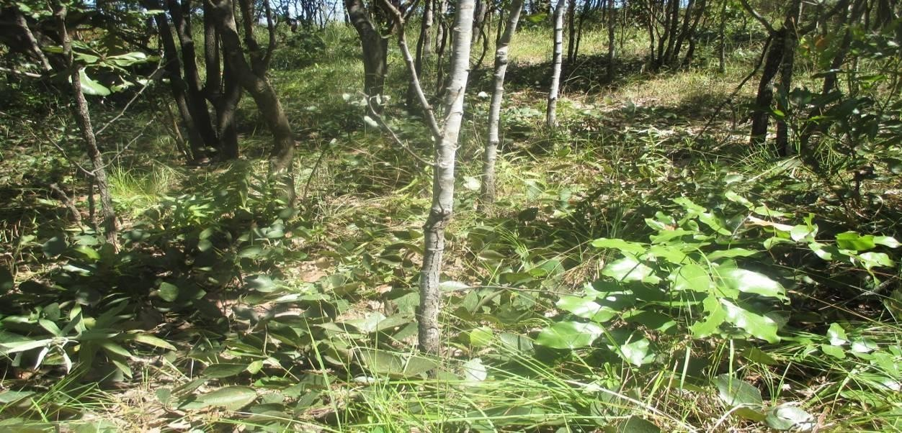

Figure ‑: Ground Covered by Small Tree Regrowth and Grass Species within the

### Grassland

The third dominant land cover is grassland; though some tree regrowths such as *Diplorhynchus condylocarpon and Anisophyllus sp,* were observed within this land cover they were insignificant and occupies less land. Grassland covers about 20% representing 0.11km² of the total area of the proposed site. This type of land cover mostly occupied old cleared land near the powerlines. It was observed on relatively flat but lower altitude land. The dominant grass species was *Hyperrhenia rufa* which covers most of this land cover. Other notable grass species include; *Dactylocterium aegyptiun*,*Cynodon dactylon, Digitaria termata, Eleusine indica, Setaria sp. Eragrostis sp, and Bidens Schmperi.*

### Secondary Miombo

The least dominant land cover is secondary Miombo vegetation; this covers 17% representing 0.10km² of the total proposed project area. These are secondary tree species but looked more natural due to fewer disturbances. These concentrated on the middle of the proposed site and were denser in distribution forming a continuous canopy cover. Most of the trees were 4-5m in height and less than 15cm in diameter. The common trees observed were; *Brachystegia boehmii, Brachystegia floribunda* and *Marquesia macroura.* Other notable species observed include; *Erythrophleum africana, Julbernardia paniculata, Anisophyllus boehmii, Parinari curatellifolia, Isoberlinia angolensis, Dichrostachys cinerea, Uapaca kirkiana, Bauhinia petersiana and Diplorhynchus condylocarpon.*

The ground is covered by a continuous patch of both grass and plant species due to the time the study was conducted in rain season. The dominant grass species occupying the ground were species of *Cyperus* and *Cynodon* while the plant species included the *Tridax sp*. *Vermonia* and *Bidens sp.* The figure below shows some the tree and ground cover of the site.

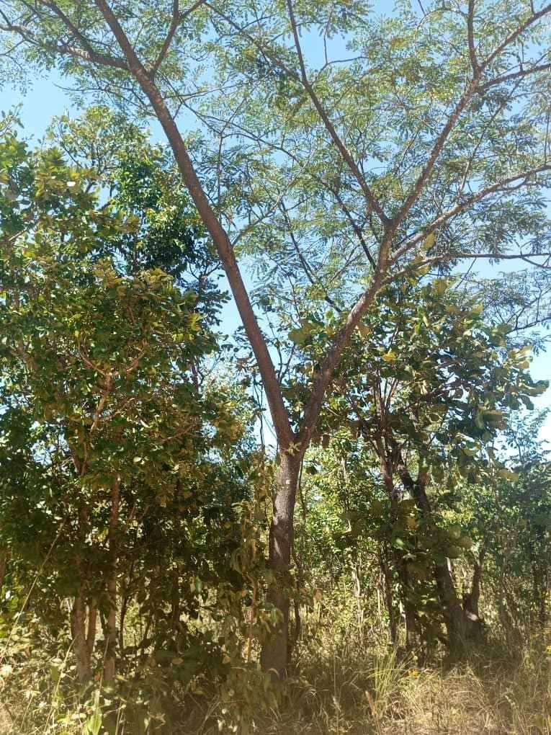

Figure ‑: Showing Secondary Miombo Woodland within the Proposed Project Site

## Terrestrial Fauna

### Mammals

Some of the small mammals spotted during field investigative studies included Rabbits (*Lepus kapensis*) and a giant rodent. Droppings of rabbits are fairly common on the Project site.

### Birds (Avifauna)

The notable species of birds as observed and interviews from the locals include; *Egretta spp, Lybiustorquatus (*Black-collard Barbet), *Mirafra rufocinnamomea* (Flappet Lark), *Hirundo rustica* (European Swallow,) Swallow (*Hirundo dimidiate),* Swallow (*Hirundo daurica)*, Swallow (*Hirundo smithii)*, *Oriolus larvatus* (Black-headed Oriole), *Corvus albus* (Pied Crow), *Turdoides jardineii* (Arrow-marked Babbler) and *Cossypha heuglini (*Heuglin’s Robin-Chat). The figure below shows evidence of some bird species.

### Reptiles

Few reptiles were observed during the site walk over. These included the lizards, Geckos, Chameleons and skinks. Some common snakes such as black mambas, puff adder and spitting cobra are reported and some of which were observed during the course of the field surveys.

## Aquatic Species in the Project Area

### Aquatic Flora

Aquatic flora was observed on both plots surveyed along Mwambashi stream. All categories of aquatic macrophytes were observed; submerged, emergent and free floating and floating leaved plants. The dominant aquatic floral were water lilies (Nymphaea sp) other notable aquatic flora include; *Cyperus papyrus, Phragmites mauritianus Typha capensis, Digitaria milanjiana*, *Aristida sp*. and *Heteropogon contortus*. The figures below show some of the aquatic species observed.

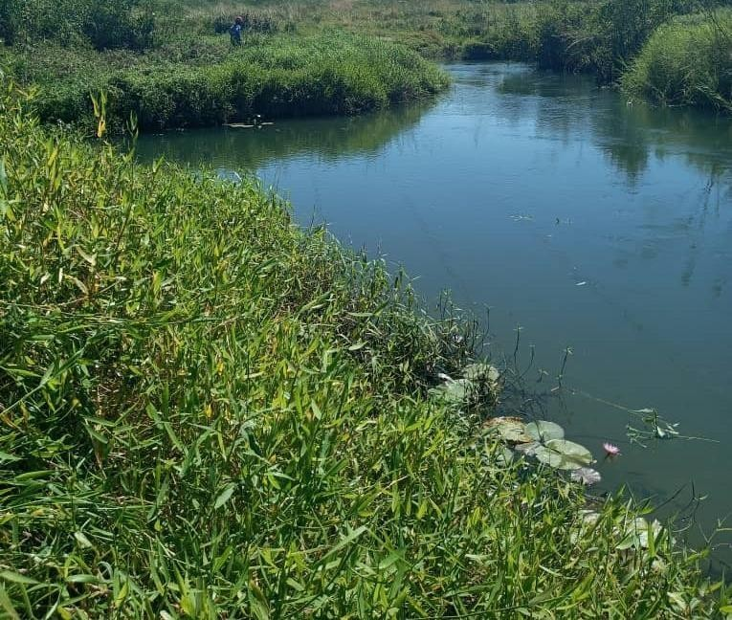

Figure ‑: Some Floating and Submerged Aquatic Flora in Mwambashi Flora

## Aquatic Fauna

### Fish/ Ichthyology

The dominant fish species in the project area as reported by the local fishermen during the field visit included the following; *Labeobarbus polylepis, Clarias stapperssi, Barbus fasciolatus, Barbus multineatus, Pseudocrealabrus philander, Tilapia sp*. *B. lineomaculatus*, *Synodontis macrostigma*, *Serranochromis macrocephalus*, *Barbus miolepis. (Mormyrus longirostris)*, *(vittatus)*, barbel (*Schilbe intermedius,* butter barbel (S*chilbe mystus.*

The local people use hand nets and fish hooks as methods to catch fish species. All the fish species highlighted above are common in the Project area and other river systems in Zambia.

## Vegetation along the Powerline Corridor

The vegetation along the power line route comprises of secondary Miombo woodland which appears to have stabilized due to absence of anthropogenic activities. The main cause of disturbance to vegetation of the powerline corridor is the seasonal clearing of the wayleave of the CSS129, 220 kV transmission line.

## Threatened species

No threatened or restricted range plant or animal species have been identified or are specifically expected to occur in the Project area or Site, largely because the Site is located near an urban area and comprises of a disturbed secondary Miombo with no meaningful vegetation that could harbor it. The Project site has been under continuous shifting cultivation practice and has for a long time served as the main source of firewood for the surrounding local communities. The site has been subjected to rampant charcoal burning that has also contributed to degradation of the natural habitat.

A total of 18 species of global conservation concern are listed for Zambia (Collar *et al*. 1994 in Leonard, 2005). Only the Endangered Grey- crowned crane and vulnerable wattled crane may occur in proximity to the site, i.e. on the river lines of the Kafue River located some 4 km north of the Site and none are considered at risk from the Project.

## Protected / Conservation Areas

The Garneton North Solar PV site is not located close to any protected forest area. The nearest protected forest area is the Ichimpe forest reserve (located about 5.37 km) across the Kitwe – Chingola (T5) road and has been reported as degraded in the 2010 Kitwe District Situation Analysis. The Shibuchinga Game Management Area (IUCN category VI conservation area) is found about 50 km in Lufwanyama District and not expected to be impacted on by the Project.

Although there are no public Forest reserves in the immediate surroundings of the Project site, private firms have shown interests in forest conservation and game ranching. A good number of small mammals are also expected in the nearby private farms with restricted entry and regenerated Miombo woodlands.

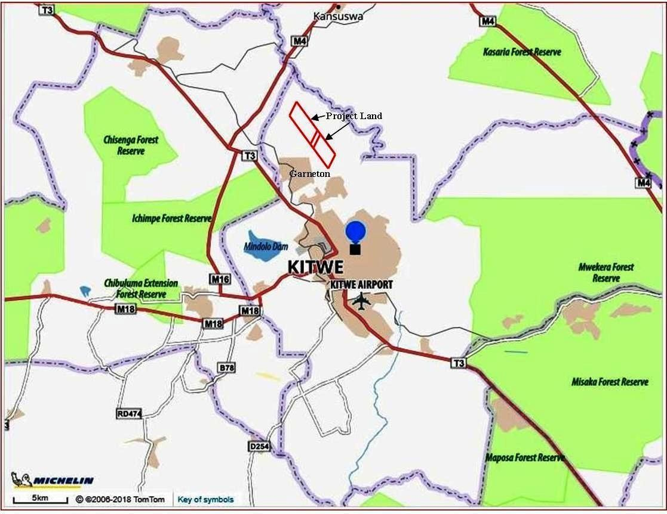

Figure 5-7- 4: Forest reserves in Kitwe

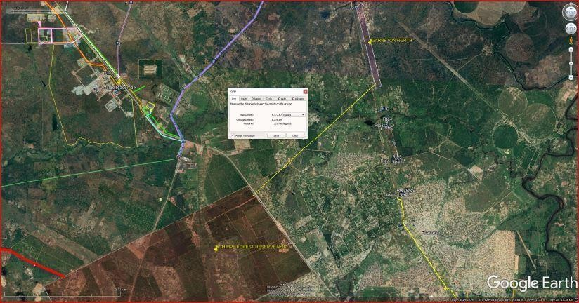

Figure 5-7- 5: Location of ichimpe forest reserve in relation to Garneton north site

## IFC Critical Habitat Status Assessment

IFC Performance Standard (PS) 6 and its supporting Guidance Note 6 ([www.ifc.org](http://www.ifc.org/)) sets out the requirements for categorising habitat status as Modified1, Natural2 and Critical, and the implications for developers. This section summarises the status of habitats in the project area in alignment with IFC definitions and thresholds.

Clause GN43 of the GN6 indicates that natural habitats should not be interpreted as untouched or pristine habitats, as may have undergone historic or recent anthropogenic impact and should be assessed by comparing current and historic conditions to determine the degree of impact. If the habitat still largely contains the principal characteristics and key elements of its native ecosystem such as complexity, structure and diversity then it should be considered a natural habitat regardless of the presence of some invasive species, secondary forest, human habitation or other human induced alteration.

The Garneton North Solar PV Site could be considered a Natural Habitat due to the lack of habitat conversion, and predominantly intact habitat structure mostly comprising of secondary woodland habitats; species composition (except for some faunal species which might have possibly been lost over time) and ecological functionality. The site has also been under continuous seasonal agricultural activities and charcoal burning for several years. This area can be reasonably be considered as “degraded Natural Habitat”.

In terms of IFC requirements, triggers for Critical Habitat primarily focus on the presence of i) Critically Endangered and Endangered species (Criterion 1); Endemic and Restricted Range species (Criterion 2); iii) Migratory and Congregatory species; iv) Highly Threatened and/or Unique ecosystems and v) Key Evolutionary Processes. No critical habitat triggers have been confirmed to occur on the project site, as summarized in the Table below.

Figure ‑: High Level Critical Habitat Assessment

|  |  |
| --- | --- |
| **IFC criterion** | **Rationale** |
| Criterion 1. Critically Endangered and Endangered Species | Not triggered – No critically endangered or endangered species of flora or fauna has been confirmed or likely to occur on the site. |
| Criterion 2. Endemic and Restricted Range Species | Not triggered – No endemic or restricted range species of flora or fauna confirmed or likely to occur on the site. Some plant species could be  endemic to Zambia or the region but are not considered to have restricted ranges. |
| Criterion 3. Migratory  and Congregatory Species | Not triggered – No migratory or congregatory species occur on the  project site or are likely to be impacted by project infrastructure (e.g. transmission lines). |
| Criterion 4. Highly Threatened and / or Unique Ecosystems | Not triggered – Miombo woodland is a widespread habitat type that is resilient to disturbance, and recovers after fire, cultivation or exploitation if left alone. |
| Criterion 5. Key Evolutionary Processes | Not triggered – Miombo woodland is a relatively recent and stable habitat the is not in any evolutionary stage |

1 Modified Habitat is defined as “areas that may contain a large proportion of plant and/or animal species of non-native origin, and/or where human activity has substantially modified an area’s primary ecological functions and species composition”.

2 Natural Habitat is defined as ‘areas composed of viable assemblages of plant and/or animal species of largely native origin, and/or where human activity has not essentially modified an area’s primary ecological functions and species composition’

## Implications for the Project

IFC GN6 Clause 14 requires that: *The proponent will not significantly convert or degrade natural habitats unless all of the following are demonstrated:*

* No other viable alternatives within the region exist for development of the project on modified habitat;
* Consultation has established the views of stakeholders, including Affected Communities, with respect to the extent of conversion and degradation, and
* Any conversion *or degradation is mitigated according to the mitigation hierarchy.*

In terms of the above, “significant conversion or degradation is: i) the elimination or severe diminution of the integrity of a habitat caused by a major and/or long-term change in land or water use or ii) a modification that substantially minimizes the habitat’s ability to maintain viable populations of native species.

Clause 15 states:

*In areas of natural habitat, mitigation measures will be designed to achieve no net loss of biodiversity where feasible. Appropriate actions include*:

* Voiding impacts on biodiversity through the identification and protection of set-asides;
* Implementing measures to minimize habitat fragmentation, such as biological corridors;
* Restoring habitats during operations and / or after operations; and
* Implementing *biodiversity offsets.*

**Note**: no net loss is defined as the point at which project-related impacts on biodiversity are balanced by measures taken to avoid and minimise the project’s impacts, to undertake on site restoration, and finally to offset significant residual impacts, if any, on an appropriate geographic scale [author’s underlining]. The project has met the above requirements through the following:

1. The solar PV park will only take up approximately 60% of the total area of the Site (34 ha out of 56 ha) with the remainder being retained as a ‘set-aside’ in a fenced area where wood harvesting and charcoal burning impacts can be effectively controlled to enhance the biodiversity status of the Miombo woodland habitat;
2. Project layout excludes areas close to the streamlines and all riparian vegetation will be retained to avoid disturbance of such habitats;
3. Mitigation measures will also include monitoring of alien invasive plants and restoration of construction disturbed areas.
4. The area where the perennial stream has its source on the adjacent private property will not be affected by the Project, thereby retaining this drainage feature to optimize rainfall runoff and recharge into the Mwambashi stream and the Kafue River;
5. Ecological monitoring should also be undertaken to confirm that the condition of the set aside areas improves over time to demonstrate that no net loss has been achieved.

## Social, Economic and Cultural Environment

### Land Tenure and Land Use

Land tenure in Zambia is governed by State and Customary ownership. The project area is under state land tenure system and under the ownership of CEC as part of the wayleave for the existing 220 kV power lines. No other individual or organization claims to have proof of ownership for the Project Site and the locals who have been practicing season agricultural activities on the site acknowledged that they were aware that the land comprising the Project Site belonged to the CEC.

Other common land uses on the project site include charcoal burning, illegal sand mining and dumping of domestic wastes.

The surrounding areas show greater diversity of land-uses. Immediately surrounding the Project site on the north are private properties (PIZ, Riverane farm and another private farm). Garneton low density residential and Zambia compound high density areas are found about 3 km south east of the site across the Mwambashi stream.

### Population, Land Administration and Settlement

Kitwe District in the Copperbelt Province has a population of 661, 901 (as at 2022), with 321,654 males and 340,247 females. This number was an increase from 517, 543, with 256, 740 males and 260, 803 females in 2010 (Zambia Statistics Agency, 2022). According to the 2022 Census Report by Zambia Statistics Agency (2022), the population growth rate for Kitwe was calculated at 2.1.

The project area Garneton falls under Chimwemwe Constituency whose population increased from 117,341 in 2010, with 57,740 males and 59,601 females; to 166,283 in 2022, with 81,017 males and 85,266 females.

Land in Kitwe is administered by the Kitwe City Council and the district has a total land area of 30,360 Km² (Kitwe City Council & ECZ, 2010) which supports a number of socio-economic activities. This land mass has accommodated the districts population growth; as well as supporting the district’s various land uses such as agriculture, industrial and commercial activities.

Garneton is a farming settlement in the western side of Kitwe District. The area is sparsely populated, with farmers owning large pieces of land, some of which are not cultivated. Commercial and smallholder farmers occupy the larger pieces of land that are well demarcated; while peasant farmers cultivate rainfed crops in the power line and road way leaves, and grow fresh vegetables near perennial streams and rivers such as Mwambashi Stream. Because Garneton is characterized by large pieces of land that are not in use by the owners, it makes the area a suitable location for setting up transmitting high voltage power lines; with adequate compensation for the land owners

### Economic and Livelihood Activities

Kitwe is historically a mining town. Apart from mining, other drivers of Kitwe’s include agriculture, trade and commerce as well as industries that support the mining industry, transport, energy and

businesses in the hospitality industry. The major economic activities include mining, commerce, trade and industry, agriculture, livestock production, energy, transport and communications.

**Mining:** Like most areas on the Copperbelt, the major economic activity has been mining and mining- related activities. Kitwe has one large scale mine located at Wusakile operated by Mopani and Konkola Copper Mining Companies. The mines employ a good percentage of the labour force in the project area. The boost in the local construction sector (both property and roads) has also created new employment opportunities for the population in Kitwe.

**Commerce and Trade:** There are two commercial centers with shopping facilities including large and medium privately-owned shops. In the recent past, Kitwe has seen construction of 3 major shopping malls including Mukuba and Freedom Park Mall in Parklands and Mindolo Mall in Mindolo area. Insurance companies, banks, accounting firms, and other professional services like surveying and architectural consultancy are also available in the district. There are a growing number of illegal street vendors. Consequently, this has contributed to increased amounts of waste generation in the district. There is also a rise in the number of people operating in undesignated places especially in the residential areas. The district has two hotels, namely Edinburgh and Moba. In addition, there are a number of lodges and guest houses that offer accommodation to all levels of clientele.

**Industry:** The industry is divided in two main areas which are the heavy and light industrial areas north and south of the district. There are however, few manufacturing companies operating in the district.

In Garneton, the most prominent economic and livelihood activity is farming. Crops commonly grown include; maize, soya beans and fresh vegetables.

### Water and Sanitation

Garneton area is facilitated with water and sanitation services by Nkana Water Supply and Sanitation Company. Therefore, most households are connected to the service. However, there are challenges of water contamination and erratic water supply by the utility. Therefore, some households opt to drill their own boreholes for access to a reliable and clean water source. Additionally, some farmers have been sub-dividing their farms into smaller plots. These new divisions have had to rely on ground water and on-site sanitation because the utility has not met their needs.

Informal settlements near Garneton such as Zambia Compound have residents using pit latrines and shallow wells for water and sanitation.

### Education

Kitwe District is home to one of Zambia’s highest learning institution, the Copperbelt University. There are also other tertiary education institutions such as Mukuba University, Copperstone University, and other tertiary institutions. The district also has a number of secondary and primary schools that are government owned, privately owned and community schools.

The school that is nearest to the project site is St. Francis Technical Secondary School. The school was established in the year 2000 as a community school. Now it identifies as a technical secondary school that caters for learners from 8th grade to 12th grade. There are 1015 leaners, with 450 boys and 565 girls that are served by 54 members of staff. The school has 21 classrooms with one learning session in the day that runs from 7:30 to 15hrs. An interview with the school’s head teacher revealed that the school has back up solar power which they use during load shedding hours and their source of water is a borehole, whose water runs out during load shedding hours.

### Health Care

Health care in the area is provided by Garneton Clinic. The clinic was opened in the late 2000s and has a catchment population of 9,523 patients. It catchment areas include:

* Garneton
* Twatasha
* Zambia Compound
* East Garneton
* Luyando

The most prevalent diseases in the areas and their prevalence rates are as follows:

* Malaria (340/1000)
* Diarrhea (230/1000)
* Respiratory tract infections (457/1000)
* Sexually transmitted disease
* HIV/AIDS

The clinic offers the following services:

* Mother and child health
* Out-patient clinic
* Reproductive health services
* Anti-retroviral therapy

The Clinic is currently facing challenges with load shedding together with the rest of the nation. This is impacting the clinic’s operations in the sense that the clinic is having challenges storing vaccines at the right temperature during load shedding. The Clinic also experiences water supply interruption from NWSC during load shedding. Therefore, Garneton Clinic highly supports the CEC solar PV project because they look forward to reduced load shedding hours if more electricity is injected into the national grid.

### Energy

Copperbelt Energy Corporations (CEC) and ZESCO are the two suppliers of grid electricity in Kitwe District. The mines are supplied with electricity by CEC, while ZESCO supplies the households, industries and other institutions.

### Traditions, Rites and Archaeology

Kitwe District has been an urban district since the early 1900s when the mines were opened. Therefore, it does not have traditional leadership system that maintains rite and rituals, or the commemoration of traditional ceremonies. The only observable ritual practiced in the study area and in Kitwe at large are rituals around death; were people gather to mourn with the family of the deceased escort the family to the gravel yard. Kitwe District does not host any of the heritage or sites of archeological importance found in Zambia. The Nakayombo cemetery, which is found about 4.2 km southeast of the Project site at GPS coordinates 35L 0629741 UTM 8593452 is the only site of cultural importance found in close proximity. This is an active cemetery which is mostly used by residents of Garneton and Zambia compound and managed by Kitwe City Council.

Field investigative surveys established that there are no other known physical cultural heritage sites, sacred sites or cultural practices that are undertaken within the Project site. This is likely attributed to the illegal sand mining, charcoal burning and the site being seasonally under shifting cultivation which would further undermine the preservation of any heritage resources or materials that may have existed. However, in case of any unforeseen archeological findings being unearthed during construction, the Chance Find Procedure shall apply.

### Potential Displacements and Compensation

The ESIA studies conducted during the period 2019/2020 adequately addressed all matters relating to potential displacements and compensations. The displacements were handled in accordance with the provisions of the IFC PS5 (Land Acquisition and Involuntary Resettlement) and other applicable Zambian legislation like the Lands Act, 1995. These displacements were largely in form of economic displacements since there were no physical structures or assets that were displaced other than seasonal subsistence agricultural fields. A rigorous stakeholder engagement process and identification of PAPs was undertaken. This was followed by an infield evaluation of crops and crop land that would be lost as a result of the project and formed the basis for computing compensation amounts. A full livelihood restoration plan (LRP) was elaborated and details the principles and basis for compensation as well as the criteria used to arrive at the compensation amounts (Please refer to appendix 6 for the LRP report). Suffice to note that all the locals who had encroached on the project land for seasonal subsistence agriculture were aware that the land in question belonged to CEC and did not expect to be compensated other than being allowed to harvest the crop for that particular season (2019/2020). None of the displaced PAPs produced evidence of any legal claim to the project land. A total of 26 PAPs were compensated and agreement forms were signed with each one of them (refer to appendix 7 of this EPB, the Livelihood Restoration Plan). The ESIA field investigative studies conducted for the update of the Environmental Project Brief for the Garneton North Solar PV project have confirmed that there are no additional or active encroachments on the project land. This is largely due to intensified patrols and awareness continuously being done by the CEC to curtail any opportunistic investments on the project land.

Following the successful implementation of the procedures laid down in the Livelihood Restoration Plan (LRP), all agricultural fields and fruit trees have been displaced with affected persons fully compensated. The PAPs were compensated for the loss of agricultural fields (or fruit trees) and disruption in livelihoods in accordance with the Zambian legislative requirements and applicable international standards.

In summary, the PAPs were compensated in the following ways:

* Loss of Agricultural fields: -This was done in the form of complete cash compensation equivalent to three times the cost of crops from agricultural fields falling on the project land for all PAPs, a lumpsum relocation amount and additional cash to allow the PAPs to find rented land elsewhere for three seasons (Refer to LRP for proof of compensation).
* Additional assistance for vulnerable PAPs: -Alternative land for agricultural fields and agricultural inputs were given to the vulnerable PAPs. The Developer managed to acquire a 10-ha piece of land close to the project site from a private owner where all vulnerable PAPs have been given appropriate pieces of land to continue with their seasonal farming activities.
* Loss of fruit trees: -Cash compensation for the full productive life of mature trees based on tree values computed by the Ministry of Agriculture.
* Loss of access routes: - All affected footpaths and dirty tracks to be displaced and new combined and agreed footpaths to be constructed, the cost of which to be borne by the proponent.

The Developer has been conducting monitoring and evaluation of the PAPs and implementation of the various livelihood restoration programs. Monitoring was done to establish the quality of life of the PAPs after being displaced.

The key aspects that have been monitored from 2020 to date include consistency of the PAPs in engaging in seasonal agriculture, their incomes, status of living, etc. The monitoring program showed that only a few PAPs from those that were assigned alternative land for continuation of seasonal farming had consistently grown something on the newly assigned land. This is in line with the findings of the socio-economic surveys undertaken in 2018/2019 which established that seasonal farming was not the main source of livelihood for the PAPs who had encroached on the project land. The monitoring program also gave evidence that the interventions given to the PAPs significantly resulted in increased agriculture productivity and income among the PAPs. The records show that on average, the PAPs income increased by 68% (refer to the LRP Evaluation and Monitoring Report in the LRP). PAP details are available on Annex 15.

Table ‑: Comparison of Crop Value of Selected PAPs Between 2019 and 2023

|  |  |  |  |
| --- | --- | --- | --- |
| Name of PAP | Crop value in 2019 | Value of crop sales in 2023 | Percent increase (%) |
| PAP 17 | 2,875 | 6,150 | 53 |
| PAP 8 | 835 | 650 | -28 |
| PAP 24 | 145 | 900 | 83 |
| PAP 18 | 605 | 1,850 | 67 |
| PAP 19 | 385 | 1,200 | 68 |

Note: comparison for other PAPs could not be shown because they did not plant any crop in the 2022/2023 season

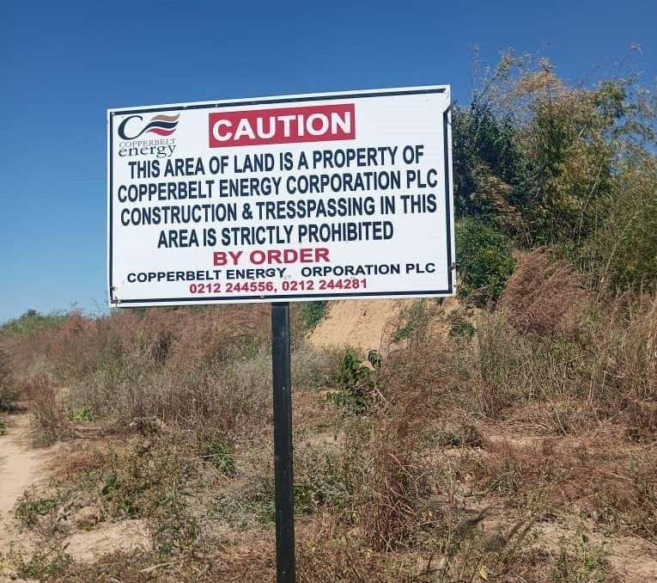

Table ‑: Caution Sign Pasted around the Project Land to Deter Encroachments.

# ENVIRONMENTAL AND SOCIAL IMPACT ASSESSMENT – SOLAR PV PLANT

The environmental and social impacts of the proposed solar PV plant on the affected environment are assessed in this chapter. Both positive and negative impacts are assessed for the construction, operation and decommissioning phases of the Project. Mitigation measures for negative impacts and enhancement measures for positive impacts are described. Mitigation and enhancement measures together with monitoring measures for both construction and operation have been carried over into the Environmental and Social Management Plan (ESMP) included in Appendix 1.1.

In arriving at the overall significance of each identified impact, the consequence rating was considered together with the probability of occurrence. The table below gives a summary of how the overall significance of impacts were arrived at (please refer to Appendix 1.2 full the full impact assessment methodology).

Table ‑: Matrix for Determining Overall Significance of Impacts

|  |  |  |  |  |  |
| --- | --- | --- | --- | --- | --- |
|  | | **PROBABILITY** | | | |
| **Improbable** | **Possible** | **Probabl** | **Definite** |
| **CONSEQUENC** | **Very Low** | **Insignificant** | **Insignificant** | **Very Low** | **Very Low** |
| **Low** | **Very Low** | **Very Low** | **Low** | **Low** |
| **Mediu m** | **Low** | **Low** | **Medium** | **Mediu m** |
| **High** | **Medium** | **Medium** | **High** | **High** |
| **Very High** | **High** | **High** | **Very High** | **Very High** |

A number of environmental and social impacts were screened prior to the assessment phase. These impacts are described in Table 6b. Based on the understanding of the environmental and social sensitivity of the Project site and the impacts of the construction and operation of a typical solar PV plant, several impacts were screened out of the impact assessment and standard mitigation measures included in the ESMP. In some cases, the impacts for the construction and operation phased of the Project are similar and are therefore assessed together. Decommissioning Phase impacts and Cumulative Impacts are assessed separately.

Table ‑: Impacts as a result of the Construction and Operation of the PV Plant

|  |  |  |
| --- | --- | --- |
| Environmental component | Impact during construction & operation (solar PV plant and transmission line) | Addressed in EIA or ESMP |
| Biophysical Impacts | Impact of air emissions | Assessed in section 6.2.1.1 |
| Impact of noise emissions | Assessed in section 6.2.1.2 |
| Impact due to soil and groundwater contamination from spills or inappropriate waste management | Standard mitigation measures included in ESMP |
| Impact of increased soil erosion due to vegetation clearance | Standard mitigation measures included in ESMP |
| Ecological Impacts | Impact of terrestrial ecology | Assessed in section 6.2.2.1 |
| Impact on aquatic ecology | Assessed in section 6.2.2.2 |
| Impact on ecosystem services | Assessed in section 6.2.2.3 |
| Socio-economic Impacts | Impact on landscape and visual amenity | Assessed in section 6.2.3.1 |
| Impact on settlements and housing developments | Assessed in section 6.2.3.2 |
| Impact on land-use and livelihoods | Assessed in section 6.2.3.3 |
| Impact on cultural heritage | Assessed in section 6.2.3.4 |
| Impact on community health and safety | Assessed in section 6.2.3.5 |
| Impact on occupational health and safety | Assessed in section 6.2.3.6 |
| Impacts on deforestation and climate change | Assessed in section 6.3 |

## Positive Impacts

### Local investment and Employment Opportunities

**Background and Baseline Conditions**

The total Project investment value is estimated at US$ 21.6 million, although this will be determined based on, among other factors, the Engineering, Procurement and Construction (EPC) procurement, equipment supply and financing. In addition, the Project is expected to employ a peak construction workforce of 150 - 200 people over a period of 10 months, while it will support an operational workforce of 6 people. The source of the construction workforce will ultimately be determined by the appointed EPC contractor. The operational phase will provide 6 permanent job opportunities to the local communities from the area since security guards and general labourers will be required on a full- time basis.

**Impact Assessment**

The Project will provide a significant positive investment into the national economy and will seek to maximize local (including both Zambian national and people resident around the Project site) employment benefits and local content in and around Kitwe Town. Recruitment, by both the Proponent and third-party contractors will prioritise or target residents of the immediate surrounding communities, and it is expected that most positions can be sourced locally. Priority of employment of unskilled labour will be given to the project affected people, especially those whose agricultural fields will be displaced by the Project.

Local businesses will also benefit during the construction phase as there will be increased spending within the area by those receiving wages who will have improved buying power while employed by the Project. The project is also expected to contribute to an increase in taxes to both the local and central government system. The overall impact will be moderately beneficial both at the national and local scale and a range of measures can be established to maximize local benefits.

Table ‑: Impact Assessment with Respect to Local Investment and Employment

|  |  |  |  |  |
| --- | --- | --- | --- | --- |
| **Type of Impact** | **Positive Benefit** | | | |
| **Impact Criteria** | **Construction** | | **Operations** | |
| **Without Enhancement** | **With Enhancement** | **Without Enhancement** | **With Enhancement** |
| **Intensity/Severity** | Medium Positive | - | Medium Positive | - |
| **Geographic Extent** | National | Regional/Local | National | Local/National |
| **Duration** | Short-Term | Short-Term | Long-Term | Long-Term |
| **Probability** | Definite | Definite | Definite | Definite |
| **Consequence** | Medium | Moderate | Medium | Moderate |
| **Significance** | Medium Benefit | Moderate | Medium Benefit | Moderate |

**Recommendations and Enhancement Measures**

* The Proponent will seek to maximise local recruitment and local content benefits, by adopting suitable local recruitment and local content policies and plans. Any established plans will form part of the contractual obligation of any third-party contactors during both the construction and operational phases of the Project. Priority of employment of unskilled labour will be given to the project affected people, especially those who seasonal agricultural fields will be displaced by the Project.
* All local recruitment and labour management will be undertaken by the Proponent, or third- party contractors, consistent with Zambian national labour and occupation health and safety laws. This will include any international obligations (including any applicable ILO provisions signed and ratified by Zambia).
* Under the recruitment policies, preferential employment will be promoted for local people, women and vulnerable groups consistent with national labour law and any affirmative action
* policies, guidelines or laws.
* Measures will be put in place measures to ensure no employee or job applicant is discriminated against on the basis of his or her race, gender, marital status, nationality, age, religion or sexual orientation.
* The Proponent will undertake, to the maximum extent possible, to promote local procurement with preferential buying from businesses in Kitwe town and Copperbelt province. Only where goods or services are not available locally to a sufficient quality or quantity will international markets be accessed.

### Improved Utilization of the Land

Some sections of the proposed project areas have been used for illegal sand mining and laterite borrow pits which have potential of degrading the land and environment. The implementation of the project will mean the land will be secured and such illegal activities will be stopped, hence, the benefit for the physical environment. This is expected to have an overall high significance in the long-term.

Table ‑: Impact Assessment with Respect to Land Utilization

|  |  |  |  |  |
| --- | --- | --- | --- | --- |
| **Type of Impact** | Positive Benefit | | | |
| **Impact Criteria** | **Construction** | | **Operations** | |
| **Without Mitigation** | **With Mitigation** | **Without Mitigation** | **With Mitigation** |
| **Intensity/Severity** | Medium Positive | - | Long-term Positive | - |
| **Geographic Extent** | Local | Local | Local | - |
| **Duration** | Short-Term | Short-Term | Long-term | - |
| **Probability** | Definite | Definite | Definite | Definite |
| **Consequence** | Medium | Moderate | Medium | High |
| **Significance** | Medium Benefit | Moderate | Moderate Benefit | High |

### Boost to Renewable Energy Sources

Since the project is based on utilisation of solar radiation to produce electricity to feed the national grid, it will help boost power levels and lessen the use of fossil fuels such as wood as more people get connected to the grid. This will benefit the communities/country at large and protected areas by reducing emissions of potentially harmful compounds that are released from the combustion of fossil fuels or the disturbance of natural habitats. In addition, fossil fuel combustion releases significant amounts of carbon dioxide, which contributes to the global pool of greenhouse gas emissions. The project will also promote a shift from reliance on hydro power source which is in most cases affected by rainfall and water levels.

### Improved Grid Stability and Decreased Transmission Losses

Over 96% of the country’s electricity is hydro generated [(www.zambiainvest.com).](http://www.zambiainvest.com/) Hydro power stations are generally centrally located and power generated from the various hydro power stations is transmitted over very long distances which in the process results into losses and compromises grid stability. Therefore, localized energy generation from the proposed solar park will decrease transmission losses and result into improved grid stability.

## Negative Biophysical Impacts

### Air Emissions

**Background and Baseline Conditions**

The Project site is located 23 km west of Kitwe Town with no significant sources of pollutants, which might lead to deteriorating quality of the ambient air. However, potential contributors to degradation of ambient air quality include the following:

1. Seasonal bush fires are ignited by residents of the local surrounding communities in the process of hunting for small mammals and land clearing for season agricultural fields.
2. Depending on the level of access to electricity especially in the nearby high-density Zambia compound, local households would also commonly utilize wood or charcoal for cooking, resulting in localized air emissions. Wood harvesting and charcoal production also results in the cutting of local trees and clearing of vegetation. This is also clearly seen and evident on the Project site.
3. The western eastern part of the site has come under pressure due to illegal sand mining and the resulting borrow pits used for illegal dumping/disposal of domestic waste from which fugitive dust and bad odour emanates. Fugitive dust is also generated by vehicular traffic using the bush road along the wayleave and access routes to private properties across the northern boundary of the Site.

The site does not support any households or permanent land-uses therefore there are no in-situ sensitive receptors. However, dust raised during land clearing and construction activities might impact on adjacent private properties (farms).

**Impact Assessment**

Project construction and operational activities may lead to a range of air emissions that are a risk to community health and safety. Such activities will include those listed below:

1. Vegetation Clearing During Construction: The establishment of the Project will initially require the clearing of approximately 50 ha (i.e. 90% of total area of the site) of land – including cutting of trees and bush. Note that this clearing is focused on removing vegetation which may shade solar modules, however vegetation unable to cast shadow on the panels, such as perennials and grasses will be allowed to return after the initial clearing, which will eventually reduce total cleared percentage down to only 60% (34 ha). The site contains fine clay particulates that will generate significant fugitive dust – notably during the dry season or windy days. There are no household on the Project site, therefore impacts are largely limited to occupational exposure to dust. However, property owners or workers on adjacent private farms (PIZ and Riverane farms) may be exposed to fugitive dust.
2. Construction Traffic (Project Site): The Project will require the accessing and movement of construction traffic within the Project Site. The movement of traffic will likely exacerbate
3. fugitive dust generated from areas that are cleared of vegetation as noted above.
4. Construction Traffic (Outside Project Site): The Project will utilise local public access roads which include both tarred and gravel access roads, e.g. the Kitwe – Chingola (T5) and wayleave dust roads. These roads support both industrial and commuter traffic and any Project construction traffic will likely cumulatively add to existing fugitive dust emissions.
5. Soil Management during Operations: Vegetation will be maintained / slashing to a max height of 0.5 - 1m. The Project site will be required to maintain free of vegetation so as not to interfere with the operations of the solar panels. Grass to be seasonally cut, which will create more employment opportunities.

In terms of the total air emissions generated by the Project, it is probable that any significant impact will be limited to fugitive dust during the construction phase, and the key receptors will be the adjacent properties on the northern boundary, and households along the main access roads. As summarised in Table 6-2-1, the air emissions impacts are ***medium*** during construction, but this may be reduced to ***very low*** if suitable mitigation measures as presented below are adopted.

Air emissions during the operational phase are likely to be of ***low*** significance (See Table 6-2-1). Solar power generation does not generate emissions and any emissions will likely be focused on fugitive dust from untreated access roads, cleared areas and areas without vegetative cover. Again, there are no households present within the Project site, so impacts are limited to occupational exposure and potential exposure by the property owners on the adjacent land.

Table ‑: Impact Assessment of Air Emissions

|  |  |  |  |  |
| --- | --- | --- | --- | --- |
| **Type of Impact** | Negative Impact | | | |
| **Impact Criteria** | **Construction** | | **Operations** | |
| **Without Mitigation** | **With Mitigation** | **Without Mitigation** | **With Mitigation** |
| **Intensity/Severity** | Medium | Low | Low | Low |
| **Geographic Extent** | Localised | Localised | Localised | Localised |
| **Duration** | Short-Term | Short-Term | Long-Term | Long-Term |
| **Probability** | Definite | Probable | Definite | Probable |
| **Consequence** | Medium | Very Low | Low | Low |
| **Significance** | Medium | Very Low | Low | Low |

**Recommendations and Mitigation Measures**

The following recommendations and mitigations measures are proposed to reduce air emissions impacts.

1. The Developer will adopt suitable measures to manage fugitive dust from vegetation clearing during the construction phase. Grass regrowth to help with wind erosion. This will include a programme of dust management that limits both occupational and community exposure to dust, including regular watering of open areas and material stockpile areas.
2. The Developer will adopt measures to control the generation of fugitive dust from
3. construction traffic including limiting construction vehicles speeds to the 30 km/hr on the access roads to the site and on site. An appropriate speed must be adopted on access roads to the site to ensure limited dust generation.
4. The Developer will ensure that fugitive dust emissions will be actively managed during the operational life of the Project.
5. Establish a grievance mechanism throughout the construction and operation phase to deal with any community complains regarding dust and noise.

### Noise Emissions

**Background and Baseline Conditions**

The Project Site is located in Garneton area in the outskirts of Kitwe urban, with no major sources of noise. However, common sources of noise around the project site include vehicular traffic moving along the wayleave route which provides access to a few owners of private farms which forms the northern boundary of the Site. Due to presence of illegal sand mining on site, high noise levels are generated by tipper trucks transporting such materials to and from the site. In the absence of haulage trucks, noise levels on site are in the range of 30 - 58 dB (A).

Sensitive receptors, with respect to noise generated within the Project site, are largely limited to private properties across the northern boundary of the site and households along the main gravel road in Garneton that may be used to access the Project site during construction and operations.

**Impact Assessment**

Project construction activities may lead to a range of noise emissions that may pose a risk to community health and safety. Such activities will include the ones listed below:

1. General Construction Noise: Site clearing, construction and installation of equipment will involve the use of heavy construction equipment including bulldozers, frontend loaders and tipper trucks. Noise will likely be generated at active work areas during normal working hours (08:00 – 18:00 hours), and the few identified receptors are deemed to be affected.
2. Movement of Construction Traffic (Inside the Project Site): The Project will require the movement of construction traffic within the Project site. This will include a main access point along the main gravel road (wayleave route) and movement throughout the site, which will generate noise for the duration of the construction phase. Owners of the nearby private properties on the adjacent north are deemed to be sensitive receptors.
3. Movement of Construction Traffic (Outside the Project Site): The Project will likely utilise the Nakayombo road as well as the wayleave route as the main point of entry into the Project site. The existing roads support both pedestrian and less commuter traffic. The introduction of construction traffic will likely have a cumulative impact on noise along these roads, and adjacent communities are deemed to be sensitive receptors.
4. Operational Noise: Operational activities are unlikely to generate significant noise and depending on the location of Project operational infrastructure. The nearest receptors will be adjacent properties on the private farms north of the Site.

The Project will generate some noise during the construction phase. However, this will mostly be limited to standard working hours. With the urgent demand for power, KfW and the GETFiT program is encouraging short construction timelines and afterhours work may be required sometimes.

The settlements are found about 3 km from the Project site and are unlikely to be affected by noise emission. Farmhouses on private properties on the immediate adjacent north the site might be exposed to construction noise generated on the Project site.

The impact on these sensitive receptors is expected to be largely of ***low*** significance where noise is limited to normal working hours of between 08:00 – 18:00 hours, given that the local landscape has minimal baseline noise emissions other than local traffic. Impacts on local receptors can be easily mitigated to reduce the impact to ***very low***, as summarised in Table 6-2-2. There are no operational activities that generate significant noise (outside of operational traffic) and any noise will be contained within the Project site. The impact on the ambient noise levels during the operational phase is considered to be ultimately ***very low***, and therefore no impact assessment or specific mitigation measures are recommended.

Table ‑: Impact Assessment of Noise Emissions

|  |  |  |  |  |
| --- | --- | --- | --- | --- |
| **Type of Impact** | Negative Impact | | | |
| **Impact Criteria** | **Construction** | | **Operations** | |
| **Without Mitigation** | **With Mitigation** | **Without Mitigation** | **With Mitigation** |
| **Intensity/Severity** | Medium | Low | Very Low | Very Low |
| **Geographic Extent** | Localised | Localised | Localised | Localised |
| **Duration** | Short-Term | Short-Term | Long-Term | Long-Term |
| **Probability** | Probable | Probable | Probable | Probable |
| **Consequence** | Low | Very Low | Very Low | Very Low |
| **Significance** | Low | Very Low | Very Low | Very Low |

**Recommendations and Mitigation Measures**

The following recommendations and mitigations measures are proposed to reduce noise emissions impacts during construction.

* The Developer will minimize construction noise exposure of nearby receptors by ensuring that noisy construction activities are not undertaken in direct proximity to these receptors and limited where possible. This will include the suitable siting of the access points / entry gates from the main gravel access road as well as active worksites.
* Construction vehicles and plant will be serviced according to manufacturer’s specifications, and maintenance records must be kept up to date and presented for inspection as required.
* Avoid or limit, noise generating construction activities outside of “normal working hours” where possible. Where working outside normal working hours is required, this should be determined together with the local authorities and communicated with sensitive receptors.

### Risks of Flooding

**Background and Baseline Conditions**

The conversion of the existing vegetation cover to bare or impervious surface at the project site will change the soil surface characteristics. This will result into reduced infiltration and attenuated surface runoff. The appreciably high gradients of the Project site might also exacerbate the problem of flooding. Verbal interviews with the local people during field investigative studies confirmed the occurrence of floods on Mwambashi stream, especially during extreme rainfall events. Events of overtopping of the bridge constructed on Mwambashi stream along the wayleave service route were confirmed during the EIA field studies.

**Impact Assessment**

Flooding is likely to occur during the operation phase in the long term and also presents a threat to electrical equipment mounted close to the ground. However, considering the footprint of the Solar PV Park and the fact that grasses and perennials will be allowed to regrow, the intensity of the impact is expected to be ***medium*** to ***low*.** The impact is therefore assessed as having an overall ***low*** consequence. Given that the likelihood of this impact is ***definite*** the pre-mitigation impact significance is ***low*.**

### Recommendations and Mitigation Measures

The following mitigation measures will help to negate the potential risk of flooding and erosion;

* Restricting vegetation clearance and excavations activities within the footprint of the project site; and
* Construction of an effective drainage network and using other well engineering measures that slow /prevent runoff flow and reduce sediment loads movements.
* Grasses and perennials will be allowed to grow to reclaim the area under the trackers. This will therefore ensure that water is retained. In additional, natural grass will be maintained below the solar modules. Grass will be kept to a height of 0.5-1m which will help to reduce runoff from the site and consequently decrease the risk of flush floods.

## Negative Ecological Impacts

### Terrestrial Ecology

**Background and Baseline Conditions**

The Project site comprises of Miombo woodland vegetation in various states of disturbance with no notable intact vegetation at all. As such, the site supports only small mammals if any, which might include giant rodents and common mice and doves and other woodland bird species. No plant or animal species of conservation concern were found or are expected to occur. Miombo woodland is a widespread habitat type in Zambia and has low sensitivity as it is highly resilient, and many species are able to rapidly recover from disturbance by re-sprouting from cut stems. In terms of IFC Performance Standard (PS) 6, the Project site has been classed as ‘degraded Natural Habitat’ due to the extent of fragmentation and degradation due to illegal sand mining, charcoal burning and seasonal shifting cultivation practices currently obtaining on site.

**Assessment of Impacts**

Impacts of the project on terrestrial habitats will arise from:

* Clearance of habitat for construction of various project components;
* Maintenance of the site and firebreaks during Operation.

**Construction Phase**: Project development will entail the clearance of approximately 50 ha of land for the solar PV plant, equivalent to ~90 percent of the site. The area under the solar panels will not have any suppression of plant re-growth with some ecological value for biodiversity, but will also reduce dust, and will need no for some chemical treatment.

The developer has planned the layout of the solar PV plant to minimize loss of the more intact portions of the riparian vegetation along the streamlines by avoiding areas close to the Mwambashi stream. This remaining portion of land will serve as a ‘set aside’ which will effectively protect the more intact vegetation thereby retaining surface water runoff into the adjacent stream line.

Owing to the above, the impact extent is rated as local within which the habitat loss is permanent and of low intensity. The impact is therefore assessed as having an overall ***low*** consequence. Given that the likelihood of this impact is ***definite*** the pre-mitigation impact significance is ***low*.**

**Operation Phase:** Project operation will entail general site maintenance to keep vegetation under and around the solar PV panels and transmission line low and prevent tree re-growth in order to maximize the amount of solar radiation reaching the panels. Following construction, if equipment and/or fill material from other areas is imported there is a high risk that alien invasive plants (such as *Lantana camara* and *Tithonia diversifolia*) may be introduced and could spread into adjacent areas where they may replace indigenous vegetation. Therefore, care must be taken not to trigger the spread of invasive species to the site or other areas beyond the boundaries of the site. Other operational impacts on terrestrial habitats include potential edge effects around the plant on vegetation and fauna due to reflection of heat and glare from the panels and disturbance from activities of operational staff on site.

The potential operational impacts on terrestrial habitats and fauna are considered of Local extent, long-term duration and of low intensity resulting in an overall ***low*** consequence, which together with the ***probable*** likelihood results in a pre-mitigation impact significance of **low**. Additional mitigation measures are summarized below which will reduce the potential post-mitigation impact significance to ***very low.***

Table ‑: Assessment of Impacts on Terrestrial Habitats

|  |  |  |  |  |
| --- | --- | --- | --- | --- |
| **Type of Impact** | Negative and Direct Impact | | | |
| **Impact Criteria** | **Construction** | | **Operation** | |
| **Without Mitigation** | **With Mitigation** | **Without Mitigation** | **With Mitigation** |
| **Intensity/Severity** | Low | Very Low | Low | Very Low |
| **Geographic Extent** | Local | Local | Local | Local |
| **Duration** | Permanent | Permanent | Long term | Long term |
| **Consequence** | Low | Very Low | Low | Very Low |
| **Probability** | Definite | Definite | Probable | Possible |

|  |  |  |  |  |
| --- | --- | --- | --- | --- |
| **Significance** | Low | Very Low | Low | Very Low |

**Recommendations and Mitigation Measures**

As indicated above the developer has already planned the layout to minimize construction phase impacts on the more intact portions of the riparian vegetation as far as possible. Implementation of the mitigation measures described below for construction and operation will reduce the impacts on terrestrial habitats to ***very low*** significance.

**Construction phase mitigation:**

* Minimize construction footprint by demarcating work site boundaries and vehicle access routes to prevent damage to vegetation surrounding the solar PV plant.
* Woody biomass: Clear all woody vegetation from the construction area, including roots, and stockpile in an area near a perimeter gate with road access to allow local community members to collect wood. Any small brush should be mulched where practical and spread on bare topsoil areas to suppress dust and provide leaf matter for soil replenishment.
* Topsoil: Topsoil should be cleared and stockpiled and used for restoration of temporary construction areas;
* Control alien invasive plant growth through:
* Sourcing of fill material: any requirement for fill material to create a level platform for site development should be sourced from weed free areas to minimise the risk of spreading alien invasive species and to reduce the ongoing maintenance requirements;
* Equipment decontamination: Wash down bulldozers / earthmoving equipment prior to site entry;
* On-site alien invasive plant monitoring and control (removal and disposal).
* Restoration / rehabilitation: Following construction, all disturbed areas not required for infrastructure should be graded to near natural contours, scarified to decompact soils, spread with stockpiled topsoil and allowed to recover naturally. If grass re-growth does not occur naturally, the area should be seeded with natural grass seed and irrigated in accordance with appropriate practices suitable for the type of soils present on site.
* The portions of land close to the Mwambashi stream and sand sales dambo will be retained and serve as a ‘set aside’ to enhance the biodiversity status of the site.

Operation Phase Mitigation:

* **Alien vegetation management:** ongoing monitoring will be required during operation to ensure the site is kept free of alien invasive species and any species are removed on a regular basis (before flowering or seeding occurs);
* **Monitoring of restoration success:** areas which have been restored or rehabilitated should be checked regularly to monitor natural plant re-growth and presence of erosion.
* **Herbicides:** use of herbicides for plant maintenance should ensure only environmentally- approved brands are used and comply with Zambian legal requirements and relevant international conventions.

### Aquatic Ecology

**Background and Baseline Conditions**

The Project site is bordered by Mwambashi stream and Sand sales dambo to the east and west respectively. However, no ecologically important aquatic resources occur on the Project site or within the streamlines. The Mwambashi stream is a tributary of the Kafue River, which is found about 4 km north of the Project site. Therefore, although, there are no ecologically important resources in the two surface drainage features, they still serve an important purpose of recharging the Kafue River.

**Assessment of Impact**

Apart from a requirement to store limited amounts of diesel and other hydrocarbons on site for construction and operation, the project involves limited hazardous chemicals and risk of pollution from these are minimal if good industry practice is implemented.

The predicted impact on aquatic ecology is of local extent, long-term duration, low intensity with overall ***low*** consequence, which together with its ***probable*** likelihood results in an overall impact significance of ***very low* after mitigation**.

Table ‑: Assessment of Impacts on Aquatic Habitats

|  |  |  |  |  |
| --- | --- | --- | --- | --- |
| **Type of Impact** | Negative and Direct Impact | | | |
| **Impact Criteria** | **Construction** | | **Operation** | |
| **Without Mitigation** | **With Mitigation** | **Without Mitigation** | **With Mitigation** |
| **Intensity/Severity** | Very Low | Very Low | Low | Very Low |
| **Geographic Extent** | Local | Local | Local | Local |
| **Duration** | Long term | Long term | Long term | Long term |
| **Consequence** | Low | Very Low | Low | Very Low |
| **Probability** | Probable | Possible | Probable | Possible |
| **Significance** | Low | Very Low | Low | Very Low |

**Recommendations and Mitigation Measures**

The developer has already designed the layout of the solar PV plant to avoid the areas close to the streamlines in order not to disturb the aquatic ecology.

Additional mitigation measures for construction and operation are summarized below, which will reduce the potential impact significance on aquatic ecology to ***very Low***.

**Construction Phase Mitigation:**

* Design site drainage and storm water runoff to minimize risk of contaminated water entering the stream course or aquatic features;
* Restrict use of chemicals on site to minimum necessary and ensure storage and use, and vehicle maintenance, complies with standard good practice. Hazardous chemicals, including fuels, should be stored in a bunded and fenced area located at least 150 m from the surface water bodies.

**Operational Phase Mitigation:**

* Conduct site inspections to check for oil spills and leaks on soil surface and water bodies (if any) and implement remediation as required.
* Chemical containers shall be stored in an enclosed restricted access area (to prevent human re-use) and disposed of at an approved waste facility or by approved waste service providers.

### Ecosystem Services

Apart from the seasonal agricultural activities and illegal charcoal burning, the Project site does not support other meaningful economic activities or livelihoods and contributes few provisioning ecosystem services for local communities. The site comprises a private titled land held by CEC and project implementation is not expected to result in major loss of livelihoods. Therefore, impacts during construction and operation are expected to have an impact of low significance.

## Socio-economic Impacts

### Landscape and Visual Amenity

**Background and Baseline Condition**

The Project site is located on a gently sloping ground with gradients of about 5 – 7%. The site slopes in two directions, i.e. towards Mwambashi stream and sand sales dambo area with elevation differences of about 60m.

The landscapes on the Project site comprises of disturbed natural Miombo woodland. Most of the vegetation on site has been cleared due to seasonal shifting cultivation practices, while the western portion is highly degraded due to illegal mining of sand which has greatly transformed the landscape in this area.

**Impact Assessment**

The potential impact of the Project is associated with how it conforms to the local landscape as well as its visual footprint. The vegetation and landscape on site are best described as degraded or disturbed and hence the establishment of the Project is not expected to alter the local landscape, though a change from natural to industrial is expected. This resultant change will largely commensurate with the prevailing activities (laterite mining and clearance for seasonal agriculture and charcoal burning). Therefore, the Project is considered to have a ***low to very low*** impact significance on the overall surrounding landscape characteristics.

The Project will still result in some visual intrusion and disruption related to vegetation clearing as well as the light reflectivity from the solar module surfaces through the construction and operational phases. The proposed solar modules could be between 3 to 5.5 meters above ground level and unlikely to be highly visible from the surrounding areas. Visibility is likely to be further reduced with screening from surrounding vegetation. Hence, any visual intrusion that may occur will be similar to the broader landscape characteristics in the area. The Project is considered to have a ***low*** impact with respect to visual intrusion and changes in visual amenity.

Table ‑: Assessment of Impacts on Landscape and Visual Amenity

|  |  |  |  |  |
| --- | --- | --- | --- | --- |
| **Type of Impact** | Negative Impact | | | |
| **Impact Criteria** | **Construction** | | **Operations** | |
| **Without Mitigation** | **With Mitigation** | **Without Mitigation** | **With Mitigation** |
| **Intensity/Severity** | Low | Very Low | Low | Low |
| **Geographic Extent** | Localised | Localised | Localised | Localised |
| **Duration** | Permanent | Permanent | Permanent | Permanent |
| **Probability** | Probable | Probable | Probable | Probable |
| **Consequence** | Low | Very Low | Low | Low |
| **Significance** | Low | Very Low | Low | Low |

**Recommendations and Mitigation Measures**

The impact on the local landscape by the Project is considered to be minimal and the following recommendations are proposed to reduce the visual profile of the Project and where possible enhance the landscape quality of the of the Project site. Where possible the Developer will seek to establish:

* A vegetated buffer or screen of vegetation along the perimeter of the Project site, to reduce visual intrusion into the directly surrounding areas.

### Settlements and Housing Developments

**Background and Baseline Conditions**

The Project site does not support any community or individual housing, as the land has been under private tenure negating the development of any settlements, except for seasonal agricultural fields. The nearest housings in proximity to the Project site are the farmhouses found on PIZ and Riverane farms located across the northern boundary of the site, about 300m away.

Other settlements near to the Project site are found about 3 km from the Site and include; Garneton low density residential and Zambia compound to the south east across the Mwambashi stream.

**Impact Assessment**

The Project is unlikely to impact on local settlement and housing development during the construction phase, as there is no proposed development within or surrounding the Project site. Housing and structures in direct proximity to the Project site will not directly be affected. The impact to due to construction is considered ***very low to insignificant*** on both local settlements and housing development.

The Project is also unlikely to impact on surrounding settlement and housing development during its operational life. Settlement development around Garneton area remains 1.5 km from the site and there is no evidence of urban sprawl or rapid settlement development towards the site. The existing 220 kV transmission line divides the settlements from the Site and prevents any possible settlement or housing expansion toward the Project site. The impact of the operational life of the Project on local settlement and housing development will probably be ***very low to insignificant***.

Table ‑: Assessment of Impacts on Settlement and Housing Development

|  |  |  |  |  |
| --- | --- | --- | --- | --- |
| **Type of Impact** | Negative Impact | | | |
| **Impact Criteria** | **Construction** | | **Operations** | |
| **Without Mitigation** | **With Mitigation** | **Without Mitigation** | **With Mitigation** |
| **Intensity/Severity** | Low | Very Low | Very Low | Very Low |
| **Geographic Extent** | Localised | Localised | Localised | Localised |
| **Duration** | Short-Term | Short-Term | Permanent | Permanent |
| **Probability** | Probable | Probable | Probable | Probable |
| **Consequence** | Very Low | Very Low | Very Low | Very Low |
| **Significance** | Very Low | Very Low | Insignificant | Insignificant |

**Recommendations and Mitigation Measures**

The impact on local settlement and housing development is not considered sufficient to warrant any active mitigation measures.

### Land-Use and Livelihoods

**Background and Baseline Description**

The Project site comprises a private land on title held by CEC. This has prevented people from establishing any permanent livelihood sources or land use on site. All persons who were practicing seasonal subsistence agriculture on the project land were adequately compensated and displaced in 2020 (see Appendix 6 for the Livelihood restoration Plan). The ESIA field investigative studies conducted for the update of the Environmental Project Brief for the Garneton North Soalr PV project have confirmed that there are no additional or active encroachments on the project land.

**Impact Assessment**

The construction phase of the Project will require the securing of the property boundaries with fencing and controlled access gates as well as clearing of vegetation. Both activities will restrict access to natural resources as well as reduce the natural resources base that may be harvested by local communities. There may also be some displacement of existing agricultural fields, and the overall impact of these displacements is moderate to high. Therefore, the impact is considered to be of ***low - medium*** significance***.***

The operational phase of the Project will entail the same levels of security established during the construction phase. However, the securing of the site with fencing and controlled access points will exist for the life of the Project. Impacts established during the construction phase are likely to extend into the operational phase, therefore the impact related to the loss of access to natural resources is considered to be ***low.***

Table ‑: Assessment of Impacts on Land-Use and Livelihoods

|  |  |  |  |  |
| --- | --- | --- | --- | --- |
| **Type of Impact** | **Negative Impact** | | | |
| **Impact Criteria** | **Construction** | | **Operations** | |
| **Without Mitigation** | **With Mitigation** | **Without Mitigation** | **With Mitigation** |
| **Intensity/Severity** | Moderate - High | Low | Moderate - High | Low |
| **Geographic Extent** | Localised | Localised | Localised | Localised |
| **Duration** | Short-Term | Short-Term | Long-Term | Long-Term |
| **Probability** | Probable | Probable | Probable | Probable |
| **Consequence** | Very Low | Very Low | Low | Low |
| **Significance** | Very Low | Very Low | Very Low | Very Low |

**Recommendations and Mitigation Measures**

The impact on land-use and livelihoods is considered to be high, however a number of recommendations are included as a means to continued use of part of the site especially the areas along the streamlines, but without compromising on the ability of the Project to secure the safety of its workers, equipment and community members access the site. The recommendations include:

* The Project will stockpile all trees cut down during site clearance and allow community access to this wood over time.
* No further displacements are envisaged as there are no new encroachments on site. All PAPs were adequately compensated in 2020.
* An appropriate Livelihood Restoration Plan was developed to ensure that all locals whose agricultural fields were displaced are well taken care of.
* Displacements and compensation were undertaken consistent with national law and policies and conform to IFC Performance Standards (notably IFS Performance Standards 5 on land acquisition and involuntary resettlement). This included provision of suitable compensation and the reinstatement of livelihoods.

### Cultural Heritage

**Background and Baseline Conditions**

The Project site does not consist of any known physical cultural heritage sites such as archaeological sites or graves, nor are there any known sacred sites or cultural practices that are undertaken within the Project site. This is likely attributed to the site being historically under private tenure and coupled with historical and current agricultural and charcoal burning activities as well as illegal sand mining. The only feature of cultural importance is the Nakayombo cemetery which is found about 4.2 km north east of the site and by no means expected to be impacted on by the project. However, in case of any unforeseen archeological findings being unearthed during construction, the Chance Find Procedure shall apply (see Appendix 10).

**Impact Assessment**

The Project is unlikely to impact on any cultural heritage resources as none have been found, nor is the site likely to support any heritage of value. The impact significance, for both construction and operations, is therefore considered to be ***insignificant***. Standard safeguards should however still be put in place for chance discoveries of artefacts or other aspects of cultural heritage value.

Table ‑: Assessment of Impacts on Cultural Heritage

|  |  |  |  |  |
| --- | --- | --- | --- | --- |
| **Type of Impact** | Negative Impact | | | |
| **Impact Criteria** | **Construction** | | **Operations** | |
| **Without Mitigation** | **With Mitigation** | **Without Mitigation** | **With Mitigation** |
| **Intensity/Severity** | Zero to Very Low | Zero to Very Low | Zero to Very Low | Zero to Very Low |
| **Geographic Extent** | Localised | Localised | Localised | Localised |
| **Duration** | Short-Term | Short-Term | Long-Term | Long-Term |
| **Probability** | Improbable | Improbable | Improbable | Improbable |
| **Consequence** | Very Low | Very Low | Very Low | Very Low |
| **Significance** | Insignificant | Insignificant | Insignificant | Insignificant |

**Recommendations and Mitigation Measures**

A Chance Find Procedure will be developed and implemented to address any potential discoveries of new cultural heritage value during the construction phase (see Appendix 12 for the chance find procedure). The Project site and immediate surrounds are underlain by good laterite, therefore care must be taken so as to avoid opening up of laterite borrow pits on the areas which might be hosts to features of cultural or historical importance.

However, in case of any unforeseen archeological findings being unearthed during construction, the Chance Find Procedure shall apply (see Appendix 12).

### Community Health, Safety and Security

**Background and Baseline Conditions**

The Project site is located on the outcast/ suburbs of Kitwe, and local communities are exposed to several existing health and safety risks – including the prevalence of malaria, cholera, dysentery and typhoid, as well as community exposure, traffic risks, poor sanitation and waste management and water contamination. Kitwe town, as an established urban town, comprises of several public hospitals and clinics that may be accessed by local communities. One such facility is the Garneton clinic found about 4.5 km from the site.

**Impact Assessment**

Project construction and operational activities may lead to a range of community health, safety or security risk. Two of the key risks, namely air and noise emissions, are assessed separately under Sections 6.2.1.1 and 6.2.1.2 respectively. Additional activities that will pose a risk include those listed below:

1. Entry into the Project site during construction and operations: This may include both authorized and unauthorized access to the Project site during construction and operations.
2. Persons entering the site will be exposed to risks related to traffic movement, construction activities (such as land clearing, general construction, raw and waste material management and handling, etc.) as well as general operational activities.
3. Traffic risks and accidents during construction and operations: The introduction of construction and operational traffic will expose communities to potential traffic incidents or accidents with Project vehicles. The risk will be cumulative and largely restricted to / or along the main gravel access, which already supports both commuter and pedestrian traffic.
4. Workforce / community interaction: Where a Project introduces a large non-local construction workforce, there is the potential for community health, safety and security risks where the non-local workforce is permitted to interact with local communities. This may include risky sexual behaviour, spread of HIV and other sexually transmitted diseases, violence and conflict, alcohol abuse amongst other social problems.

The Project will require a construction workforce complement of 150 - 200 people, most of them will be drawn from the local communities, including Zambia Compound and Garneton low density residential area. The Project will establish a construction camp and not permit any non-local workforce to be resident in the local communities. Suitable controls will be put in place to manage workforce and community interactions. However given that the Project is in a largely urbanized environment and with a large resident population, the overall impact is ***low***.

As such, the key community health and safety risks largely pertain to entry into the project site and incidents with Project vehicles during construction. The site will not be commonly accessed by local communities, therefore the impact is considered ***low***, although the Project will need to establish measures to manage any entry of people during construction including those presented below. In addition, the main gravel access roads already support existing commercial and commuter traffic. Therefore, local communities will be well versed in terms of traffic risks. The overall impact in terms of construction traffic and potential community incidents is ***low***, however the Project will need to establish measures to maximize traffic safety during construction.

Community health, safety and security risks during the operational phase will be limited to access to the operational site and operational traffic risks. Assuming standard security measures are established, the potential community safety and health impacts are ***low***.

Table ‑: Assessment of Impacts on Community Health, Safety and Security

|  |  |  |  |  |
| --- | --- | --- | --- | --- |
| **Type of Impact** | **Negative Impact** | | | |
| **Impact Criteria** | **Construction** | | **Operations** | |
| **Without Mitigation** | **With Mitigation** | **Without Mitigation** | **With Mitigation** |
| **Intensity/Severity** | Medium | Low | Low | Very Low |
| **Geographic Extent** | Localised | Localised | Localised | Localised |
| **Duration** | Short-Term | Short-Term | Long-Term | Long-Term |
| **Probability** | Probable | Probable | Probable | Probable |
| **Consequence** | Low | Very Low | Low | Low |
| **Significance** | Low | Very Low | Low | Low |

**Recommendations and Mitigation Measures**

The following recommendations and mitigations measures are proposed to reduce community health and safety impact during construction and operations.

* The Developer will establish suitable security fencing and other control measures to restrict or control public access to the Project site. This will include any authorized access given the members of the public for visits, casual labour, collecting of cleared trees/vegetation.
* The Developer will adopt suitable traffic safety measures, with particular focus on ensuring community commuter and pedestrian traffic safety is considered on all access roads leading to the site.
* The Developer will establish emergency response plans for emergency incidences related to any construction or operational activities, infrastructure or traffic.
* The Developer will establish suitable traffic safety rules to minimize potential traffic hazards on shared access roads that will be used by public traffic and pedestrian traffic.
* The Developer, or third-party contractor(s), will establish a worker health programmes during the construction phase that specifically targets risky behaviors, training and voluntary screening of HIV and other sexually transmitted diseases.

### Occupational Health and Safety

**Background and Baseline Conditions**

The development of the solar PV plant is expected to support a peak construction workforce of about 150 - 200 persons. The workforce will be exposed to standard occupational health and safety risks founds at any solar PV plant construction site including (1) operation of heavy equipment and vehicles, (2) handling of bulk materials, (3) electrocution, (4) general construction risks and (5) exposure to environmental risks such as fugitive dust and wildlife etc. Occupational health and safety risks during operations are likely to be lower and mainly concerning general maintenance requirement of the solar PV plant.

**Impact Assessment**

All construction phase occupational health and safety risks are those that are typical of any solar PV plant construction, and there no known unique risk related to the construction of such a plant. As the local workforce will potentially be unfamiliar with international good practice procedures, occupational health and safety risks would be considered of ***medium*** significance during construction and ***medium*** during operations. It is assumed, that Project, and where relevant third-party contractors, will adopt standard procedures required under national health and labour laws as well as conforming with international health and safety guidelines, which will reduce potential impacts to ***low*** significance during both the construction and operational phases.

Table ‑: Assessment of Impacts on Occupational Health and Safety

|  |  |  |  |  |
| --- | --- | --- | --- | --- |
| Type of Impact | Negative Impact | | | |
| Impact Criteria | Construction | | Operations | |
|  | **Without Mitigation** | **With Mitigation** | **Without Mitigation** | **With Mitigation** |
| **Intensity/Severit y** | Medium | Low | Medium | Low |
| **Geographic Extent** | Localised | Localised | Localised | Localised |
| **Duration** | Short-Term | Short-Term | Long-Term | Long-Term |
| **Probability** | Probable | Probable | Probable | Probable |
| **Consequence** | Medium | Low | Medium | Low |
| **Significance** | Medium | Low | Medium | Low |

**Recommendations and Mitigation Measures**

* The Developer, and where relevant any third-party contractors, will adopt all required occupational health and safety requirements as stipulated under the Zambian Occupational Health and Safety Act, No. 36 of 2010, as well as conform with any relevant international best practice standards and in accordance with IFC PS2.
* This will include the establishment of policies, procedures and actions during both the construction and operational phase that results in strict adherence to health and safety measures by the Proponent staff, third-party contractors and supply chain contractors.

### Employee Welfare

**Background and Baseline Conditions**

InnoVent will engage an EPC Contractor to build the solar plant and the associated infrastructure and the O&M contractor to operate and maintain the project infrastructure. More employees will be employed during the construction phase compared to the operation phase. Both the EPC and O&M contractor will be expected to comply with Innovent – CEC Garneton North environmental and social policy. The Site Manager and Environmental and Social Officer will ensure that all employee related issues are properly addressed throughout the phases of the project and that issues needing the attention of the government are escalated following the company escalation procedure.

Impact Assessment

Failure to adhere to the provisions of the various labour laws and good international industry practice as well as the various performance standards such as the AfDB Operational Safeguards and the IFC Environmental and Social Performance standards, there is a risk for employees being subjected to unhealthy working conditions and inhumane treatment. With the mitigation measures proposed, the overall impact of the project on employee welfare is considered low negative. The table below shows the assessment of the project impact on employee welfare.

Figure ‑: Assessment of Negative Impacts on Employee Welfare

|  |  |  |  |  |
| --- | --- | --- | --- | --- |
| **Type of Impact** | **Negative Impact** | | | |
| **Impact Criteria** | **Construction** | | **Operations** | |
| **Without Mitigation** | **With Mitigation** | **Without Mitigation** | **With Mitigation** |
| **Intensity/Severity** | High Negative | Low Negative | Medium Negative | Low Negative |
| **Geographic Extent** | Localised | Localised | Localised | Localised |
| **Duration** | Short-Term | Short-Term | Long-Term | Long-Term |
| **Probability** | Probable | Probable | Probable | Unlikely |
| **Consequence** | High | Moderate | High | Moderate |
| **Significance** | High | Moderate | High | Low |

**Recommendations and Mitigation Measures**

The EPC and O&M contractor should address the following issues:

* Membership to Employee Welfare Organizations

Employees should be allowed freedom to join any trade union they feel will help them to negotiate conditions of service with the employer. Union leaders who will be appointed among the employees will give reasonable accommodation to attend organize and attend to union matters within the confines of the Zambian Laws and the International Labor Organization guidelines.

* Water and Sanitation

Employees will be given adequate access to clean water and sanitation facilities. If borehole water is provided to employees, the water will be regularly tested to ensure that the water is fit for human consumption. Where it is determined that the borehole water is not safe, employees will be given alternative access to water such as procuring bottled water from third party suppliers.

Both the EPC and O&M contractors will ensure that workers are provided with ablution facilities for both male and female and that the number of these facilities is commensurate with the number of employees to guarantee adequate access to these facilities.

* Staff Accommodation

It is most likely that staff accommodation will be needed during the construction phase. The staff sleeping quarters will be provided with adequate facilities such as an eating area, ablution facilities and clean and safe water. Cross air ventilation will be an important consideration to ensure that the staff sleeping quarters are well ventilated to mitigate the outbreak of diseases associated with poor ventilated areas. The EPC contractor will ensure that the public health department from the Kitwe City Council inspects and issues an occupational certificate before the staff are allowed to use the sleeping quarters. All construction work will follow the approved building plans by the Kitwe City Council.

* Capacity Building Programs

Employees will be given opportunities for capacity building. Capacity building programs will include coaching, mentorship and access to short training to bridge identified skills gaps. Employees identified for capacity building will be given reasonable paid time off work to attend the recommended training programs.

* Grievance redress

A grievance redress procedure will be developed and will form part of the overall project grievance mechanism. The procedure will outline submitting grievances, screening grievances, resolving grievances and giving feedback on submitted grievances. Employees will submit any grievances through their immediate supervisor who will screen and escalate the grievance if need be, to an appropriate authority capable of resolving the grievance. The aggrieved employee will be involved in the grievance redress procedure through asking for more clarifications, participating in arriving at an amicable resolution to the grievance and giving the employee feedback on the final resolution. The employee has the right to appeal the resolution if not happy with it and if the internal grievance mechanism fails to resolve the grievance, the employee is free to elect to submit the grievance to mediation or seeking legal redress. Employees wishing not to disclose their identities will be free to submit anonymous grievances by depositing the grievance in the grievance/ suggestion box which will be posted within the project site.

* Gender considerations

Innovent and all its supply chain partners will adhere to the principles of inclusivity in making labour hire decisions. The company will not be segregating against any gender wneh employing and all employees will be paid equally for equal work done without considering the gender of an employee. All employees will have equal access to promotions, capacity building programs and other incentives such as annual leave and off days. Due consideration will be given to the nature of women employees and provide due consideration on the things they need at the workplace to enable them to thrive be productive. Such things will include providing adequate sanitary facilities for them and giving each woman an extra day off each month (Mother’s Day) as provided for under section 47 of the Employment Code Act No. 3 of 2019.

* Sexual Harassment and Exploitation

Innovent have adopted a zero tolerance towards sexual harassment and exploitation. This will be expected of all the supply chain partners for the project. Employees for Innovent as well as contractor employees will be sensitized on how to identify sexual harassment and exploitation and how to report it.

* Forced and Child Labour

All workers will work for the company because they want to and not that they are being forced to do so. Employees who will be sponsored by the company acquire the necessary skills will not be bonded by the company. All employment advertisements will have a clause advising potential applicants that persons below the employment age in Zambia are not eligible. All employment candidates will be screened for the employment age requirements using the National Registration Card document or any other document recognized by the Zambian laws as proof one’s identity when seeking employment. This requirement will be extended to the EPC and O&M contractor, and it will the responsibility of InnoVent – CEC Garneton North Limited to ensure that this requirement is adhered to by the contractors and other supply chain partners.

* Occupational health and safety

InnoVent will ensure that occupational health and safety issues are adequately addressed by all contractors and other supply chain partners. All employees working on the project will need to be registered with Workers Compensation Control Board, be subjected to occupational health and safety inductions before starting work, attend routine occupational health and safety meetings (Tool Box Talks), understand the main occupational health and safety hazards associated with their work, the prescribed measures to mitigate occupational health and safety risks and that the hazard register is regularly updated. Employees will be given appropriate personal protective equipment and will be subjected to pre-employment and periodic medical checkups once employed as provided for in the Zambian Labour laws. An occupational health and safety plan has been developed to guide Innovent and its implementation partners on the everyday actions necessary to promote occupational health and safety.

### Human Rights

**Background and Baseline Conditions**

Human rights are important considerations in development projects to ensure that people’s dignity and freedoms are not adversely impacted and if they are, immediate remedial actions are implemented. The human rights screening was done using the Zambian Constitution, relevant Zambian Laws which addresses some human rights issues and the UN Guiding Principles on Business and Human Rights. The International Finance Corporation Environmental and Social Performance Standards and African Development Bank Operational Safeguards were also reviewed.

The UN Guiding Principles on Business and Human Rights require businesses to comply with all applicable laws, respect human rights, avoid infringing on the human rights of others, and address adverse human rights impacts with which they are involved. The need for businesses to respect human rights exists over and above compliance with national laws and regulations protecting human rights. It calls for concerted effort to be invested towards complying with the International Bill of Human Rights and the principles concerning fundamental human rights set out in the international labour Organization’s Declaration on Fundamental Principles and Rights at Work. It further requires measures to be put in place to mitigate vulnerable groups from experiencing heightened vulnerability to human rights risks and ensuring that the human rights risks likely to be faced by men and women are considered.

The Zambian Constitution guarantees **fundamental** **human** **rights** and freedoms, including the right to freedom of expression, and freedom from discrimination. The Bill of Rights in Zambia is enshrined in Part III of the Constitution and guarantees fundamental human rights and freedoms. Among the human rights issues discussed in the Zambia Constitution include the following;

* Protection from Inhuman Treatment
* Personal Liberty
* Protection from Slavery and Forced Labor
* Freedom of Expression
* Freedom of Assembly and Association and
* Protection from Discrimination

Both the International Finance Corporation Environmental and Social Standards and the African Development Bank Operational Safeguards calls for businesses to ensure that the rights of employees and communities in their area of operation are respected, provisions are made to address any perceived or real human rights violations and that employees and the communities are made aware of such provisions. Any potential human rights violations must be addressed by putting in place adequate mitigation measures while actual human violations must be immediately mitigated by implementing remedial actions in a transparent manner.

The human rights screening was aimed at establishing the human rights situation in the project area and the likely impact of project activities on human rights including the human rights needs of vulnerable groups. Engagement with key stakeholders such as community leaders, ward councillor, ward development committee, and literature review helped in understanding the human rights situation in the project area. The engagements with communities provided a platform for nearby members of the community to provide input and address their concern for respect for human rights. This ensured that their voices were heard. The human rights screening followed the human rights principle of universality, inalienability, indivisibility and interdependency. With this approach, the consulting team considered the following key factors:

* All people are born with and are entitled to the same human rights, regardless of nationality, residence, gender, race, ethnicity, religion and cultural heritage.
* Human rights should not be taken away or compromised except in specific situations and according to due process.
* All human rights should be equally considered. Civil and political rights are of equal importance to economic, social and cultural rights.
* Human rights are mutually reinforcing. The enjoyment of one human right often relies wholly, or in part, on the existence of other human rights. Similarly, the interference of one human right often negatively affects other human rights.

The interactions and informal interviews with the affected people revealed that they generally did not understand all their rights. They showed evidence of inadequate understanding about rights to do with employment, living in a clean and healthy environment, conditions of employment, rights to health and associating with others and expressing their viewpoints.

**Assessment of Impacts**

The inadequate knowledge of the members of the community around the area has a risk of making them fail to realize that their human rights have been violated and thus may not report such violations. Failure to report may impede the company’s response to remedy human rights violations involving both the employees and members of the community. The following are the potential human rights risks for which appropriate mitigation measures need to be implemented.

* Child labour

The poverty levels in the project area are quite high. This may force children to want to get some form of income by seeking employment from the company.

InnoVent should mitigate this by ensuring that any advertisement for job opportunities within the project area clearly states that children are not eligible. All job applicants will be screened for age using their national registration cards. Where community leaders are asked to recommend job candidates from the community, a requirement not to recommend people below the employment age should be made clear.

* Gender discrimination for existing employment opportunities

Women often feel sidelined for job opportunities and most often allowed to participate in nonpaid work at home while the male counterparts engage in paid work. This already existing stereotype in the community may make it hard for women to access employment opportunities from the project.

Innovent should mitigate this by sensitizing the communities that the project will have employment opportunities for both the men and women. The women should be encouraged to apply for existing job opportunities and the requirement to not discriminate against women for existing job opportunities should be extended to the contractors as well.

* Unhealthy working conditions

Where communities do not have the confidence to speak out on things they are not happy with and where unemployment levels are high, people tend to compromise on certain things just to keep their jobs. This increases the risk of people accepting unhealthy working conditions.

Innovent should mitigate this by implementing effective occupational health and safety programs and create a platform where employees participate in identifying the occupational health and safety hazards and deciding on the appropriate actions to take to remove such hazards. Attention needs to be put on ergonomics, rest periods, access to clean and safe drinking water, clean and safe sleeping quarters, appropriate personal protective equipment and developing safe working procedures for high-risk jobs.

* Access to collective bargaining

High unemployment levels, low education status and lack of confidence to speak out may make workers fail to organize themselves or join a trade union to help them negotiate better conditions of services. A company may take advantage of the absence of collective bargaining and not give workers the best conditions possible.

Innovent should mitigate this risk by allowing workers the freedom to organize themselves or join a worker’s representative union for purposes of addressing employment related matters affecting employees. Leaders of employees must be given reasonable accommodation to undertake the tasks of organizing and bargaining for their fellow employees such leaders must be protected from reprisal from management.

* Access to a healthy and clean environment

Pollution which may come from project activities such as increased dust and noise levels may adversely affect community health and safety. Where members of the community are not empowered to speak up, these risks may not be brought to the attention of the company and thus may persist for a long time.

InnoVent should mitigate this by sensitizing the communities about the grievance mechanism and encouraging them to report any company activities which have potential or have adversely affected them.

However, with the proposed mitigation measures, the project impact on human rights is considered low negative. The table below shows the human rights impact assessment.

Figure ‑: Assessment of Negative Impacts on Human Rights

|  |  |  |  |  |
| --- | --- | --- | --- | --- |
| **Type of Impact** | **Negative Impact** | | | |
| **Impact Criteria** | **Construction** | | **Operations** | |
| **Without Mitigation** | **With Mitigation** | **Without Mitigation** | **With Mitigation** |
| **Intensity/Severity** | High Negative | Low Negative | Medium Negative | Low Negative |
| **Geographic Extent** | Localised | Localised | Localised | Localised |
| **Duration** | Short-Term | Short-Term | Long-Term | Short-Term |
| **Probability** | Definite | Unlikely | Probable | Unlikely |
| **Consequence** | High | Moderate | High | Moderate |
| **Significance** | High | Low | High | Low |

**Recommendations and Mitigation Measures**

To bridge the identified gaps, communities will be sensitized on the fundamental human rights as expounded in the Universal Declaration of Human Rights (UDHR) adopted by the United Nations (UN) in 1948, the Zambia constitution and the rights of workers as explained in the Zambian labour laws. Among the rights and freedoms members of the community and employees should be sensitized about include the following:

* Freedom of Expression
* Freedom of Assembly and Association
* Right to a healthy environment
* Right to fair wages and safe working conditions
* Freedom from discrimination at the workplace
* Right to just and favourable conditions of work
* Right to health
* Right of protection of the child
* Right not to be subjected to slavery, servitude or forced labor
* Right to access effective remedies
* Right to privacy
* Right to own property
* Right to freedom of association
* Right to social security
* Right to work
* Right to form trade unions and join the trade unions,
* Right to life

Stakeholders, including the community, should be sensitized on the existence of the grievance mechanism crafted to also handle human rights violations and the existence of the human rights commission. The commission has been put in place to promote and protect human rights in Zambia. Sensitizing communities and workers about their rights empowers them to hold the company accountable for any human rights violations and be able to report such violations. A provision in the grievance mechanism to resolve grievances associated with human rights violations associated with project activities has been made. The grievance mechanism has also made provision for other organizations such as civil society organizations and non-governmental organizations with expertise in human rights issues to be co-opted into the grievance committee on an adhoc basis to help with the timely and fair resolution of human rights violation grievances and to build capacity in the project team to adequately address human rights issues during project implementation.

Respect for human rights has been integrated into the E&S policy for InnoVent. The company commitments to respecting human rights will be monitored using the environmental and social monitoring plan as well as specific procedures addressing human rights violations will be developed and implemented under the company’s environmental and social management system. Human rights performance will be monitored and reported both internally and externally to relevant stakeholders. These will be subjected to independent verification through environmental and social audits. To ensure that human rights considerations are considered and adequately addressed throughout InnoVent Supply chain, InnoVent will extend the requirement for respect of human rights to all its supply chain partners. The human rights considerations will be implemented within the United Nations Protect, Respect and Remedy framework.

### Deforestation and Climate Change

**Background and Baseline Conditions**

The potential impact of deforestation and climate change relate to vegetation clearance within the proposed project site footprint and its effect on soils and climate change. The proposed Project site is a modified ecosystem, which is characterised with some tall grass and some regrowth vegetation arising from previous disturbances such as shifting cultivation, charcoal burning and illegal sand mining. The vegetation is mainly of regrowth nature with species of Miombo woodland dominating. The site was initially dominated with Miombo woodland vegetation but because of human activities, the vegetation has been reduced to open savannah vegetation characterized by grasses, shrubs and secondary regenerating trees.

**Impact Assessment**

Construction activities of the proposed project will involve clearing of existing vegetation cover which has already been disturbed. The site is a modified habitat that is in its early stage of woodland recovery from previous disturbances. Deforestation of the site will occur and the impact will be direct and negative. The proposed Project will require a relatively huge piece of land (i.e. 56 ha), which could be shared and used for other purposes, including agriculture. The Project will result in displacement of seasonal agricultural fields belonging to identified local people from surrounding communities and their displacement is likely to force them to move to other nearby areas where they would continue with their agricultural practices. This will consequently lead to more vegetation clearing and deforestation if not controlled. The extent of the impact will be on-site as the clearing will be limited to the boundaries of the project site. The magnitude of the impact is considered to be low and the sensitivity of the resource in terms of its value is considered to be low having been degraded through the aforementioned human activities. The overall significance of the impact is therefore considered to be very low.

The proposed project is a clean and renewable source of energy for power supply generating far less to no CO2/MW. Therefore, the project will not likely to contribute to Green House Gases (GHG) emissions that contribute to negative effects of climate change.

**Recommendations and Mitigation *Measures***

* The impact associated with loss of trees (deforestation) at the project site will be minor considering that the site has already been disturbed. The measures to mitigate loss of trees will include; confining vegetation clearing during construction to site boundaries.
* The proposed project is the clean and renewable source of energy for power supply and will not result in GHG emissions that negatively contribute to human induced climate change. Therefore, no climate change abatement mitigation measures are proposed.
* The potential impacts anticipated as a result of deforestation and climate change are considered to be minor. The significance of the proposed project on climate change is positive since it will use a clean and renewable source of energy that will not generate Green House Gases (GHG).

### **Potential Implications of Climate Change on the Project’s Environmental and Social Risks**

Climate variability and change is a cross-cutting issue that can undermine development progress and increase risk and insecurity in developing countries. Although the impacts of climate change can compound social, political and economic stresses, they may also offer important opportunities for the

proposed solar PV project. Therefore, by considering climate risks and opportunities at the strategy, project and activity levels as part of the planning and design process, the Proponent can increase the sustainability and impact of the investment into the Project. The adverse impacts of climate change, including changes in temperatures, more frequent extreme precipitation and floods, more severe droughts and water availability, and wildfire activity to a lesser extent, may have significant implications for the proposed solar PV project and its viability.

#### Changing temperatures

Due to its location in the southern hemisphere, Zambia experiences high temperatures which are expected to favour solar energy generation. Like any other place in the world, the country has also recorded rising temperatures over the years which is intuitively have a positive effect on solar PV projects. However, a balanced scenario is that of dimming and brightening oscillations. The recent years have seen installation of solar powered hammer mills throughout the country under the Zambia Cooperatives Federation (ZCF). The operations of these hammer mills have been greatly affected especially during the rainy seasonal (cloudy and rainy days) and during the cold season when dimming and brightening oscillations are commonly experienced.

In most cases, the planning and assessment of solar energy systems are based on the assumption that the amount of solar radiation incident on the Earth’s surface is constant over the years. However, with changing climate and air pollution levels, radiation incident on earth may not be stable over time due to substantial decadal changes. Wild et al. 2015, reported a decrease of surface solar radiation from the 1950s to the 1980s ("global dimming") and a more recent recovery ("brightening") which were alluded to anthropogenic air pollution patterns. The occurrence of the global dimming would inevitably negatively impact on the efficiency of electricity generation from solar PV projects, although the impact of this would be very low.

#### More frequent Extreme Rainfall Events and Floods

The project site is bordered by the Mwambashi stream on the east. Therefore, extreme rainfall events in the project area and the site might imply more accumulation of runoff in this nearby surface water body which might also result in flooding of the uplands. The floods might extend onto the solar PV site and consequently damage the solar installations. The other extreme of rainfall events would be persistent showers for the most part of the day when the solar modules are supposed to trap the incoming solar radiation. This situation might lead to low efficiency and low production from the solar plant and present a moderate to high risk on the Project.

The Solar PV Park should not be constructed too close to the Mwambashi stream avoid submerging of the installations in times of floods. Enough space should be left between the Mwambashi stream and the starting point of the Solar PV Park.

Although hailstorms are rare, incidents may occur to the extent that they can cause damage on solar panels. Botzen et.al 2010 reports that, few studies conducted indicate that a strong positive relation exists between hailstorm activity and hailstorm damage, as predicted by minimum temperatures using simple correlations. This relation suggests that hailstorm damage may increase in the future if global warming leads to further temperature increase. Temporal dynamics are explicitly modelled. Extrapolations of the historical relations between hailstorm damage and weather indicators under climate change scenarios project a considerable increase in future hailstorm damage. During such heavy pours, solar panels are likely to get damaged, disrupting the power generation processes. Occurrence of hailstorm events has a moderate to high risk on the solar PV Project.

#### Severe Droughts and Water Availability

Severe droughts as a result of climate change increases the prospect of potentially large and persistent event risks related to water or resource scarcity (creating socio-economic tensions. While such climate related events cannot be predicted, the scientific evidence suggests that the incidence and magnitude of such events are likely to increase, owing to climate change, and in which case their risks needs to be considered.

Water requirements for the project are expected to be met from a nearby water abstraction point located on Mwambashi stream and owned by Nkana Water Supply Company Ltd. Therefore, events of severe droughts might result in declined flow rates which have an impact on sustained abstraction rates. Low flow rates and disrupted water supply might disrupt construction or operation activities, which in turn compromises the Project’s viability. The scenario presents a low to medium risk on the Project.

In accordance to the resource efficiency requirements of the IFC Performance Standard 3; CEC and InnoVent shall adopt measures to reduce water consumption so that the project’s water usage does not have significant adverse impacts on the users such as the surrounding community and the peasant farmers further downstream. These measures shall include, but are not limited to conducting technical feasible water conservation measures within the project’s operations and the use of alternative water supplies. There is need for project designs to include on-site back-up water supply in the form of

boreholes, which can help to meet the water demand for the project in case of supply disruption from the primary source.

#### Persistent Winds

In the recent past, early warning units of the Southern Africa Development Community have sensitised communities in southern African countries on the risk of natural disasters such as cyclones, floods and droughts. More consideration is being given to persistent wind as an adverse climatic condition ([www.researchgate.net](http://www.researchgate.net/) ). In the recent times, the Southern African region was hit by cyclone Idai, which left cities and property damaged in Mozambique, Zimbabwe and Malawi, which poses a moderate to high risk on the proposed Project. With projected climatic conditions due to global warming, winds may persist in doldrum area such as Zambia. Persistent winds have a significant effect on solar energy generation. When winds are persistent, they force convection currents off the surface of a solar panel and therefore reduce the cell temperature which may consequently reduce electricity generation, although the impact of this would be very low to negligible.

The project design should include technical protection measures / features to enable project components withstand severe winds.

## Decommissioning Phase Impacts (Solar PV Plant and Transmission Line)

The impacts during the decommissioning phase for both the solar PV plant and the transmission line will be similar as during the construction phase where none are considered to result in impacts of high or medium significance. A detailed ESMP will be compiled for the decommissioning phase prior to decommissioning of the Solar PV plant.

Once the Solar PV plant reaches its end of life, there are two options. The first includes refurbishing or replacing the PV modules to allow the Project to continue generating electricity. The second option is to decommission the facility. The latter option entails removal of all components of the Solar PV plant and subsequent site rehabilitation. Where possible materials will be recycled, alternatively they will be disposed of according to both local and international waste management practices (see Appendix 3 for Developer’s waste management guidelines).

## Cumulative Impacts

Cumulative impacts are impacts arising from the combination of multiple impacts from existing projects, the proposed project and/or future projects. The prevailing trend of increasing industrialization and urbanization of the project area (Garneton-Kitwe) will result in cumulative impacts associated with the project. These impacts relate to the following:

* Impacts on recharge of the aquifers: land clearing due to other developmental projects in the project area will reduce infiltration and groundwater recharge subsequently affecting water supply in Kitwe and base flow into rivers and streams draining out of the major aquifer of the Project area. Kitwe and Garneton forms an important component of the Kafue River basin, therefore increased demand for groundwater from the basin area will increase the sensitivity of even small reduction in recharge to the system. These effects are likely to be cumulative, arising from the various industrial developments in the project area.
* Aquifer contamination may arise as a result of other developments that may potentially and indirectly release into the groundwater raw sewage, wastewater, hydrocarbons effluent and leakages. The impacts associated with potential aquifer contamination would have a wider geographical extent and would affect the ground water sources in the whole project area.
* Noise and vibration impacts are likely to increase in the short term during the constructionworks. These will be short term and localised in nature and are reversible.
* Air quality is likely to reduce in the short term (dust emission during construction) to long term (gaseous pollutants emission during operation) because of other industrial developments to do with manufacturing and mining especially along Kitwe – Chingola Road.
* Solid waste conditions will cumulatively increase as industrialization continues in the project area. The proposed project will also contribute to generation of solid waste throughout its development phases, this will cumulatively contribute to waste generation in the project area.
* Traffic congestion and its associated negative effects will increase along the access roads to the Project site (Kitwe – Chingola Road and Nakayombo Road) as construction and operations of the proposed project and other similar projects starts. These will negatively and cumulatively result in reduced road safety along the access roads and may also negatively affect the developments in the project area and the expected economic multiplier effects.
* Cumulative positive socio-economic impacts relating to employment opportunities, capacity building and skills transfer for skilled and unskilled workers will arise and will be incremental as more new developmental projects are developed.

Another cumulative impact that needs to be considered is the combined impact of 2 x 20 MWac solar PV plants proposed on adjacent sites (The proponent proposes to develop another 20 Mwac solar PV Park across Mwambashi Stream and intends to submit both projects for the GETFiT Tender). In the event of both projects being funded and implemented, the impact of both will be felt on the receiving environment. However, when the impact assessment was undertaken, all impacts were assessed for the full project i.e. 2 x 20MWac solar PV plants. In addition, each solar Park is only expected to take up 60% of the sites with an estimated footprint of roughly 34 ha each. When siting the PV plants, the avoidance as far possible of the streamlines was considered (see Section 4.3.4). As a result the cumulative impact of both projects was considered when assessing the individual project.

The Project area is highly urbanized and industrialized, and flush floods are experienced in parts of urban communities such as Buchi. However, this has largely been due to poor drainage systems within the high residential areas. Therefore, it is unlikely that this will result in significant additional negative cumulative impacts when viewed with the impacts of the proposed Garneton South Solar PV plant. Floods are also experienced on Mwambashi stream in the rainy season. Increased runoff due to increased bare land as the result of Project implementation is likely to contribute to cumulative flooding events on Mwambashi stream in the long-term, although this will be highly localized.

No impact was assessed to be of high or medium significance post-mitigation and as a result no further recommendations are proposed to mitigate cumulative impacts.

# ENVIRONMENTAL AND SOCIAL MANAGEMENT PLAN

An Environmental and Social Management Plan (ESMP) is included in Appendix 1.1.

# DECOMMISSIONING AND CLOSURE PLAN

The key objective of the Decommissioning and Closure Plan is to return the disturbed areas on the Project site back to an acceptable state. In general, the Project site comprises areas of disturbed grassland and Miombo woodland characterized by seasonal agricultural activities, charcoal burning, and illegal sand mining. The rehabilitation programme will attempt to restore the area to an acceptable standard. The overall closure objectives for the Garneton North Solar PV power plant are:

* Minimise the visual impact of the solar PV power plant and rehabilitated areas by carefully shaping the site to blend with the surrounding landscape and by using indigenous vegetation from the area for rehabilitation.
* Ensure that the plant communities which establish within the rehabilitated areas comprise of indigenous vegetation only.
* Ensure that all areas are stable and rehabilitated to prevent erosion or dust generation.
* Ensure that the area is safe for the intended end land use after the removal of the project infrastructure.

At the end of the life of the solar PV power plant, the following decommissioning and rehabilitation activities will take place:

* Shut down and disconnect the solar PV power plant from the transmission line connection;
* Disconnect all services;
* Dismantle all solar PV panels and dispose them of in accordance with the Developers waste management requirements (see appendix 3);
* Dismantle solar PV stands, send PV stands for scrap metal reclamation;
* Dismantle / demolish buildings;
* Concrete foundations will be ripped;
* Rubble will be removed and disposed of at a suitably licensed facility;
* Removal of fencing;
* Compacted and disturbed areas on the project footprint will be ripped, sloped and shaped;
* Disturbed areas will be sloped to enhance natural run-off patterns;
* Seeding of the project footprint will be undertaken using indigenous seed mix;
* Monitoring and ongoing management of the vegetation establishment at site for a period of time to be determined after rehabilitation.

The cost of decommissioning and site restoration activities is estimated at US$ 22,360 for Garneton North Solar PV Project. Additional financing for project decommissioning activities is expected to come from money recovered from scrap value of components from the Solar Park.

# SUMMARY AND CONCLUSION

The EIA studies for the Garneton North Solar PV Project were undertaken to update the baseline information and compile a report that would provide sufficient information to allow ZEMA to make an informed for renewal of the environmental approval issued for the project in 2020. The update of the Environmental Project Brief has been done in accordance with national legislation, the IFC Performance Standards and the KfW Sustainability Guidelines.

The solar PV site does not support any critical habitat as defined by the IFC. The solar PV site is located on private title held land owned by CEC and as a result will not adversely impact on the livelihoods of local communities. All persons who had illegally encroached on the project land were adequately compensated in accordance with the requirements of the IFC Performance Standard 5. Occupational health and safety issues for the workforce during both the construction and operational phases of the project are of concern due to the potential unfamiliarity of the local workforce with international good practice procedures. However, this can easily be mitigated through appropriate training and implementation of health and safety management system throughout the construction and operational phases of the project.

The benefits of job creation and opportunities for local suppliers cannot be overlooked. This combined with the sole objective of the GETFiT program of promoting renewable energy and Government’s efforts of increasing communities’ access to clean energy will result in increased benefits to the surrounding local communities and the nation at large.

The impacts of the construction and operation of the solar PV plant and the associated transmission line is adequately addressed in this report. There are no impacts that are assessed to be of medium significance after mitigation; all range from low to insignificant. It is concluded that if mitigation and monitoring measures contained in the Environmental and Social Management Plan (ESMP) (Appendix 1.1) are implemented and the developer commits to enhancing community benefits through creation of local jobs and use of local contractors and suppliers will outweigh the negative impacts. The assessed impacts are summarized in the tables below.

Table ‑: Summary of impacts of the Solar PV Plant

|  |  |  |  |  |  |  |
| --- | --- | --- | --- | --- | --- | --- |
| Environmental component | Ref # | Impact during construction & operation phase of the solar PV plant. | **CONSTRUCTION PHASE**  Impact significance without mitigation | | **OPERATIONAL PHASE**  Impact significance with mitigation | |
| Without mitigation | With mitigation | Without mitigation | With mitigation |
| Biophysical Impacts | 6.2.1.1 | Impact of air emissions | Medium | Very low | Low | Low |
| 6.2.1.2 | Impact of noise emissions | Low | Very low | Very low | Very low |
| 6.2.1.3 | Risk of flooding | Low | Low | Low | Low |
| ESMP | Impact due to soil & groundwater  contamination | - | - | - | - |
| ESMP | Impact of increased soil erosion | - | - | - | - |
| Ecological Impacts | 6.2.2.1 | Impact of terrestrial ecology | Low | Very low | Low | Very low |
| 6.2.2.2 | Impact on aquatic ecology | Low | Very low | Low | Very low |
| 6.2.2.3 | Impact on ecosystem services | Low | Low | Low | Low |
| Socio- economic Impacts | 6.2.3.1 | Impact on landscape and visual amenity | Low | Very low | Low | low |
| 6.2.3.2 | Impact on settlements & housing  developments | Very low | Very low | Insignificant | Insignificant |
| 6.2.3.3 | Impact on land-use and livelihoods | Very low | Very low | - | - |
| 6.2.3.4 | Impact on cultural heritage | Insignificant | Insignificant | - | - |
| 6.2.3.5 | Impact on community health and safety | Low | Very low | Low | Low |
| 6.2.3.6 | Impact on occupational health and safety | Medium | Low | Medium | Low |
| 6.3 | Deforestation and climate change |  |  |  |  |

DECLARATION OF AUTHENTICITY OF REPORT CONTENTS

This is to confirm that the contents of this Environmental Project Brief (EPB) reflect the updated status of the baseline environment at the Project site and within the broader project area for the Garneton North Solar PV Project. We trust that the information described in this updated EPB provides adequate information to satisfy the laws and regulations of Zambia regarding construction and operation of the proposed Solar PV Project and meet the Zambia Environmental Management Agency’s (ZEMA) requirements for approval.

__________________

Caroline Sinkamba

Senior Manager- HSE and Risks Copperbelt Energy Corporation Plc

REFERENCES

Collar, N.J. et al. 1994. Birds to Watch 2: The World list of threatened birds, (Birdlife Conservation Series No. 4).

IFC World Bank, 2015. Utility Scale Solar Plants A guide for Developers and Investors IFC World Bank Group. Kitwe City Council, 2010. Kitwe District State of Environment Outlook Report.

Kitwe District Health Office, 2009. The state of health facilities in Kitwe, Copperbelt Province, Zambia.

Ministry of Energy and Water Development, 1995. National Water Resources Master Plan Study, Lusaka, Zambia

Wild, M., Folini, D., Henschel, F., Fischer, N., and Mueller, B., 2015: Projections of long-term changes in solar radiation based on CMIP5 climate models and their influence on energy yields of photovoltaic systems, Solar Energy, 116, 12-24.

World Bank Group, 2007. Environmental, Health, and Safety General Guidelines. World Bank Group.

APPENDICES

APPENDIX 1.1: ENVIRONMENTAL AND SOCIAL MANAGEMENT PLAN FOR THE SOLAR PV PARK AND POWERLINE

APPENDIX 1.2: IMPACT ASSESSMENT METHODOLOGY

APPENDIX 1.3: ENVIRONMENTAL MONITORING PLAN

APPENDIX 2.3: PROPOSED FOOTPATHS

APPENDIX 3: WASTE MANAGEMENT PROCEDURE

APPENDIX 4.1: WATER TEST RESULTS

APPENDIX 4.2: HYDROLOGICAL STUDY REPORT

APPENDIX 5: SOIL SURVEY REPORT

APPENDIX 6: BIODIVERSITY REPORT

APPENDIX 7: LIVELIHOOD RESTORATION PLAN

APPENDIX 8: AGRICULURAL SURVEY REPORT

APPENDIX 9.1: RDA CLEARANCE LETTER

APPENDIX 9.2: ZEMA COMFIRMATION OF EPB

APPENDIX 9.3: ZEMA DECISION LETTER

APPENDIX 9.4: ZESCO MINUTES ON POWER CONNECTION AGREEMENT

APPENDIX 10.1: SOCIO-ECONOMIC SURVEY

APPENDIX 10.2: SOCIO-ECONOMIC-DATA COLLECTION FORMS

APPENDIX 11: CERTIFICATE OF TITLE

APPENDIX 12: CULTURAL HERITAGE STANDARD

APPENDIX 13: SITE PLAN

APPENDIX 14: CERTITICATE OF INCORPORATION

APPENDIX 15: DETAILS OF THE PROJECT AFFECTED PERSONS